<https://howtodoinjava.com/series/spring-boot/>

<https://www.springboottutorial.com/spring-boot-introduction-in-10-steps>

<https://www.javaguides.net/2021/07/spring-boot-tutorial-for-beginners.html>

Although --> అయినప్పటికీ

proceed futher --> take it further,

under the hood --> behind the scenes, Beneath the surface; internally.

overwhelming --> అధిక

***DataSource*** *– It is an interface, this one we will use for connection pooling purpose.*

*connection pooling? It is a pool of connections, Provides pre-created connections, advantage is reusing the*

*connections efficiently.*

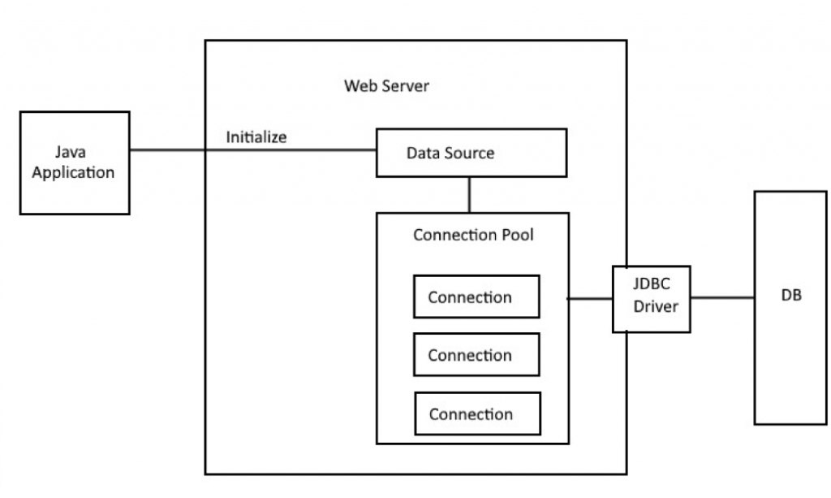

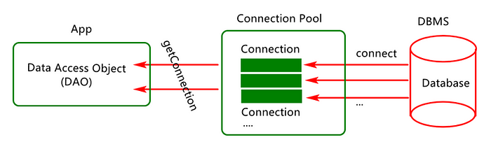

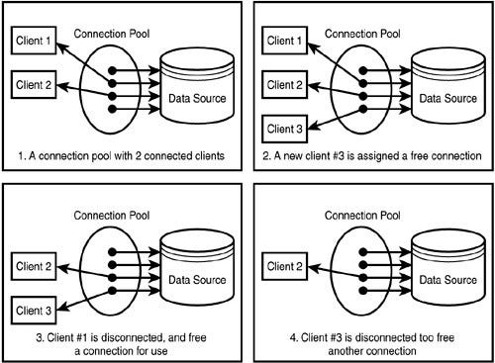

*transaction management? To make CURD operation in your application.*

*@*Entity? – used for hibernate mapping class.

<https://start.spring.io/>

springboot starters? – it is a template for all the libraries, main advantage is auto configuration.

Spring Boot DevTools? 🡪 it will **restart** your application when you do changes in spring boot project in STS.

It is useful for development.

Thymeleaf ? 🡪 it is Dynamic HTML template for springboot project.

SQL VS NoSql Difference?

Schema based / No-Schema.

SQL stores data in tables, NO-SQL stores data in json format in docemnts.

ACID property?

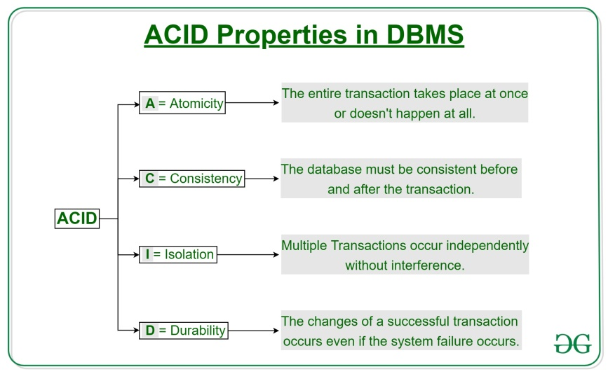

Fault tolerance?

What is <https://start.spring.io/> ?

Installing D:\10.30PM Discussion\sts_projects\demo\demo\target\demo-0.0.1-SNAPSHOT.jar to C:\Users\HP\.m2\repository\com\example\demo\0.0.1-SNAPSHOT\demo-0.0.1-SNAPSHOT.jar

What is **the** use of “starter” dependency in spring boot? Related and dependent jar / libraries files will be **downloaded**.

Springboot important concepts:

Spring Boot Starters

Auto-Configuration

Embedded Servers – default server is TOMCAT.

Java Development Kit (JDK) 🡪 For Spring boot 3.x which version of java is required? 🡪 Minimum java 17+

For Spring boot 2.x which version of java is required? 🡪 Minimum java 8+

Lombok?

H2 databse? It is IN-Memory database.

Annotations in SB?

**@SpringBootApplication**

@Target(ElementType.***TYPE***)

@Retention(RetentionPolicy.***RUNTIME***)

@Documented

@Inherited

@SpringBootConfiguration

@EnableAutoConfiguration

@ComponentScan

@Configuration

@Indexed

@AutoConfigurationPackage

@Import(AutoConfigurationImportSelector.**class**)

Main class:

It contains the *main()* method that is the starting point of the application runtime. It contains the *@SpringBootApplication* annotation. It internally triggers the bean auto-configuration and component scanning that configures all the beans in the application and registers them with the application context.

**How springboot parent starter tag works in springboot?**

1. Create one maven project, now, inside pom.xml file under <packaging> tag add value as “**pom**”.

Like below,

<packaging>pom</packaging>

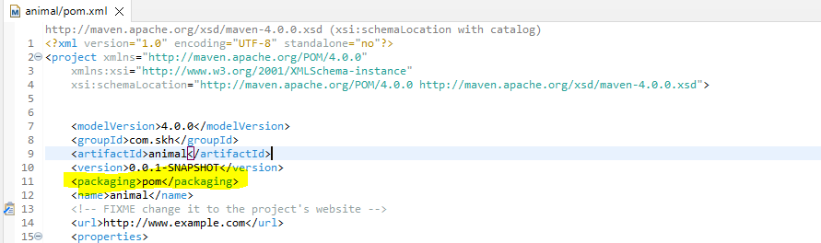

For <packaging> tage we have so many values. we can see below.

Eg: ear, ejb, jar, maven-plugin, **pom**, war, …etc.

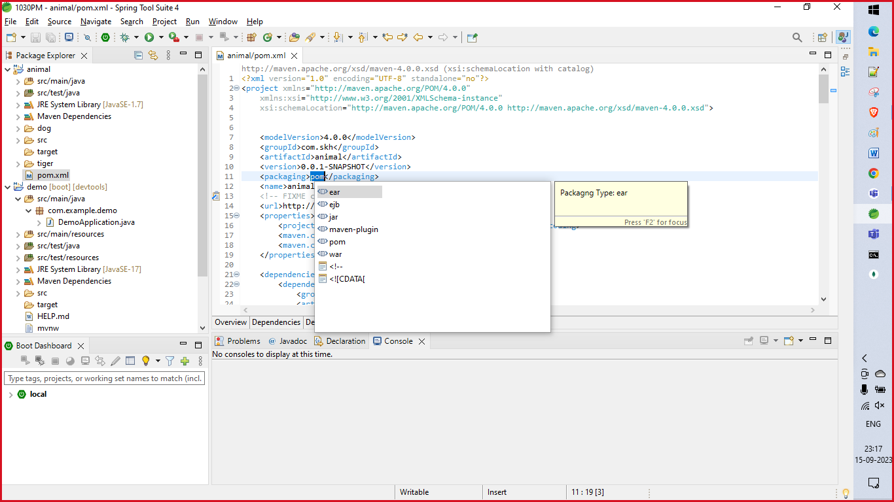

That’s all from this project.

1. Now create another maven project, but while creating it do not select as mavne project, select as maven module.

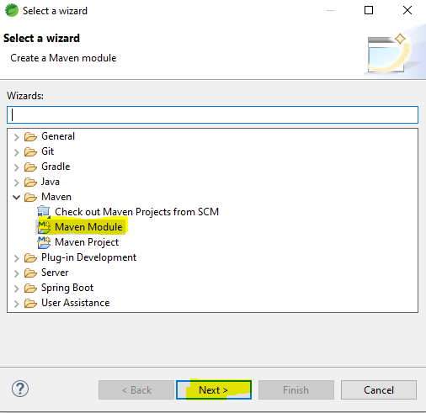

Now click on next,

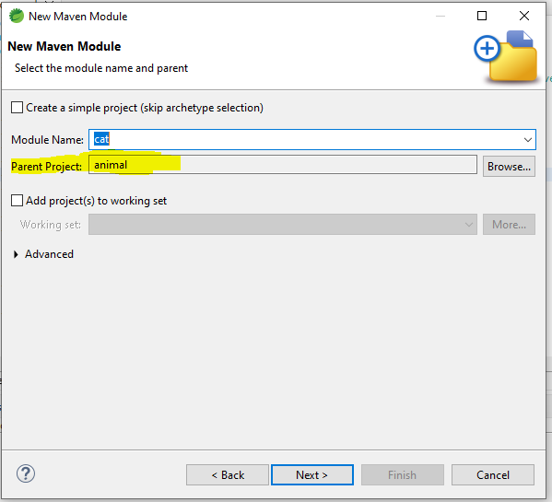

You can give module name as anything, but we need to select “Parent project” as animal project we created earlier.

Click on next and select maven-archetype-quickstart next click on NEXT .

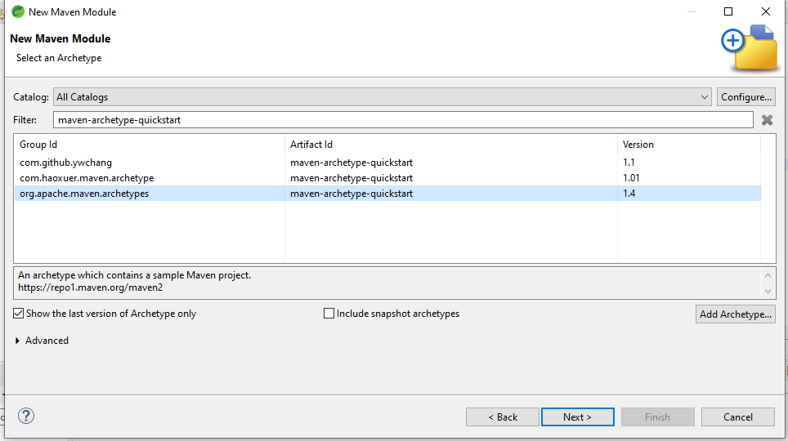

Next..

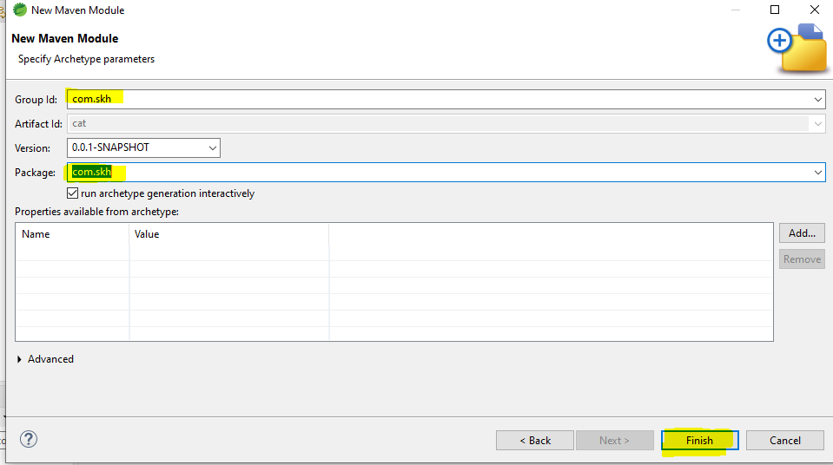

Finally click on finish.

Now in the child project pom.xml file we can see <parent> tag with parent project detaisl.

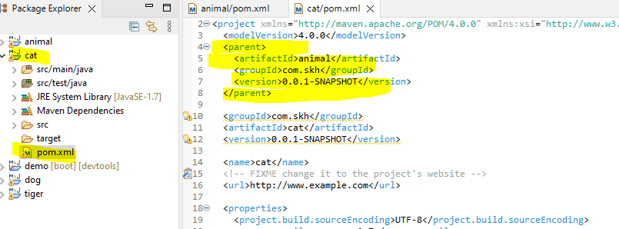

And in parent pom.xml file we can see child project is updated as <module>

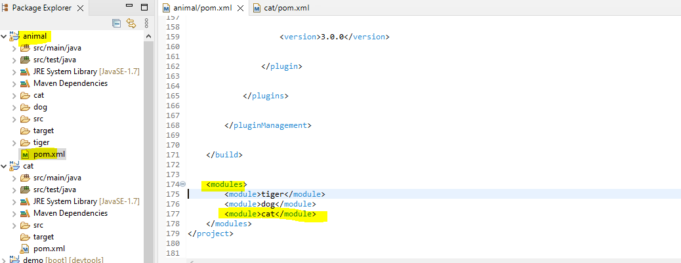

This is how parent tag is generated in child projects.

If we add any our own dependency in parent pom.xml file and if you create child project based on this parent project then all those parent project dependent jar files will available in child project also. It directly downloads the jar files, but not add tags in child pom.xml file.

These jar files we can see in maven decencies of child project.

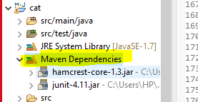

Suppose we already created child project, after that some new dependencies are added in parent project in pom.xml file as dependencies. Then to get those jar files in child class project we need to do maven update.

Right click on child project 🡪 Maven 🡪 Update project 🡪

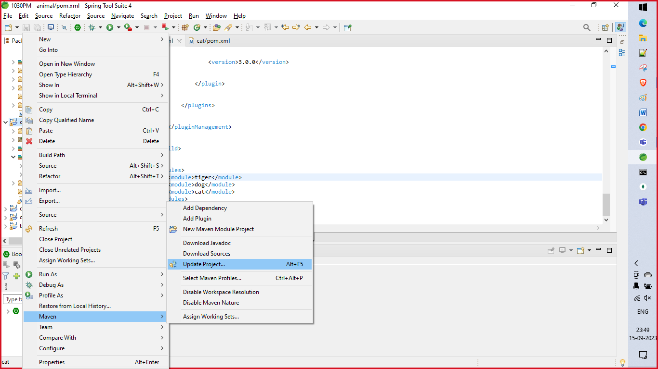

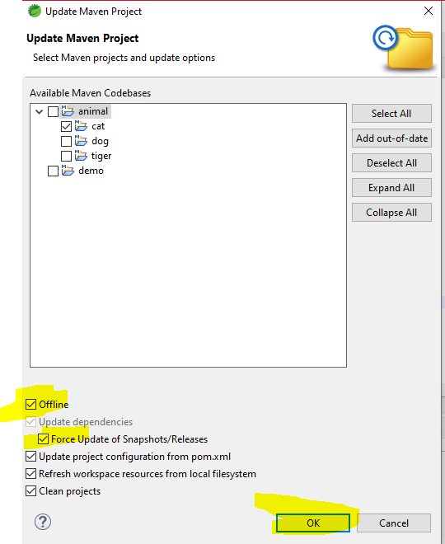

Noe check the checkbox “OFFLINE” and “Force update of snapshots/Release”, now child project will be synched with parent project and all parent dependent jar files will be downloaded in child maven dependency.