Working with UI means working with below technologies.

1. HTML. 🡪 HTML describes the structure of a Web page, HTML consists of a series of elements, HTML elements tell the browser how to display the content
2. CSS. 🡪 or styling (color), size representations. it tells how HTML elements are to be displayed on screen.
3. **JavaScript**. 🡪 validations, Event 🡪 Action. **It performs actions DYNAMICALLY.**

**Event means? 🡪 onclick, ondbclik, onmouseover, etc..**

**Actions means? 🡪 to perform validations on user given input data, changing element colors dynamically on any event, changing elements size and width dynamically on any event.**

**JavaScript Actions:**

1. Predefined actions (functions). Eg: alert(), console.log()…etc.
2. Custom actions (functions). Eg: myFunction()…..etc.

In above code we can see we have written JavaScript code as INTERNL JS, means we have written in **<script>** tag.

|  |  |  |  |
| --- | --- | --- | --- |
|  | **Inline** | **Internal** | **External** |
| **CSS** | <tagName **style=”p:v;p:v**”  Eg:  <p **style=”color:red;”>**  </p> | <style>  P{ **// selector**  Color:red;  }  </style> | Create **test.css**  In this CSS file Write direct code.  Import this file in HTML:  **<link href="test.css" rel="stylesheet">** |
| **JavaScript** | eventName=function  eg:  onclick=”myFunctionName()” | <script>  JS code..  Functions etc…  </script> | Create Test.js  In this JS file Write direct code.  Import this file in HTML:  **<script src="test.js"></script>** |

**What is Browser Inspect?** What options are there in it? Please explain all options.

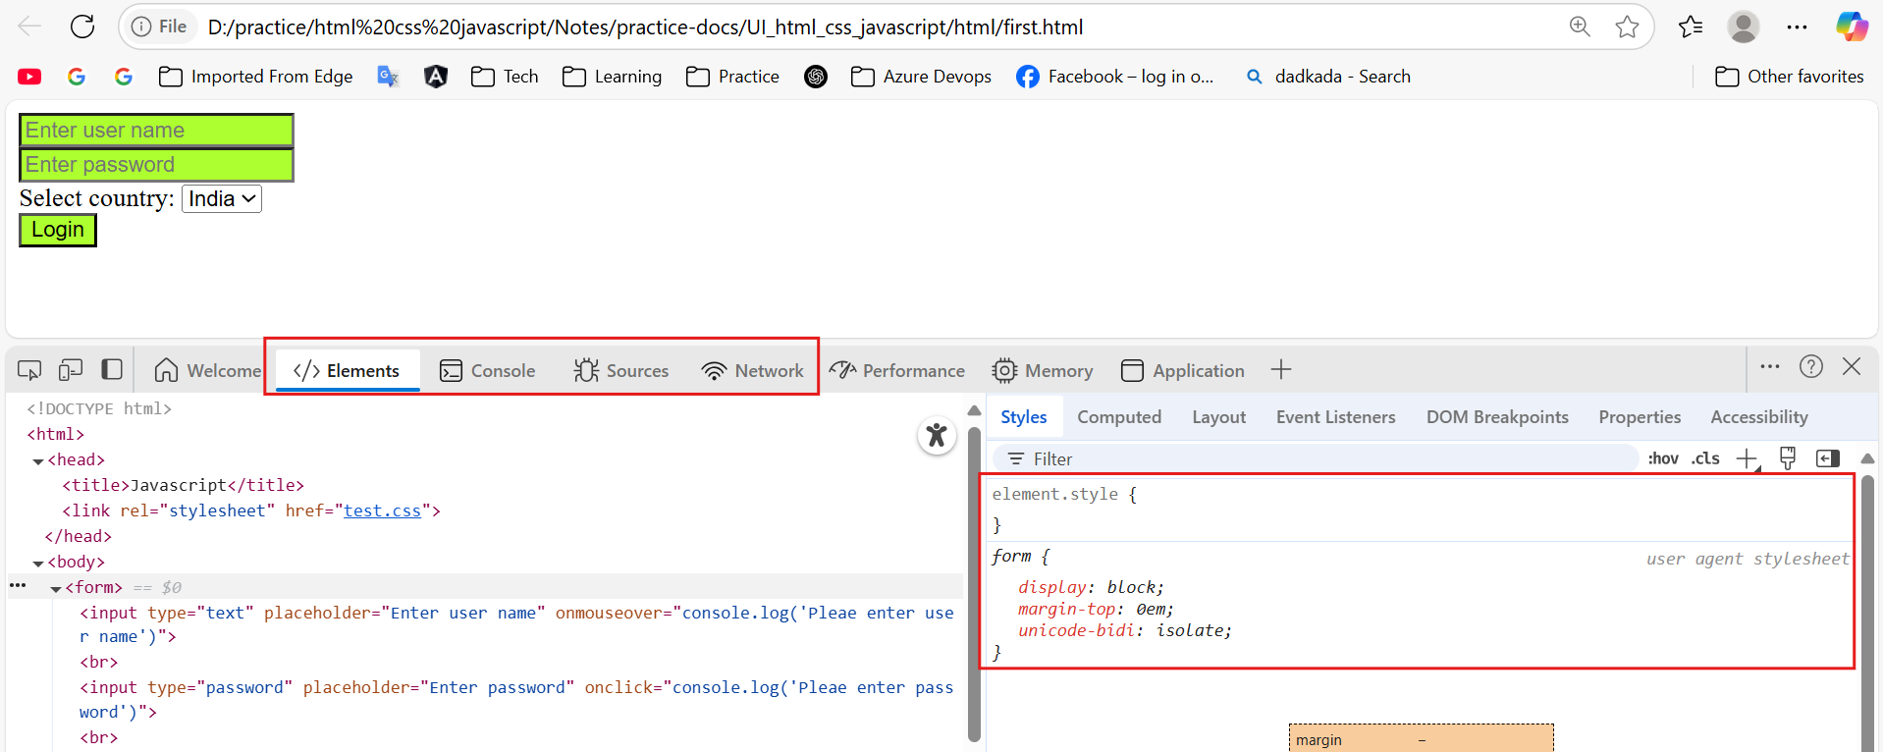

We use above technologies for creating UI (User Interface) pages.

UI – User Interface – Which ever user experiences that page is called as UI page / Browser page.

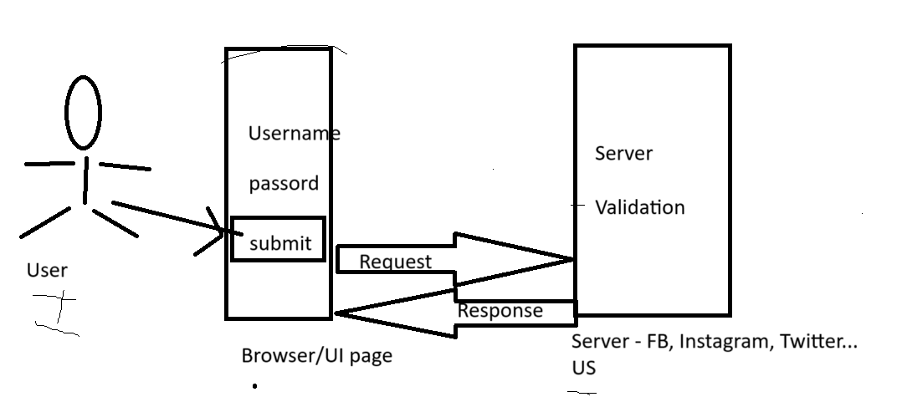

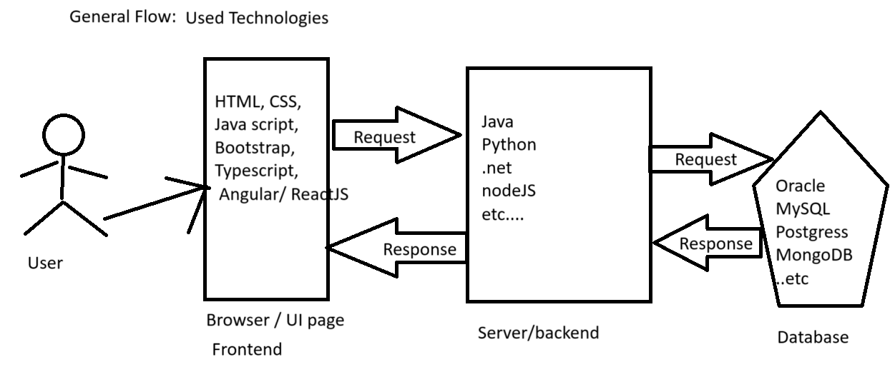

**Validation?** – Checking the user entered details (user name, password, email, phone number etc..) at client side and at server side is called as Validation.

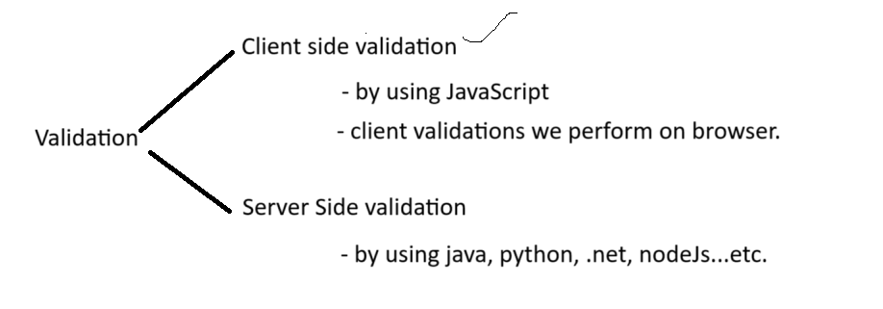

Server or Client always perform validation on user given input data.

Response is two types🡪 Valid(Success) response / Error response.

Browser**?** 🡪 HTML page rendering/ displaying location. It internally has engine to execute UI technologies.

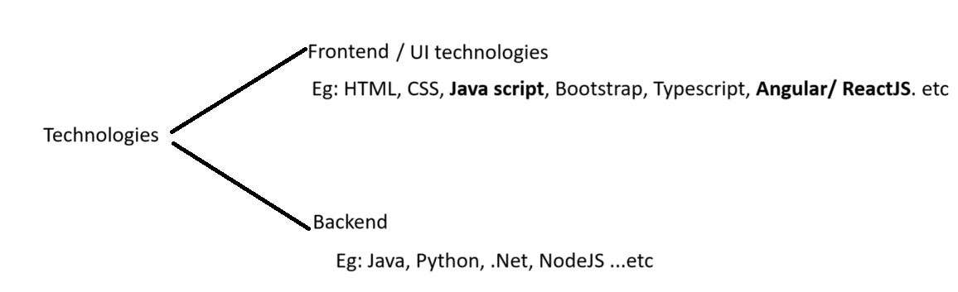

Browser:

How many browsers are there in the market? 🡪 So many browsers are available in the market.

What are they? Tell me 4 browsers?

Different companies created different browsers. Based on **browsing speed, memory usage** we use different browser.

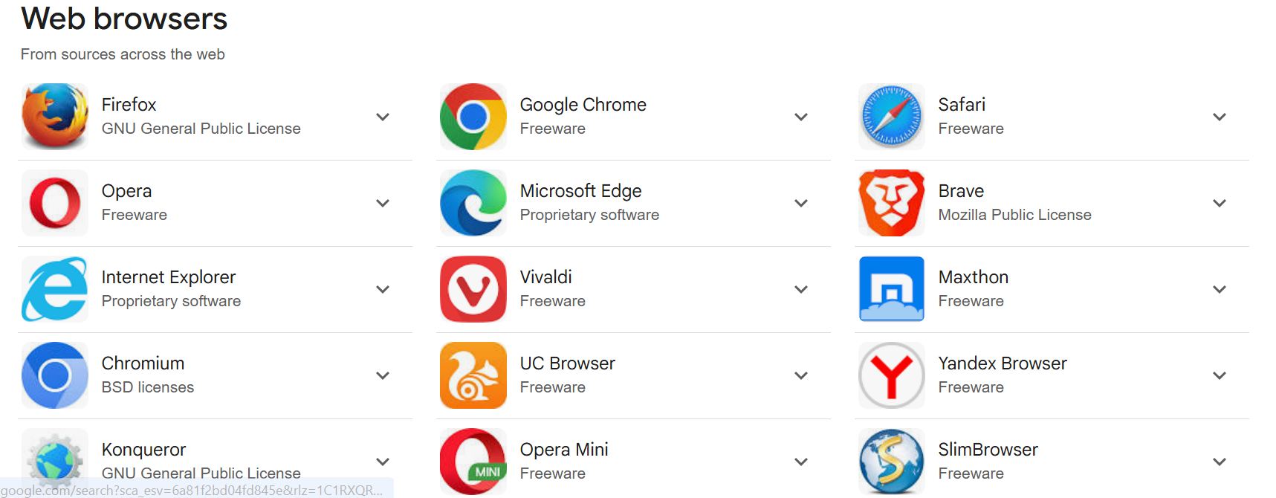

Which technologies can a browser understand? **HTML, CSS, Javascript**.

A browser can execute/run only **HTML, CSS, Javascript** files.

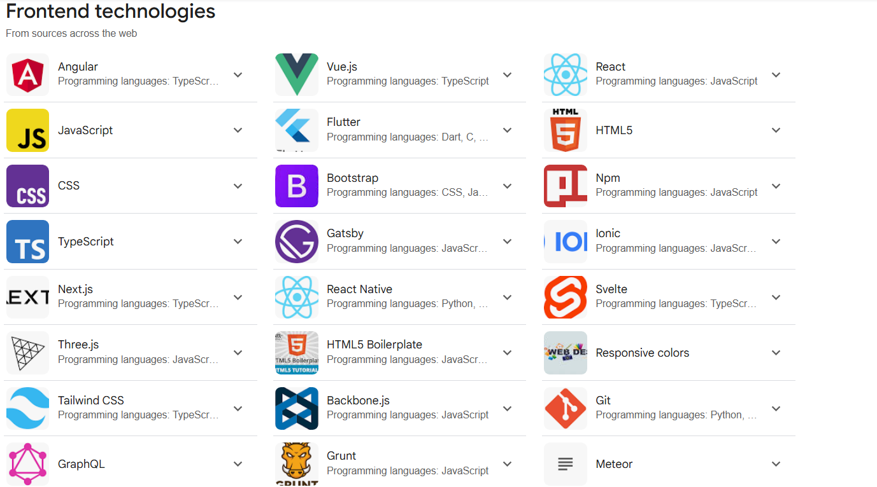

Then what about other UI technologies? How they run in browser? ->

For example, Angular or ReactJs how they run in browser? 🡪 First, we convert/compile/transpile the angular/reactjs into JavaScript code then we run in browser.

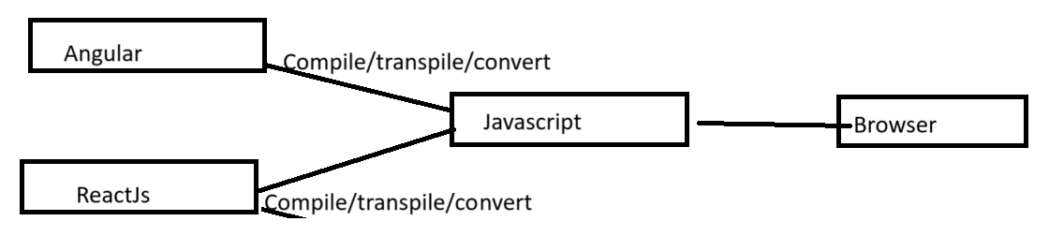

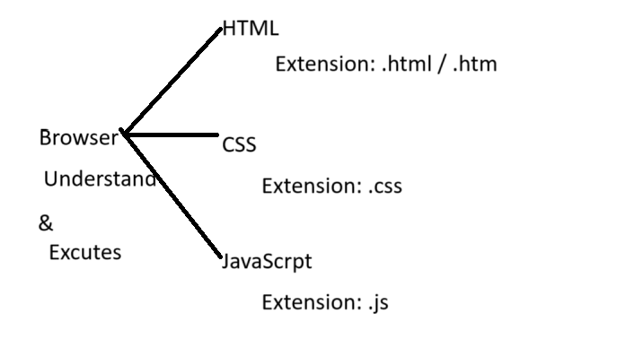

What is meant by Extension 🡪 It is File format.

How to create these files? 🡺 Left/Right Arrow mark.

**<anyName>.extension**

<anyName>.html, <anyName>.css, <anyName>.js

Extension? -> Which tells which type/format of the file we are going to create.

Eg: for TEXT file we use extension as **.txt**

for WORD file we use extension as **.docx**

for PDF file we use extension as **.pdf**

for JAVA file we use extension as **.java**

for IMAGES file we use extension as **.jpeg, .png, .gif….**

for HTML file we use extension as **.html / .htm**

for CSS file we use extension as **.css**

for Javascript file we use extension as **.js**

**etc…………………………..**

**Abbreviations:**

**HTML 🡪 Hyper Text Markup Language.**

**CSS 🡪 Cascading Style Sheet.**

**“id”(#) attribute and “class”(. DOT) attribute:**

Attributes always give additional information about element.

**we use “id” to identify element uniquely.**

|  |
| --- |
| <!DOCTYPE html>  <html>  <head>    <title>Javascript</title>  </head>  <style>  </style>  <body>    <form action="**#**">      Enter Name: <input type="text**" id="uName"** class="abcClass" style="color: red;" value="Kamal"/><br>      Enter password: <input type="password" **id="pwd"**><br>      Select country: <select **id="country**">        <option>India</option>        <option>US</option>        <option>UK</option>      </select>      <br>      <input type="submit" value="Login" **onclick="test1();"**><br>    </form>  **<script>**  **function test1() {**  **console.log(document.getElementById('uName'));**  **}**  **</script>**  </body>  </html> |

Here **document.getElementById('uName')** is a Javascript selector.

Selector 🡪 Find and Apply. (CSS)

**JS selector 🡪 Find and Fetch (JacaScript)**

|  |
| --- |
| function validateInpuData() {      document.getElementById('uName'**).value = "AAAAAAAAA";**      document.getElementById('pwd').value = "BBBBBBB";      var v = document.getElementById('country').value;      document.getElementById("male**").checked** = true;      document.getElementById('uName'**).style = "background-color:red;";**      document.getElementById('pwd').style = "background-color:red;";    } |

|  |
| --- |
| <!DOCTYPE html>  <html>  <head>  </head>  <style>  </style>  <script>    function validateInpuData() {      document.getElementById('uName'**).disabled = false;**      document.getElementById('pwd').disabled = true;  **document**.getElementById('male').disabled = true;      document.getElementById('fMale').disabled = true;      document.getElementById('country').disabled = true;      document.getElementById('sbmt').disabled = true;      document.getElementById('fMale').**checked = true;**      document.getElementById('eng').checked = true;      document.getElementById('tel').checked = true;      document.getElementById('tml').checked = true;      document.getElementById('eng').disabled = true;      document.getElementById('tel').disabled = true;      document.getElementById('tml').disabled = true;    }  </script>  <body>    <form action="#">      Enter user Name: <input type="text" id="uName" style="color: red;" value="Kamal" disabled="true"/> <br>      password : <input type="password" id="pwd" value="abc123" /> <br>      Gender : Male : <input type="radio" name="gender" id="male" />      Female : <input type="radio" name="gender" id="fMale" /><br>      Select Country:      <select id="country">        <option>Select</option>        <option>US</option>        <option selected="true">India</option>        <option>Aus</option>      </select>      <br>      Select languages:      English: <input type="checkbox" id="eng" />      Telugu: <input type="checkbox" id="tel" />      Tamil: <input type="checkbox" id="tml" />      <br>      <input type="submit" **onclick="validateInpuData()"** value="Submit" id="sbmt" /> <br>    </form>  </body>  </html> |

|  |
| --- |
| <!DOCTYPE html>  <html>  <head>  </head>  <body>    <form action="#">      Enter Name : <input type="text" id="userName" /><br>      Enter Password: <input type="password" id="pwd" /><br>      Select coubtry: <br>      <select id="country">        <option>Select</option>        <option>Aus</option>        <optio>India</option>          <option>UK</option>      </select><br>      Gender: <br>      Male : <input type="radio" id="male" name="g" />      Female : <input type="radio" id="female" name="g" />      <br>      Select Langualges:      English : <input type="checkbox" id="eng" />      Telugu: <input type="checkbox" id="tel" />      Tamil: <input type="checkbox" id="tml" />      <br>      <input type="submit" value="Submit..." onclick="testFunction()" />      <input type="submit" value="Enable Form" onclick="enalbeElements()" />    </form>    <script>      function testFunction() {        document.getElementById('userName').value = "Kamal";        document.getElementById('pwd').value = "ASASAS";        document.getElementById('male').checked = true;        document.getElementById('eng').checked = true;        document.getElementById('tel').checked = true;        document.getElementById('country').selectedIndex = 2;        var uName = document.getElementById("userName").value;        console.log(uName);        var passordV = document.getElementById('pwd').value;        console.log(passordV);        /*          int uName = "Kamal";          System.out.println(uName);        */      }      function enalbeElements() {      }      </script>  </body>  </html> |