Working with UI means working with below technologies.
- HTML. HTML describes the structure of a Web page, HTML consists of a series of elements, HTML elements tell the browser how to display the content
- CSS. or styling (color), size representations. it tells how HTML elements are to be displayed on screen.
- JavaScript. validations, Event Action. It performs actions DYNAMICALLY.
Event means? onclick, ondbclik, onmouseover, etc..
Actions means? to perform validations on user given input data, changing element colors dynamically on any event, changing elements size and width dynamically on any event.

JavaScript Actions:
- Predefined actions (functions). Eg: alert(), console.log()…etc.
- Custom actions (functions). Eg: myFunction()…..etc.

In above code we can see we have written JavaScript code as INTERNL JS, means we have written in <script> tag.
 | Inline | Internal | External
CSS | <tagName style=”p:v;p:v”  Here p – property of css  V – values of that css property.  Eg:  <p style=”color:red;”>  </p> | <style>  P{ // selector  Color:red;  }  </style> | Create test.css  In this CSS file Write direct code.  Import this file in HTML:  <link href="test.css" rel="stylesheet">
JavaScript | eventName=function  eg:  onclick=”myFunctionName()” | <script>  JS code..  Functions etc…  </script> | Create Test.js  In this JS file Write direct code.  Import this file in HTML:  <script src="test.js"></script>

What is Browser Inspect? What options are there in it? Please explain all options.
Brower inspect is used for debugging the errors, for checking elements, for checking requests, for checking source paths.
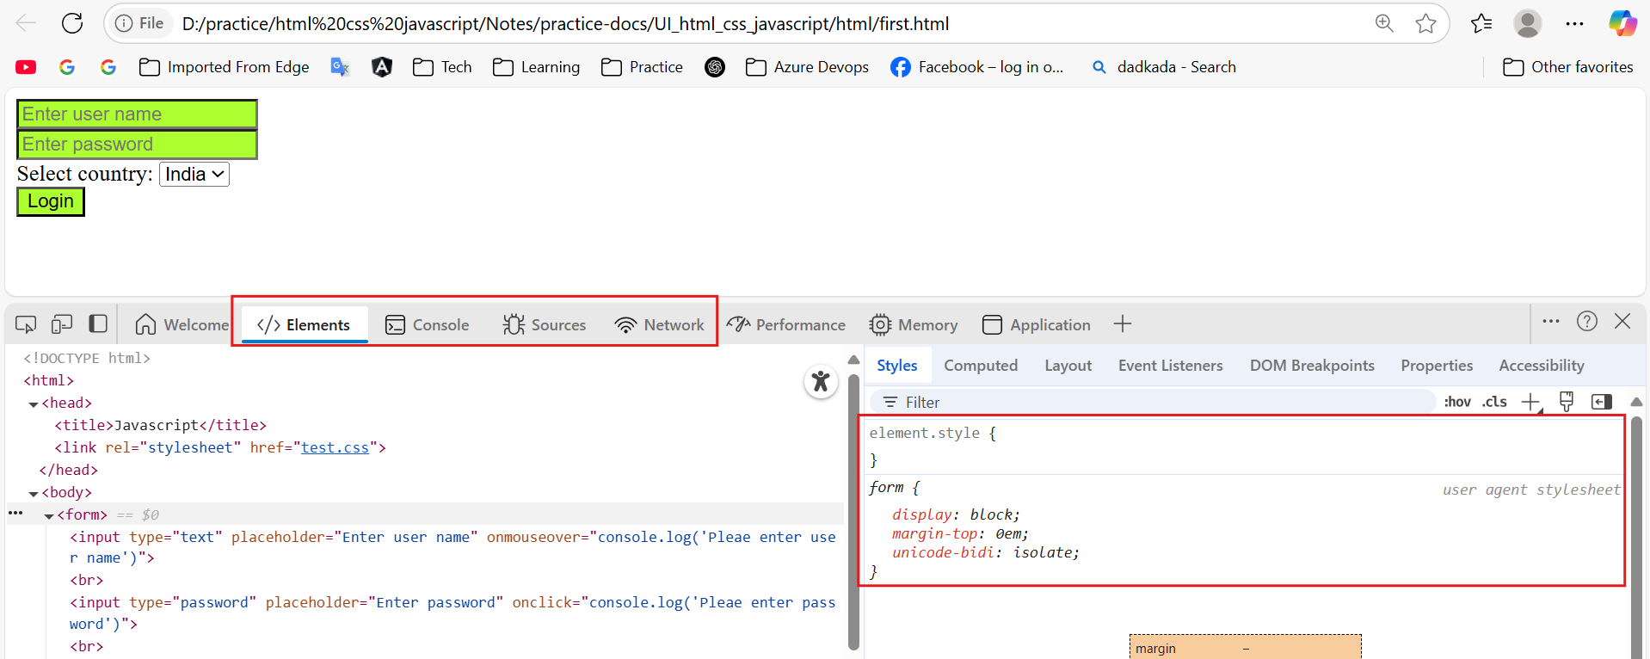

We use above technologies for creating UI (User Interface) pages.
UI – User Interface – Which ever user experiences that page is called as UI page / Browser page.

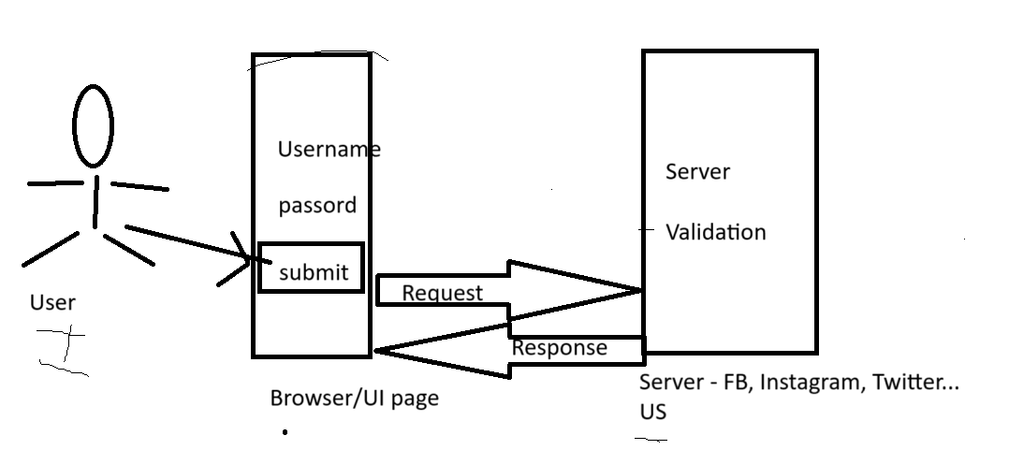

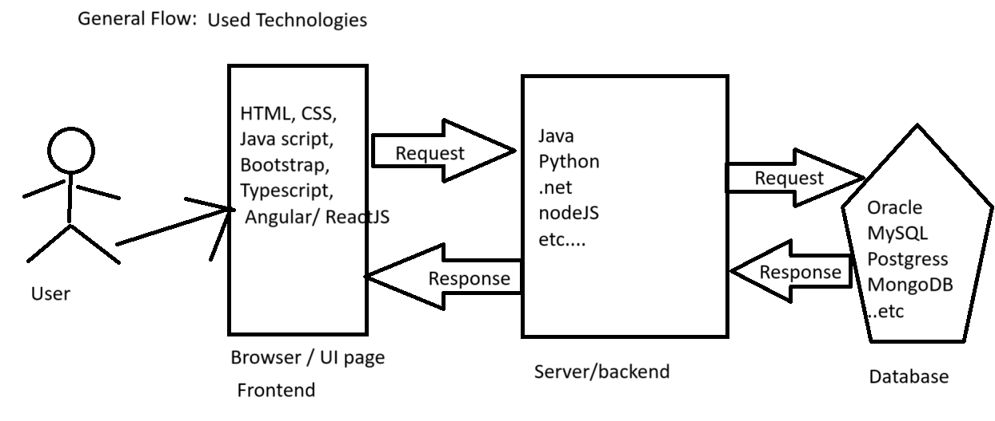

Validation? – Checking the user entered details (user name, password, email, phone number etc..) at client side and at server side is called as Validation.

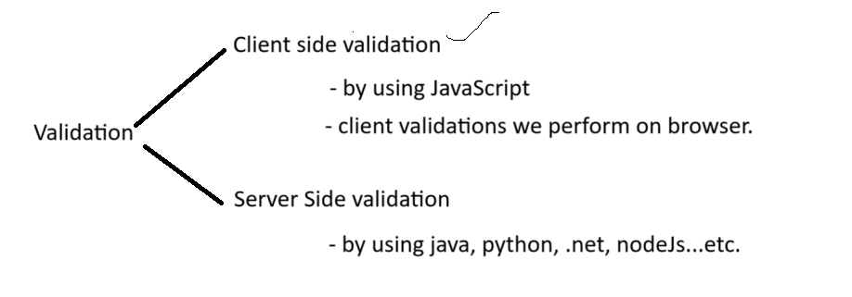

Server or Client always perform validation on user given input data.

Response is two types Valid(Success) response / Error response.

Browser? A web browser, or simply a browser, is a software application used to access and view content on the World Wide Web. It acts as an interface between the user and the internet, allowing them to navigate and interact with websites.

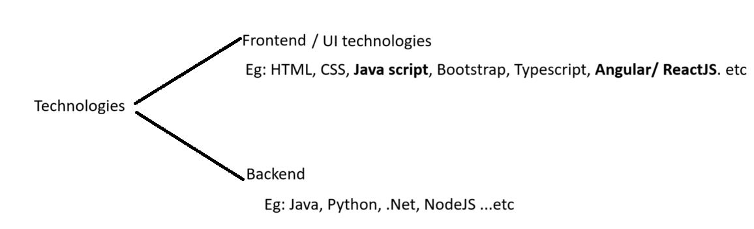
Browser:
How many browsers are there in the market? So many browsers are available in the market.
What are they? Tell me 4 browsers?
Different companies created different browsers. Based on browsing speed, memory usage we use different browser.

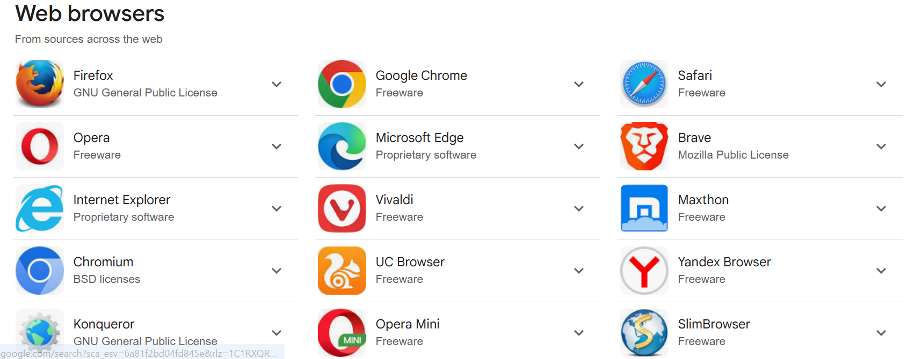

Which technologies can a browser understand? HTML, CSS, Javascript.
A browser can execute/run only HTML, CSS, Javascript files.

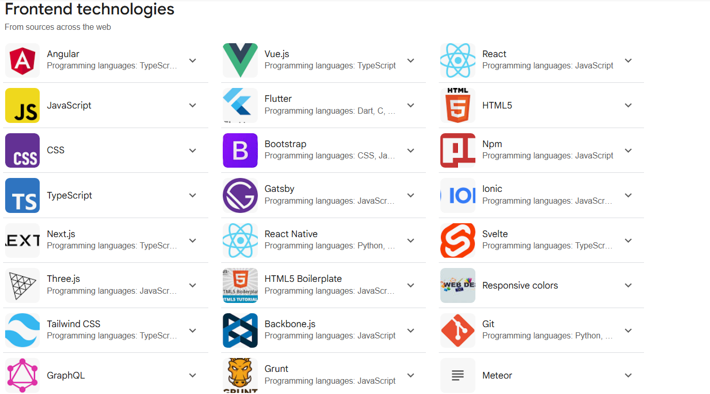

Then what about other UI technologies? How they run in browser? ->
For example, Angular or ReactJs how they run in browser? First, we convert/compile/transpile the angular/reactjs into JavaScript code then we run in browser.

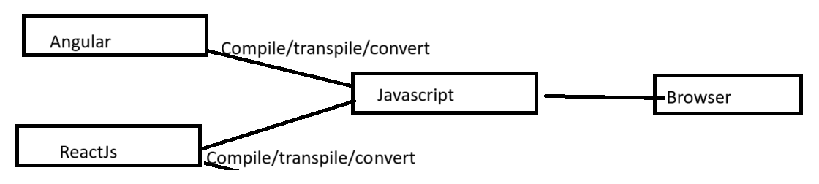

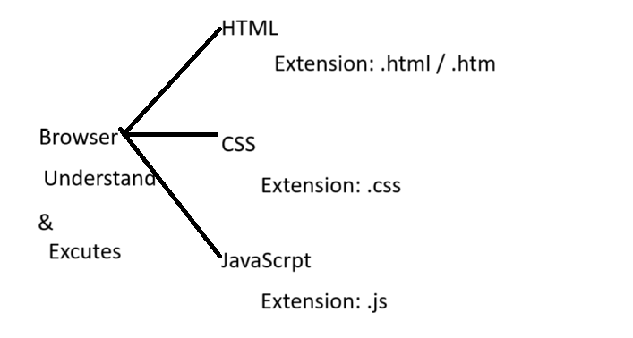

What is meant by Extension It is File format.

How to create these files? Left/Right Arrow mark.
<anyName>.extension

<anyName>.html, <anyName>.css, <anyName>.js
Extension? -> Which tells which type/format of the file we are going to create.
Eg: for TEXT file we use extension as .txt
for WORD file we use extension as .docx
for PDF file we use extension as .pdf
for JAVA file we use extension as .java
for IMAGES file we use extension as .jpeg, .png, .gif….
for HTML file we use extension as .html / .htm
for CSS file we use extension as .css
for Javascript file we use extension as .js
etc…………………………..

How many ways we can write HTML code, CSS code, JS code?
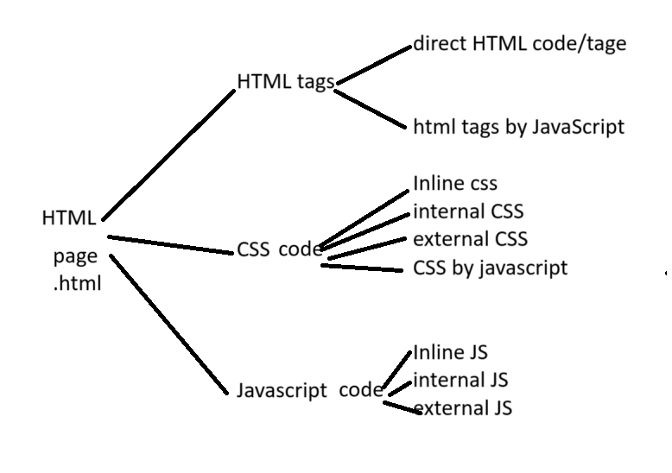

Abbreviations:
HTML Hyper Text Markup Language.
CSS Cascading Style Sheet.

“id”(# - in CSS) attribute and “class”(. DOT – in CSS) attribute:
Attributes always give additional information about element.
we use “id” to identify element uniquely.

<!DOCTYPE html>
<html>

<head>
<title>Javascript</title>
</head>
<style>
</style>

<body>
<form action="#">
Enter Name: <input type="text" id="uName" class="abcClass" style="color: red;" value="Kamal"/><br>
Enter password: <input type="password" id="pwd"><br>
Select country: <select id="country">
<option>India</option>
<option>US</option>
<option>UK</option>
</select>
<br>
<input type="submit" value="Login" onclick="test1();"><br>
</form>

<script>
function test1() {
console.log(document.getElementById('uName'));
}
</script>
</body>

</html>

Here document.getElementById('uName') is a Javascript selector.
Selector Find and Apply. (CSS)
JS selector Find and Fetch (JacaScript)
function validateInpuData() {
document.getElementById('uName').value = "AAAAAAAAA";
document.getElementById('pwd').value = "BBBBBBB";
var v = document.getElementById('country').value;
document.getElementById("male").checked = true;

document.getElementById('uName').style = "background-color:red;";
document.getElementById('pwd').style = "background-color:red;";

}

<!DOCTYPE html>
<html>

<head>

</head>
<style>

</style>
<script>
function validateInpuData() {
document.getElementById('uName').disabled = false;
document.getElementById('pwd').disabled = true;
document.getElementById('male').disabled = true;
document.getElementById('fMale').disabled = true;
document.getElementById('country').disabled = true;
document.getElementById('sbmt').disabled = true;

document.getElementById('fMale').checked = true;
document.getElementById('eng').checked = true;
document.getElementById('tel').checked = true;
document.getElementById('tml').checked = true;

document.getElementById('eng').disabled = true;
document.getElementById('tel').disabled = true;
document.getElementById('tml').disabled = true;
}

</script>

<body>

<form action="#">
Enter user Name: <input type="text" id="uName" style="color: red;" value="Kamal" disabled="true"/> <br>
password : <input type="password" id="pwd" value="abc123" /> <br>
Gender : Male : <input type="radio" name="gender" id="male" />
Female : <input type="radio" name="gender" id="fMale" /><br>
Select Country:
<select id="country">
<option>Select</option>
<option>US</option>
<option selected="true">India</option>
<option>Aus</option>
</select>
<br>
Select languages:
English: <input type="checkbox" id="eng" />
Telugu: <input type="checkbox" id="tel" />
Tamil: <input type="checkbox" id="tml" />

<br>
<input type="submit" onclick="validateInpuData()" value="Submit" id="sbmt" /> <br>
</form>
</body>
</html>

<!DOCTYPE html>
<html>

<head>

</head>

<body>

<form action="#">
Enter Name : <input type="text" id="userName" /><br>
Enter Password: <input type="password" id="pwd" /><br>
Select coubtry: <br>
<select id="country">
<option>Select</option>
<option>Aus</option>
<optio>India</option>
<option>UK</option>
</select><br>
Gender: <br>
Male : <input type="radio" id="male" name="g" />
Female : <input type="radio" id="female" name="g" />
<br>
Select Langualges:
English : <input type="checkbox" id="eng" />
Telugu: <input type="checkbox" id="tel" />
Tamil: <input type="checkbox" id="tml" />
<br>
<input type="submit" value="Submit..." onclick="testFunction()" />
<input type="submit" value="Enable Form" onclick="enalbeElements()" />

</form>

<script>

function testFunction() {

document.getElementById('userName').value = "Kamal";
document.getElementById('pwd').value = "ASASAS";

document.getElementById('male').checked = true;

document.getElementById('eng').checked = true;
document.getElementById('tel').checked = true;

document.getElementById('country').selectedIndex = 2;

var uName = document.getElementById("userName").value;
console.log(uName);

var passordV = document.getElementById('pwd').value;
console.log(passordV);

/*
int uName = "Kamal";
System.out.println(uName);
*/

}
function enalbeElements() {

}

</script>

</body>

</html>

<!DOCTYPE html>
<html>

<head>

</head>

<body>

<form action="#">
Enter Name : <input type="text" id="userName" /><br>
Enter Password: <input type="password" id="pwd" /><br>
Select coubtry: <br>
<select id="country">
<option>Select</option>
<option>Aus</option>
<option>India</option>
<option>UK</option>
</select><br>
Gender: <br>
Male : <input type="radio" id="male" name="g" />
Female : <input type="radio" id="female" name="g" />
<br>
Select Langualges:
English : <input type="checkbox" id="eng" />
Telugu: <input type="checkbox" id="tel" />
Tamil: <input type="checkbox" id="tml" />
<br>
<input type="submit" value="Submit..." onclick="testFunction()" id="btn"/>
<input type="submit" value="Enable Form..." onclick="enableForm()" id="btn"/>

</form>

<script>

function testFunction() {

// document.getElementById('userName').value= "AAAAAA";
// document.getElementById('pwd').value= "BBBBB";
// document.getElementById("country").selectedIndex = 2;
// document.getElementById('male').checked = true;
// document.getElementById('tel').checked = true;
// document.getElementById('tml').checked = true;

document.getElementById('userName').disabled = true;
document.getElementById('pwd').disabled = true;
document.getElementById("country").disabled = true;
document.getElementById('male').disabled = true;
document.getElementById('female').disabled = true;
document.getElementById('tel').disabled = true;
document.getElementById('tml').disabled = true;
document.getElementById('eng').disabled = true;
document.getElementById('btn').disabled = true;

document.getElementById('pContent').style.display = 'block';
document.getElementById('divContent').style.display = 'none';

}

function enableForm(){
document.getElementById('userName').disabled = false;
document.getElementById('pwd').disabled = false;
document.getElementById("country").disabled = false;
document.getElementById('male').disabled = false;
document.getElementById('female').disabled = false;
document.getElementById('tel').disabled = false;
document.getElementById('tml').disabled = false;
document.getElementById('eng').disabled = false;
document.getElementById('btn').disabled = false;

}

</script>

</body>

</html>

What is the purpose of “innerHTML” attribute?
To fetch the content of <p> element or fetch the content of <div> elements…etc related contents we will use “innerHTML” aatribute.
If you want to fetch the content we need to use “innerHTML” attribute.
var pContetnt = document.getElementById('pContent').innerHTML;
console.log(pContetnt);

How to hide <p> and <div> or any other elements on loading html page?
We write “hidden=true” attribute in that cooresponding element.
<p id="pContent" hidden="true" style="background-color: greenyellow;">
Form Submitted successfull...!!!<br>
Please wait for 10 working Days to get mail.
</p>

How to show elements on click of submit button ? How to show elements on any javacript event?
We use “.style.display = 'block'” on document object.
document.getElementById('pContent').style.display = 'block';

Here block means not blocking the content. Block means showing the content.

How to HIDE elements on click of submit button ? How to HIDE elements on any javacript event?
We use “.style.display = none” on document object.
document.getElementById('divContent').style.display = 'none';

How to fetch the “select” element data, selected innerHTML and selected value?
function testFunction() {
var index = document.getElementById('country').selectedIndex;
console.log(index);

var optns = document.getElementById('country').options;
console.log(optns[index].innerHTML);
console.log(optns[index].value);

if(optns[index].value == 111){
alert('You selected Austriala');
}
}

var index = document.getElementById("country").selectedIndex;
var options = document.getElementById('country').options;
var finalValue = options[index].value;
var htmlContent = optns[index].innerHTML;

List of attributes we used so far:
Syntax:
document.getElementById("ID_NAME") it gives complete element and all attributes details.
document.getElementById("ID_NAME").ANY_ATTRIBUTE_NAME;

document.getElementById("country").value; - to get the values from text fields/boxes.
document.getElementById("country").checked = true; - to get the values from radio buttons or multi checkboxes.
document.getElementById("country").disabled = true/false; To disable any kind of element in html page.

document.getElementById("country").selectedIndex; To get selected index value from drop down.
document.getElementById("country").options; To get all the options available in dropdown.
document.getElementById("country").options[index].value; To get value of selected dropdown.
document.getElementById("country").options[index].innerHTML; To get inner text / label of selected dropdown / get the content of <p> or <div> tags.

document.getElementById("country").innerHTML; to inner content of <p> tag, <div> tag or etc tags…

document.getElementById("country").style.display = ‘block’; To show hidden element / content.
document.getElementById("country").style.display = ‘none; To hide element / content.

document.getElementById('uName').style = "background-color:red;";

<!DOCTYPE html>
<html>

<head>

</head>

<body>

<form action="#">
Enter Name : <input type="text" id="userName" /><br>
Enter Password: <input type="password" id="pwd" /><br>
Select coubtry: <br>
<select id="country" onchange="showElements();">
<option value="slect">Select</option>
<option value="111">AUS</option>
<option value="222">INDIA</option>
<option value="333">UK</option>
</select><br>
<div id="sec1">
Gender: <br>
Male : <input type="radio" id="male" name="g" />
Female : <input type="radio" id="female" name="g" />
<br>
Select Langualges:
English : <input type="checkbox" id="eng" />
Telugu: <input type="checkbox" id="tel" />
Tamil: <input type="checkbox" id="tml" />
<br>

</div>
<input type="submit"value="Submit..." onclick="submitFunction(); return false;" id="btn1" />
<input type="submit" disabled="true" value="Enable Form..." onclick="enableForm(); return false;" id="btn2" />
</form>

<p id="pContent" hidden="true" style="background-color: greenyellow;">
Form Submitted successfull...!!!<br>
Please wait for 10 working Days to get mail.
</p>
<div id="myDIV" style="color: green;">
Form submitted successfully..!!!<br>
100K+ creators trust Graphy to teach online
𝕏
Logiclabs Technologies 2025<br>
Privacy policy<br>
Terms of use<br>
Contact us<br>
Refund policy<br>
</div>
<script>
function submitFunction() {
document.getElementById('myDIV').style.display = "block";
}
function enableForm() {
document.getElementById('myDIV').style.display = "none";
}
function showElements() {
var index = document.getElementById("country").selectedIndex;
var options = document.getElementById('country').options;
var finalValue = options[index].value;
if (finalValue == 222) {
document.getElementById('sec1').style.display = 'block';
document.getElementById('btn1').disabled = false;
document.getElementById('btn2').disabled = false;
} else {
alert("You are unautorized to submit form!!");
}
}
</script>
</body>
</html>

->How to fetch the values from form & How to assign values to existing form?
Write two functions, one is for fetching the all values, another is for assigning new values.

“document” object:
Why always we are writing document.getElementById()???
What is this “document”? why are we writing?

In the browser, what ever white/below yellow screen is visible is called as “document” object.
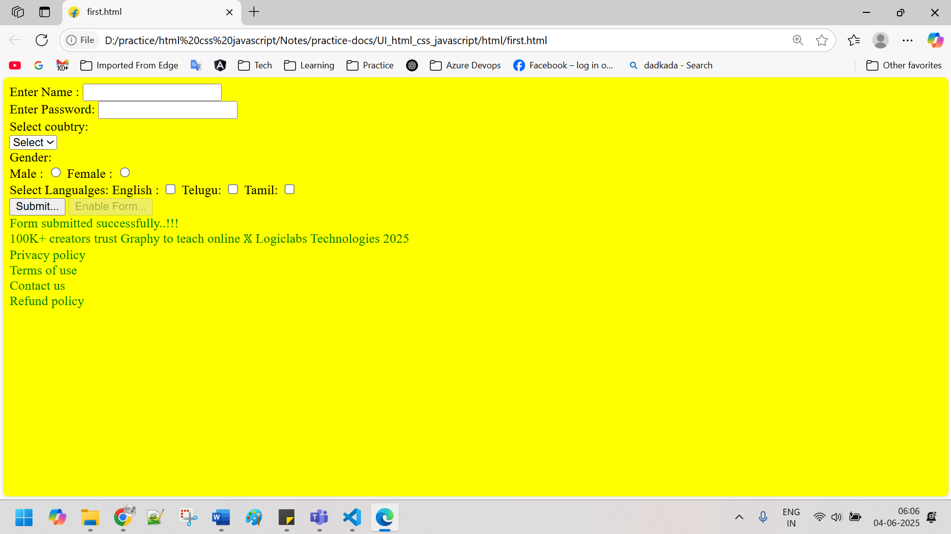

Above we can see yellow area we called as “document” object.

Complete browser is called as “window” object.

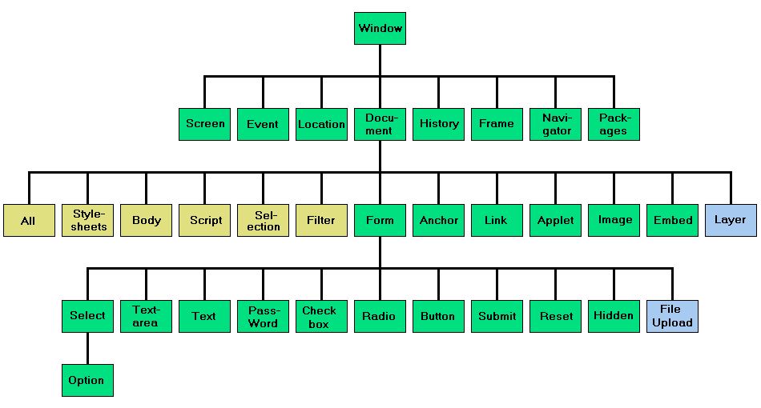

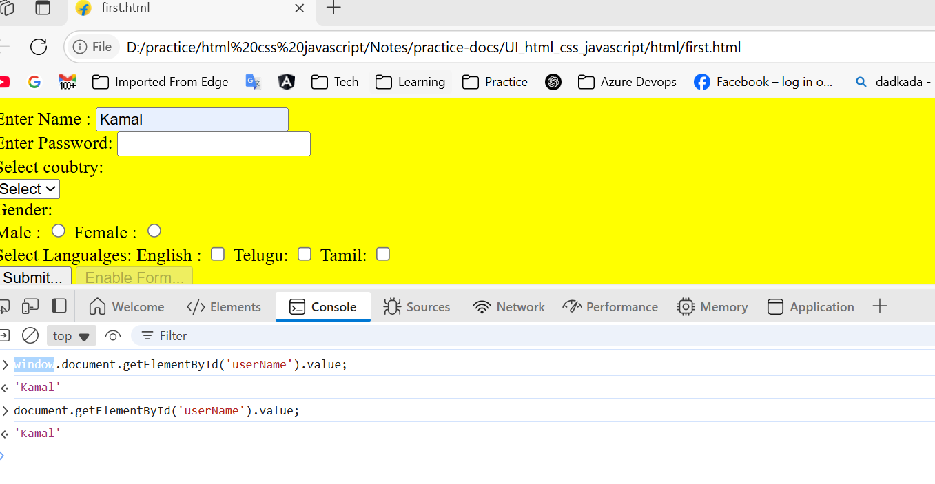

Tutorial reading:
https://www.w3schools.com/js/default.asp

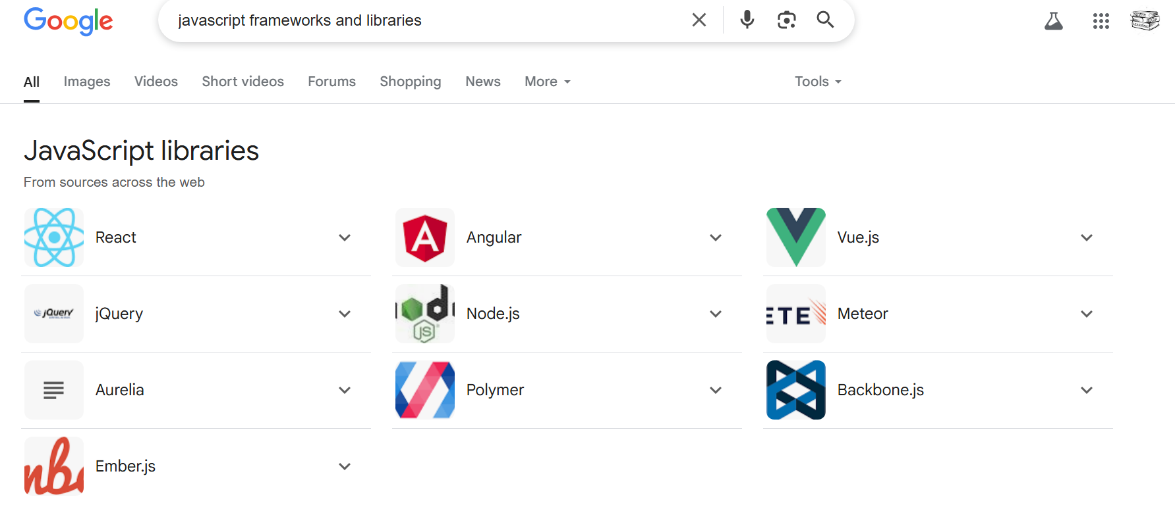
If we see above listed frameworks, all those are developed based on the JavaScript only.
Those framework code finally converted or transpiled or compiled into JavaScript code only, why because, browser only understands HTML, CSS and JavaScript.

“=” is assignment operator. We use it for assigning values. Means for storing the values in variables.
“==” comparison operator, used in mostly in “if” conditions.

This tutorial covers every version of JavaScript:
ES means – ECMA Script.
- The Original JavaScript ES1 ES2 ES3 (1997-1999)
- The First Main Revision ES5 (2009)
- The Second Revision ES6 (2015)
- The Yearly Additions (2016, 2017 ... 2021, 2022)

What is JavaScript?
JavaScript is the programming language of the web.
It can update and change both HTML and CSS.
It can calculate, manipulate and validate data.

function showContent() {
document.getElementById('myDIV').innerHTML = new Date();
document.getElementById('myDIV').style.color = 'blue';

var nameValue = document.getElementById('nameId').value;
if(nameValue == ''){
alert('Please enter Name!');
}else{
console.log(nameValue);
}
}

Why Study JavaScript?
JavaScript is one of the 3 languages all web developers must learn:
1. HTML to define the content of web pages,
2. CSS to specify the layout of web pages, colors applying, size applying..
3. JavaScript to program the behaviour (action) of web pages. Onclick,onchange,onbdclick,onmousehover..etc.
To perform client side validations.

JavaScript accepts both double and single quotes.

JavaScript Can Change HTML Attribute Values.
document.getElementById('mtInput').value = "Kamal";

<img src="pic_bulb_off.gif" id="imageId" />
<button type="button" onclick="bulbONFunction();" id="aaaa">Bulb ON</button><br>
<button type="button" onclick="bulbOFFFunction();">Bulb OFF</button><br>

<script>
function myFunction() {
document.getElementById("demo").innerHTML = "Hello JavaScript!";
document.getElementById('mtInput').value = "Kamal";
}
function bulbONFunction() {
document.getElementById('imageId').src = 'pic_bulb_on.gif'
}
function bulbOFFFunction() {
document.getElementById('imageId').src = 'pic_bulb_off.gif'
}
</script>

JavaScript Can Change HTML Styles (CSS).
function myFunction() {
document.getElementById('demo').style = "background-color:red;font-size:100px";
}

JavaScript Can Hide and shoe HTML Elements:
document.getElementById("demo").style.display = "none"; to HIDE the content / element.
document.getElementById("demo").style.display = "block"; to SHOW the content / element.

JavaScript and Java are completely different languages, both in concept and design.
JavaScript was invented by Brendan Eich in 1995, and became an ECMA standard in 1997.
ECMA-262 is the official name of the standard. ECMAScript is the official name of the language.

ECMA Script is documentation.

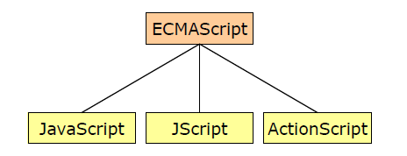
JavaScript and others like JScript and ActionScript are all different implementations of ECMAScript.
Like JavaScript, we have Jscript and ActionScript other scripting languages, but JavaScript is very famous because of its syntax and performance. So developers more use JavaScript only.

Old JavaScript examples may use a type attribute: <script type="text/javascript">.
But now in latest browsers the “type” attribute is not required. JavaScript is the default scripting language in HTML.

JavaScript Functions and Events:
A JavaScript function is a block of JavaScript code, that can be executed when "called" for.
For example, a function can be called when an event occurs, like when the user clicks a button.

You can place any number of <script> tags in an HTML document.
<script>s can be placed in the <body>, or in the <head> section of an HTML page, or in both.

Placing <script>s at the bottom of the <body> element improves the display speed, because script interpretation slows down the display.

Interpretation line by line execution. In HTML, Browser engine will do the Interpretation.
In java JVM performs Interpretation. Means line by line execution.

External script file should not contain <script> tags. Means in .js file we no need to write <script> tag.

Which is the recommended place to keep <script> tag in html page?
At the bottom of the <body> tag/ element.

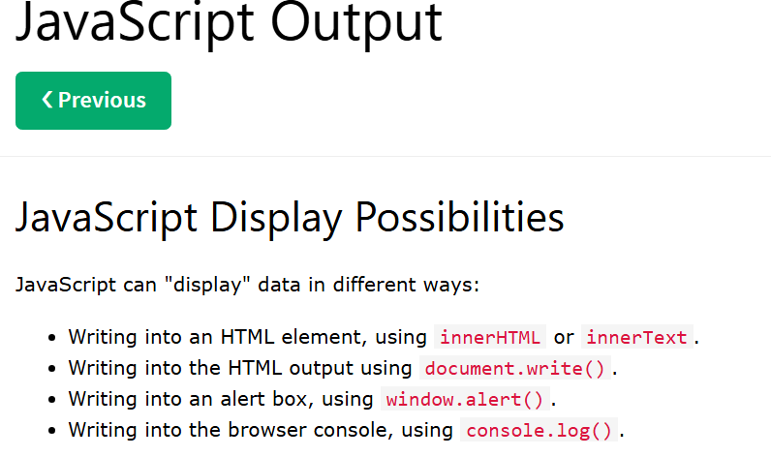

What is the difference between innerHTML and innerText attributes?

innerHTML = html contetnt + html tags.
innerTest = html content.

Note:
Use innerHTML when you want to change an HTML element.
Use innerText when you only want to change the plain text.

We should never use “document.write()” on events, why because it ls erasing existing all html content.

Print:
It is used to print the current page of html code.
<!DOCTYPE html>
<html>
<body>
<button onclick="window.print()">Print this page</button>
</body>
</html>

what is the difference between instance variable and local variable java?
Only the scope.
we declare Local variables in either methods or constructors or blocks, their scope is up to methods or constructors or blocks only.

We declare instance variable / class level variable at the top of the class. This variable scope is up to class. Means all methods, constructors and blocks can use/access this this variable.

public class App {
int a; // variable declaration1
{
int f = 10; // declaration + initialization
}
public App(){
int x = 10; // declaration + initialization
//f = 556; ==> Error
a = 54545;// initialization
}
public void m1(String[] args) {
int b = 30; // declaration + initialization
a = 34; // declaration + initialization
}
}

What is meant by declaration and Initialization?

JavaScript code works without termination / semi column, but it is always recommended to use termination for each line. Why because in PROD JS code will be minified or compressed into single line. If we don’t have termination then code will overlap and code will fail.

For example: below bootstrap plugin.
https://cdn.jsdelivr.net/npm/bootstrap@5.3.3/dist/js/bootstrap.bundle.min.js
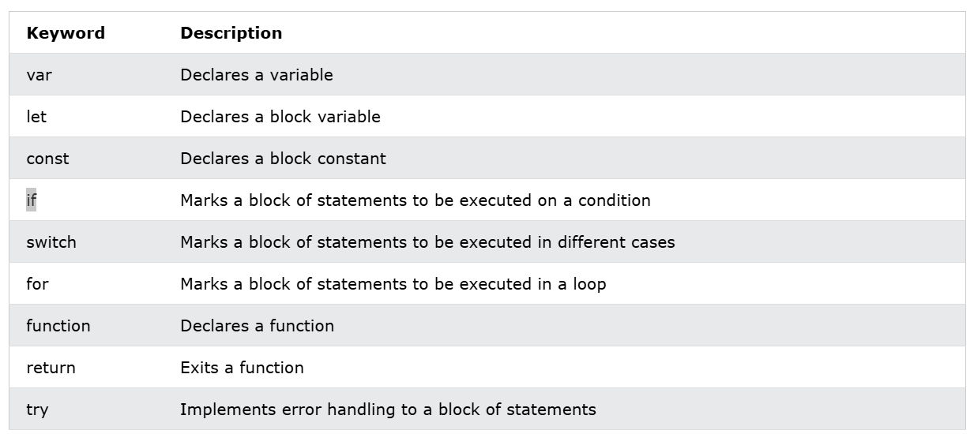

JavaScript keywords are reserved words. Reserved words cannot be used as names for variables.

JavaScript Variables:
In a programming language, variables are used to store data values.
JavaScript uses the keywords var, let and const to declare variables.
An equal sign (=) is used to assign values to variables.
let name = “AZAD”;

JavaScript Variables:
Variables are Containers for Storing Data
JavaScript Variables can be declared in 4 ways:
- Automatically (no variable declaration)
- Using var
- Using let **
- Using const

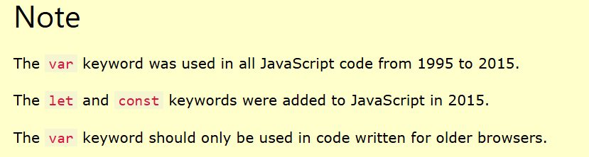

As per the above conclusion at present in the latest browsers we always use “let” and “const” variable types only.
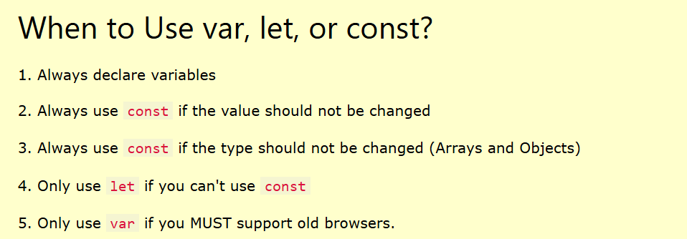

mostly we use “let” variable type only.
/*
JAVA primitive types:
BSIL
float
double
boolean
char
+
classes + abstract classes +interfaces.
*/

Value = undefined:
A variable declared without a value will have the value undefined. In JavaScript default value of any variable is “undefined”.

let name; it contains ‘undefined’ value internally.

Re-Declaring JavaScript Variables;
If you re-declare a JavaScript variable declared with var, it will not lose its value.
The variable carName will still have the value "Volvo" after the execution of these statements:

var carName = "Volvo";
var carName;
document.getElementById("demo").innerHTML = carName;
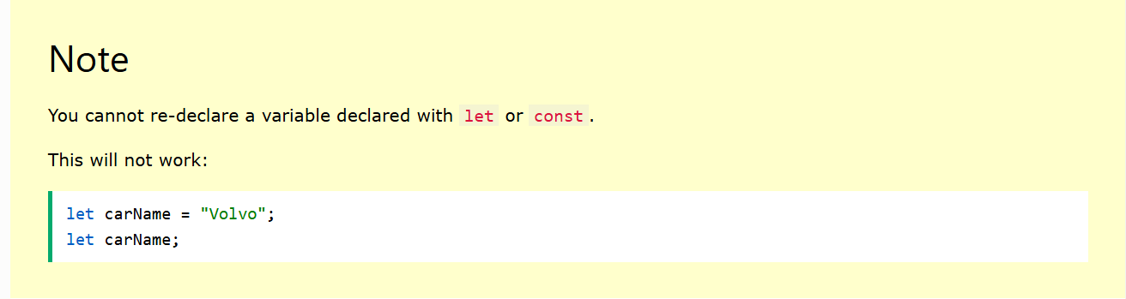
With ”var” we have lot’s of issues, so it is always recommended to use “let” and “const” variable types only.

JavaScript “Let”:
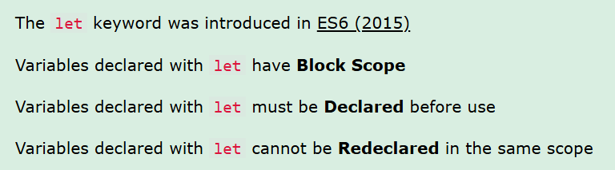

What is meant by backtick? What is the use of it? IT will be used to concatenate with values without using “+” operator.
let x = 10;
console.log(`vaue is : ${x}`);

To represent dynamic value in backtick approach we need to use ${dynamicVariableName}

What is the main difference between let and const keywords?
Values assigned to “const” variables are FIXED / CONSTANT. Their value we cannot changes in future.
const x = 10;
x = 30;

In Java also we can declare constants. To do that we will use “final” keyword.
final String name ="AAAA"; // it is CONSTANT in java
We cannot reassign value to constant variable again and again.

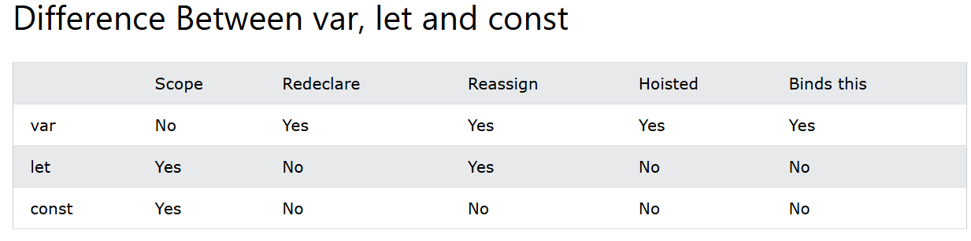

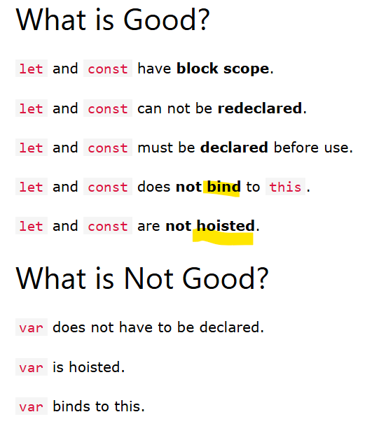
ES is an api document.
https://ecma-international.org/publications-and-standards/standards/ecma-262/
Java also have an API document.
https://docs.oracle.com/en/java/javase/21/docs/api/java.base/java/lang/package-tree.html
https://docs.oracle.com/javase/7/docs/api/
Hoisting:
Variables defined with var are hoisted to the top and can be initialized at any time.
Meaning: You can use the variable before it is declared:
<script>
carName = "Volvo";
console.log(carName);
var carName;
</script>
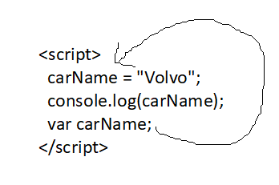
Let and const are not hoisted.
Using a let variable before it is declared will result in a ReferenceError:

JavaScript Const:
The const keyword was introduced in ES6 (2015)
Variables defined with const cannot be Redeclared
Variables defined with const cannot be Reassigned. It is not possible to assign value to variable multiple times.
Variables defined with const have Block Scope.

Must be Assigned: JavaScript const variables must be assigned a value when they are declared:

When to use JavaScript const?
Always declare a variable with const when you know that the value should not be changed.

Read “const” after completing arrays and objects.
https://www.w3schools.com/js/js_const.asp

Operators:
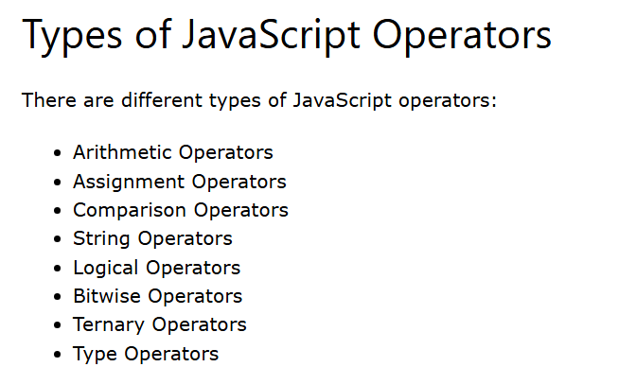
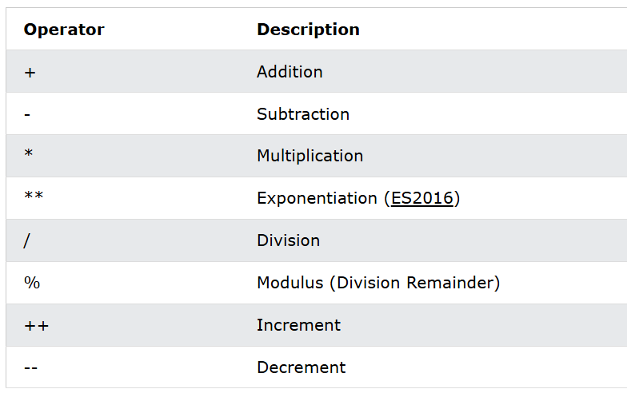

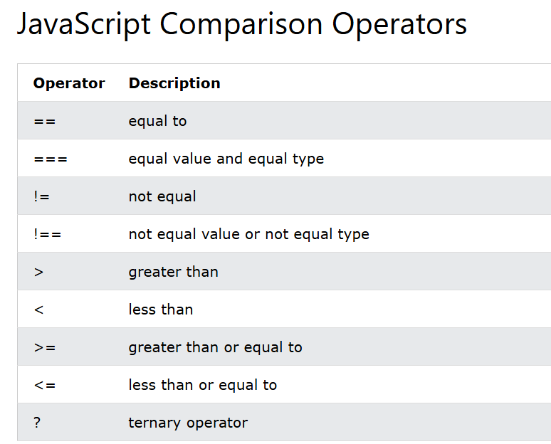

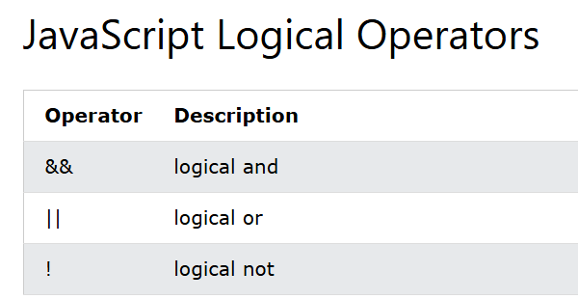

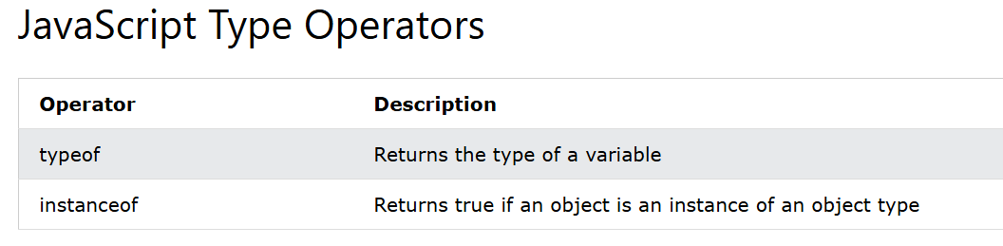

JavaScript Data Types:

// Object:
const person = {firstName:"John", lastName:"Doe"};
// Array object:
const cars = ["Saab", "Volvo", "BMW"]; cars[0], cars[1], cars[2].

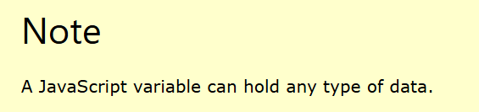

JavaScript evaluates expressions from left to right. Different sequences can produce different results.
let x = 16 + 4 + "Volvo";
let x = "Volvo" + 16 + 4;

JavaScript Types are Dynamic
JavaScript has dynamic types. This means that the same variable can be used to hold different data types:
let x; // Now x is undefined
x = 5; // Now x is a Number
x = "John"; // Now x is a String

Strings are written with quotes. You can use single or double quotes:

You can use quotes inside a string, as long as they don't match the quotes surrounding the string.

We can not use double quotes inside double quotes.
We can not use single quotes inside single quotes.
But still if you want to use then we need to use escaping(“\”) character.

We can use single quotes in double quotes and double quotes in single quotes.

Java script Object:  {  empId: 90,  empName: "ec40884d",  empDOJ: "2025-07-11T11:56:02.591+00:00",  empSalary: 40,  isPermenentEmp: true  } | JSON Object: [JavaScriptObjectNotation]  {  "empId": 90,  "empName": "ec40884d",  "empDOJ": "2025-07-11T11:56:02.591+00:00",  "empSalary": 40,  "isPermenentEmp": true  }

The main difference between JavaScript object and JSON object is, JSON object keys have doublw quotes.
https://www.w3schools.com/js/js_datatypes.asp
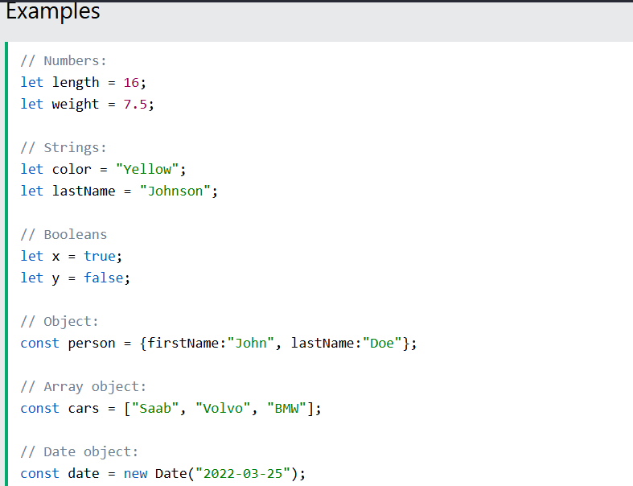
Note
A JavaScript variable can hold any type of data.
The typeof Operator:
You can use the JavaScript typeof operator to find the type of a JavaScript variable.
The typeof operator returns the type of a variable or an expression:
typeof "" // Returns "string"

typeof 0 // Returns "number"
typeof 314 // Returns "number"
typeof 3.14 // Returns "number"

typeof undefined // returns “undefined”,.

typeof null // returns object.

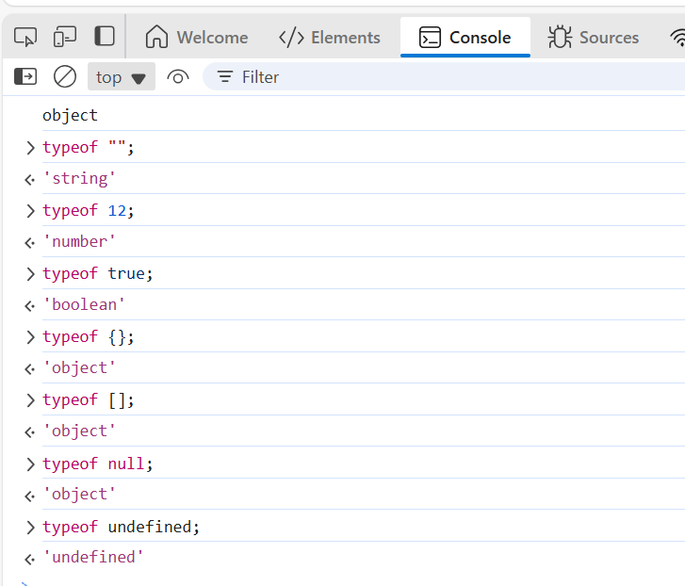

JavaScript Functions:
A JavaScript function is a block of code designed to perform a particular task. code within {} is called as block of code.
A JavaScript function is executed when "something" invokes/accessing/ calling it (calls it).
<body>

Enter First value: <input type="text" id="fValue"/> <br>
Enter Second value: <input type="text" id="sValue"/><br>
<button value="Submit" onclick="add()"> Submit </button>

<script>
function add(){

let fValue = document.getElementById("fValue").value;
let sValue = document.getElementById("sValue").value;
console.log(parseInt(fValue) + parseInt(sValue));
}
</script>

</body>

Functions are reusable block of code designed to perform a particular task.
Functions execute when they are "called" or "invoked".

<html>
<!DOCTYPE html>
<html lang="en">
<head>
<title>Employee Form</title>
</head>
<body>
<input type="text" id="employeeId" placeholder="Employee ID"><br>
<input type="text" id="employeeName" placeholder="Employee Name"><br>
<input type="number" id="employeeSalary" placeholder="Employee Salary"><br>
<input type="text" id="employeePhone" placeholder="Employee Phone"><br>
<button onclick="sendEmployeeData()">Save Employee</button>
</body>
<script>
function sendEmployeeData() {
console.log(document.getElementById('employeeId').value);
console.log(document.getElementById('employeeName').value);
console.log(document.getElementById('employeeSalary').value);
console.log(document.getElementById('employeePhone').value);
}
function calculateSum(engMarks, mathMarks, scienceMarks) {
return engMarks + mathMarks + scienceMarks;
}
let result = calculateSum(10, 20, 30);
console.log("Sum of marks: " + result);
</script>l̥
</html>

Functions with parameters:
While declaring parameters in JS functions we no need to mention data types like we do in java.
Directly we can declare parameter names, like below.
<script>
function calculateSum(engMarks, mathMarks, scienceMarks) {
return engMarks + mathMarks + scienceMarks;
}

Example 1:
let result1 = calculateSum("Kamal ", 23, true);
console.log("Sum of marks: " + result);

let result = calculateSum("Kamal ", 23, true);
console.log("Sum of marks: " + result);

Example 2:
let result2= calculateSum(12, “asasas”, true);
console.log("Sum of marks: " + result);

</script>l̥

In case of Java, because of datatypes in parameter declaation, we can pass arguments similar to data types we declared.
But in case of JS we can pass any kind of data to parameters. Means we can pass string values, integer values, Boolean values …objects, arrays …etc.

Why Functions?
With functions you can reuse code. Write code once and use it for multiple times in multiples places(html/js).
You can write code that can be used many times.
You can use the same code with different arguments, to produce different results.

Function Invocation:
The code inside the function will execute when "something" invokes (calls) the function:
- When it is invoked (called) from JavaScript code
- When an event occurs (a user clicks a button)****
- Automatically (self invoked) put it in <script> tag.

**************************FAT Arrow Functions? [A short cut form to regular function syntax].

We just convert normal functions into arrow functions.

How to create Array function or Fat arrow function?
For our normal method remove “function” keyword. Remove the function name declaration.
Add fat arrow (=>) symbol after parenthesis.

Below are the rules to convert normal function as fat arrow function. First create one normal function and apply below rules.
- Remove “function” keyword.
- Remove the function name declaration.
- Add => fat arrow symbol after parenthesis().
- Assign a variable name to fat arrow function. To utilize in some other places like calling on events etc.

Regular function | Fat arrow function
function addition(a, b) {  return a + b;  } | let addition = (a, b) => {  return a + b;  }
Let result = addition(45,657);  Consol.log(result); | Let result = addition (45,657);  Consol.log(result);

Examples:
function myFunction(myvalue){  alert(myvalue);  } | function addition(firstValue, secondValue){  alert(firstValue + secondValue);  } | let a = () => {  console.log("Welcome to JS");  }
let aa = (vf, sv) => {  console.log(vf * sv);  } | function abc(name){  alert(`my name is ${name}`);  } | let displayName = currentCount => {  alert(`my name is ${currentCount }`);  }
Functiom display(){  console.log(‘welcome to JS’);  } | Let display = () => {  console.log(‘welcome to JS’);  }

Try converting normal functions to fat arrow functions with examples with NO Parameter function, with SINGLE Parameter function and with TWO Parameters function.

Local Variables? -> Variables which we declare inside functions or blocks or constructors are called as local variables.
Variables declared within a JavaScript function, become LOCAL to the function.
Local variables can only be accessed from within the function.

Since local variables are only recognized inside their functions, variables with the same name can be used in different functions.
Local variables are created when a function starts, and deleted when the function is completed.

Parameters vs. Arguments
In JavaScript, function parameters and arguments are distinct concepts:
Parameters are the names listed in the function definition.
Parameters are the names of the values that will be passed.

<script>
function addition(a, b) {// here a,b are called as parameters.
return a + b;
}

let result = addition(5, 10); // here 5,10 are called as arguments.
console.log(result);
</script>l̥

Arguments are the values passed to the function when it is invoked or called.
Arguments are the values received by the function.

JavaScript Objects: [State, Behaviour, Identity][SBI].

State, Behaviour, Identity(optional)
In real life, objects are things like: houses, cars, people, animals, or any other subjects.
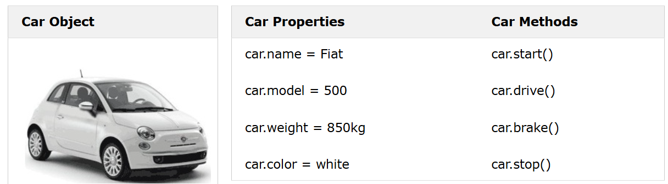

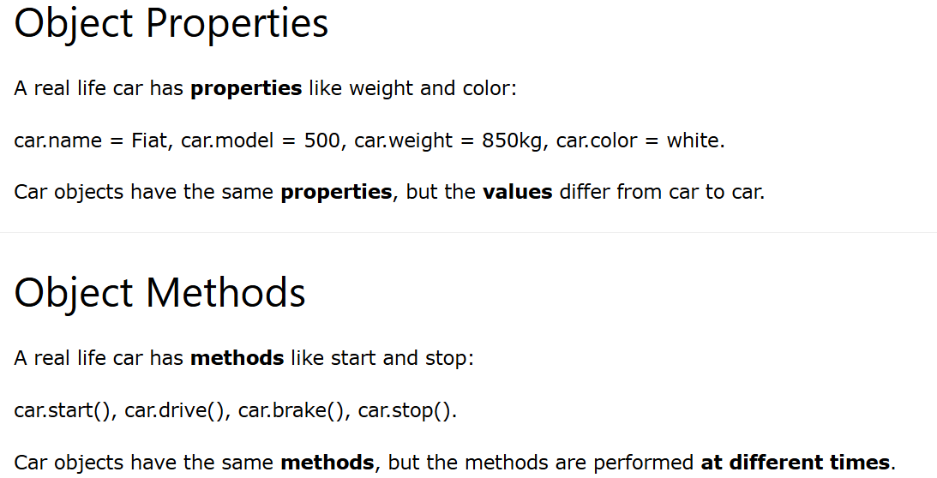

JavaScript Variables:
JavaScript variables are containers for data values.
This code assigns a simple value (Fiat) to a variable named car:
let car = "Fiat";

JavaScript Objects: {}
Objects are variables too. But objects can contain many values.
This code assigns many values (Fiat, 500, white) to an object named car:
const car = {type:"Fiat", model:"500", color:"white"};

<script>  const car = {  name:"TATA",  model:"2025",  price:232323,  color:"red",  drive: function(){  return 'drive very fast....';  }  };  </script> | console.log(car.name);  console.log(car.model);  console.log(car.price);  console.log(car.color);  console.log(car.drive());
We can access object properties with object reference name, we can access object functions or methods using object reference variable, but while calling function or method we must use “()”.

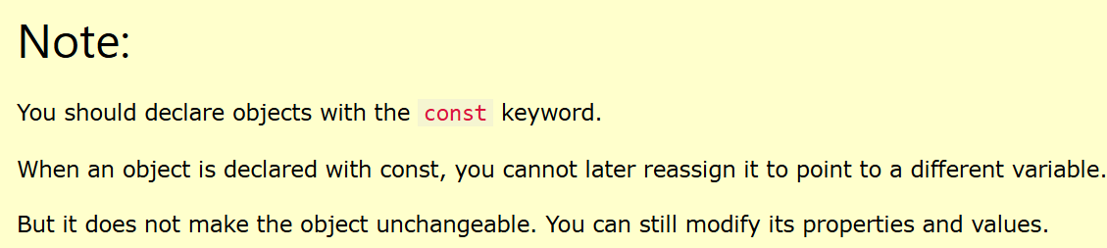

WRONG approach of declaring object with let
<script>  let car = {  name:"TATA",  model:"2025",  price:232323,  color:"red",  drive: function(){  return 'drive very fast....';  }  };  car = "WHITE";  console.log(car.name);  </script> | <script>  const car = {  name:"TATA",  model:"2025",  price:232323,  color:"red",  drive: function(){  return 'drive very fast....';  }  };  car.color = "WHITE";  car.color = "WHITE";  console.log(car.name);  console.log(car.model);  console.log(car.price);  console.log(car.color);  console.log(car.drive());  </script>
How many ways we can create JS Objects?
- Using an Object Literal -> {key:value, key: value,……….}*** here : is Column.
- Using the new Keyword
- Using an Object Constructor
Using an Object Literal:
An object literal is a list of named values inside curly braces { }.
{} empty Object.
{key:value, key: value, functionName: function(){ ….. }, ……….} -> object with some data.

: Column
; Semi-Column.

In JavaScript first we can create an empty object and then later we can assign properties also dynamically.
After creating object declaring the properties. | While creating object declaring properties also.
const person = {}; // creating one empty object.  // Add Properties  person.firstName = "John";  person.lastName = "Doe";  person.age = 50;  person.eyeColor = "blue";  console.log(person); | const studentObject = {  stuName: "Kamal",  stuId: 12,  reading: function () {  console.log("i am reading..asdadad..");  },  writing: function () {  console.log("i am writing..adasdasds..");  }  }  studentObject.stuName = "Azad...";

2nd approach of creating JS object:
Creating JS object Using the new Keyword:
Create a new JavaScript object using new Object():
// Create an Object  const person = new Object({ }); // empty object | // Create an Object  const person = new Object({  firstName: "John",  lastName: "Doe",  age: 50,  eyeColor: "blue"  });

If we observe above, again in new Object() constructor we are passing “Object Literal - {}” only.
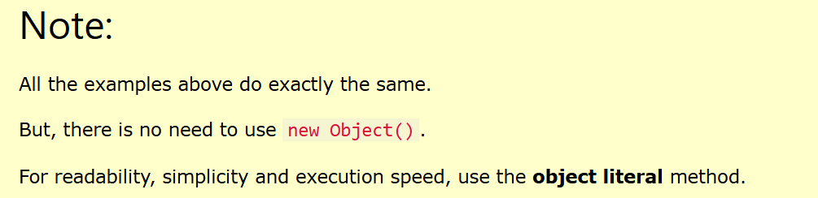

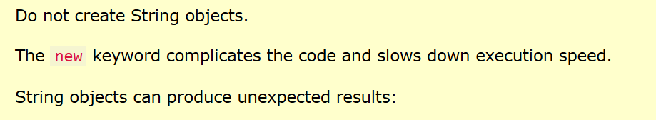

In JS or in Java we should not use “new” keyword multiple times. It will put burden on JVM in java also.
We should avoid creating objects repeatedly in JS or in Java or in any other technology.
In JS if we use “new” keyword for creating objects, browser performance will be slowdown. Loading the page will be slow.

Accessing Object Properties:
You can access object properties in two ways:
objectName.propertyName | objectName["propertyName"]
console.log(student.id); | console.log(student["id"]);

“this” – always represents “current” object / current element.

“this” with Correct example. | WRONG example.
const person = {  firstName: "Shaik",  lastName: "Azad",  id: 5566,  fullName: function () {  return this.firstName + " " + this.lastName;  }  };  console.log(person.fullName()); | const person = {  firstName: "Shaik",  lastName: "Azad",  id: 5566,  fullName: function () {  return firstName + " " + lastName;  }  };  console.log(person.fullName());

How many ways we can create functions in JavaScript?
Total 4 ways we can create functions in JS.
Normal function | Variable function | FAT Arrow function | Nameless function
function myFunction1() {  console.log(`myFunction1`);  } | let myFunction2 = function () {  console.log(`myFunction1`);  } | let myFunction3 = () => {  console.log(`myFunction1`);  } | function () {  console.log(`myFunction1`);  }  Nameless FAT Arrow function:  () => {  console.log(`myFunction1`);  }  Single line FAT arrow function:  () =>console.log(`myFunction1`);

Example:
setTimeout(() => {  console.log("Hi…");  },2000); | setInterval(() => {  console.log("HI…");  },2000);

When a function have single line return statement, we can remove curly braces {} and we can remove “return” keyword also from the code.

Normal function with single line return statement | FAT arrow function with single line return statement | Single line FAT arrow function.
function sum(fValue, sValue) {  return fValue + sValue;  }  console.log(f33(23, 56)); | let f22 = (fValue, sValue) => {  return fValue + sValue;  }  console.log(f22 (23, 56)); | let f33 = fValue => fValue + sValue;  console.log(f33(23, 56));

Below is WRONG:
function sum(fValue, sValue) {  console.log("this is Kamal");  alert(`this is Azad...`);  return fValue + sValue;  } | let f123 = (fValue, sValue) => console.log("this is Kamal");  alert(`this is Azad...`);  return fValue + sValue;

If we have multiple line to execute, we must use block symbol means we must use Curly braces {} in FAT arrow function.

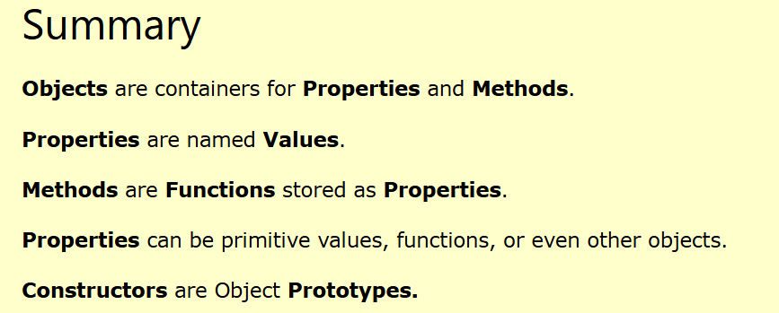

In JavaScript, Objects are King.
If you Understand Objects, you Understand JavaScript.

In java script for writing strings we can use either double quotes or single quotes.
let carName1 = "Volvo XC60"; // Double quotes
let carName2 = 'Volvo XC60'; // Single quotes

https://www.w3schools.com/js/js_strings.asp

Template Strings? for Template Strings we use back tick character. ``. For concatenation purpose and to overcome breaking lines into multiple lines.
let text = `He's often called "Johnny"`;

Interpolation: `${variableName}`
Template Strings allow variables in strings.
Template strings provide an easy way to interpolate variables in strings.

let firstName = "John";
let lastName = "Doe";
let text = `Welcome ${firstName}, ${lastName}!`;

== --> compares content in object.
=== --> compares content + object types are same or not in in object.

let name1 = "kamal";
let name2 = "kamal";
console.log(name1 === name2); true

let name1 = "kamal";
let name2 = new String("kamal");
console.log(name1 === name2); false

Comparing two JavaScript objects created with “new” keyword, always returns false.
let name1 = new String("kamal");
let name2 = new String("kamal");
console.log(name1 === name2); false

Numbers:
In java for decimals and non-decimals we have different datatypes. byte, int, double, float.
In JavaScript for decimals and non-decimals we use same datatypes. let OR const.
let x = 123e5; // 12300000
let y = 123e-5; // 0.00123

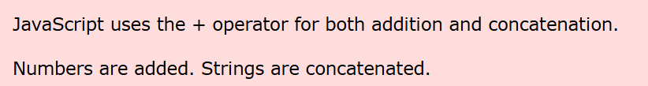

let x = "100";  let y = "10";  let z = x / y;  console.log(z); 10 | let x = "100A";  let y = "10";  let z = x / y;  console.log(z); NaN[Not A Number] | let x = "100";  let y = "10";  let z = x * y;  console.log(z); 1000

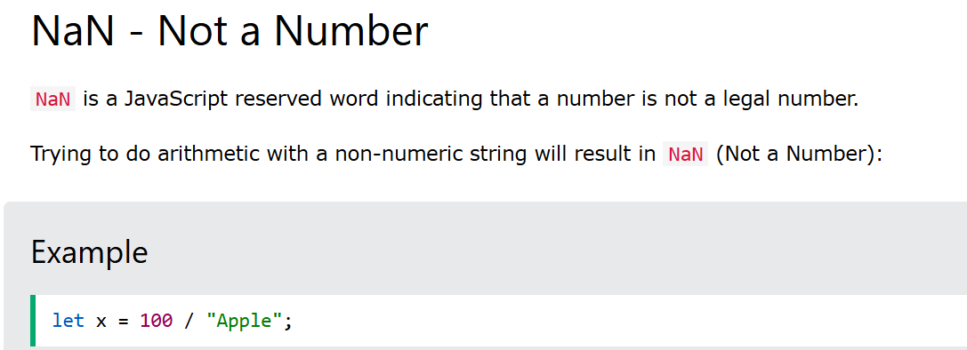
You can use the global JavaScript function isNaN() to find out if a value is a not a number:
let x = 100 / "Apple";
isNaN(x);

console.log(NaN + 10); NaN

<input type="text" id="fNumber" placeholder="Employee ID">
<input type="text" id="sNumber" placeholder="Employee Name">
<button onclick="callMyFunction();">Click</button>

function callMyFunction() {

let x = document.getElementById('fNumber').value;
let y = document.getElementById('sNumber').value;
let result = x / y;

if (isNaN(result)) {
alert("Please enter valid number for division...");
}else{
console.log(result);
}

}

JavaScript Arrays:

Java Array example:
int[] intArr = {12,23,323,23,2,343,5,343,2323,4545,2323,56,467, 345};
System.out.println(intArr.length);
System.out.println(intArr [intArr.length -1] );

But why we should go for arrays?

let name1 = 'Kamal'; // 1MB.
let name2 = 'Azd...';
let name3 = 'adasd';
let name4 = 'adasd';
// 1000 varialbes --> 1MB.

let studentName = ['121212','34343434']; // --> 5MB.

An array can hold many values under a single name, and you can access the values by referring to an index number.

In Java we are going to use curly braces {}, but in JavaScript we are going to use square brackets []
Java array {}
JavaScript array []
const cars = ["Saab", "Volvo", "BMW"];

Key characteristics of JavaScript arrays are:
- Elements: An array is a list of values, known as elements.
- Ordered: Array elements are ordered based on their index.
- Zero indexed: The first element is at index 0, the second at index 1, and so on.
- Dynamic size: Arrays can grow or shrink as elements are added or removed. [In java NOT allowed]
- Heterogeneous: Arrays can store elements of different data types (numbers, strings, objects and other arrays). [In Java NOT allowed]
let namesArr = ['A', true, {name: "kamal",id: 1234}, 123, [12,23,12,23]];

It is a common practice to declare arrays with the const keyword.
What is the recommended approach for javascript objects and javascript arrays declaration? Which one use can use? Let or const? and why?

let objRef = {name: “Azad”} NOT RECOMMONDED.
const objRef = {name: “Azad”} RECOMMONDED.

Spaces and line breaks are not important. A declaration can span multiple lines:
const cars = [
"Saab",
"Volvo",
"BMW"
];
We can do same approach for javascript objects also.
You can also create an empty array, and provide elements later in javascript.
But in java it is not possible.
const cars = [];
cars[0]= "Saab";
cars[1]= "Volvo";
cars[2]= "BMW";

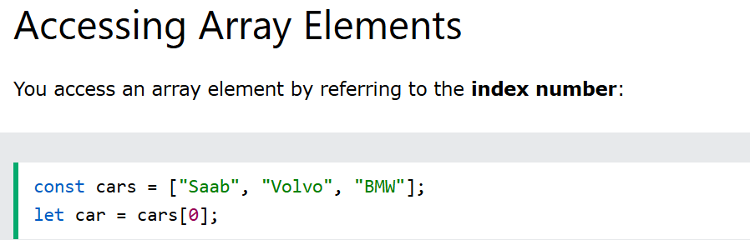

Note: Array indexes start with 0.
[0] is the first element. [1] is the second element.
Changing an Array Element
This statement changes the value of the first element in cars:
const cars = ["Saab", "Volvo", "BMW"];
cars[0] = "Opel";

-We can create Arrays using “new” keyword also, but it is not recommended.
const cars = new Array("Saab", "Volvo", "BMW"); NOT RECOMMONDED.
Let obj = new Object(); NOT RECOMMONDED.
Let str = new String(); NOT RECOMMONDED.

Sorting of arrays:
let myArr = [56,1,45,67,3,556,12];
let newArr = myArr.sort((a,b) => a-b);
console.log(newArr);

Looping Array Elements:
let myArr = [56,1,45,67,3,556,12];
for(let i = 0; i < myArr.length; i++)
console.log(myArr[i]);

You can also use the Array.forEach() function for iterating values from array.
let myArr = [56,1,45,67,3,556,12];  myArr.forEach(callBackFunction)  function callBackFunction(val){  console.log(val);  }  --------------------------------------------------------------------------  OR we can pass 3 parameters to forEach() fat arrow function.  let myArr = [56, 1, 45, 67, 3, 556, 12];  myArr.forEach(f1);  function f1(val, index, originalArray){  console.log(`${val} - ${index} ==> ${originalArray}`);  } | let myArr = [56,1,45,67,3,556,12];  myArr.forEach(val => console.log(val));  --------------------------------------------------------------------------  let myArr = [56, 1, 45, 67, 3, 556, 12];  myArr.forEach((val, index, originalArray) => console.log(`${val} - ${index} ==> ${originalArray}`));
Adding and removing Array first index and last index elements Element using javascript methods.:
Push(), pop(); adding at the end of the array and fetching from the last index of the array.
Unshift(),shift(); adding at the start index of the array and fetching from the start index of the array.
let myArr = [56, 1, 45, 67, 3, 556, 12];

// myArr.push(343434);
//let lasVal = myArr.pop();

// myArr.unshift(3333);
// let v = myArr.shift();

console.log(v);

Note: In java we don’t have methods support to arrays, due to that reason only they introduced collections of framework.
Java array support only length property.

Means JavaScript arrays have methods support, but java doesn’t have any methods support.
Java gives methods support by some additional feature called java 8 streams.

The Difference Between Arrays and Objects:
In JavaScript, arrays use numbered indexes.
In JavaScript, objects use named indexes.

How to Recognize an Array:
A common question is: How do I know if a variable is an array?
The problem is that the JavaScript operator typeof returns "object":
const myObj = {name:"kamal", id: 123};
const myArr = [56, 1, 45, 67, 3, 556, 12];
console.log(typeof myObj); object
console.log(typeof myArr); object
For an array the typeof operator returns object because a JavaScript array is an object.
Solution 1:
To solve this problem ECMAScript 5 (JavaScript 2009) defined a new method Array.isArray():
Solution 2:
Use instanceof operator.
Array.isArray() | instanceof
const myObj = {name:"kamal", id: 123};  const myArr = [56, 1, 45, 67, 3, 556, 12];  console.log(typeof myObj);  console.log(typeof myArr);  console.log(Array.isArray(myArr)); | const myObj = {name:"kamal", id: 123};  const myArr = [56, 1, 45, 67, 3, 556, 12];  console.log(typeof myObj);  console.log(typeof myArr);  console.log(myArr instanceof Array);

We use same instanceof operator in Java also to find the type of any object.
Object name = "kamalhussain";
Object i = 10;
System.out.println(i instanceof String);

Nested Arrays and Objects:
Values in objects can be arrays, and values in arrays can be objects.
const collegeStaff = {
collegeName: "Nova",
collegeEtbYear: 2003,
staffDetails: [
{ name: "Kamal", subject: "english", specilization:["English", "Java", "Angular", "Js"] },
{ name: "aZAD", subject: "Maths" , specilization:["Match", "Java", ".Net", "Typescript"]},
{ name: "arafath", subject: "chemi", specilization:["Telugu", "CyberScec", "Linux", "Js"] },
{ name: "Hamid", subject: "Java", specilization:["English", "Java", "Angular", "Js"] }
]
}
collegeStaff.staffDetails.forEach(fetchStaffDetails);

function fetchStaffDetails(a){
a.specilization.forEach(v => console.log(v));
}

Loops in JavaScript:
We use loops to fetch/iterate values from collections like arrays, objects, Set and Map.
In case of variable we can store only one value, but in case of collections in single variable we can store multiple values.

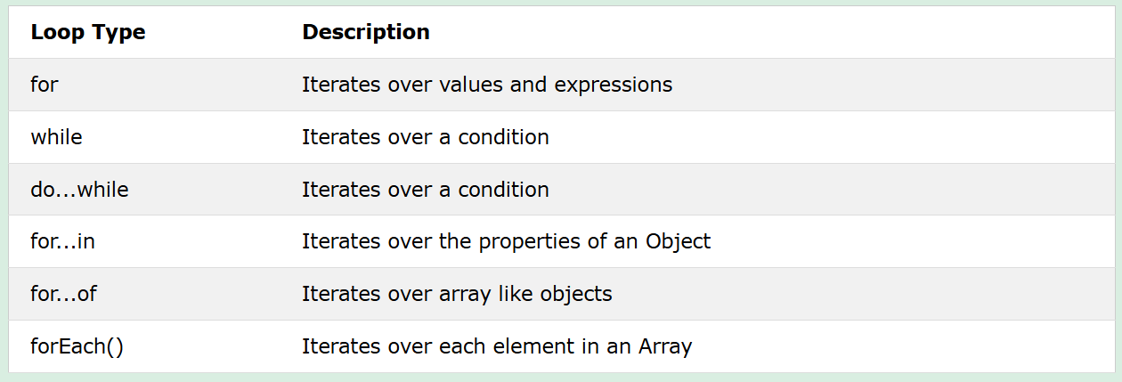

Below are used to fetch values from arrays and objects.
For loop: | while loop: | do-while loop: | forEach() method:
const myArr = [1, 21, 34, 45, 46, 23, 121, 3];  for (let i = 0; i < myArr.length; i++) {  // console.log(myArr[i]);  } | const myArr = [1, 21, 34, 45, 46, 23, 121, 3];  let index = 0;  while (index < myArr.length) {  console.log(myArr[index]);  index++;  } | const myArr = [1, 21, 34, 45, 46, 23, 121, 3];  let indexDW = 0;  do{  console.log(myArr[indexDW]);  indexDW++;  }while(indexDW < myArr.length); | const myArr = [1, 21, 34, 45, 46, 23, 121, 3];  myArr.forEach(val => console.log("Value is : "+ val));

The for...in Loop: To fetch the data from Objects.

For fetching the data from object one by one using key, we have two ways.
- objectRefName.keyName
- objectRefName[“keyName”]
Example:
const myEmpObject = {empName: "Kamal", empId: 12, empAge: 34, empAddress: "BVG", empSalary: 343434};
console.log(myEmpObject.empName);
console.log(myEmpObject["empId"]);

For fetching all object details in single loop we use for..in loop.
Syntax:
for (key in object) {
// code block to be executed
}
Example:
const myEmpObject = {empName: "Kamal", empId: 12, empAge: 34, empAddress: "BVG", empSalary: 343434};  for(key in myEmpObject){  console.log(key);  } | const myEmpObject = {empName: "Kamal", empId: 12, empAge: 34, empAddress: "BVG", empSalary: 343434};  for(key in myEmpObject){  console.log(myEmpObject[key]);  }

We can iterate arrays also using for..in loop:
By default for..in loop iterates index numbers from the array. By using index number we can fetch all values in the array.
const myArr = [12,34,56,34,23,12,34,435,23];  for(key in myArr){  console.log(key);// fetch all indexes of array.  } | const myArr = [12,34,56,34,23,12,34,435,23];  for(key in myArr){  console.log(myArr[key]);  }

By default for..in fetches keys in object, indexes in arrays.
The for...in loop is primarily used for objects to access their property names (keys).
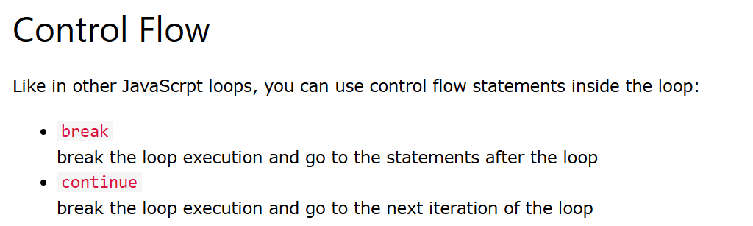
const myEmpObject = {empName: "Kamal", empId: 12, empAge: 34, empAddress: "BVG", empSalary: 23};
for(key in myEmpObject){
if(key == "empAge"){
// continue; // skip
break; // loop breaking.
}
console.log(`${key} - ${myEmpObject[key]}`);
}

Array.forEach():
The forEach() method calls a function (a callback function) once for each array element.
Callback function? A function which internally calls another function.
const myArr = [23,34,23,343,2323];  myArr.forEach(myCallBackFunction);  function myCallBackFunction(value){  // console.log(value);  } | const myArr = [23,34,23,343,2323];  myArr.forEach(value => console.log(value));

The for...of Loop: To fetch the data from Arrays.
The for...of loop iterates over the values of iterable objects such as arrays, strings, Maps, Sets, and NodeLists.
Syntax:
for..of directly fetches the array values, We don’t need to use indexes here, for..of internally takes care about indexes.
for (variable of iterable) {
// code block to be executed
}

Example:
const myArr = [23,34,23,343,2323];
for(i of myArr){
console.log(i);
}

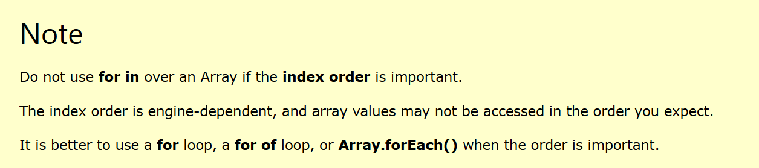

JavaScript Classes:
ECMAScript 2015, also known as ES6, introduced JavaScript Classes.
JavaScript Classes are templates for JavaScript Objects. Blueprint for creating object.

Class is logically existed; object is physically existed.

JavaScript Class Syntax
Use the keyword class to create a class.
Always add a method named constructor().
class ClassName {
constructor() {
// our logic here.
}
}

A JavaScript class is not an object.
It is a template/blueprint for creating JavaScript objects.
class Car{
constructor(name, year){
this.name = name;
this.year = year;
}
}
let tataCar = new Car('Tata',2025);
let maruthiCar = new Car('maruthi',2000);
The constructor method is called automatically when a new object is created.
Constructor is used to initialize instance variable.
Below in java:
Java Class.
public class Employee {  private String empName;  private Integer empId;  public Employee(String empName, Integer empId){  this.empName = empName;  this.empId = empId;  }  @Override  public String toString() {  }  } | public class App {  public static void main(String[] args) {  Employee e = new Employee("Kamal",123);  System.out.println(e);  }  }

The Constructor Method:
The constructor method is a special method:
- It has to have the exact name "constructor" / but in java we use class name as constructor.
- It is executed automatically when a new object is created / in java also same.
- It is used to initialize object properties / in java also same.
If you do not define a constructor method, JavaScript will add an empty constructor. In java also same.

Class Methods;
Class methods are created with the same syntax as object methods.
Use the keyword class to create a class.
Always add a constructor() method.
Then add any number of methods.
Class Syntax:
class ClassName {
constructor() { ... }
method_1() { ... }
method_2() { ... }
method_3() { ... }
}

JavaScript Example: | Java Example:
class Car {  constructor(name, year) {  this.name = name;  this.year = year;  }  age() {  const date = new Date();  return date.getFullYear() - this.year;  }  } | class Car {  private String name;  private Integer year;  Car(String name, Integer year) {  this.name = name;  this.year = year;  }  void age() {  Date date = new Date();  return LocalDateTime.now().getYear() - this.year;  }  }

this current object representation.
We can pass parameters to methods in java script same as java methods.
class Car {
constructor(name, year) {
this.name = name;
this.year = year;
}
age(ownerName) {
console.log(`Hi ${ownerName} Good day...!`);
const date = new Date();
return date.getFullYear() - this.year;
}
}

let tatCar = new Car('Tata', 1987);
document.getElementById('demo').innerHTML = `${tatCar.name} - ${tatCar.age('Kamal')}`;

"use strict":
The purpose of "use strict" is to indicate that the code should be executed in "strict mode".
Check for proper syntax is written in JavaScript code or not?
“use strict”;  date = new Date();  console.log(date); ERROR. | “use strict”;  let date = new Date();  console.log(date);

NOTE: Please don’t use “name” as variable name. It is library word. “use strict” not effects on variable name “name”.

Strict mode is declared by adding "use strict"; to the beginning of a script or a function.
Declared at the beginning of a script, it has global scope (all code in the script will execute in strict mode):
function myFunction() {
"use strict";
y = 3.14; // This will cause an error
}

NOTE: The "use strict" directive is only recognized at the beginning of a script or a function.

JavaScript Class Inheritance[వారసత్వం]:
General explanation:
Azad sonOf Hambdi. ==> Azad extends Hambdi.
Hamid sonOf Hambdi. ==> Hamid extends Hambdi.

Azad GrandSonOf Abdulla. ==> Azad extends Abdulla

Azad implements Abdulla.

Behaviours, assets, thinking, color, height …etc.

Class Inheritance:
To create a class inheritance, use the extends keyword.
A class created with a class inheritance inherits all the methods from another class.

Class A{ // parent class / super class.
// properties and methods.
}

Class B extends A{ // child class / sub class.
// super properties and methods are available here without creating object to super class.
}

If you want to call one class method and properties in another class, we need to create object and we need call properties and methods.

But if those two classes in inheritance we don’t need to create object to super class.

WithOUT inheritance | With inheritance
class A {  eName = "kamal";  displayEmpName() {  console.log(this.eName);  }  }  class B{  sName = "Azad";  displayStudentName() {  let a = new A(); // we are creating object.  a.displayEmpName();  console.log(a.eName);  }  }  let b = new B();  b.displayStudentName(); | class A {  eName = "kamal";  displayEmpName() {  console.log(this.eName);  }  }  class B extends A {  sName = "Azad";  displayStudentName() {  this.displayEmpName(); // not creating object  console.log(this.eName);  }  }  let b = new B();  b.displayStudentName();

class Car {
constructor(brand) {
this.carname = brand;
}
present() {
return 'I have a ' + this.carname;
}
}
class Model extends Car {
constructor(brand, mod) {
super(brand);
this.model = mod;
}
show() {
return this.present() + ', it is a ' + this.model;
}
}
let myCar = new Model("Ford", "Mustang");
document.getElementById("demo").innerHTML = myCar.show();

IMP: If you want to call super class constructor from child class constructor, we need to use “super” keyword.
If you super class constructor is empty parameter constructor then in child class use super();
If you super class constructor is single parameter constructor then in child class use super(“Kamal”);
If you super class constructor is two parameter constructor then in child class use super(“Kamal”, “Azad”);

class M1{
public M1(String name){
}
}
class M2 extends M1{
public M2(){
super("Azad");
}
}

The super() method refers to the parent class.

By calling the super() method in the constructor method, we call the parent's constructor method and gets access to the parent's properties and methods.

NOTE:
When we create object to child class, first object will be created to the parent class and then object will be created to child class.

Getters and Setters:
Setters methods and constrictors: To initialize the instance variables.
Getters methods: To get the value from instance variables.

It can be smart to use getters and setters for your properties.
To add getters and setters in the class, use the get and set keywords.

