https://angular.dev/tutorials/learn-angular
https://www.tektutorialshub.com/angular-tutorial/
https://tutorial.techaltum.com/angular.html
https://www.tutorialspoint.com/angular/index.htm

SPA?
https://www.amazon.in/alm/category/fresh/Tea?almBrandId=ctnow&node=4860063031&ref=fs_dsk_sn_fs-nav-teacoffee-0d85b

Angular is an open-source framework and development platform for building Web, window and mobile applications. Angular is built on TypeScript. Angular was build and owned by Google although Microsoft was also involved in Angular Development. It is a Frontend Framework to create SPA (Single Page Application).

Eg: Gmail, amazon page, Instagram, Facebook…etc….
Only necessary page will be loaded, complete page will not be loaded for each request. Due to this performance is very high.
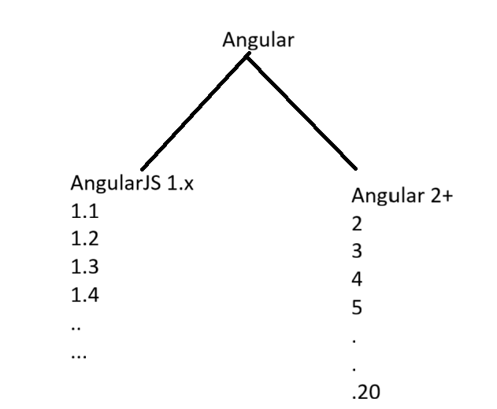
Angular before 1.x is called AngularJS. After 2+ version it is called as only “Angular”.
AngularJS to Angular:
AngularJS is basically 1.x Version which was launched in 2010 but Angular without JS represents Angular 2 and 2+ Version like Angular 2 ( beta), Angular 4 to 20. Angular which is released after AngularJS is not updated version of AngularJS but its Re-Written form of AngularJS. Angular is faster than AngularJS. AngularJS is only Web based Framework but Angular is Web, Desktop and Mobile Application based Framework and development platform.

Angular is component based.
Angular use components instead of controllers in AngularJS. Also angular is installed using npm. Angular JS use JavaScript, but angular use typescript with is a JavaScript Superset. Thus Angular supports better class features. This is good for Java and C++ Developers.

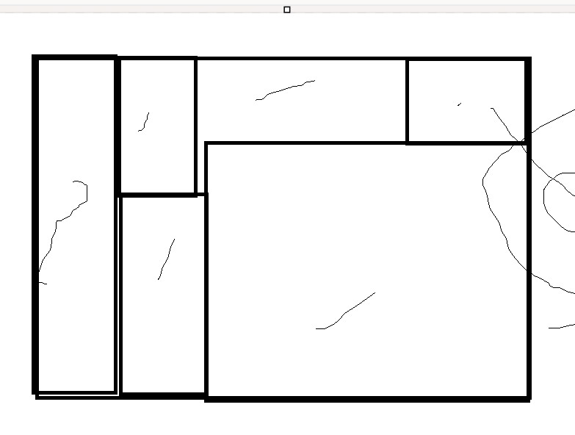

Component means, web page divided into multiple parts, each part Is called as component.
For example. GMAIL.. AMAZON..etc…

