Name: Kamal Sharma
UID: 24BAI70380
Course: BE-CSE (AI&ML)
Subject: Database Management System

Experiment: Implementation of Stored procedures

1. Aim of the Session

To explore the design and implementation of stored procedures in PL/SQL, with emphasis on the use of parameter modes (IN, OUT, and INOUT) for encapsulating business logic and enabling modular programming within a database.

2. Software Requirements
- Database:
  - Oracle live SQL
  - PostgreSQL Database (PgAdmin)

3. Objective of the Session

By the end of the session, the following objectives were achieved:
- Develop and execute a parameterized stored procedure that processes employee data.
- Demonstrate the use of IN, OUT, and INOUT parameters to return computed results and execution status.
- Illustrate the invocation of procedures through anonymous blocks.

4. Practical / Experiment Steps

The experiment was carried out through the following activities:
- Schema Setup: Created the employees table with a primary key and defined appropriate data types for personal and financial attributes.
- Procedure Encapsulation: Designed the procedure get_employee_count_by_gender to count records based on gender.
- Parameter Configuration: Applied IN for input, OUT for returning the count, and INOUT for updating the execution status.
- Logic Integration: Used the SELECT INTO clause to assign aggregate query results directly to output variables.
- Anonymous Block Execution: Constructed a DO block to declare local variables, invoke the procedure, and display results to the user.

5. Procedure of the Practical

Execution was performed in the following order:
- Connected to the PostgreSQL server and initialized the workspace.
- Executed CREATE TABLE to define the employee structure and inserted a balanced dataset of male and female records.
- Defined the procedure signature with IN, OUT, and INOUT parameters.
- Implemented the PL/pgSQL body to perform a COUNT(*) operation filtered by gender.
- Updated the STATUS variable with the string 'SUCCESS' to indicate successful execution.
- Declared variables in an anonymous block, initialized with 'Female' as the gender filter and 'Pending' as the status.
- Called the procedure using CALL, passing arguments and capturing returned values.
- Printed the results using RAISE NOTICE.
- Verified the output against table records to confirm accuracy.

6. I/O Analysis (Input / Output Analysis)

SQL Input Queries

CREATE TABLE employees (

emp_id SERIAL PRIMARY KEY,

emp_name VARCHAR(50),

gender VARCHAR(10),

salary NUMERIC(10,2)

);

Output :

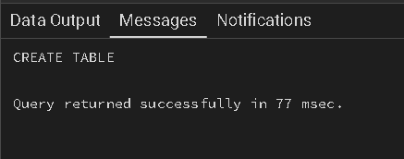

SQL Input Queries

INSERT INTO employees (emp_name, gender, salary) VALUES

('Amit', 'Male', 30000),

('Riya', 'Female', 35000),

('John', 'Male', 28000),

('Sneha', 'Female', 40000),

('Rahul', 'Male', 32000);

Output :

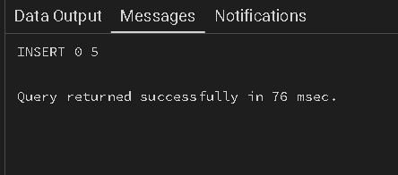

SQL input Queries

CREATE OR REPLACE PROCEDURE get_Employee_Count_BY_Gender (IN IN_GENDER VARCHAR(20), OUT OUT_COUNT INT, INOUT STATUS VARCHAR(20))

AS

$$

BEGIN

SELECT COUNT(*) INTO OUT_COUNT FROM employees WHERE GENDER='Male';

STATUS:='SUCCESS';

END;

$$ LANGUAGE PLPGSQL;

Output :

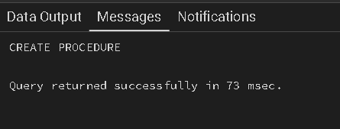

SQL input Queries

DO

$$

DECLARE

GEN VARCHAR(20):='Male';

Count_of_Employee int;

STATUS VARCHAR:='Pending';

BEGIN

CALL get_Employee_Count_BY_Gender(GEN,Count_of_Employee,STATUS);

RAISE NOTICE 'YOUR COUNT OF EMPLOYEE BY GENDER IS % AND YOUR STATUS IS %',Count_of_Employee,STATUS;

END;

$$

Output :

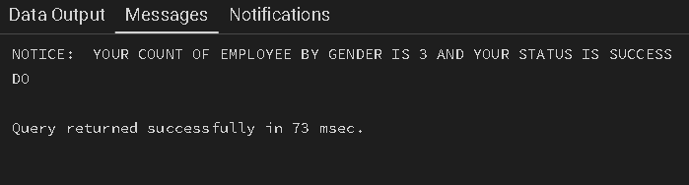

7. Learning Outcome
- Gained understanding of how SQL logic can be encapsulated into reusable procedures for better maintainability.
- Practiced the use of IN, OUT, and INOUT parameter modes for data transfer in stored subprograms.
- Learned to connect aggregate SQL functions with PL/SQL variables using the INTO keyword.
- Acquired skills in using status flags and notice alerts to track execution success and results.

