Name: Kamal Sharma
UID: 24BAI70380
Course: BE-CSE (AI&ML)
Subject: Database Management System

Experiment: Implementation of Conditional Logic using IF–ELSE in PL/SQL

1. Aim of the Session

To understand the basic structure of a PL/SQL program by creating and executing a simple PL/SQL block that includes declaration and execution sections, and to display output using built-in procedures.

2. Software Requirements
- Database:
  - Oracle live SQL
  - PostgreSQL Database (PgAdmin)

3. Objective of the Session

By the end of the session, the following objectives were achieved:
- To practice writing PL/SQL blocks with proper syntax and structure.
- To declare and initialize variables in PL/SQL effectively.
- To apply conditional logic using IF-ELSIF-ELSE statements for decision making.
- To display results using DBMS_OUTPUT for verification and debugging.

4. Practical / Experiment Steps

The experiment was carried out through the following activities:
- Variable Declaration: Declared EMP_ID, EMP_NAME, SALARY, and TAX variables with appropriate data types.
- Initialization: Assigned meaningful values to EMP_ID, EMP_NAME, and SALARY to simulate employee data.
- Output Display: Printed employee details using DBMS_OUTPUT to confirm correct variable assignment.
- Conditional Logic: Applied IF-ELSIF-ELSE statements to calculate tax based on salary slabs, demonstrating control flow.
- Result Display: Printed calculated tax using DBMS_OUTPUT to validate the conditional logic.

5. Procedure of the Practical

Execution was performed in the following order:
- Environment Setup: Logged into Oracle LIVE SQL Developer to prepare the workspace.
- PL/SQL Block Creation: Wrote the PL/SQL block with variable declarations and initialization.

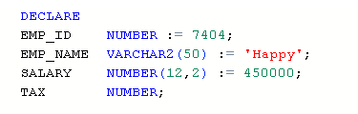
- Conditional Execution: Implemented salary-based tax calculation logic using IF-ELSIF-ELSE.
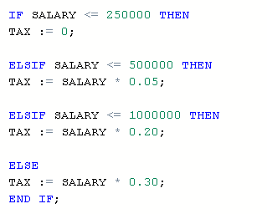

- Output Verification: Executed the block and verified the output for correctness.

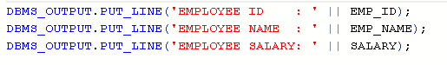
- Documentation: Saved the PL/SQL script and captured outputs for reporting and future reference.

6. I/O Analysis (Input / Output Analysis)

Input SQL Queries

DECLARE

EMP_ID NUMBER:= 7404;

EMP_NAME VARCHAR2(50) := 'Happy';

SALARY NUMBER(12,2): = 450000;

TAX NUMBER;

BEGIN

DBMS_OUTPUT.PUT_LINE('EMPLOYEE ID : ' || EMP_ID);

DBMS_OUTPUT.PUT_LINE('EMPLOYEE NAME : ' || EMP_NAME);

DBMS_OUTPUT.PUT_LINE('EMPLOYEE SALARY: ' || SALARY);

IF SALARY <= 250000 THEN

TAX := 0;

ELSIF SALARY <= 500000 THEN

TAX := SALARY * 0.05;

ELSIF SALARY <= 1000000 THEN

TAX := SALARY * 0.20;

ELSE

TAX := SALARY * 0.30;

END IF;

DBMS_OUTPUT.PUT_LINE('TAX PAYABLE : ' || TAX);

END;

Output

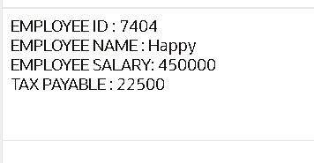

7. Learning Outcome
From this practical, the following knowledge and skills were gained:
- Learned how to declare and initialize variables in PL/SQL with appropriate data types.
- Understood the use of conditional logic using IF-ELSIF-ELSE statements to control program flow.
- Practiced tax calculation based on salary ranges, reinforcing the concept of conditional branching.
- Gained experience in displaying results using DBMS_OUTPUT, which is essential for debugging and output verification.
- Strengthened understanding of PL/SQL procedural programming concepts, preparing for more complex database programming tasks.
- Developed the ability to translate real-world business rules into executable PL/SQL code.

