Name: Kamal Sharma
UID: 24BAI70380
Course: BE-CSE (AI&ML)
Subject: Database Management System

Experiment: Library Management System Implementation

1. Aim of the Session

The aim of this lab session was to design and implement a relational database for a Library Management System. The task involved building structured tables, defining relationships among entities, and enforcing role-based security to ensure controlled access.

2. Objective of the Session

By the end of the session, the following objectives were achieved:
- Developed relational tables with Primary Keys, Foreign Keys, and Check Constraints to ensure data accuracy.
- Practiced DML operations (INSERT, UPDATE, DELETE, SELECT) for managing records.
- Applied DCL commands to configure role-based permissions for secure access.
- Maintained referential integrity across tables such as BOOKS, LIBRARY_VISITORS, and BOOK_ISSUE.

3. Practical / Experiment Steps
The work was carried out through the following activities:

1. Schema Design: Created tables for books and visitors with constraints like NOT NULL, UNIQUE, and CHECK (e.g., minimum age requirement).

2.Relationship Setup: Built the BOOK_issue table linking BOOKS and LIBRARY_VISITORS using foreign keys.

3.Data Insertion: Added sample records to validate schema and constraints.

4.Functional Testing: Performed update and delete operations to check cascading and referential rules.

5.Security Setup: Created a role with login privileges and controlled access using GRANT and REVOKE.

4. Procedure of the Practical

Execution was performed in the following order:
- Environment Setup: Logged into DBMS interface and accessed the server instance.
- Database Setup: Created a dedicated database for the library system.
- Schema Execution: Executed CREATE TABLE commands ensuring parent tables were defined first.
- Data Entry Phase: Inserted records into BOOKS and LIBRARY_VISITORS.
- Verification Queries: Verified data using SELECT queries
- Update/Delete Checks: Tested mutability with UPDATE and DELETE.
- Role Creation: Created a librarian role and assigned relevant operations through DCL.
- Permission Testing: Validated access control by revoking permissions and checking role privileges.
- Documentation: Saved final SQL script and captured outputs for reporting.

5. I/O Analysis (Input / Output Analysis)

Input Queries
SQL

CREATE TABLE BOOKS(

BOOK_ID INT PRIMARY KEY,

NAME VARCHAR(20) NOT NULL,

AUTHOR_NAME VARCHAR(20),

BOOK_COUNT INT CHECK(BOOK_COUNT>0) NOT NULL

)

CREATE TABLE LIBRARY_VISITORS(

USER_ID INT PRIMARY KEY,

NAME VARCHAR(20) NOT NULL,

AGE INT CHECK(AGE>=17) NOT NULL,

EMAIL VARCHAR(30) NOT NULL UNIQUE

)

CREATE TABLE BOOK_ISSUE(

BOOK_ISSUE_ID INT PRIMARY KEY,

USER_ID INT NOT NULL,

BOOK_ID INT NOT NULL,

ISSUE_DATE DATE NOT NULL,

FOREIGN KEY(USER_ID) REFERENCES LIBRARY_VISITORS(USER_ID),

FOREIGN KEY(BOOK_ID) REFERENCES BOOKS(BOOK_ID)

)

INSERT INTO BOOKS VALUES(101,'STAR WARS','DAVID',5)

INSERT INTO BOOKS VALUES(102,'DEMON','JAMES',8)

SELECT * FROM BOOKS

INSERT INTO LIBRARY_VISITORS(USER_ID,NAME,AGE,EMAIL)

VALUES(501,'SHIVAM SINGH',20,'SHIVAM18@GMAIL.COM')

INSERT INTO LIBRARY_VISITORS(USER_ID,NAME,AGE,EMAIL)

VALUES(502,'SAM SHARMA',20,'SAM18@GMAIL.COM')

SELECT * FROM LIBRARY_VISITORS

INSERT INTO BOOK_ISSUE VALUES(10001,501,101,'2026-01-08')

INSERT INTO BOOK_ISSUE VALUES(10002,502,102,'2026-01-09')

SELECT * FROM BOOK_ISSUE

UPDATE BOOK_ISSUE

SET ISSUE_DATE='2026-02-09'

WHERE BOOK_ISSUE_ID=10001

SELECT * FROM BOOK_ISSUE

DELETE FROM BOOK_ISSUE WHERE BOOK_ISSUE_ID=10002

SELECT * FROM BOOK_ISSUE

CREATE ROLE LIBRARIAN WITH LOGIN PASSWORD 'PASSWORD'

GRANT SELECT, INSERT, DELETE, UPDATE ON BOOKS TO LIBRARIAN

GRANT SELECT, INSERT, DELETE, UPDATE ON LIBRARY_VISITORS TO LIBRARIAN

GRANT SELECT, INSERT, DELETE, UPDATE ON BOOK_ISSUE TO LIBRARIAN

REVOKE SELECT, INSERT, DELETE, UPDATE ON BOOKS,LIBRARY_VISITORS,BOOK_ISSUE FROM LIBRARIAN

Output Details
1. Schema Creation
- All three tables (BOOKS, LIBRARY_VISITORS, and BOOK_ISSUE) were successfully created.
- The PRIMARY KEY constraints ensured unique identification of books and visitors.
- The CHECK(age>=18) constraint prevented entries of visitors below 18 years of age.
- The CHECK(count>0) constraint disallowed non-positive values for book count.
- FOREIGN KEY constraints ensured that book issue entries could only reference existing books and visitors.
✔ Result: Schema creation completed without errors.
2. DML Outputs

The following SQL commands executed successfully:
visitor insertion :
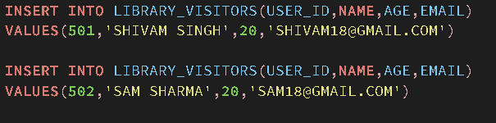
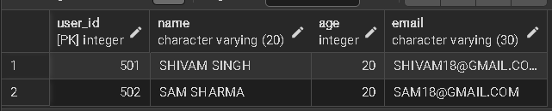
Book Issue Entry :
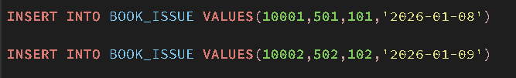
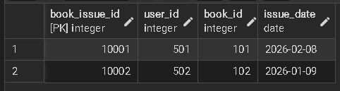
Update Book Issue Entry :
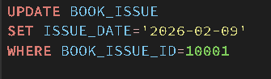
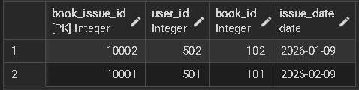

3. DELETE Operation Result
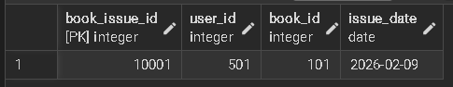
4. DCL (Security / Role-Based Access Control) Output
- DCL Verification: The librarian role was successfully created and assigned the necessary privileges for library management tasks.
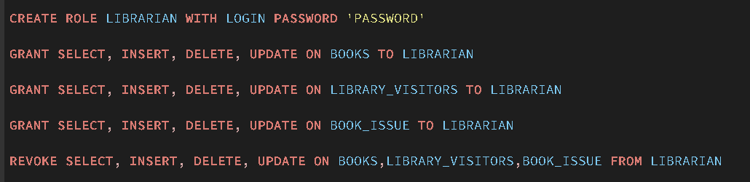
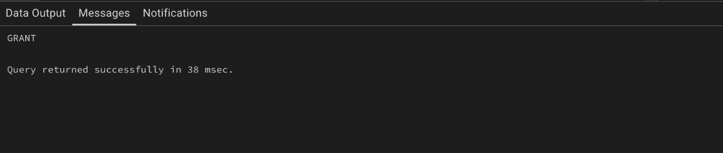

- Validation: Testing confirmed that after the REVOKE command, the librarian could no longer perform operations on the books table, ensuring the security policy is functional.
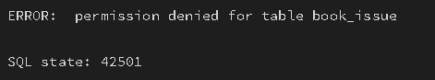

6. Learning Outcome
From this practical, the following knowledge and skills were gained:
- Schema Design Insight: Learned how relational constraints like CHECK, UNIQUE, and FOREIGN KEY contribute to logical data consistency.
- Database Security Skills: Understood the advantage of assigning roles instead of individual user permissions for scalable security.
- Real-world Contextualization: Saw how SQL is applied in real applications (such as library systems) where multiple entities interact systematically.

