Project Report
Submitted in partial fulfilment of the requirements for the award of degree of

BTECH (CSE – AI and ML)
Submitted To
LOVELY PROFESSIONAL UNIVERSITY PHAGWARA PUNJAB


From 16th of June To 16th of July

Submitted By:
Kamal Swarnkar
Registration Number: 12319379

Student Declaration

To whom it may concern,
I, Kamal Swarnkar, Registration Number: 12319379, hereby declare that the work presented in this report on “Social Awareness” from 16th of June to 16th of July
, is a record of my original work carried out for the partial fulfillment of the requirements for the degree.

Date: 18/7/2023

Certificate and Annexure B

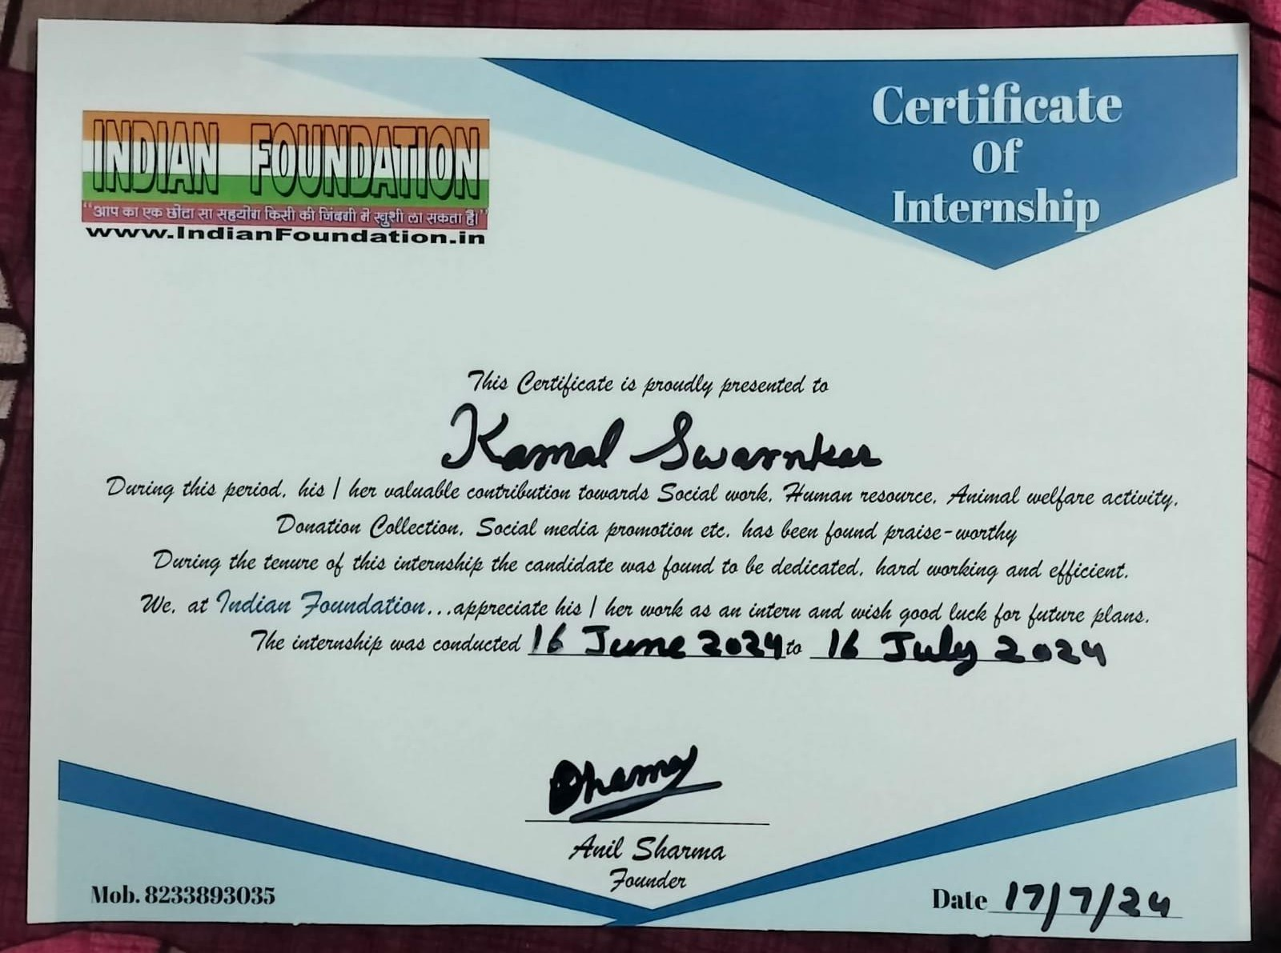

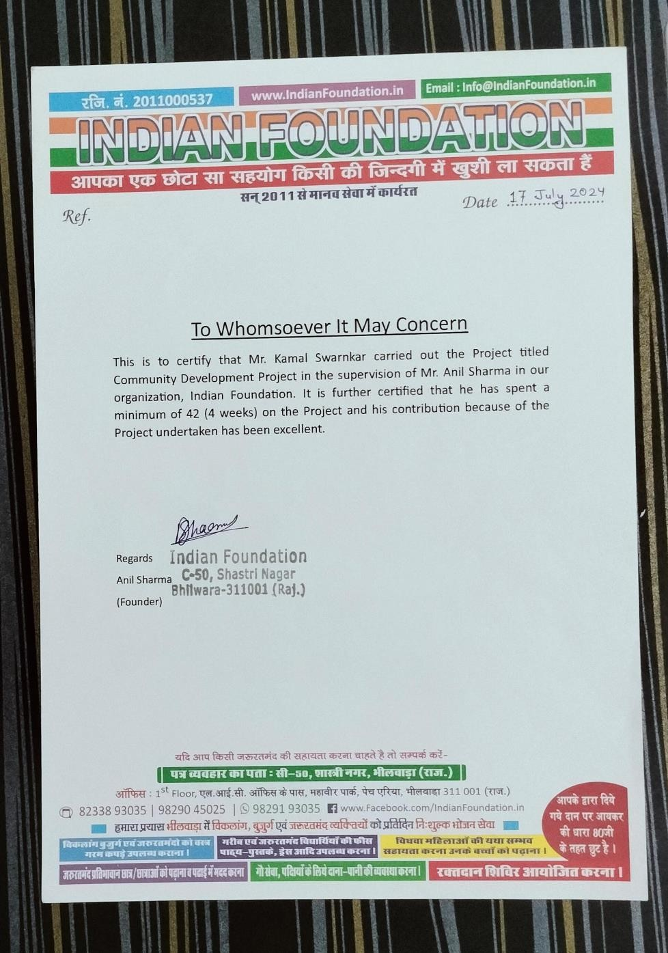

ACKNOWLEDGEMENT

I am deeply thankful to the NGO where I had the opportunity to work for four weeks. Your continued support and encouragement made this experience immensely valuable.
I would like to express my sincere appreciation to my supervisors and colleagues at the NGO for the learning opportunities and guidance provided throughout this period. The completion of my weekly tasks and the achievement of the certificate would not have been possible without your help and motivation.
A special thanks to my friend, seniors, and classmates for their support and encouragement. Your belief in me and the assistance you provided were crucial in completing this project.
I also extend my gratitude to my parents and close friends for their unwavering support. Your encouragement and the time you dedicated to helping me will always be cherished. To my caring and supportive friends and classmates, thank you for your resourcefulness and kindness.
Lastly, my heartfelt thanks to everyone who gave their time and attention to assist me in this journey. Your support has been a great comfort and relief. Thank you all for making this possible.

Introduction

During my college's community guideline project, I had the opportunity to work with the Indian Foundation, an NGO dedicated to cow welfare and social awareness. For four weeks, our team focused on various tasks, including social media promotion, raising awareness about cow welfare, collecting donations, and utilizing the funds for the welfare of cows and the needy. The Indian Foundation's mission is to promote an efficient and effective culture that provides greater opportunities for the poor in India to survive and live to their fullest. The NGO is committed to overcoming poverty, epidemics, unemployment, illiteracy, and starvation by utilizing all its resources to fulfill the basic needs of the most disadvantaged.
Indian Foundation also takes responsibility for the situation of deprived children and women in India, motivating them to seek resolution through individual and collective action. Their vision is to create a society where every child's rights are protected and honoured, built on respect for dignity, justice, and equity for all. This experience allowed me to understand the significance of cow welfare and social upliftment in our society and the impact of collective efforts in bringing about positive change. My involvement with the Indian Foundation has been both enriching and enlightening, providing me with practical insights into the workings of an NGO and the challenges faced in addressing societal issues.

Issue Identification and Root Causes
The primary problem identified was the poor condition of stray and abandoned cows in the community, coupled with a lack of awareness about their welfare. Many cows were left to fend for themselves, leading to malnutrition and diseases. The root cause of this problem was the insufficient knowledge among the public about the importance of cow welfare and the limited resources available for their care.

Objective
The main objective of our project was to enhance the welfare of stray and abandoned cows by ensuring they receive proper care, shelter, and nutrition. Additionally, we aimed to address broader societal issues aligned with the Indian Foundation’s mission, such as alleviating poverty, epidemics, unemployment, illiteracy, and starvation. By leveraging the Foundation’s resources and promoting their values, we sought to create a sustainable model for cow welfare and social upliftment.
Our specific goals included raising awareness about cow welfare within the community, encouraging donations and volunteer work, and educating the public on the importance of cow welfare and the positive impact it has on the environment and society. We also aimed to motivate individuals and communities to take responsibility for improving the lives of the poorest and most disadvantaged, reflecting the Foundation’s belief in transparency, accountability, and the importance of giving back.

Steps Taken to Achieve the Objectives
To achieve our objectives, we undertook several steps during the four-week project period. Each week was meticulously planned to ensure we made significant progress towards our goals.

Week 1: Community Involvement and Education The first week focused on involving the community and educating them about the importance of cow welfare. We concentrated on increasing community participation by encouraging individuals to volunteer at the shelters and contribute to the care of the cows. We shared success stories and updates on social media to showcase the positive outcomes of our efforts, further motivating the community to get involved. By the end of the week, we noticed a significant increase in community involvement and a greater willingness to support cow welfare initiatives.
Throughout the project, we faced several challenges, including limited resources and initial resistance from the community. However, our team's dedication and strategic approach helped us overcome these obstacles. Regular team meetings and feedback sessions ensured that we stayed on track and adapted our strategies as needed.
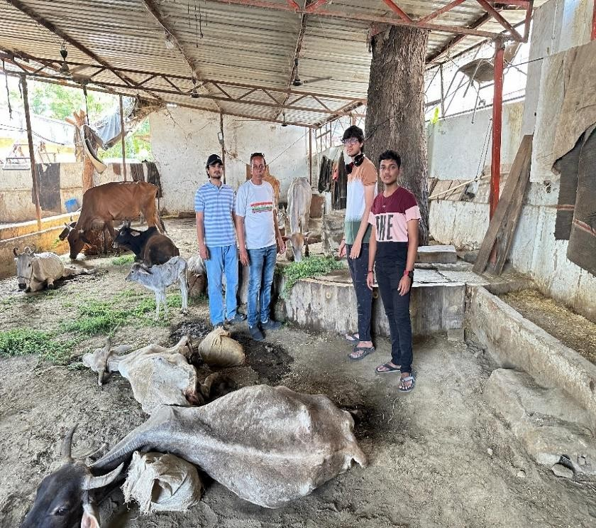
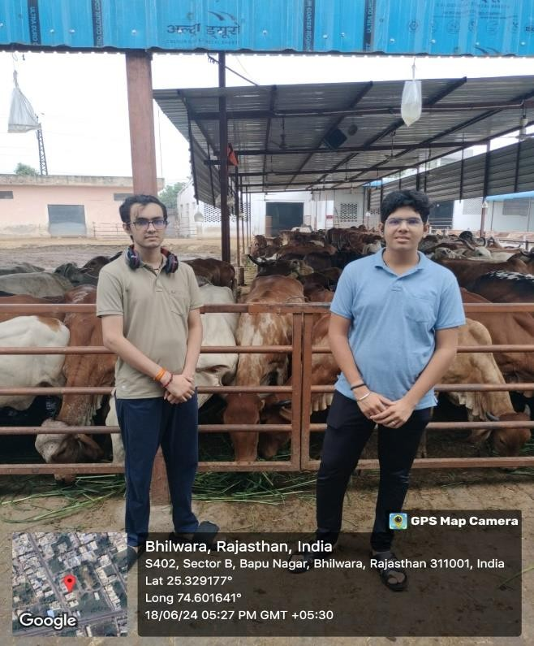

Week 2: Awareness Campaign In the second week, our focus was on creating and executing an awareness campaign. We designed eye-catching social media posts highlighting the plight of stray cows and the importance of their welfare. We utilized platforms such as Facebook, Instagram, and Twitter to reach a broad audience. Our posts included informative content, compelling images, and statistics to engage the public and encourage them to support our cause. We also approached locals and students to amplify our message and increase our reach.
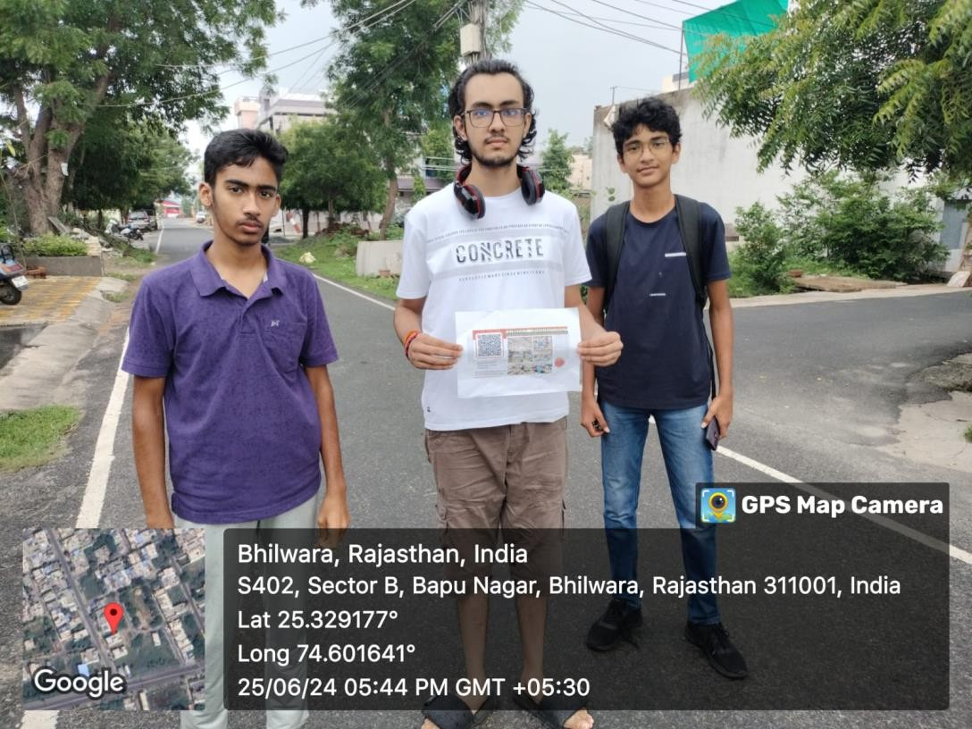

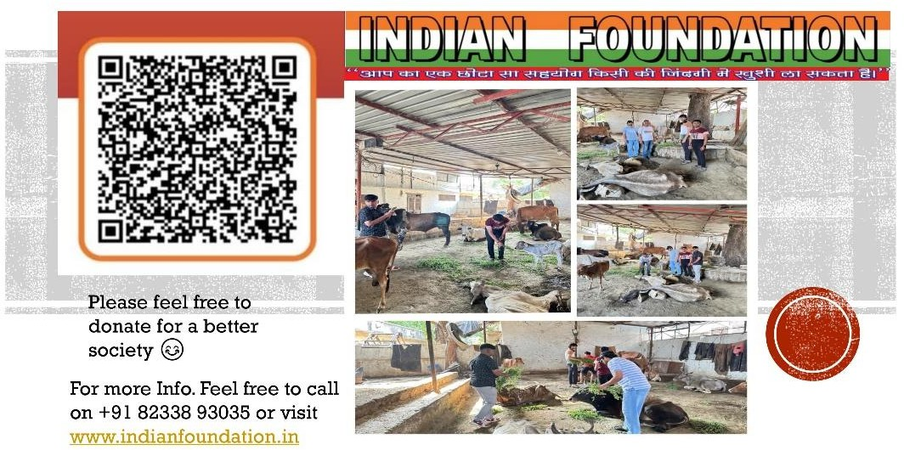

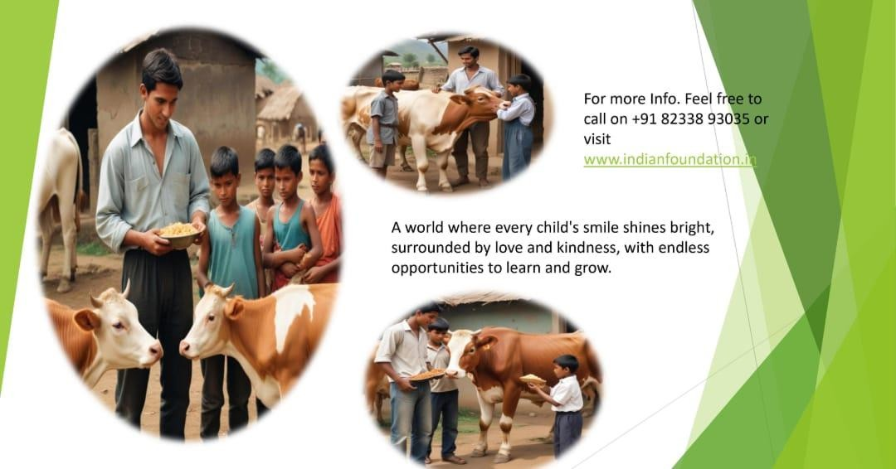

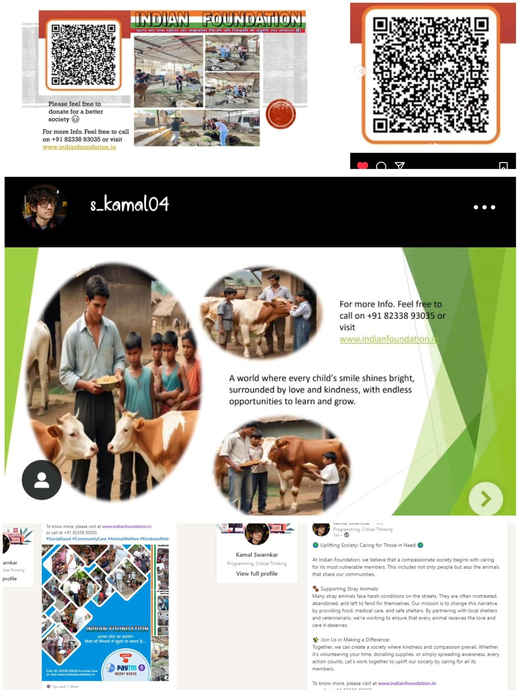

Week 3: Donation Drive The third week was dedicated to organizing a donation drive. We set up both online and offline channels for collecting donations. Online, we used crowdfunding platforms and social media campaigns to solicit contributions. Offline, we went to public places like gardens and playground where generally groups of people can be found easily and encouraged people to donate. We emphasized transparency by providing regular updates on the amount collected and how it would be used for cow welfare. This approach helped build trust and encouraged more people to contribute.
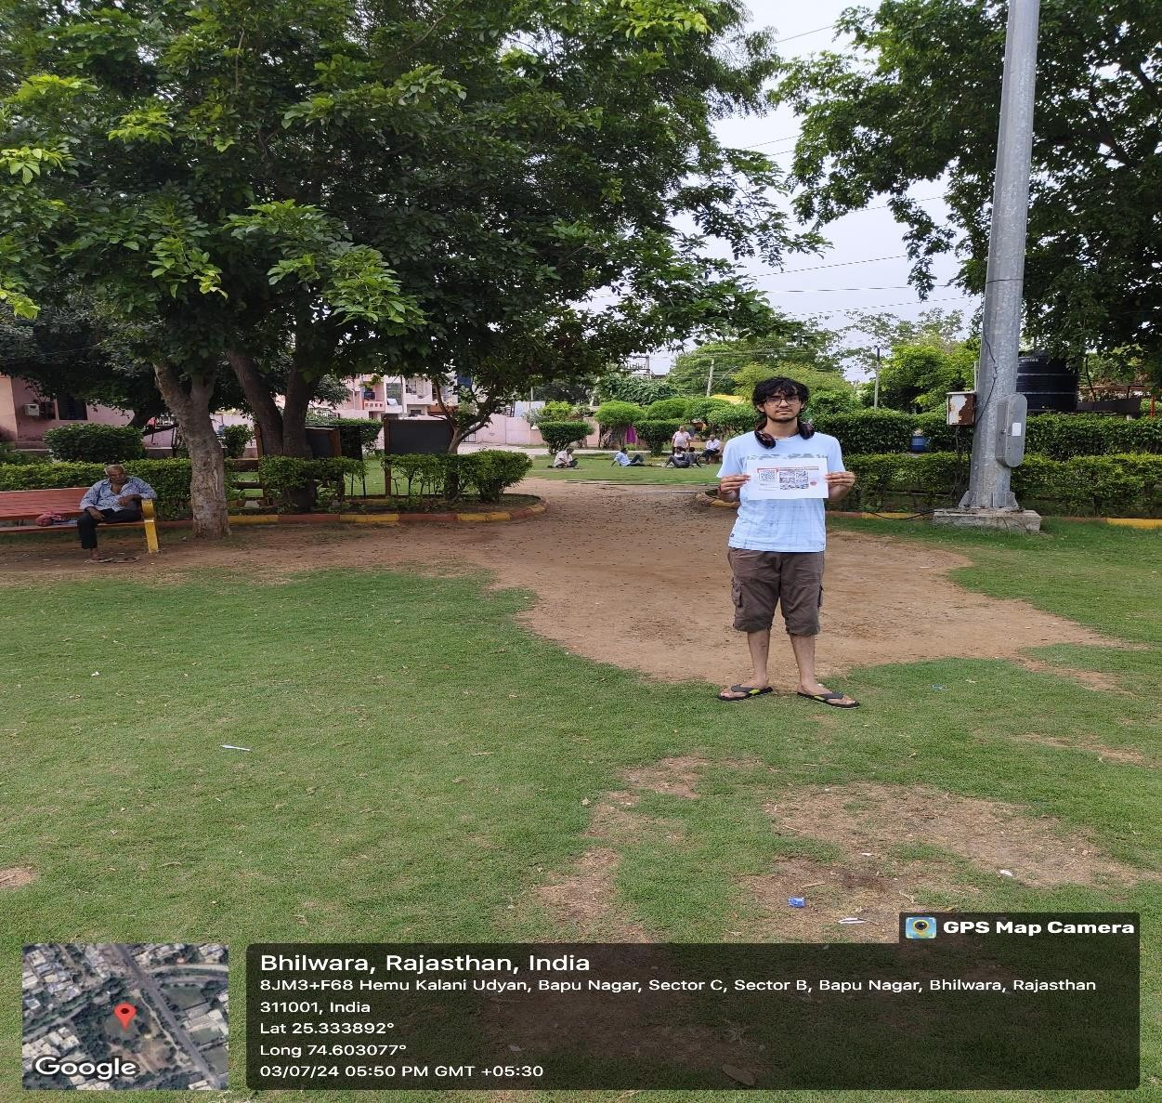

Week 4: Implementation of Welfare Activities In the final week, we focused on using the collected donations to support both cow welfare and the basic needs of the community. We donated essential items like slippers to the needy, providing them with basic necessities to improve their quality of life. Additionally, we collectively donated funds to the owner of a herd of cows to ensure they had enough food. These efforts not only provided immediate relief but also encouraged the community to participate in ongoing welfare activities.
Throughout the project, we faced several challenges, including limited resources and initial resistance from the community. However, our team's dedication and strategic approach helped us overcome these obstacles. Regular team meetings and feedback sessions ensured that we stayed on track and adapted our strategies as needed.

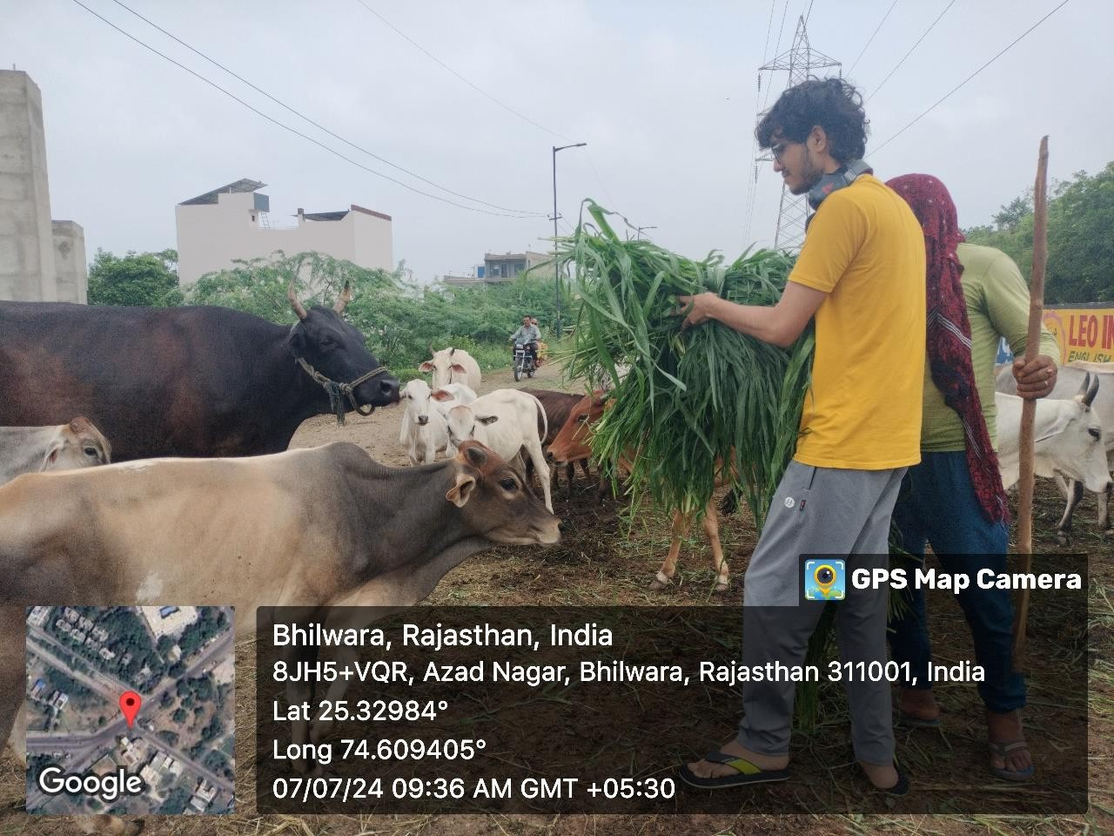

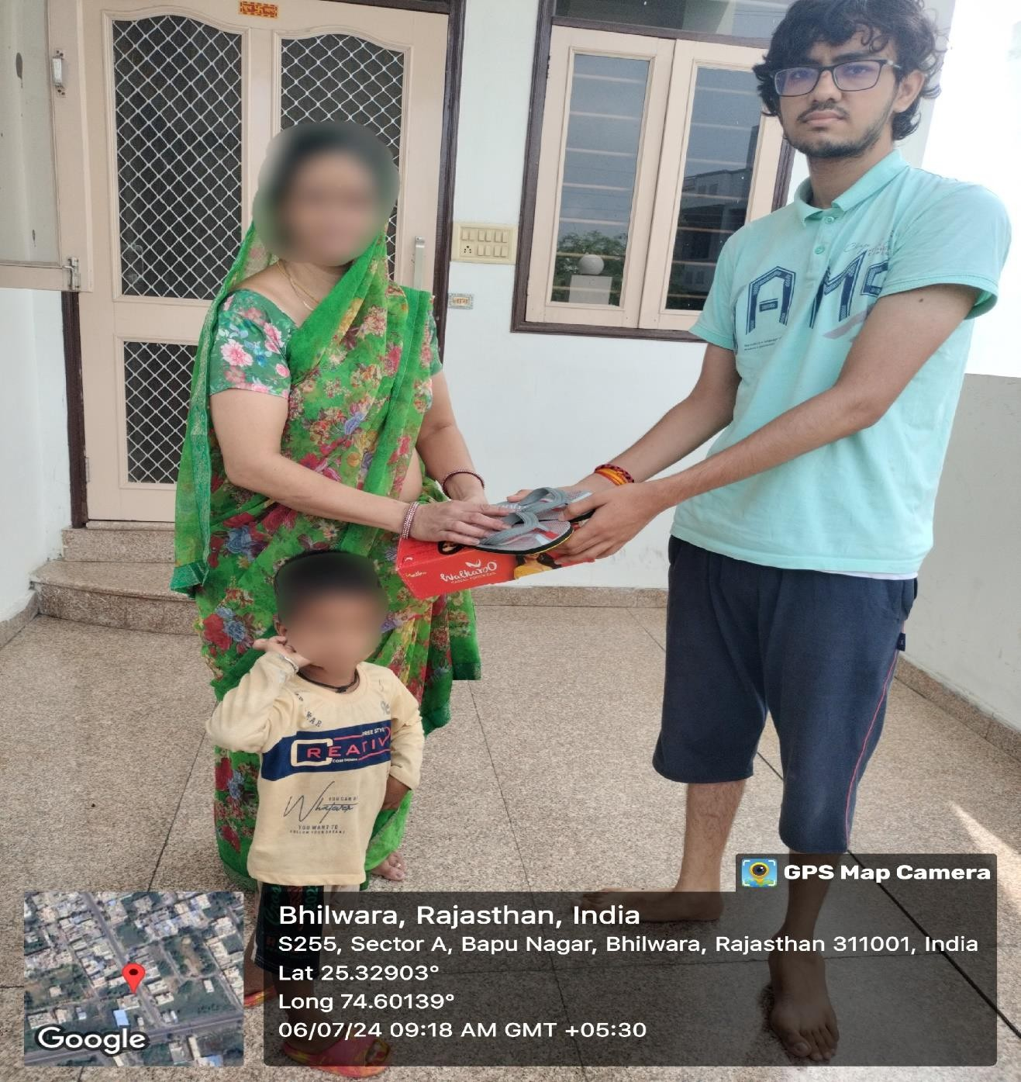

Effectiveness of the Project

The project proved to be highly effective in achieving its objectives. By the end of the four weeks, we observed a noticeable improvement in the condition of the stray and abandoned cows we cared for. The shelters provided a safe and nurturing environment, leading to better health and well-being for the cows. Our awareness campaigns reached a wide audience, resulting in increased donations and community involvement. The donation drives were particularly successful, as we managed to gather significant funds that were transparently used for cow welfare activities, including medical care and nutrition.
Our focus on social media promotion and community engagement proved crucial in raising awareness and mobilizing resources. The community's response was overwhelmingly positive, with many individuals volunteering their time and contributing to the cause. The regular updates and success stories shared on social media further motivated the community to get involved, showcasing the tangible impact of our efforts. Overall, the project successfully raised awareness, mobilized resources, and created a sustainable model for cow welfare in the community, reflecting the Indian Foundation's mission and values.

Identified Societal Problems

- Lack of Awareness about Animal Welfare: Many people in the community were unaware of the importance of animal welfare, particularly for stray and abandoned cows. This lack of knowledge led to neglect and poor living conditions for these animals.

- Insufficient Resources for Cow Welfare: There was a significant shortage of resources, including funds and medical care, dedicated to the welfare of stray and abandoned cows. This shortage hindered efforts to provide adequate care and support for these animals.

- Poverty and Basic Needs: A substantial portion of the population struggled with poverty, lacking access to essential resources such as food, shelter, and healthcare. This situation was particularly dire for the poorest and most disadvantaged members of the community.

- Challenges Faced by Children and Women: Deprived children and women in the community faced significant challenges, including limited access to education, healthcare, and opportunities for personal growth. These challenges hindered their ability to realize their full potential and contribute positively to society.

The Indian Foundation works to address these societal problems by promoting awareness, mobilizing resources, and providing direct support to both animals and people in need. Their efforts aim to create a more just and equitable society where the welfare of all living beings is prioritized.

Conclusion

My experience with the Indian Foundation has been incredibly fulfilling and enlightening. Over the course of four weeks, I gained valuable insights into the challenges and rewards of working in an NGO focused on animal welfare and broader societal issues. Our project aimed to improve the welfare of stray and abandoned cows while also addressing poverty, basic needs, and the challenges faced by children and women in the community.
The project allowed me to apply my skills in social media promotion, fundraising, and community engagement to make a tangible difference in the lives of both animals and people. We successfully raised awareness, gathered significant donations, and provided essential resources for cow welfare. Our efforts also highlighted the importance of supporting the poorest and most disadvantaged members of society, reflecting the Indian Foundation’s mission and values.
The success of the project underscores the importance of collective action and community involvement in addressing societal issues. Moving forward, I am inspired to continue advocating for animal welfare and contributing to initiatives that promote the well-being of all living beings. The lessons learned and experiences gained during this project will undoubtedly influence my future endeavours and my commitment to making a positive impact on society.

