from datetime import datetime
import tensorflow as tf
from tensorflow import keras
import pandas as pd
import matplotlib.pyplot as plt
from sklearn.preprocessing import StandardScaler
import numpy as np
import seaborn as sns
Stock = pd.read_excel
Stock.head()
Date Open High Low Close Adj Close \
0 2018-02-05 262.000000 267.899994 250.029999 254.259995 254.259995
1 2018-02-06 247.699997 266.700012 245.000000 265.720001 265.720001
2 2018-02-07 266.579987 272.450012 264.329987 264.559998 264.559998
3 2018-02-08 267.079987 267.619995 250.000000 250.100006 250.100006
4 2018-02-09 253.850006 255.800003 236.110001 249.470001 249.470001
Volume
0 11896100
1 12595800
2 8981500
3 9306700
4 16906900
Stock.shape
(1009, 7)
Stock.info()
<class 'pandas.core.frame.DataFrame'>
RangeIndex: 1009 entries, 0 to 1008
Data columns (total 7 columns):
# Column Non-Null Count Dtype
--- ------ -------------- -----
0 Date 1009 non-null datetime64[ns]
1 Open 1009 non-null float64
2 High 1009 non-null float64
3 Low 1009 non-null float64
4 Close 1009 non-null float64
5 Adj Close 1009 non-null float64
6 Volume 1009 non-null int64
dtypes: datetime64[ns](1), float64(5), int64(1)
memory usage: 55.3 KB
Stock.describe()
Open High Low Close Adj Close \
count 1009.000000 1009.000000 1009.000000 1009.000000 1009.000000
mean 419.059673 425.320703 412.374044 419.000733 419.000733
std 108.537532 109.262960 107.555867 108.289999 108.289999
min 233.919998 250.649994 231.229996 233.880005 233.880005
25% 331.489990 336.299988 326.000000 331.619995 331.619995
50% 377.769989 383.010010 370.880005 378.670013 378.670013
75% 509.130005 515.630005 502.529999 509.079987 509.079987
max 692.349976 700.989990 686.090027 691.690002 691.690002
Volume
count 1.009000e+03
mean 7.570685e+06
std 5.465535e+06
min 1.144000e+06
25% 4.091900e+06
50% 5.934500e+06
75% 9.322400e+06
max 5.890430e+07
plt.plot(Stock['Date'],
Stock['Open'],
color="blue",
label="open")
plt.plot(Stock['Date'],
Stock['Close'],
color="green",
label="close")
plt.title("Open-Close Stock")
plt.legend()
<matplotlib.legend.Legend at 0x23a630e8d30>
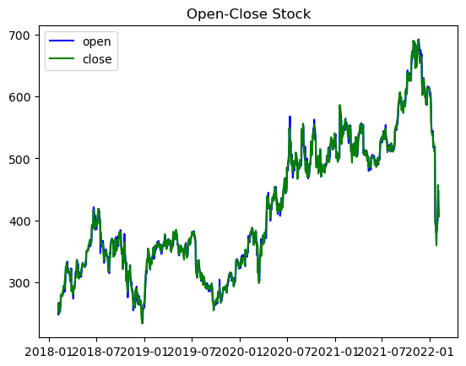
plt.plot(Stock['Date'],
Stock['Volume'])
plt.show()
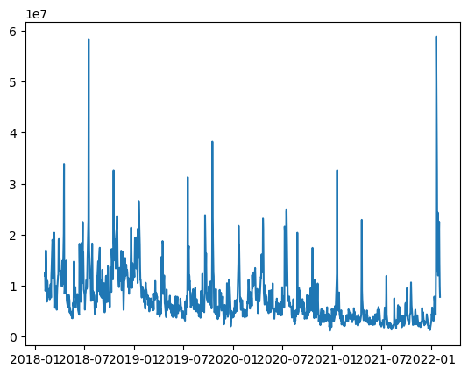
sns.heatmap(Stock.corr(),
annot=True,
cbar=False)
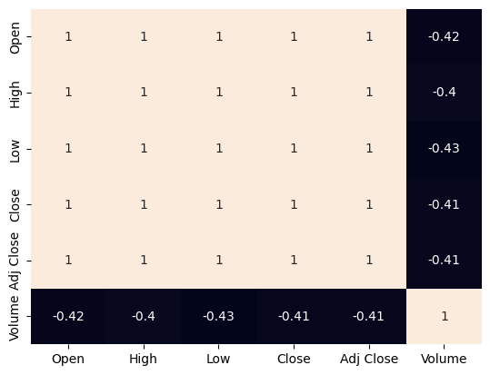
Stock['Date'] = pd.to_datetime(Stock['Date'])
prediction = Stock.loc[(Stock['Date']
> datetime(2018, 2, 5))
& (Stock['Date']
< datetime(2022, 2, 5))]
plt.figure(figsize=(10, 10))
plt.plot(Stock['Date'], Stock['Close'])
plt.xlabel("Date")
plt.ylabel("Close")
plt.title("Stock Prices")
Text(0.5, 1.0, 'Stock Prices')
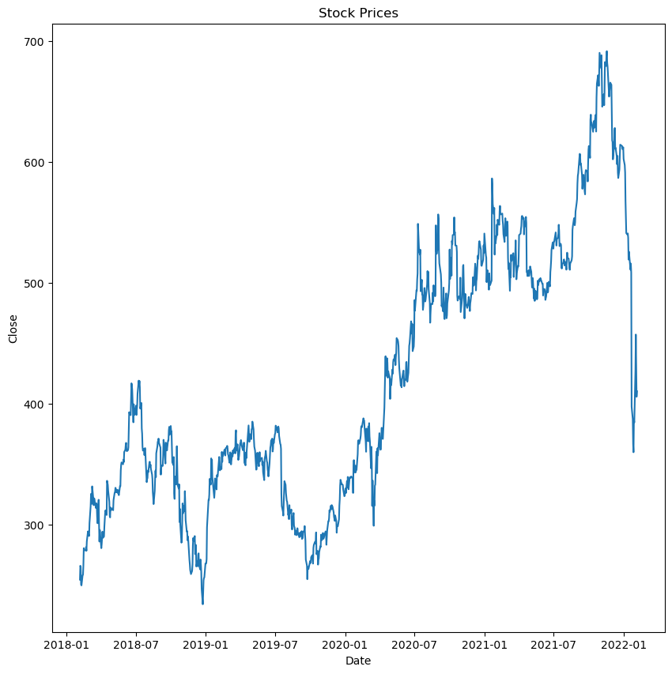
# prepare the training set samples
st_close = Stock.filter(['Close'])
dataset = st_close.values
training = int(np.ceil(len(dataset) *.95))
# scale the data
ss = StandardScaler()
ss = ss.fit_transform(dataset)
train_data = ss[0:int(training), :]
x_train = []
y_train = []
# considering 60 as the batch size,
# create the X_train and y_train
for i in range(60, len(train_data)):
x_train.append(train_data[i-60:i, 0])
y_train.append(train_data[i, 0])
x_train, y_train = np.array(x_train),\
np.array(y_train)
X_train = np.reshape(x_train,
(x_train.shape[0],
x_train.shape[1], 1))
# model = keras.models.Sequential()
# model.add(keras.layers.LSTM(units=128,
# return_sequences=True,
# input_shape
# =(X_train.shape[1], 1)))
# model.add(keras.layers.LSTM(units=128))
# model.add(keras.layers.Dense(256))
# model.add(keras.layers.Dropout(0.2))
# model.add(keras.layers.Dense(1))
# print(model.summary())
model = keras.models.Sequential()
model.add(keras.layers.LSTM(units=128,
return_sequences=True,
input_shape=(X_train.shape[1], X_train.shape[2])))
model.add(keras.layers.LSTM(units=128))
model.add(keras.layers.Dense(256))
model.add(keras.layers.Dropout(0.2))
model.add(keras.layers.Dense(1))
print(model.summary())
Model: "sequential_3"
_________________________________________________________________
Layer (type) Output Shape Param #
=================================================================
lstm_6 (LSTM) (None, 60, 128) 66560
lstm_7 (LSTM) (None, 128) 131584
dense_6 (Dense) (None, 256) 33024
dropout_3 (Dropout) (None, 256) 0
dense_7 (Dense) (None, 1) 257
=================================================================
Total params: 231,425
Trainable params: 231,425
Non-trainable params: 0
_________________________________________________________________
None
from keras.metrics import RootMeanSquaredError
model.compile(optimizer='adam',
loss='mae',
metrics=RootMeanSquaredError())
history = model.fit(X_train, y_train,
epochs=20)
Epoch 1/20
29/29 [==============================] - 3s 55ms/step - loss: 0.2412 - root_mean_squared_error: 0.3542
Epoch 2/20
29/29 [==============================] - 2s 58ms/step - loss: 0.1418 - root_mean_squared_error: 0.1864
Epoch 3/20
29/29 [==============================] - 2s 61ms/step - loss: 0.1244 - root_mean_squared_error: 0.1632
Epoch 4/20
29/29 [==============================] - 2s 63ms/step - loss: 0.1184 - root_mean_squared_error: 0.1552
Epoch 5/20
29/29 [==============================] - 2s 64ms/step - loss: 0.1106 - root_mean_squared_error: 0.1477
Epoch 6/20
29/29 [==============================] - 2s 65ms/step - loss: 0.1091 - root_mean_squared_error: 0.1459
Epoch 7/20
29/29 [==============================] - 2s 61ms/step - loss: 0.1109 - root_mean_squared_error: 0.1467
Epoch 8/20
29/29 [==============================] - 2s 60ms/step - loss: 0.0987 - root_mean_squared_error: 0.1312
Epoch 9/20
29/29 [==============================] - 2s 58ms/step - loss: 0.0909 - root_mean_squared_error: 0.1216
Epoch 10/20
29/29 [==============================] - 2s 59ms/step - loss: 0.0900 - root_mean_squared_error: 0.1202
Epoch 11/20
29/29 [==============================] - 2s 59ms/step - loss: 0.0940 - root_mean_squared_error: 0.1261
Epoch 12/20
29/29 [==============================] - 2s 59ms/step - loss: 0.0874 - root_mean_squared_error: 0.1185
Epoch 13/20
29/29 [==============================] - 2s 60ms/step - loss: 0.0848 - root_mean_squared_error: 0.1159
Epoch 14/20
29/29 [==============================] - 2s 63ms/step - loss: 0.0844 - root_mean_squared_error: 0.1139
Epoch 15/20
29/29 [==============================] - 2s 60ms/step - loss: 0.0833 - root_mean_squared_error: 0.1133
Epoch 16/20
29/29 [==============================] - 2s 60ms/step - loss: 0.0816 - root_mean_squared_error: 0.1108
Epoch 17/20
29/29 [==============================] - 2s 62ms/step - loss: 0.0815 - root_mean_squared_error: 0.1110
Epoch 18/20
29/29 [==============================] - 2s 66ms/step - loss: 0.0821 - root_mean_squared_error: 0.1126
Epoch 19/20
29/29 [==============================] - 2s 64ms/step - loss: 0.0910 - root_mean_squared_error: 0.1223
Epoch 20/20
29/29 [==============================] - 2s 61ms/step - loss: 0.0766 - root_mean_squared_error: 0.1040
testing = ss[training - 60:, :]
x_test = []
y_test = dataset[training:, :]
for i in range(60, len(testing)):
x_test.append(testing[i-60:i, 0])
x_test = np.array(x_test)
X_test = np.reshape(x_test,
(x_test.shape[0],
x_test.shape[1], 1))
pred = model.predict(X_test)
2/2 [==============================] - 1s 14ms/step
train = Stock[:training]
test = Stock[training:]
test['Predictions'] = pred
plt.figure(figsize=(10, 8))
plt.plot(train['Close'], c="b")
plt.plot(test[['Close', 'Predictions']])
plt.title('Microsoft Stock Close Price')
plt.ylabel("Close")
plt.legend(['Train', 'Test', 'Predictions'])
