Contents
CHAP.1. INTRODUCTION 1
1.1. Definition 1
The word Biology comes from two Greek words: Bios which means life, and Logos, which means knowledge. Biology means the study of life (or living organism). Biology is the science of living things. Biology is a study of living things. 1.2. Reason for studying biology 1
1.3 Branches of biology 1
1.4. Characteristics of living things 1
1.5 The classification system 2
CHAP.2. THE FIVE KINGDOMS OF THE LIVING WORLD 2
2. 1. Kingdom monera 4
2.2. Kingdom proctista 6
2. 2.1. Protozoa 6
2.2.2. Classification of protozoa 6
2.2.2. Protophyta (alga) 9
2.3. KINGDOM FUNGI 9
2.3 1. General characteristics 9
2.3.2. Parts of mushroom 9
2. 3.3. Fungi in nature 10
2.3.4. Economic importance of fungi 10
2.4. Kingdom plantae 11
2.5. KINGDOM ANIMALIA 11
CHAP.3. PLANTS 11
3.1. General characteristics 11
3.2 Classification 12
3. 3 Structures of the flowering plants 13
3.3.1 Roots system 14

CHAP.1. INTRODUCTION

1.1. Definition

The word Biology comes from two Greek words: Bios which means life, and Logos, which means knowledge. Biology means the study of life (or living organism). Biology is the science of living things. Biology is a study of living things. 1.2. Reason for studying biology
Scientists who study Biology are called Biologists. Studying biology help us understanding:
* How living thing work * Ourselves * Our environment

1.3 Branches of biology
There are different areas of biology. In the past, biology was divided into two main branches, Zoology (the study of animals) and Botany (the study of plants). Today, biology is divided into more specialized areas:
* Taxonomy: the study of classification of living things
* Ecology: the study of living things in their environment
* Anatomy: the study of structure of living things
* Cytology: the study of cells
* Genetics: the study of heredity, or how traits are transmitted from generation to generation
* Physiology: the study of functioning or working of living things.
* Microbiology: the study of microscopic living things
* Entomology: the study of insect and the impact they have on human lives.

1.4. Characteristics of living things
The scientific term for complete individual living thing is organism. All organisms are made of cells. Some organisms, called unicellular are single celled. Other living things called multicellular organisms are made up of more than one cell. All cellular organisms fall under two main groups: Prokaryotes and eukaryotes. Viruses, termed as Akaryotes, lack cellular components like nucleus, mitochondria etc. Prokaryotes lack true nucleus and don’t have nuclear membrane or nucleolus. Eukaryotes have nucleus and both nuclear membrane and the nucleolus.
Some of the characteristics of living things are: Movement, Respiration, Feeding, excretion, reproduction, and use of energy, irritability and growth.
There are two principal methods of obtaining food called autotrophic and heterotrophic. Autotrophic organisms (autotrophs) are organisms that are able to make their own food from the inorganic materials (e.g. plants). Heterotrophic organisms (heterotrophs) are organisms that are not able to make their own food. They feed on autotrophic organisms.

1.5 The classification system
Taxonomy is the process of classifying organisms. The system we use, groups living things into categories called toxa (taxon).
The largest groups are kingdoms. Kingdom is subdivided into phyla (sing phylum), each phylum into classes, and each class into orders, each order into families, each family into genera, and each genus into species. The species is the smallest unit of classification.
Naming living things
All the different languages have different names for the same animal or plant (Vernacular names). Then it becomes impossible for one scientist to know what organism another scientist is talking about. The problem is solved by giving a scientific name to every organism.
This name is given according to the Binomial system of Nomenclature discovered by Corolus Linnaeus. Binomial means two names. The two names are in Latin.
Simple rules for writing scientific names
The fist name is the name of the genus to which the organism belongs. It is written with a capital letter. The second name is the name of species to which the organism belongs. It is written with a small letter. The two names are underlined when handwritten, or in italics when printed.
Example: Homo sapiens (humain); Zea mays (Maze); Phaseolus vulgaris (Beans); Plasmodium falciparum (Malaria parasite)

CHAP.2. THE FIVE KINGDOMS OF THE LIVING WORLD
Classification began in the eighteenth century with a Swedish botanist Corolus Linnaeus. He divided organisms into two kingdoms: the animals and plants. In the modern classification system, there are five kingdoms: Monera (Bacteria), Protoctista (protista), Fungi (Mycota), Plantae, Animalia.
Note that viruses are not classified in any of the above kingdom. This is because virus has not all the seven characteristics of life.
They can reproduce and feed, but do not respire, excrete, move or grow. Viruses are visible under electronic microscope e.g.: Human Immune deficiency Virus (HIV).

Some viral diseases
Diseases | Tissues affected | Method of transmission
Poliomyelitis | Nervous system | Human feces or droplet infection
Yellow fever | Liver | Aedes mosquito via bites
Measles | Respiratory passage | Droplet infection
Rabies | skin | Via infected dogs bites
AIDS | Immune system | Via sexual contact

HIV cause Acquired Immune-deficiency syndrome (AIDS). It because serious damages to the immune system. HIV is transmitted by:
* Sexual relation: oral, vaginal, and anal
* Contaminated blood via blood transfusion or sharing of needles
* A pregnant carrier of HIV can transmit the virus to the fetus by exchange of blood during birth or after birth through breast feeding.
HIV /AIDS are prevented by:
*Abstinence
* Use of condoms during sexual relation
* Not abuse intravenous drugs
* HIV positive should not breast feed their children and should avoid pregnancy

2. 1. Kingdom monera
General characteristics
All monerans are prokaryote. Their cells lack a true nucleus and membrane bound organelle. Like plant cell, monera cells have cell walls. They are single celled organisms (unicellular) .
Size and shape
Average sized bacteria measures about 1Um in length. Bacteria can be characterized by their shape and by the way they group together. Bacteria have three basic shapes.
Sphere shaped bacteria are called Cocci (sing coccus), rod – shaped bacteria are called Bacilli (sing bacillus) and cork crew – shaped bacteria called spirilla (sing spirillum). Cocci that form pairs are called diplococci, those that form clusters are called staphylococci and those that form chains are called streptococci.
Typical bacteria have all of the structure below:
* Cell wall that surround the plasma membrane
* Capsule, a structure that surround the cell wall
* Plasma membrane that surround the cell and regulate what enter and leaves the cell
* Flagellum (pl.flagella), structure that enable bacteria to move.
figure.

Nutrition of bacteria
Some bacteria produce their own food (autotrophs), other depend on autotophs for food (Heterotroph). Some heterotroph bacteria are parasite, meaning that they obtain their food from living organisms, other feed on dead organisms or organic matter (saprophytes).
Respiration
Some bacteria need oxygen to respire, other do not need oxygen and die in the presence of oxygen. Bacteria that require oxygen to live are called obligate aerobes (e.g.: Bacterium that cause tuberculosis). Bacteria that cannot live in the presence of oxygen are called obligate anaerobes (e.g.: Clostridium botulinum) Bacteria that can grow without or with oxygen are called facultative anaerobes (e.g.: E.coli in human digestive tract). Not all bacteria cells are capable of movement: that move is called motile and those that do not move are called non motile. Bacteria use their flagella to move.
The importance of bacteria
Beneficial bacteria
*Symbiotic bacteria inhabiting the alimentary canal of man manufacture vitamin B and C
* Symbiotic bacteria in the gut of ruminants help in the digestion of cellulose in the grass eaten
* Saprophytic bacteria help in the decay of dead organic matter into mineral salt.
* Nitrifying bacteria (Rhizobium) in root nodule of legumes (e.g.: soybeans) fixe nitrogen gas in the soil into nitrates used by the plant. Other bacteria (denitrifying bacteria) maintain a balance of nitrogen in the soil and atmosphere.
* In biotechnology, they are used in manufacturing milk product, and medicines.
Harmful bacteria
* Some bacteria cause disease in plants and animals
*Many spoil or decay food and cause food poisoning.
Some bacterial diseases
Diseases | Tissues affected | Method of transmission
Cholera | Small intestine | Via housefly on feces
Tetanus | Blood nerves and muscles | Infection of wound
Gonorrhea | Reproductive organ | Via sexual intercourse
Tuberculosis | Lungs | Droplet infection

2.2. Kingdom proctista
Characteristics
Protists are unicellular or multicellular eukaryotic organisms. They can be autotrophic or heterotrophic. Some protists resemble animal in their method of nutrition. The animallike protition are called protozoa. Unlike animal, protozoa are unicellular. Other protists are plantlike autotrophic using photosynthesis to make their food. Plantlike protists are called protophyta. Unlike plants, photophytes do not have organ such as roots, stems, and leaves.

2. 2.1. Protozoa
Protozoa are animallike protists. All protozoans are unicellular and feed or other organisms (parasites) or dead organic matter (Saprophyte).

2.2.2. Classification of protozoa
Protozoa are grouped according to the way they move and feed.
A. Phylum Rhizopoda (Sarcodina)
The phylum rhizopoda includes hundreds of species of amoebas and amoebalike organisms. Amoeba has not the cell wall and form pseudopodia (False – foot) to move.
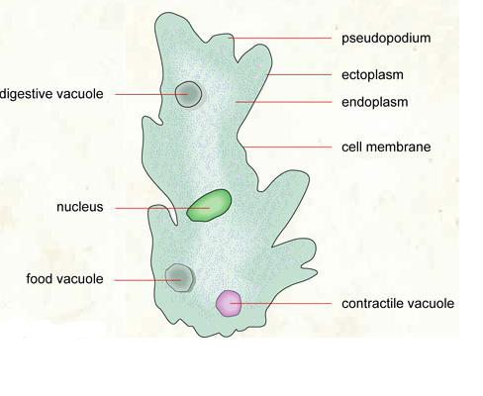
Amoeba uses pseudopodia to move and feeding. When amoeba find food particle, it surround the food with pseudopodia forming a food vacuole. This process is called phagocytosis. The products of digestion are absorbed where the undigested foods are expelled out of the amoeba by exocytosis. Note that Biologist distinguishes two types of endocytosis based on the kind of material that is taken into the cell. Pinocytosis (cell - drinking) involves the transport of solute or fluids while phagocytosis (cell eating) is the movement of larges particles or whole cell.
Amoeba and human
Entamoeba hystolytica cause amoebic dysentery to the human. Amoebic dysentery is transmitted by ingestion of Entamoebic hystitolytica cysts with water or food. The symptoms of the disease are blood stained diarrhea, abdominal cramps, fever. Amoebic dysentery is prevented by drinking boiled water and having hygiene of food and water
B. Phylum Ciliophora (ciliates)
General characteristics
Ciliates move by cilia that cover their body. All ciliates cells have two kinds of nuclei, the macro (mega) nucleus and the micro nucleus. The macronucleus is responsible of metabolic and developmental function and is also necessary for asexual reproduction. The micronucleus participates in sexual reproduction by conjugation. Ciliate are adapted to all aquatic habitats. Example of those organisms includes paramecium.
Structure of paramecium
Those organisms have distinct anterior and posterior ends. The front end of the body is rounded and the back end is pointed
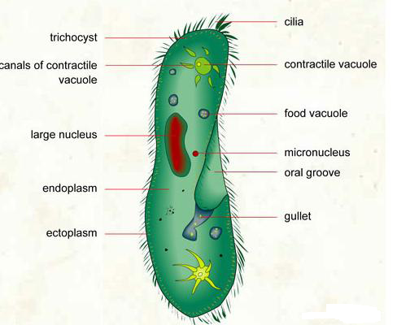

* Cilia are used for swimming and feeding
* Contractile vacuoles are used for excretion and regulation of the amount of water.
* Cytoplasm is a fluid containing water, protein and mineral ions and other nutrients.
* Oral groove act as a passage for food particles into paramecium
* Cell membrane or pellicle binds the cell content together
* Food vacuole stores food and also digestion take place in them.
C . Phylum sporozoa
Protista in the phylum protozoa are called sporozoans because most of them produce spores in their reproduction. Sporozoans do not have cilia, flagella, or pseudopodia to move. The best known sporozoa is plasmodium that causes the diseases malaria in human, other mammals and in birds. There four species of plasmodium that infect man are transmitted by anopheles mosquito.
There are three ways to control malaria.
1. Reduce the number of mosquitoes
* By draining marshes
* By stocking ponds with fish to eat the mosquitoes larvae
* By spraying with the biological control agent
2. Avoid being bitten by mosquitoes
* By using insect repellent
* By wearing covering clothing
* By sleeping under mosquitoes nets
3. Use drugs to prevents infection
D. Phylum zooflagellate (zoomastigina)
The phylum zoonastigina consists of animallike protists called zooflagellates. Because they have one or more flagella, zoomagistina are called flagellate. They move by whipping their flagella from side to side. Zoomagistina, to which belong to the genus Trypanosomes are pathogen protists. Two species of trypanosome cause African trypanosomiasis or sleeping sickness.
Trypanosomiasis is transmitted by tsetse fly which lives only in Africa. The trypanosome destroys blood cell and infects other tissues in the body. The symptoms of infection include fever, lethargy, mental deterioration and coma. As trypanosome attack the nervous system, infected individuals become weak and lose consciousness, passing into the deep sleep from which the disease gets its name. It is prevented by taking measures against the insect.
Some protozoan diseases
Diseases | Protozoan | Tissues affected | Transmission
Malaria | Plasmodium | erythrocytes | Bites of an anopheles
Sleeping sickness | Trypanosomes | Blood and lymph nodes | Tsetse fly
Amoebic dysentery | Entamoeba hystolytica | Large intestine | Contamineted food

2.2.2. Protophyta (alga)
This group includes the plants like flagellates. They use flagella for locomotion and contain chlorophyll for photosynthesis. Members of this phylum are algae. They live in streams, laves, swamps and all oceans of the world. In addition to the chlorophyll, the algae contain additional pigment in order to adapt to their aquatic habitat. Those accessory pigments give different colors to the alga. Then there are green algae, red algae, and brown algae. Example of green algae includes euglena, chlamydomonas and spirogyra Euglena is unicellular green algae which inhabit fresh water and ponds. Chamydomonas is unicellular cup-shaped green algae that have the flagella. Spirogyra is freshwater green algae. It is not a unicellular organism but consists of thin filament made up of identical cylindrical cells. The filaments are visible to the necked eye.

2.3. KINGDOM FUNGI
2.3 1. General characteristics Fungi (sing fungus) have the following characteristics.
* Fungi have the cell wall made of chitin * Fungi have large cell with many nuclei * Fungi do not have chlorophyll. They are heterotrophy * Fungi digest their food before it is ingested * Fungi grow well in dark, warm and moist areas

2.3.2. Parts of mushroom
Mushroom: plant without flowers or chlorophyll, fast-growing, especially in dark, damp locations.
Scale: small, hard plate that covers and protects the mushroom.
Tubes: duct.
Pores: small holes.
Stipe, stalk: part of the mushroom between the cap and the soil.
Scales: small, hard plates that cover and protect.
Volva: thick membrane covering the foot.
Ring: membrane that envelops part of the stem.
Gills: each of the gills forming the head.
Cap: top of the mushroom.
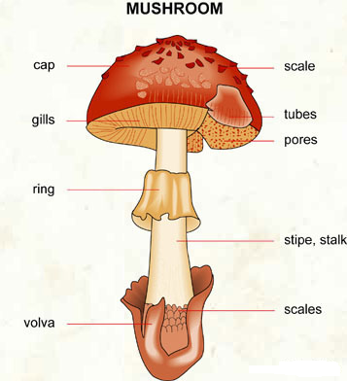

2. 3.3. Fungi in nature
In the environment, fungi decompose and recycle organic waste. Many fungi associate with root of green plant forming mycorrhizae. They also associate with algae forming Lichens

2.3.4. Economic importance of fungi
Fungi are both useful and harmful to human.
* Yeast cells are used as a source for vitamin B extracts * Fungi produce antibiotics, example Penicillium * Fungi are a source of food, example mushroom * Fermentation of beer by Saccharomyces cerevisiae * Fungi can spoil food( example Rhizopus and Penicillium on bread) * They cause plant and animal diseases.

Some fungal diseases
Disease | Symptoms | Fungus | Route of transmission
Athlete’s foot | Scaly skin , itching | Trichophyton species or Epidermophyton species | Contact with skin lesions or contaminated floor
Ringworm | Ring shaped skin lesions | Microsporum or Trychophyton | Contact with skin lesions or contaminated floor or objects
Vaginal yeast infection | Burning sensation , itching | Candida | Contact with fecal material

2.4. Kingdom plantae
General characteristics
Plants are eukaryotic, multicellular organisms. They have cell wall made of cellulose they contain chlorophyll (green pigment).They synthesize food through photosynthesis

2.5. KINGDOM ANIMALIA
Animals are multicellular eukaryotic organisms that feed on other living organisms (heterotrophic nutrition). They don’t have chlorophyll and can locomote. Their cells do not have the cell wall. Scientists make a major distinction between vertebrates, animal with a backbone or a spine and invertebrates animals without a backbone. The kingdom animalia consists of eight phyla of invertebrates and one phylum (chordata) of vertebrates. The eight phyla of invertebrates are porifera (sponge), coelentereta (cnidaria) platyhelminthes (flatworms), nematode (round worms), anmelida (segmented worms), mollusca, echinodermata and arthropoda.

CHAP.3. PLANTS

3.1. General characteristics
Plants are eukaryotic, multicellular organisms. They have cell wall made of cellulose they contain chlorophyll (green pigment).They synthesize food through photosynthesis

3.2 Classification
Phyla of plant kingdom are called division. The main divisions of plantae kingdom are: Bryophyte, Pteridophyta and Spermaphyta A. Divisions Bryophyta (moss and liverworts) General characteristics Bryophytes (the mosses and liverworts) are small plants that need damp place to live. Their body is differentiated into simple stem, leaves and rhizoids used for anchorage. They do not have a vascular transport system to conduct fluid through the plant. Bryophytes need water to reproduce. They reproduce by the means of spores instead of seeds. The liverworts belong to the class hepatica and mosses belong to the class musci.
- Importance of bryophytes
* Mosses are pioneer plants *The growth of rhizoids sprit off rock creating new soil * Rhizoids help preventing erosion by anchoring existing soil * When they die, their body add organic matter to the soil
B. Division pteridophyta
General characteristics
Most pteridophytes are ferns. They have true stem (rhizome), leaves (fronds) and roots. They have a transport system of water. They reproduce by means of spores. Because of their way of reproduction, they are found in damp and shady areas.
Importance of fens Some species of ferns are used to make medicines, drugs and perfumes. Others are used in decoration. A few types of ferns are eaten by human. C. Division spermaphyta. General characteristics The spermaphytes are the seed – bearing plants. They are the most common plant on earth. Spermaphytes are successful of all land plant because they:
* Have well developed root, stem and leaves * Have well developed vascular (water transport) of tissue * Reproduce using seeds and fruits of various types.
Main groups
The spermaphytes are divided into two subdivisions: The gymnosperms and angiosperms.
Gymnosperms: produce seeds that are formed inside cones. They don’t have flowers, seed are naked, no fruit. They include the conifers and cycades. They are usually evergreen. Conifers are very useful trees for producing timber. They have been brought in Africa. They are not native plants. e.g.: Pinus and Cupressus.
Angiosperms: Commonly known as flowering plants, reproduce using flowers, producing seeds that are enclosed within fruits. They have good water - transport system of vessels, made up of special tissues called xylem and phloem. The flowering plants are split into two main classes the Monococytyledons (liliopsida) and the dycotyledons (magnoliopsida).
Dicotyledonae (magnoliopsida) are flowering plants that have two seed leaves named cotyledons e.g.: Beans. Monocotyledons (liliopsida) are flowering plants that have one seed leaf. Monocot includes the grasses, cereal plants such as maize and palms. Note that an intermediate group (Chlamydosperms) exists between angiospermes and gymnosperms. Chlamydosperms are plants whose seeds are more or less protected. e.g. Welwitschia, a plant found in Namibia.

3. 3 Structures of the flowering plants
A typical flowering plant consists of two main parts that is the shoot system which carries the leaves flowers and fruits and roots system. Flowering plants have four mains organs divided into two groups: Vegetative parts (leaves, stem, and roots) and Reproductive parts (flowers)
Figure: Structure of a flowering plant
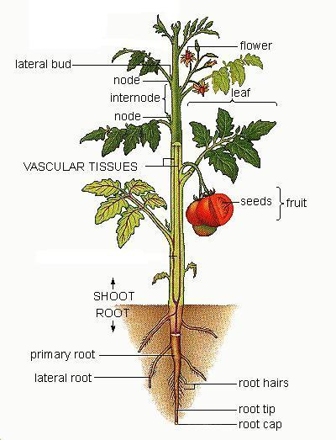

3.3.1 Roots system
Structure
The root system of flowering plants develops from the radicle of seed. There are two main types of root system.
A tap root system consists of a single main root that grows down with smaller lateral roots branching from it. Tap root system is found in dicot plant such as carrot and beans. Figure 11: Root structure
A fibrous root consists of a more than one main root growing from the same point with lateral from them. Example of a fibrous system includes monocot plants such as maize and sorghum. Sometimes roots grow from the nodes of stems as in maize, on from leaves. Such roots are called adventious roots.
THE ZONES OF A ROOT
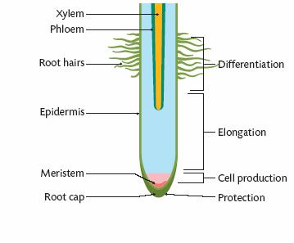
Zone of protection also known as the Root Cap: envelope that protects the root as it pushes through the soil.
Meristem: tissue at the tip of the root composed of rapidly multiplying cells. Meristem tissue is found in many areas of the plant. These are all tissues that have rapidly dividing cells for cell growth.
Elongation zone: set of cells that determine the growth of the root. This area is where plant growth regulators, such as auxins, stimulate the cells from the meristem to grow larger.
Zone of Differentiation: This is the area where the elongated cells develop into different types of tissues. These types are:
Dermal tissue- such as epidermis that protects the plant.
Ground tissue- tissue found between the dermal and vascular tissue. Serves as structural strength.
Vascular tissue- tissue that transports material. Xylem transports water and phloem transports food.

Function
The mains functions of roots are to:
* Fix (anchor) the plant firmly in the soil * Absorb water and mineral from the soil * Conduct water and minerals to the stem
Root can also be modified to carry out other functions, mainly asexual reproduction and food storage and other function illustrated below:

2.4.3.2 The shoot system
The shoot system is found above the ground. It consists of stem bearing leaves and buds. At a certain times it also carries flower and fruit.

A. The stem Structure
A Stem is an alternating system of nodes (the point at which leaves are attached) and internodes (the stem segment between nodes). The stem develops from the plumule of the embryo in the seed.
Function of stems
The main functions of stem are to:
*Conduct water and minerals salts from the root to the leaves and to all others parts of the plants. * Transports sugar from leaves to all other parts of the plants * Support the leaves so they can receive enough light. * Hold flowers in the best position for pollination * Support the fruits and seeds in the best position for dispersal
Plants often modify their stems for special functions such as asexual reproduction, storage, photosynthesis and for storage. These modifications can have unusual and even bizarre shapes, and can grow above as well as below the ground.
Modified stems that grow above ground:
* Stolons or runners are horizontally oriented stems that grow along the soil surface. Their function is vegetative production. e.g. Strawberry
* Succulent stems have a low surface to volume ration and store large amounts of water and are common in desert plants. e.g. Cactus

Modified stems that grow below ground:
* Bulbs are rosette stems surrounded by fleshy leaves that store nutrients. When the nutrients are removed, the leaves collapse. e.g. onions
* Rhizomes are underground stems that grow near the soil surface. They typically have short internodes and scale leaves, and produce roots along their lower surface. They store food for renewing growth of the shoot after periods of stress. e.g. Ginger, lily, cana
* Corms are stubby, vertically oriented stems that grow underground, have only a few thin leaves, and store nutrients.
* Tubers are swollen regions of stems that store food for subsequent growth. e.g. Irish potato, yam
Stems are of two types:
* Aerial stems (Aboveground stem)
* Underground stems.
Aboveground stems are of two types: woody or herbaceous
Woody stem is tough and winter hardy. It contains a lot of lignin, or wood that makes them hard; while herbaceous stem is succulent often green, have less (or no) lignin or wood. Some are erect and other grow along ground
B. The leaf
Leaves are flat, thin and green part of flowering plants attached on the stem. A leaf consists of two main parts: The stalk (petiole) that attaches the leaf to the stem and the lamina (blade) that has a number of features such as mid – vein, vein, margin, apex, and base. A leaf with petiole is called petiolated leaf, whereas a leaf without a petiole is called sessile

Leaf structure
According to the arrangement leaves on stem we have alternate, opposite and Whorled leaves:
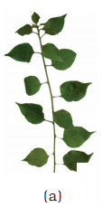 | 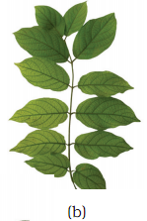 | 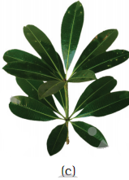
Alternate: One leaf attached to the node, usually staggered (spiral) along stem. | Opposite: two leaves (a pair) attached to the node, usually opposite each other. | Whorled: three or more leaves attached to the node, usually equally spaced around the node

There are two main types of leaves according to the division of lamina: Simple and compound leaves.
Simple leaves
Simple leaves have lamina that is either not divided or not completely divided. Example of plants with simple leaves includes mango, sweet potato, and cassava.
According to the arrangement of veins (venation)
we have the following types of simple leaves:
Venation of leaves
According to the base of the leaf we have:

Compound leaves
Compound leaves are leaves where the lamina is completely divided into leaflets. Example of plant with compound leaves includes cassia, acacia beans and jacaranda.
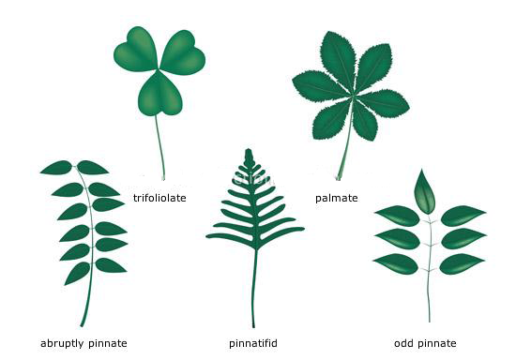
Leaf functions
* photosynthesis; take place in chloroplast located in palisade mesophyll.
* Respiration take place in mitochondria of leaf cells
* regulate water loss by transpiration by opening and closing stomata
* propagation; ex. bryophyllum with plantlets on leaves
Leaves may be modified to perform specific function other than photosynthetic. In this case, they form:
* Tendril that provide support to weak plants (ex vines)
* Thorns (spines) that offer protection against predators and avoid loss of water (ex cactus)
* Swollen or succulent leaves that store food and water
* Brightly colored that help attract pollinator to the flower

C .Flowers
Flowers are the reproductive organ of plants. Flowers are made of two main parts: essential and non – essential parts. The essential parts produce the male and female sex cells. The non – essential part protects the flower and attract animal to pollinate the flower.
In flowering plant, the flower develops on the receptacle. Receptacle is the swollen end of the special flower stalk or pedicel.
Structure of a flower
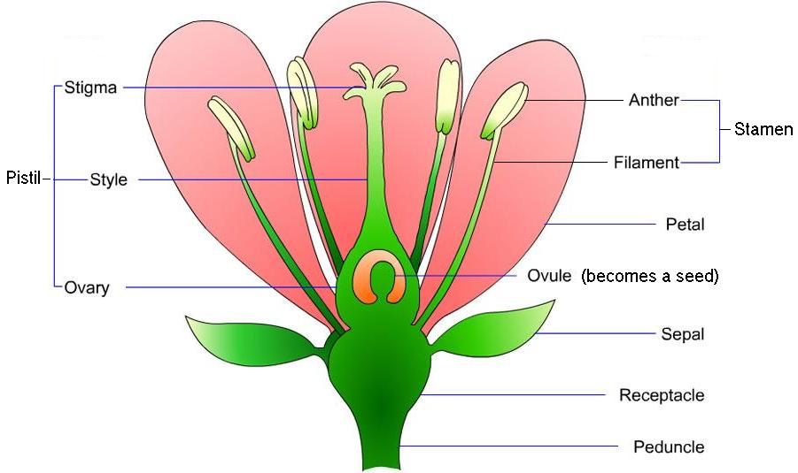
No – essential parts of the flower
No – essential parts of the flower are sepal and petals.
* Sepals: they are small leaves that protect the flower buds as it grows. In some flower the sepals are fused to the petals. In other flower they are free. Collectively sepals form calyx
* Petals: they are brightly colored part to attract pollinators. Sometimes the petals of a flower are joined together (fused). Sometimes they are free and individual. Collectively petals form corolla. Calyx and corolla form the perianth of flower.
Essential parts of the flower They are parts of flower that produce the gametes. These include the male parts called stamen or androecium formed by the anther (that produce pollen) and the filament. The female part called pistil or Gynoecium consists of the stigma, style and the ovary that contain ovules. Depending on the relative position of the pistil with the perianth and the stamen, there are three types of ovary and three types of flowers:
* Hypogynous flower: Flower with perianth and stamen positioned below the pistil. It has superior ovary

* Perigynous flower: Flower with perianth positioned around the pistil. It has inferior ovary.
* Epigynous flower: flower with perianth and stamen positioned above the pistil. It has inferior ovary.
Flowers differ in number and kinds of part they have:
* Complete flowers: have all four characteristics part – calyx, corolla, androecium and gynoecium.
* Incomplete flower: lack one or more of the four characteristics parts
* Perfect flower: (hermaphrodite) have both stamen and pistil.
* Imperfect flower: have either female part, or male part, but not both

These unisexual flowers are called Staminate or corpellate if they respectively miss corpel or stamen. If staminate or corpellate flower are located on the same individual plant, that plants species is called monoecious. In contrast a dioecious plant has staminate flower and corpellate flower on separate plants. A condition where stamen and pistil mature and ripen at different time is called dichogamy. When the stamen matures earlier than the pistil, the flower is protandrous. Whereas when the pistil matures earlier than the stamen, the flow is protogynous.
Other terms used to describe flowers
* Pedicelate flowers are flower with stalk (pedicel). Flowers without pedicel is sessile
* Solitary flowers are the flowers which stand on its own
* Inflorescence is made up of flowers that grow together in group on the same stalk.
Parts of the flowers and their functions
Flower part | Part function
Petal | Petals are used to attract insects into the flower, they may have guidelines on them and be scented.
Leaf | Structure attached to a stem and functioning as a principal organ of photosynthesis and transpiration in most plants.
Roots | Organ of a plant body that typically lies below the surface of the soil and absorbs water and inorganic nutrients along with anchoring the plant body to the ground.
Pistil or carpel | The female reproductive organ of a flower, consisting of an ovary, style, and stigma.
Stigma | Is covered in a sticky substance that the pollen grains will adhere to.
Style | The style raises the stigma away from the Ovary to decrease the likelihood of pollen contamination. It varies in length.
Ovary | This protects the ovule and once fertilisation has taken place it will become the fruit.
Ovule | The Ovule is like the egg in animals and once fertilisation has taken place will become the seed.
Receptacle | This is the flower's attachment to the stalk and in some cases becomes part of the fruit after fertilisation e.g. strawberry.
Flower stalk or stem | Gives support to the flower and elevates the flower for the insects.
Nectary | This is where a sugary solution called nectar is held to attract insects.
Sepal | Sepals protect the flower while the flower is developing from a bud.
Stamen | The filament and the Anthers are collectively known as the Stamen or the male parts of the plant.
Filament | This is the stalk of the Anther.
Anther | The Anthers contain pollen sacs. The sacs release pollen on to the outside of the anthers that brush against insects on entering the flowers. The pollen once deposited on the insect is transferred to the stigma of another flower or the same flower. The ovule is then able to be fertilised.

Inflorescences
In some plants, such as the tulip, each flower grows on its own separate stalk. In many other plants however, flower grow in various kinds of clusters. These clusters are called inflorescences. The stalk of the inflorescence is called the pedoncle and the stalk of an individual flower is the pedicel.
* Corymb: Inflorescence composed of a main axis and laterally borne flowers with pedicels of unequal length, all ending at the same height.
* Umbel: Inflorescence composed of a main axis and laterally borne flowers with pedicels of equal length, all originating from the same point.
* Biparous cyme: Inflorescence whose main axis ends in a flower under which two lateral twigs develop; the process is repeated under each terminal flower.
* Uniparous cyme: Inflorescence whose main axis ends in a flower under which a single lateral twig develops; the process is repeated under each terminal flower.
* Spike: Inflorescence composed of a main axis and laterally borne flowers with no pedicel.
* Raceme: Inflorescence composed of a main axis and laterally borne flowers with pedicels of equal length.
* Spadix: Inflorescence composed of flowers with no pedicel, all embedded in an elongated ovoid receptacle.
* Capitulum: Inflorescence composed of flowers with no pedicel, all embedded in a flat recept
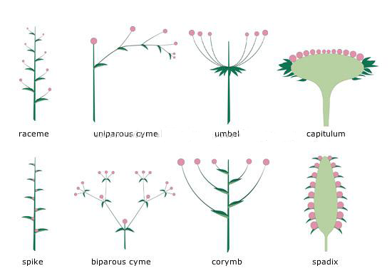
D. Fruits and seed
Botanists define fruits as matured ovary. Fruits protect seeds and aids in their dispersal. A seed is a plant embryo surrounded by a protective coat called seed coat Pollination and fertilization Pollination is a transfer of pollen grain from stamens to the stigma of a flower of the same species. We have two kinds of pollination:
* Self – pollination is a transfer of pollen from anther to the stigma of the same flower.
* Cross – pollination is the transfer of pollen from one flower to the stigma of another flower of the same species on a different plant.

Cross pollination is more advantageous than self pollination because: It leads to genetic variation in the offspring. The offspring gets a mixture of desirable qualities from both parents. Because of this, flowers show specific adaptation that tend to favour cross pollination and that hinder self pollination. These adaptations include:
* Self sterility or incompatibility where pollen grains are sterile to the stigma of same plant.
* Protandry: Here the stamen ripens earlier and the anther releases their pollen grain before the stigma is mature enough.
* Protogyny: The stigma mature earlier and receive pollen grains before the anther are ripe enough to release their pollen grains.

There are also features that hinder cross pollination but encourage self pollination. These adaptations include:
* The stamen situated above the stigma on the anther close to the stigma
* Stamen and carpel mature at the same time
* Bisexual or hermaphrodites flowers may not open or remain underground
* Pollen grain released by the ripe anther into the stigma before the flower opens
* The pollen grains germinate on the stigma after absorbing nutrients from the stigma
Agents of pollination
These help the transfer of pollen grain from the anther to the stigma. Polllinators are biotic or abiotic. The abiotic agents are: wind and water
* Wind pollination is called anemophily
* Water pollination is called hydrophily

The main biotic pollinators’ agents are:
* Insect pollination is called Entomophily
* Animals pollination is called zoophily
* Human pollination is called Anthropophily.
* Birds pollination is called Ornithophily
* Bats pollination is called Cheiropterophily

Adaptation of flower to pollination
A. For insect pollinated flowers (Entomophilous) The flower is large, have brightly colored petals, bracts or inflorescence .They produce nectars. Pollens are relatively large, heavy and rough or sticky so as to stick onto the body of the insect.
B. For wind pollinated flower (Anemophilous) Flowers are small, lack nectar, other are large. Pollen usually small, smooth and light to enable them float in the air currents for dispersal Pollen are produced in large number to increase the chances of effectives pollination.
Fruits formation
Pollination leads to fertilization which results in the formation of fruit and seeds. Fertilization is the fusion of female with the male gametes. After fertilization the following change occurs.
Sepals/petals/stigmas dry out and fall of.
Structure of a fruit
Botanists define fruits as matured ovary. Fruits protect seeds, and aid in their dispersal.The wall of the fruit, developed from the ovary wall of the flower, is called the pericarp. The pericarp is often differentiated into two or three distinct layers called the exocarp (outer layer - also called epicarp), mesocarp (middle layer), and endocarp (inner layer)
Roles of seeds in the life cycle of plants
* The seeds protect the embryo
* The seeds nourishes the embryo
* The see help in propagation of species
Types of fruits
Fruits are divided into three main groups:
* Simple fruits: are fruits formed from a flower with either one carpel on several carpels fused together.
* Aggregate fruits: are fruits formed from one flower with several free carpel ( a collection of simple fruits) e.g.: rose
* Multiple fruits are fruits formed from an inflorescence, not from one flower eg: pineapple
Simple fruit are subdivided into two subs – groups: Succulent fruit and dry fruits.
Succulent fruit are fruits that are soft, fleshy and juicy, and can be eaten. This group is further subdivided, according to the part becomes fleshy into drupe fruits and berry fruits.
*A drupe is a fruit with a partly fleshy ovary wall or pericarp, but a hard layer forming a “stone” containing the seed in the center. E.g. Mango, coconut and avocado.
* A Berry fruits are fruit where the whole pericarp is fleshy and juicy. Example of berry fruits includes tomato, guava orange and banana.

Dry fruits are fruits that are not fleshy, but instead are hard and dry when mature. Dry fruits are divided into dry explosive (dehiscent), and dry non explosive (indehiscent) fruits.
* A dry dehiscent fruit is one where the seed case splits open or dehisces to release the seeds. Ex: pea, beans.
* A dry indehiscent fruits does not split when dry.

Fruit and seed dispersal
Dispersal is the scattering of fruits and seed away from the parent plant. Different agent helps with the dispersal. These include animals, wind, explosive mechanisms (self – dispersal) and water. In addition o of seed leaf, the four main parts allow biologist to distinguish Monocotyledons from dicotyledons:
MONOCOTS AND DICOTS
Monocots and dicots get their names because of the number of cotyledons present in their seeds. Cotyledons are leaves in the seed that provide food for the seed embryo before it is able to develop its own leaves and make its own food (after germination).
Monocots have one seed leaf or cotyledon while dicots have 2 seed leaves or cotyledons.
Bean seed is a dicot and a corn seed is a monocot.

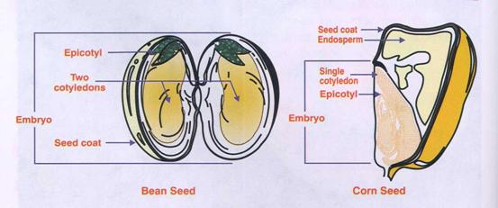
There are quite a few differences between a monocot and a dicot plant. This chart displays their differences:
