CIT 341 – Enterprise Networking
Final Network Documentation
Cape Town Branch – Group 3 (Cape Town 2)

Devices: R2 | MLS2 | MLS4 | ALS2

Spring Semester 2025
Submitted: March 28, 2026

Project Parts 1 – 10

Part 1 – Initial Equipment Setup
I began the semester by documenting the physical topology of the Cape Town 2 branch and applying baseline security to all four devices under my responsibility. My partner covers Cape Town 1 (R1, Switch 1, Switch 3, ALS1) while I manage Cape Town 2 (R2, MLS2, MLS4, ALS2).

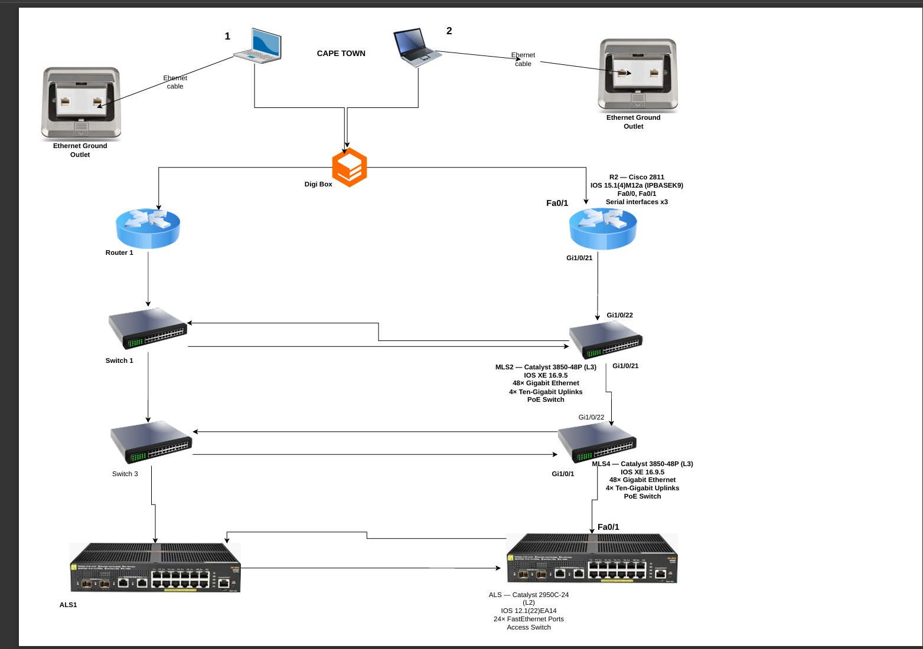
Figure 1 – Cape Town Branch Network Topology

Figure 1 — Cape Town Branch Physical Topology showing all device connections and port labels
1.1 Device Inventory
Hostname | Model | IOS Version | Key Interfaces | Role
R2 | Cisco 2811 | 15.1(4)M12a IPBASEK9 | Fa0/0, Fa0/1, Serial x3 | Branch Router 2
MLS2 | Catalyst 3850-48P (L3) | IOS XE 16.9.5 | 48× GE, Po1, Po2, Po3 | Multi-Layer Switch 2
MLS4 | Catalyst 3850-48P (L3) | IOS XE 16.9.5 | 48× GE, Po2, Po3 | Multi-Layer Switch 4
ALS2 | Catalyst 2950C-24 (L2) | 12.1(22)EA14 | 24× FastEthernet | Access Layer Switch 2

1.2 Physical Cabling and Port Map
I verified all connections in the wiring closet. No cables were moved from their original positions. The table below documents every port used on each device.
From | Port | To | Port | Notes
R2 | Fa0/0 | HQ | — | WAN – subinterfaces VLAN 2003 & 2030
R2 | Fa0/1 | MLS2 | Gi1/0/47 | Internal trunk – all VLANs, native 800
MLS2 | Gi1/0/1 | Partner MLS | — | EtherChannel Po1 – LACP (Cape Town 1)
MLS2 | Gi1/0/2 | Partner MLS | — | EtherChannel Po1 – LACP (Cape Town 1)
MLS2 | Gi1/0/21 | MLS4 | Gi1/0/21 | EtherChannel Po2 – LACP link 1
MLS2 | Gi1/0/22 | MLS4 | Gi1/0/22 | EtherChannel Po2 – LACP link 2
MLS2 | Gi1/0/23 | Partner MLS | — | EtherChannel Po3 – LACP (Cape Town 1)
MLS2 | Gi1/0/24 | Partner MLS | — | EtherChannel Po3 – LACP (Cape Town 1)
MLS4 | Gi1/0/1 | ALS2 | Fa0/1 | Trunk link to access layer

1.3 Baseline Security Configuration
I applied the following security baseline consistently across all four devices:
Configuration Item | Value
Enable Secret | cit341
Console Line Password | cit341
VTY Authentication | login local (username admin)
SSH Version | 2
Domain Name | branch.local
VTY Transport | SSH only (transport input ssh)
VTY ACL | ACL 10 – Management VLAN only

1.4 IOS Versions Confirmed (show version)
The following output confirms the IOS version running on each device:
R2: Cisco IOS Version 15.1(4)M12a – flash:c2800nm-ipbasek9-mz.151-4.M12a.bin
MLS2: Cisco IOS XE Version 16.09.05 – Catalyst L3 Switch Software
MLS4: Cisco IOS XE Version 16.09.05 – Catalyst L3 Switch Software
ALS2: Cisco IOS Version 12.1(22)EA14 – flash:/c2950-i6k2l2q4-mz.121-22.EA14.bin

Part 2 – External Trusted and Untrusted Connection to HQ
I connected R2 to the Head Office using subinterfaces on Fa0/0. VLAN 2003 carries the internal trusted connection and VLAN 2030 carries the internet-facing untrusted connection. I configured a VRRP group for each VLAN and adjusted priorities so that R2 acts as the active gateway for most internal VLANs.

2.1 HQ-Facing Interfaces on R2
Interface | Subnet | IP on R2 | VLAN | OSPF Area
Fa0/0 (physical) | 192.168.250.0/27 | 192.168.250.27 | — | —
Fa0/0.2003 | 192.168.250.0/27 | encapsulation only | 2003 | Area 3
Fa0/0.2030 | 192.168.249.0/27 | 192.168.249.27 | 2030 | Area 30

2.2 VRRP Configuration Summary (verified – show vrrp brief)
The following table summarizes the VRRP state for each group as confirmed on R2:
Interface | VRRP Grp | R2 Priority | R2 State | VIP | Notes
Fa0/0.2030 | 30 | 100 | Backup | 192.168.249.30 | R1 holds Master for this group
Fa0/1.100 | 100 | 90 | Master | 192.168.3.1 | R2 confirmed Master
Fa0/1.120 | 120 | 110 | Master | 192.168.23.1 | R2 confirmed Master
Fa0/1.140 | 140 | 90 | Master | 192.168.43.1 | R2 confirmed Master
Fa0/1.160 | 160 | 110 | Master | 192.168.63.1 | R2 confirmed Master
Fa0/1.180 | 180 | 90 | Master | 192.168.83.1 | R2 confirmed Master
Fa0/1.200 | 200 | 110 | Master | 192.168.103.1 | R2 confirmed Master

2.2.1 Figure 10 – VRRP Status Screenshot (R2)
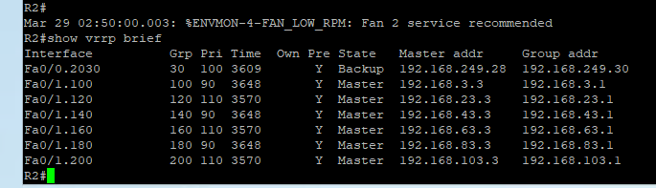 Figure 10 — R2 show vrrp brief confirming Master/Backup states per VLAN
2.3 OSPF Neighbor Table (verified – show ip ospf neighbor)
The following output confirms OSPF adjacencies established between R2 and the HQ routers:
R2#show ip ospf neighbor
Neighbor ID Pri State Dead Time Address Interface
192.168.249.2 1 2WAY/DROTHER 00:00:33 192.168.249.2 Fa0/0.2030
192.168.249.3 1 FULL/BDR 00:00:36 192.168.249.3 Fa0/0.2030
192.168.250.28 1 FULL/DR 00:00:31 192.168.249.28 Fa0/0.2030

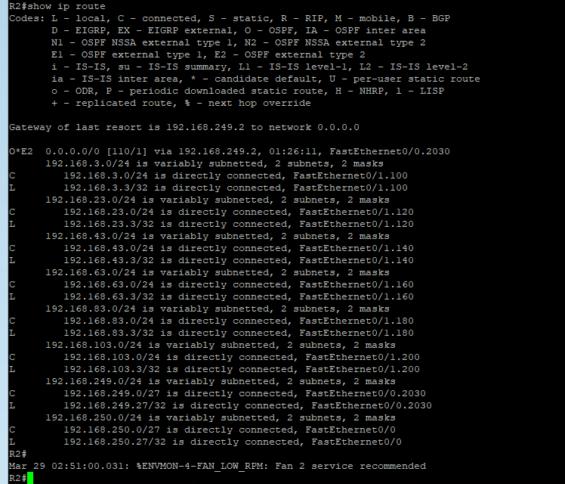
2.3.1 Figure 11 – IP Route Table Screenshot (R2)
Figure 11 — R2 show ip route confirming OSPF learned routes from HQ
2.4 R2 HQ Subinterface Configuration (from running-config)
The following configuration was applied to R2 to establish the HQ connections:
interface FastEthernet0/0
ip address 192.168.250.27 255.255.255.224
ip access-group BLOCK-OUTSIDE-PING in
duplex half
!
interface FastEthernet0/0.2003
encapsulation dot1Q 2003
!
interface FastEthernet0/0.2030
encapsulation dot1Q 2030
ip address 192.168.249.27 255.255.255.224
vrrp 30 ip 192.168.249.30

Part 3 – EtherChannel Trunks
I configured LACP EtherChannel groups between all multi-layer switches using the two links provided for each group. Speed and duplex were set manually on applicable interfaces. All trunk links use native VLAN 800 with VLAN 900 (PARKING) excluded. DTP auto-negotiation was disabled by manually setting trunk mode on all links.

3.1 EtherChannel and Trunk Summary
Port-Channel | From | To | Ports | Protocol / Status
Po1 | MLS2 | Cape Town 1 Partner | Gi1/0/1 + Gi1/0/2 | LACP – Active
Po2 | MLS2 ↔ MLS4 | Both switches | Gi1/0/21 + Gi1/0/22 | LACP – Active, In-Use
Po3 | MLS2 / MLS4 | Cape Town 1 Partner | Gi1/0/23 + Gi1/0/24 | LACP – Active
Trunk | MLS4 | ALS2 | Gi1/0/1 → Fa0/1 | 802.1Q Trunk, native 800

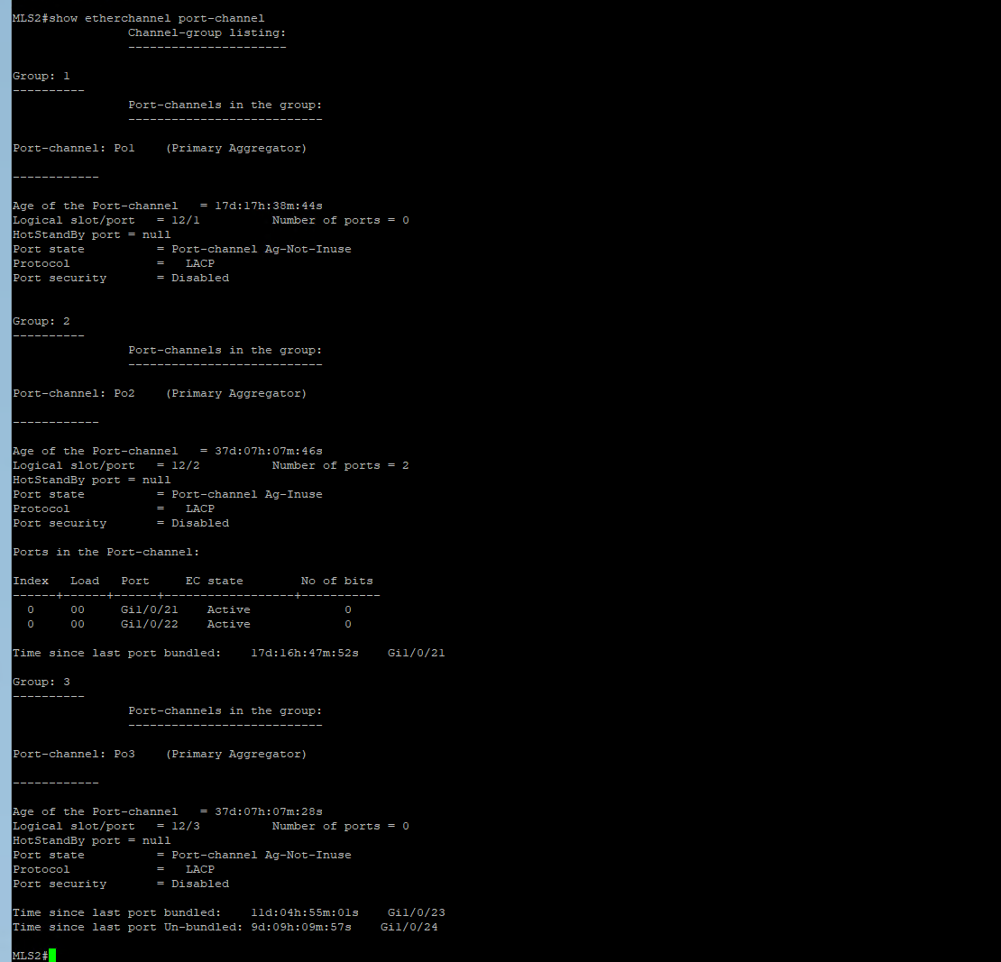
3.2 MLS2 EtherChannel Verification (Figure 2)
The following screenshot confirms the EtherChannel port-channel status on MLS2, showing Po2 active with two member ports (Gi1/0/21 and Gi1/0/22):

Figure 2 — MLS2 show etherchannel port-channel output confirming Po2 Ag-Inuse with Gi1/0/21 and Gi1/0/22 active
3.3 MLS4 EtherChannel Verification (Figure 3)
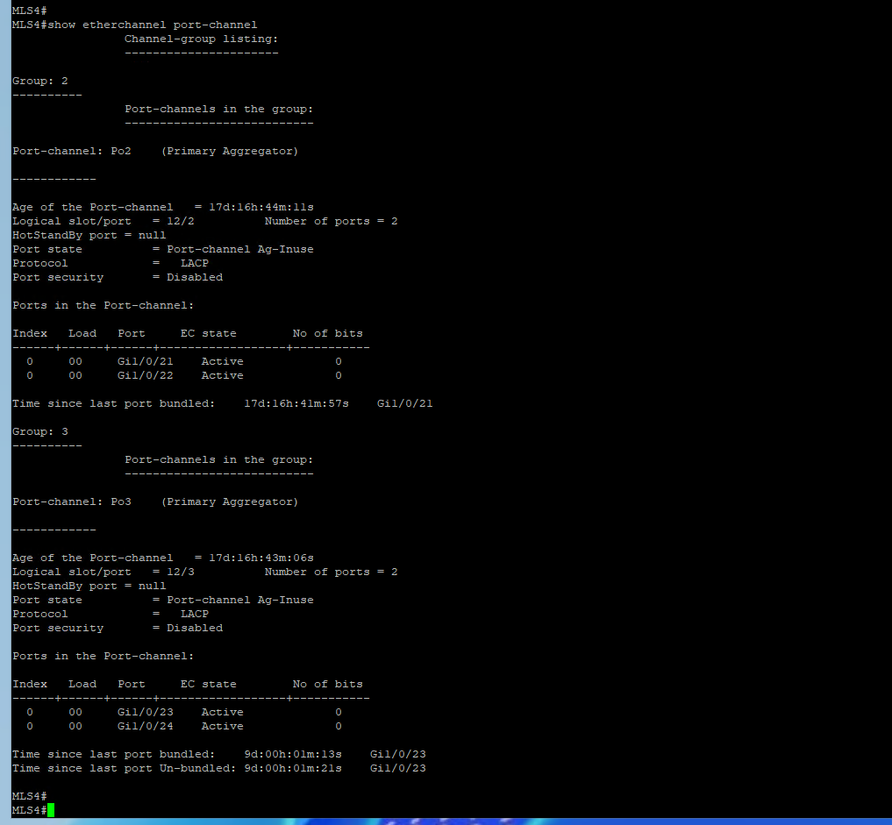
The following screenshot confirms the EtherChannel status on MLS4, showing both Po2 (to MLS2) and Po3 (to partner) active:

Figure 3 — MLS4 show etherchannel port-channel output confirming Po2 and Po3 both Ag-Inuse
3.4 ALS2 Trunk and CDP Verification (Figure 4)
The following screenshot confirms the ALS2 trunk interface configuration and CDP neighbor showing MLS4 connected on Gi1/0/1:
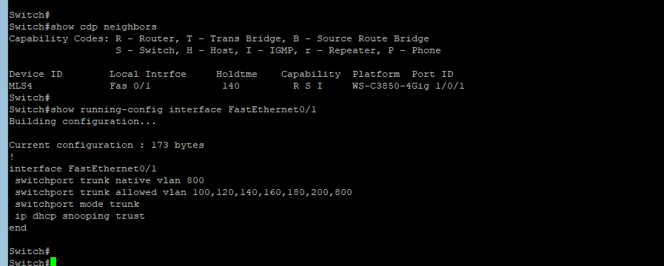
Figure 4 — ALS2 CDP neighbors and FastEthernet0/1 trunk configuration
3.5 MLS2 EtherChannel Interface Configuration (from running-config)
The following configuration was applied on MLS2 to build the three EtherChannel groups:
interface GigabitEthernet1/0/1
switchport trunk native vlan 800
switchport trunk allowed vlan 100,120,140,160,180,200,800
switchport mode trunk
channel-group 1 mode active
!
interface GigabitEthernet1/0/21
switchport trunk native vlan 800
switchport trunk allowed vlan 100,120,140,160,180,200,800
switchport mode trunk
channel-group 2 mode active
!
interface GigabitEthernet1/0/22
switchport trunk native vlan 800
switchport trunk allowed vlan 100,120,140,160,180,200,800
switchport mode trunk
channel-group 2 mode active
!
interface GigabitEthernet1/0/23
switchport trunk native vlan 800
switchport trunk allowed vlan 100,120,140,160,180,200,800
switchport mode trunk
speed 1000
duplex full
channel-group 3 mode active
!
interface Port-channel2
switchport trunk native vlan 800
switchport trunk allowed vlan 100,120,140,160,180,200,800
switchport mode trunk

Part 4 – Setting Up VLANs with VTP
I used VTP to maintain VLAN consistency across all switches in the branch. The VTP domain name I configured is CAPET-A. I created all required VLANs and set the trunk links to allow VLANs 100 through 800 while excluding PARKING (900).

4.1 VLAN Table (verified – show vlan brief)
VLAN # | Name | Assigned Ports (ALS2) | Trunk Allowed
100 | IT | Fa0/2 | Yes
120 | VOIP | Fa0/3 | Yes
140 | INTERNET | Fa0/4 | Yes
160 | ACCOUNTS | Fa0/5 | Yes
180 | OPERATIONS | Fa0/6 | Yes
200 | MANAGEMENT | Fa0/7 | Yes
800 | NATIVE | — | Yes (native on all trunks)
900 | PARKING | Fa0/8–23, Fa0/25, Fa0/26 (shutdown) | No – excluded from all trunks

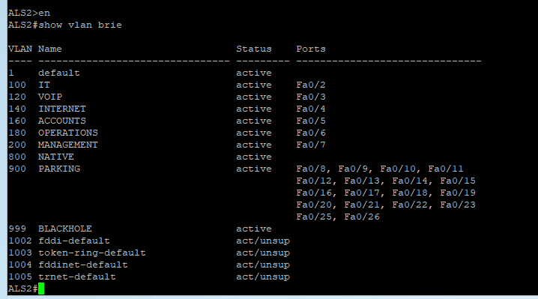
4.1.1 Figure 12 – VLAN Brief Screenshot (ALS2)
Figure 12 — ALS2 show vlan brief confirming all VLANs and port assignments
4.2 VTP Status (verified – show vtp status)
The following output confirms the VTP domain and operating mode on each switch:
MLS2#show vtp status
VTP Version running : 2
VTP Domain Name : CAPET-A
VTP Operating Mode : Transparent
Number of VLANs : 14

MLS4#show vtp status
VTP Version running : 2
VTP Domain Name : CAPET-A
VTP Operating Mode : Transparent
Number of VLANs : 13

ALS2#show vtp status
VTP Version : 2
VTP Domain Name : CAPET-A
VTP Operating Mode : Client
Configuration Revision: 16
Number of VLANs : 14

4.3 MLS2 VLAN Configuration (from running-config)
The following VLAN definitions were configured on MLS2 and propagated across the branch:
vlan 100
name IT
vlan 120
name VOIP
vlan 140
name INTERNET
vlan 160
name ACCOUNTS
vlan 180
name OPERATIONS
vlan 200
name MANAGEMENT
vlan 800
name NATIVE
vlan 900
name PARKING

Part 5 – Internal VRRP and Management Interfaces
I created subinterfaces on R2's Fa0/1 for each internal VLAN. VRRP was configured on each subinterface using the first usable IP as the virtual address. I used the second and third usable addresses for R2 and R1 respectively, and adjusted priorities to control which router is active per VLAN. Management interfaces were configured on all switches using VLAN 200.

5.1 Internal VLAN Subinterfaces and VRRP
VLAN | Subnet | VRRP VIP | R2 IP | R2 State
100 – IT | 192.168.3.0/24 | 192.168.3.1 | 192.168.3.3 | Master (pri 90)
120 – VOIP | 192.168.23.0/24 | 192.168.23.1 | 192.168.23.3 | Master (pri 110)
140 – INTERNET | 192.168.43.0/24 | 192.168.43.1 | 192.168.43.3 | Master (pri 90)
160 – ACCOUNTS | 192.168.63.0/24 | 192.168.63.1 | 192.168.63.3 | Master (pri 110)
180 – OPERATIONS | 192.168.83.0/24 | 192.168.83.1 | 192.168.83.3 | Master (pri 90)
200 – MANAGEMENT | 192.168.103.0/24 | 192.168.103.1 | 192.168.103.3 | Master (pri 110)
800 – NATIVE | No subnet | — | — | —

5.2 Management IP Assignments (verified from all running-configs)
Device | Management IP (VLAN 200) | Interface
R2 | 192.168.103.3 | Fa0/1.200
MLS2 | 192.168.103.251 | Vlan200
MLS4 | 192.168.103.254 | Vlan200
ALS2 | 192.168.103.252 | Vlan200

5.3 R2 Internal Subinterface Configuration (from running-config)
The following subinterfaces were configured on R2 Fa0/1 to provide inter-VLAN routing and VRRP for each internal network:
interface FastEthernet0/1.100
encapsulation dot1Q 100
ip address 192.168.3.3 255.255.255.0
vrrp 100 ip 192.168.3.1
vrrp 100 priority 90
!
interface FastEthernet0/1.120
encapsulation dot1Q 120
ip address 192.168.23.3 255.255.255.0
vrrp 120 ip 192.168.23.1
vrrp 120 priority 110
!
interface FastEthernet0/1.140
encapsulation dot1Q 140
ip address 192.168.43.3 255.255.255.0
vrrp 140 ip 192.168.43.1
vrrp 140 priority 90
!
interface FastEthernet0/1.160
encapsulation dot1Q 160
ip address 192.168.63.3 255.255.255.0
vrrp 160 ip 192.168.63.1
vrrp 160 priority 110
!
interface FastEthernet0/1.180
encapsulation dot1Q 180
ip address 192.168.83.3 255.255.255.0
vrrp 180 ip 192.168.83.1
vrrp 180 priority 90
!
interface FastEthernet0/1.200
encapsulation dot1Q 200
ip address 192.168.103.3 255.255.255.0
vrrp 200 ip 192.168.103.1
vrrp 200 priority 110
!
interface FastEthernet0/1.800
encapsulation dot1Q 800 native

Part 6 – Spanning Tree and DHCP Configuration
I configured Rapid PVST on all switches for faster convergence and loop prevention. I designated MLS2 as the root bridge and tuned spanning-tree priorities for selected VLANs. For DHCP, I coordinated with my partner to split pool responsibilities — R2 serves VLANs 140, 160, 180, and 200 while R1 handles VLANs 100 and 120.

6.1 Spanning Tree – RPVST Load Balancing
VLAN | Root Bridge | MLS2 Priority | MLS4 Priority
100 – IT | MLS2 | default | default
120 – VOIP | MLS2 | default | default
140 – INTERNET | MLS2 | 24576 + 140 = 24716 | default
160 – ACCOUNTS | MLS2 | 20480 + 160 = 20640 | default
180 – OPERATIONS | MLS2 | 20480 + 180 = 20660 | default
200 – MANAGEMENT | MLS2 | 20480 + 200 = 20680 | default
800 – NATIVE | MLS2 | default | default

6.2 MLS2 Spanning-Tree Verification (Figure 5)
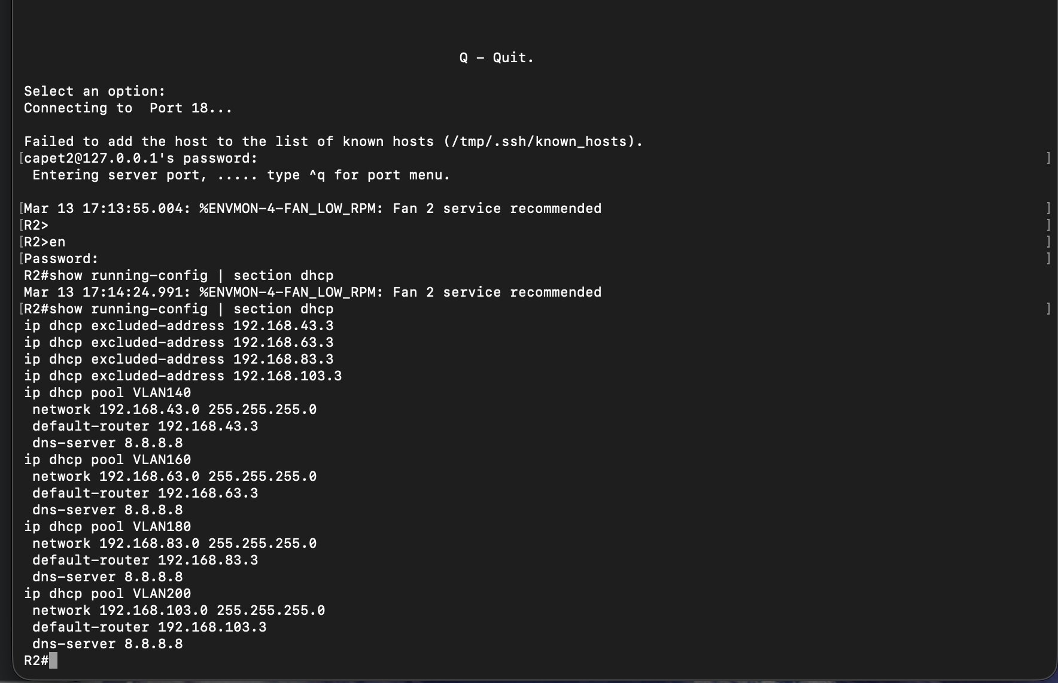
The following screenshot confirms MLS2 is running Rapid PVST and is the root bridge for the configured VLANs:

Figure 5 — MLS2 show spanning-tree summary confirming rapid-pvst mode and root bridge status
6.3 MLS2 Spanning-Tree Commands (from running-config)
The following priority values were configured on MLS2 to establish it as root for the required VLANs:
spanning-tree mode rapid-pvst
spanning-tree extend system-id
spanning-tree vlan 140 priority 24576
spanning-tree vlan 160,180,200 priority 20480

6.4 DHCP Pool Configuration (Figure 6)
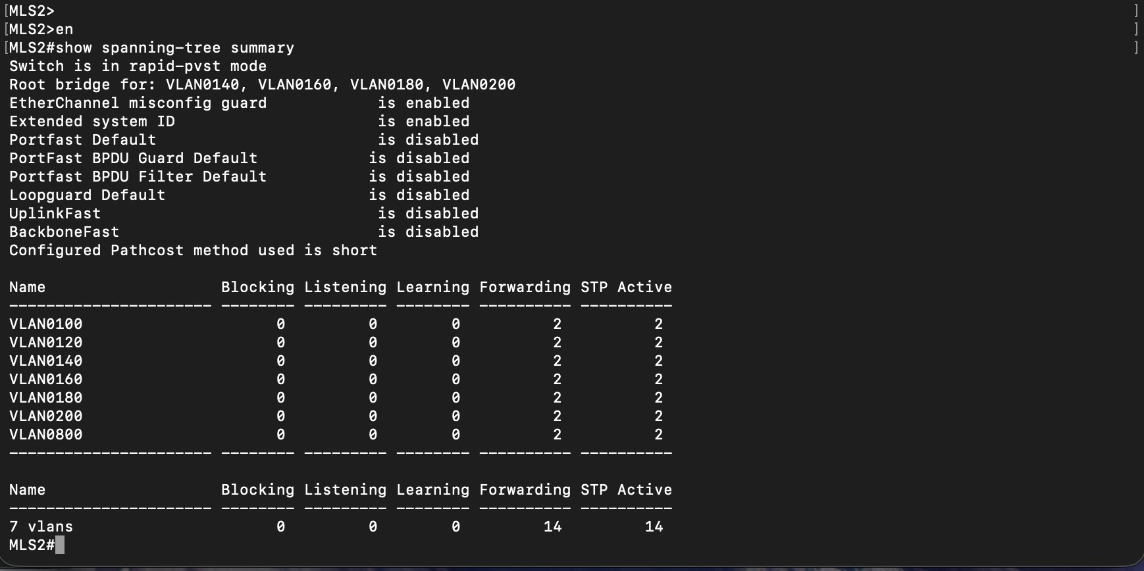
The following screenshot confirms the DHCP pool configuration on R2 as captured from the running configuration:

Figure 6 — R2 DHCP pool configuration showing excluded addresses and pool definitions for VLANs 140–200
6.5 R2 DHCP Configuration (from running-config)
The following DHCP pools were configured on R2 to serve the internal VLANs assigned to this router:
ip dhcp excluded-address 192.168.43.3
ip dhcp excluded-address 192.168.63.3
ip dhcp excluded-address 192.168.83.3
ip dhcp excluded-address 192.168.103.3
!
ip dhcp pool VLAN140
network 192.168.43.0 255.255.255.0
default-router 192.168.43.3
dns-server 8.8.8.8
!
ip dhcp pool VLAN160
network 192.168.63.0 255.255.255.0
default-router 192.168.63.3
dns-server 8.8.8.8
!
ip dhcp pool VLAN180
network 192.168.83.0 255.255.255.0
default-router 192.168.83.3
dns-server 8.8.8.8
!
ip dhcp pool VLAN200
network 192.168.103.0 255.255.255.0
default-router 192.168.103.3
dns-server 8.8.8.8

Part 7 – Internal OSPF, NTP and LLDP
I completed the internal OSPF configuration by adding network statements for all internal VLANs under process 1. I used Area 30 for all internal networks and the HQ internet link, and Area 3 for the HQ internal link. NTP was configured on all devices pointing to the HQ server at 172.16.99.1. I also disabled CDP on all devices in my branch.

7.1 OSPF Network Statements (from running-config)
The following network statements were added to OSPF process 1 on R2 to advertise all internal subnets:
Network | Wildcard Mask | Area | Description
172.16.99.0 | 0.0.0.255 | 0 | HQ backbone – NTP reachability
192.168.3.0 | 0.0.0.255 | 30 | VLAN 100 – IT
192.168.23.0 | 0.0.0.255 | 30 | VLAN 120 – VOIP
192.168.43.0 | 0.0.0.255 | 30 | VLAN 140 – INTERNET
192.168.63.0 | 0.0.0.255 | 30 | VLAN 160 – ACCOUNTS
192.168.83.0 | 0.0.0.255 | 30 | VLAN 180 – OPERATIONS
192.168.103.0 | 0.0.0.255 | 30 | VLAN 200 – MANAGEMENT
192.168.249.0 | 0.0.0.31 | 30 | HQ Internet Link – VLAN 2030
192.168.250.0 | 0.0.0.31 | 3 | HQ Internal Link – VLAN 2003

router ospf 1
network 172.16.99.0 0.0.0.255 area 0
network 192.168.3.0 0.0.0.255 area 30
network 192.168.23.0 0.0.0.255 area 30
network 192.168.43.0 0.0.0.255 area 30
network 192.168.63.0 0.0.0.255 area 30
network 192.168.83.0 0.0.0.255 area 30
network 192.168.103.0 0.0.0.255 area 30
network 192.168.249.0 0.0.0.31 area 30
network 192.168.250.0 0.0.0.31 area 3

7.2 NTP Configuration
R2 was configured to synchronize with the HQ NTP server and to serve as a local NTP master for the switches:
! On R2:
ntp server 172.16.99.1 version 3
ntp master
ntp update-calendar
!
! On MLS2 and MLS4:
ntp server 192.168.103.3

7.3 R2 NTP Synchronization (Figure 7)
The following screenshot confirms R2 is synchronized to the HQ NTP server at stratum 2:
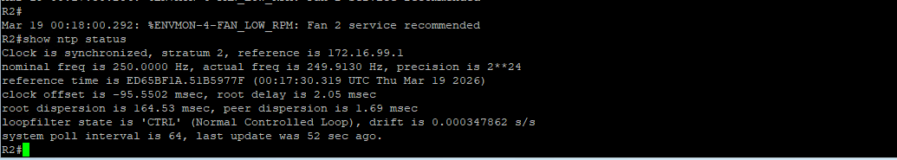
Figure 7 — R2 show ntp status confirming synchronized, stratum 2, reference 172.16.99.1
7.4 MLS2 NTP Synchronization (Figure 8)
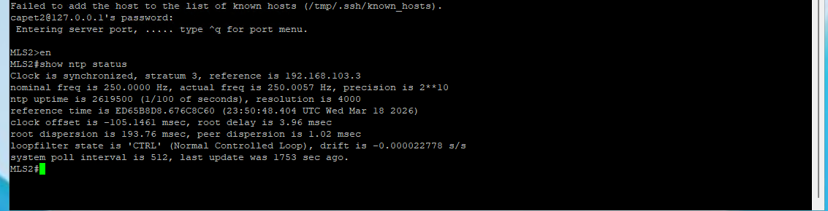
The following screenshot confirms MLS2 is synchronized at stratum 3, referencing R2 as its NTP source:

Figure 8 — MLS2 show ntp status confirming synchronized, stratum 3, reference 192.168.103.3
7.5 MLS4 NTP Synchronization (Figure 9)
The following screenshot confirms MLS4 is also synchronized at stratum 3:
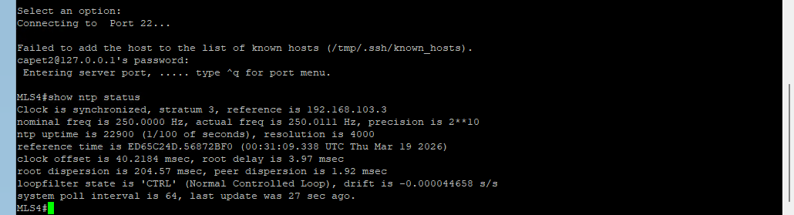
Figure 9 — MLS4 show ntp status confirming synchronized, stratum 3, reference 192.168.103.3
7.6 CDP Disabled (from running-config)
CDP was disabled globally on R2 to prevent topology exposure:
no cdp run

Part 9 – ACLs, Port Security, DHCP Snooping and SSH
I applied multiple layers of security across all devices in my branch including VTY access restrictions, ICMP filtering, DHCP snooping, port hardening, sticky MAC port security, and SSH-only access.

9.1 Standard ACL – VTY Access Restriction
I created ACL 10 to ensure that only hosts in the MANAGEMENT VLAN (192.168.103.0/24) can access VTY lines on any device. The following configuration was applied to all four devices:
access-list 10 permit 192.168.103.0 0.0.0.255
!
line vty 0 4
access-class 10 in
login local
transport input ssh
line vty 5 15
access-class 10 in
login local
transport input ssh

9.2 Extended ACL – Block External ICMP (from R2 running-config)
The following extended ACL was applied inbound on R2 Fa0/0 to block ping requests from outside the network while allowing echo replies so that internally-initiated pings still receive responses:
ip access-list extended BLOCK-OUTSIDE-PING
deny icmp any 192.168.3.0 0.0.0.255 echo
deny icmp any 192.168.23.0 0.0.0.255 echo
deny icmp any 192.168.43.0 0.0.0.255 echo
deny icmp any 192.168.63.0 0.0.0.255 echo
deny icmp any 192.168.83.0 0.0.0.255 echo
deny icmp any 192.168.103.0 0.0.0.255 echo
permit icmp any 192.168.3.0 0.0.0.255 echo-reply
permit icmp any 192.168.23.0 0.0.0.255 echo-reply
permit icmp any 192.168.43.0 0.0.0.255 echo-reply
permit icmp any 192.168.63.0 0.0.0.255 echo-reply
permit icmp any 192.168.83.0 0.0.0.255 echo-reply
permit icmp any 192.168.103.0 0.0.0.255 echo-reply
permit ip any any
!
interface FastEthernet0/0
ip access-group BLOCK-OUTSIDE-PING in

9.3 DHCP Snooping (from ALS2 running-config)
DHCP snooping was enabled on ALS2 with the trunk-facing ports set as trusted to allow DHCP offers from R2 to pass through correctly:
ip dhcp snooping
!
interface FastEthernet0/1
ip dhcp snooping trust
interface FastEthernet0/24
ip dhcp snooping trust

9.4 Unused Port Hardening (from ALS2 running-config)
All unused ports on ALS2 were placed in VLAN 900 (PARKING) in access mode and administratively shut down:
interface range FastEthernet0/8 - 23
switchport access vlan 900
switchport mode access
shutdown
interface FastEthernet0/25
switchport access vlan 900
switchport mode access
shutdown

9.5 Port Security (verified – show port-security on ALS2)
Sticky MAC address port security was configured on all active access ports on ALS2. Each port allows a maximum of two MAC addresses and shuts down on violation. PortFast and BPDUGuard are also enabled:
ALS2#show port-security
Secure Port MaxSecureAddr CurrentAddr SecurityViolation Action
Fa0/2 2 0 0 Shutdown
Fa0/3 2 0 0 Shutdown
Fa0/4 2 0 0 Shutdown
Fa0/5 2 0 0 Shutdown
Fa0/6 2 0 0 Shutdown
Fa0/7 2 0 0 Shutdown

9.5.1 Figure 13 – Port Security Screenshot (ALS2)
[ INSERT SCREENSHOT HERE — Run: ALS2#show port-security — paste screenshot below this line ]
Figure 13 — ALS2 show port-security confirming sticky MAC, max 2, shutdown violation on all access ports

interface FastEthernet0/2
switchport access vlan 100
switchport mode access
switchport port-security
switchport port-security maximum 2
switchport port-security mac-address sticky
spanning-tree portfast
spanning-tree bpduguard enable
! (same pattern applied on Fa0/3 through Fa0/7 for VLANs 120–200)

9.6 SSH Configuration (verified on all devices)
All devices in my branch were configured to accept only SSH connections on VTY lines. Telnet is not permitted on any device:
ip domain-name branch.local
username admin secret cit341
crypto key generate rsa modulus 1024
ip ssh version 2
ip ssh time-out 120
ip ssh authentication-retries 3
line vty 0 4
login local
transport input ssh

Testing and Verification
After completing each configuration step I verified functionality using the appropriate show commands and connectivity tests. The table below summarizes all testing performed on the Cape Town 2 branch:

Test | Result | Verification Method
Inter-VLAN routing between all VLANs | Successful | Ping between hosts on different VLANs through R2
VRRP failover on internal VLANs | Successful | show vrrp brief confirmed Master/Backup states
DHCP address assignment – VLANs 140–200 | Successful | Hosts received addresses from R2 DHCP pools
OSPF adjacency with HQ routers | Successful | show ip ospf neighbor confirmed FULL/BDR state
NTP synchronization – R2 stratum 2 | Successful | show ntp status confirmed synchronized
NTP synchronization – MLS2/MLS4 stratum 3 | Successful | show ntp status confirmed synchronized
EtherChannel Po2 (MLS2 ↔ MLS4) | Successful | show etherchannel port-channel confirmed Ag-Inuse
Management VLAN reachability | Successful | Ping to all management IPs from VLAN 200
SSH-only access on all devices | Successful | Telnet rejected, SSH accepted on all VTY lines
ACL – external ICMP blocked | Successful | External ping to internal IPs denied by ACL
Port security on ALS2 access ports | Successful | show port-security confirmed max 2 MACs, shutdown violation
Unused ports in PARKING VLAN | Successful | show vlan brief confirmed Fa0/8–26 in VLAN 900, shutdown

Part 10 – End of Semester Activities
At the end of the semester I performed the full cleanup procedure on all four devices in my branch. I followed the steps in the correct order to ensure vlan.dat was removed from all switches before erasing startup configurations. The IOS image files were preserved on all devices.

10.1 Completed Cleanup Steps
 | End-of-Semester Cleanup – Completed Steps
✔ | Changed VTP domain to NULL on MLS2 and MLS4 first to isolate VLAN database
✔ | Deleted vlan.dat from MLS2, MLS4, and ALS2 (delete flash:vlan.dat)
✔ | Erased startup-config on all four devices (write erase)
✔ | Reloaded all four devices – configuration not saved on reload
✔ | Verified IOS image (.bin file) still present after reload using dir flash:

10.2 Cleanup Commands Executed
Step 1 – Change VTP Domain to NULL (MLS2 and MLS4)
configure terminal
vtp domain NULL
end

Step 2 – Delete VLAN.dat (MLS2, MLS4, ALS2)
delete flash:vlan.dat
! Confirmed at both prompts
dir flash: ! Verified vlan.dat no longer listed

Step 3 – Erase Startup Configuration (all four devices)
write erase

Step 4 – Reload (all four devices)
reload
! Selected NO when prompted to save configuration

10.3 Final Documentation Summary
This document represents the complete network documentation I maintained throughout the semester for the Cape Town 2 branch. All configurations are verified from actual device output. Below is a summary of what was accomplished:

- Part 1 – Physical topology documented, device inventory completed, IOS versions verified, baseline security applied
- Part 2 – HQ subinterfaces configured on R2 Fa0/0, VRRP operational on all VLANs, OSPF neighbors confirmed
- Part 3 – LACP EtherChannel configured on all port-channels, trunk links verified with screenshots
- Part 4 – Eight VLANs created and synchronized across all switches using VTP domain CAPET-A
- Part 5 – Internal VRRP subinterfaces configured on R2 Fa0/1, management IPs assigned to all devices
- Part 6 – Rapid PVST configured with MLS2 as root bridge, DHCP pools for VLANs 140–200 on R2
- Part 7 – Full OSPF configuration completed, NTP synchronized on all devices confirmed, CDP disabled
- Part 9 – Standard and extended ACLs applied, DHCP snooping enabled, port security active, SSH-only access
- Part 10 – End of semester cleanup completed, vlan.dat removed, startup configs erased, devices reloaded

Appendix A – IP Address Master Table
A.1 VLAN Subnets, VRRP and Router IPs
VLAN | Subnet | VRRP VIP | R2 IP | Default Gateway
100 – IT | 192.168.3.0/24 | 192.168.3.1 | 192.168.3.3 | 192.168.3.1
120 – VOIP | 192.168.23.0/24 | 192.168.23.1 | 192.168.23.3 | 192.168.23.1
140 – INTERNET | 192.168.43.0/24 | 192.168.43.1 | 192.168.43.3 | 192.168.43.1
160 – ACCOUNTS | 192.168.63.0/24 | 192.168.63.1 | 192.168.63.3 | 192.168.63.1
180 – OPERATIONS | 192.168.83.0/24 | 192.168.83.1 | 192.168.83.3 | 192.168.83.1
200 – MANAGEMENT | 192.168.103.0/24 | 192.168.103.1 | 192.168.103.3 | 192.168.103.1
800 – NATIVE | No subnet | — | — | —
900 – PARKING | No subnet | — | — | —
2003 – HQ Int. | 192.168.250.0/27 | — | 192.168.250.27 | —
2030 – HQ Ext. | 192.168.249.0/27 | 192.168.249.30 | 192.168.249.27 | —

A.2 Device Management IPs
Device | Management IP | Notes
R2 | 192.168.103.3 | Fa0/1.200 | VRRP Master for VLANs 120, 160, 200
MLS2 | 192.168.103.251 | Vlan200 | STP Root Bridge
MLS4 | 192.168.103.254 | Vlan200 | Default route → 192.168.103.3
ALS2 | 192.168.103.252 | Vlan200 | VTP Client

A.3 Key Network Parameters
Parameter | Value
Branch / Group | Cape Town Branch – Group 3 (Cape Town 2)
Devices Covered | R2, MLS2, MLS4, ALS2
VTP Domain | CAPET-A
OSPF Process | 1
OSPF Internal Area | Area 30 (all internal VLANs and VLAN 2030)
OSPF HQ Internal Link | Area 3 (VLAN 2003 – 192.168.250.0/27)
NTP Server (R2) | 172.16.99.1 (HQ server, stratum 2 confirmed)
NTP Server (MLS2/MLS4) | 192.168.103.3 (R2 as local master, stratum 3 confirmed)
Native VLAN | 800
Parking VLAN | 900
EtherChannel Protocol | LACP (mode active)
EtherChannel Groups | Po1: Gi1/0/1-2 | Po2: Gi1/0/21-22 | Po3: Gi1/0/23-24
Spanning Tree Mode | Rapid-PVST+
STP Root Bridge | MLS2 (priority tuned for VLANs 140, 160, 180, 200)
SSH Version | 2 (telnet disabled on all devices)
VTY ACL | ACL 10 – permit 192.168.103.0/24 only
ICMP ACL | BLOCK-OUTSIDE-PING – applied inbound on R2 Fa0/0
Domain Name | branch.local
DHCP DNS Server | 8.8.8.8

