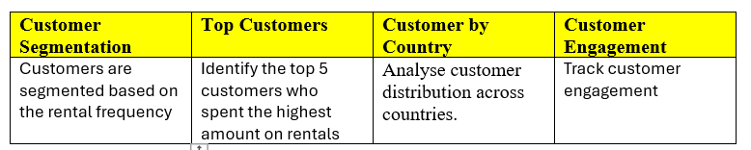
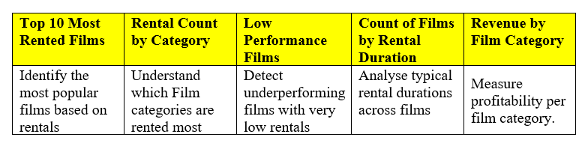
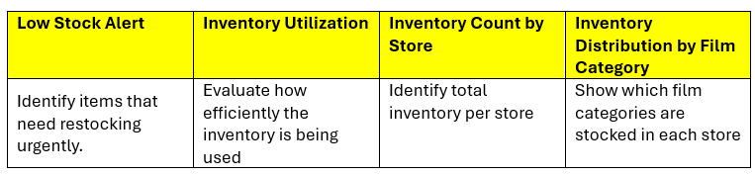
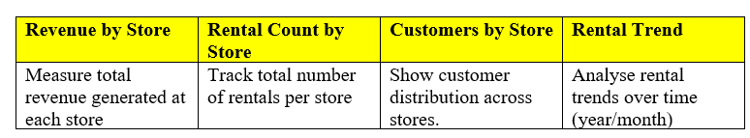
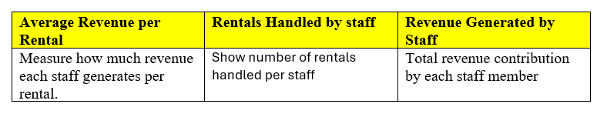
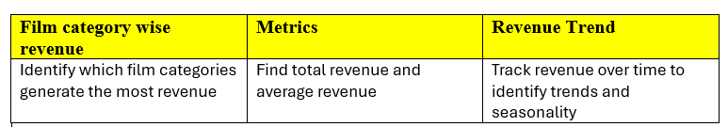
Movie Rental
Dataset
Payment Analysis
Staff Performance Analysis
Stock Analysis
Inventory Management
Film performance & film category Analysis
Customer Segmentation

