EMBEDDED AI ON EDGE USING ESP32 AND DHT22 SENSOR

Abstract
This project demonstrates an Embedded AI on Edge system using an ESP32 microcontroller and a DHT22 temperature-humidity sensor. The system performs local decision making without relying on cloud processing. Based on sensor readings, the ESP32 classifies environmental conditions into SAFE, WARNING, and CRITICAL categories and indicates the status through LEDs. The project highlights the importance of edge computing in reducing latency, improving privacy, and enabling real-time monitoring.

Introduction
Embedded AI combines artificial intelligence techniques with embedded hardware platforms. Edge computing allows processing data close to the source instead of sending all information to remote cloud servers. In this project, an ESP32 board reads environmental parameters and performs local classification. The system is suitable for industrial monitoring, smart homes, agriculture, and safety applications where quick decisions are required.

Literature Survey
Recent research emphasizes the use of edge intelligence for IoT applications. Traditional cloud-based monitoring systems suffer from latency and network dependency. Edge devices such as ESP32 provide sufficient processing capability for lightweight AI models and rule-based predictions. Environmental monitoring systems commonly use temperature and humidity sensors for detecting abnormal conditions. This project adopts a simple edge classification approach suitable for educational and industrial demonstrations.

Objectives
• Design an Edge AI based monitoring system.
• Measure temperature and humidity using DHT22.
• Perform local decision making on ESP32.
• Classify conditions as SAFE, WARNING, or CRITICAL.
• Display status through LEDs.
• Demonstrate edge intelligence without cloud dependence.

Hardware and Software Requirements
Hardware: ESP32 Development Board, DHT22 Sensor, Breadboard, 3 LEDs (Green, Yellow, Red), 220Ω Resistors, Jumper Wires, USB Cable.
Software: Wokwi Simulator, Arduino IDE, ESP32 Board Package, DHT Sensor Library.

Circuit Connections
DHT22 VCC → ESP32 3.3V
DHT22 GND → ESP32 GND
DHT22 DATA → GPIO15
Green LED → GPIO18
Yellow LED → GPIO19
Red LED → GPIO21
All LED cathodes connected to GND through 220Ω resistors.

Working Principle
The DHT22 continuously measures temperature and humidity. The ESP32 reads the values and applies classification rules. If the values are within normal limits, the system indicates SAFE status using the green LED. Moderate environmental conditions trigger WARNING status using the yellow LED. High temperature and humidity conditions activate the CRITICAL state using the red LED.

Methodology
Step 1: Initialize ESP32 and DHT22 sensor.
Step 2: Read temperature and humidity values.
Step 3: Compare values with predefined thresholds.
Step 4: Determine SAFE, WARNING, or CRITICAL state.
Step 5: Turn on the corresponding LED.
Step 6: Display readings and prediction on the Serial Monitor.
Step 7: Repeat continuously.

Flowchart
Start → Initialize System → Read Sensor Data → Analyze Values → SAFE? → Green LED
If not SAFE → WARNING? → Yellow LED
Else → CRITICAL → Red LED → Repeat.

Results and Discussion
The simulation successfully produced three operating conditions. The green LED represented SAFE environmental conditions. The yellow LED indicated WARNING conditions when values approached threshold limits. The red LED indicated CRITICAL conditions when temperature and humidity exceeded safe ranges. The serial monitor displayed sensor readings and classification results in real time.

Advantages
• Low-cost implementation
• Real-time monitoring
• Fast local decision making
• Reduced cloud dependency
• Low power consumption
• Suitable for IoT applications

Applications
• Smart Agriculture
• Industrial Safety Monitoring
• Smart Homes
• Environmental Monitoring
• Warehouse Management
• Healthcare Monitoring

Future Scope
The project can be enhanced using TinyML models, cloud dashboards, mobile notifications, data logging, and predictive analytics for advanced industrial applications.

Conclusion
The Embedded AI on Edge project successfully demonstrates real-time environmental monitoring using ESP32 and DHT22. The system performs local analysis and classification without requiring cloud processing. The project validates the concept of edge intelligence and provides a foundation for advanced AI-enabled IoT systems.

Screenshots Section (Insert Your Wokwi Screenshots Here)
1. Circuit Diagram Screenshot
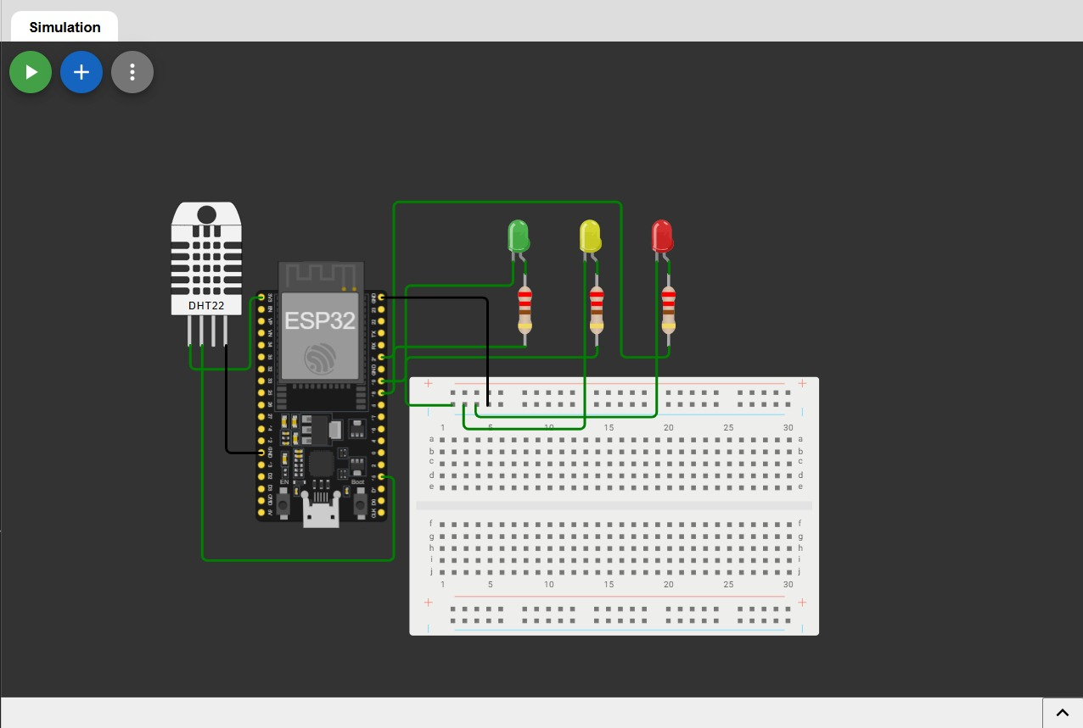
2. SAFE Output (Green LED ON)
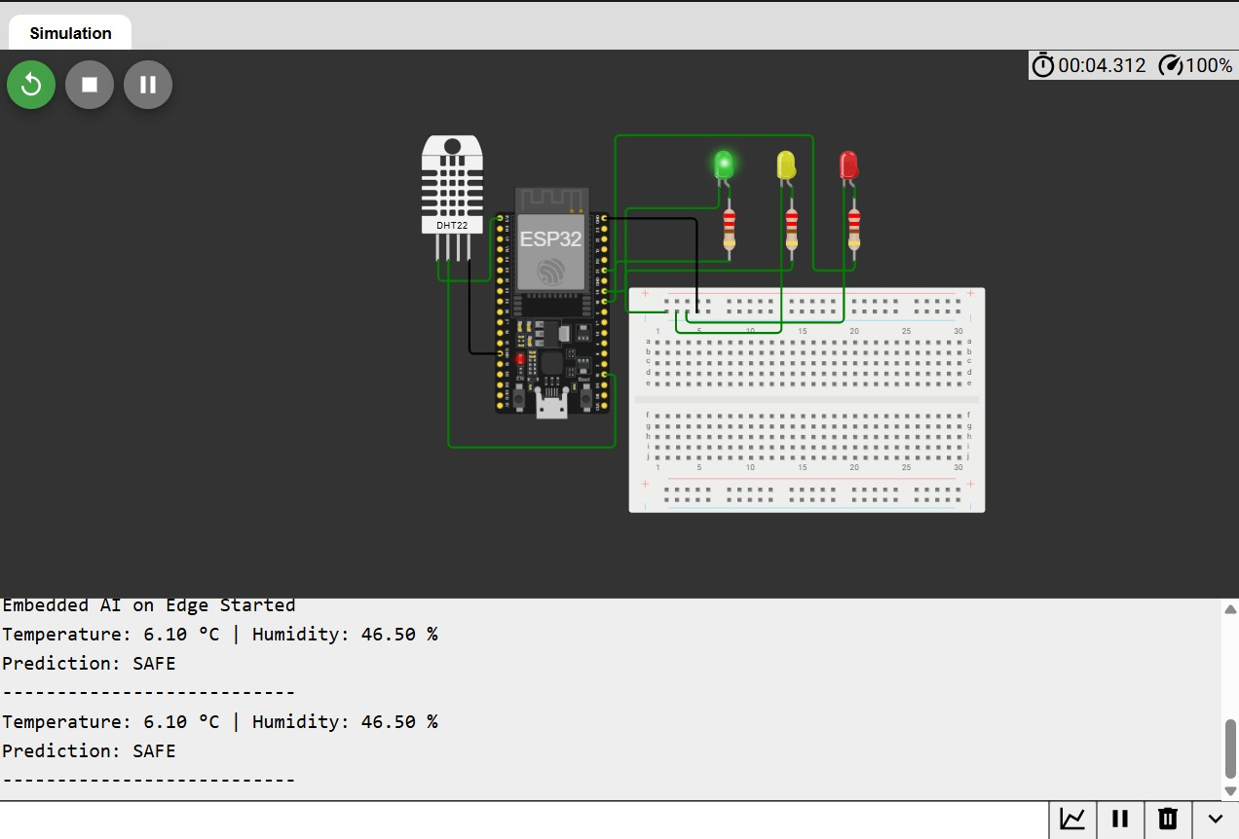
3. WARNING Output (Yellow LED ON)
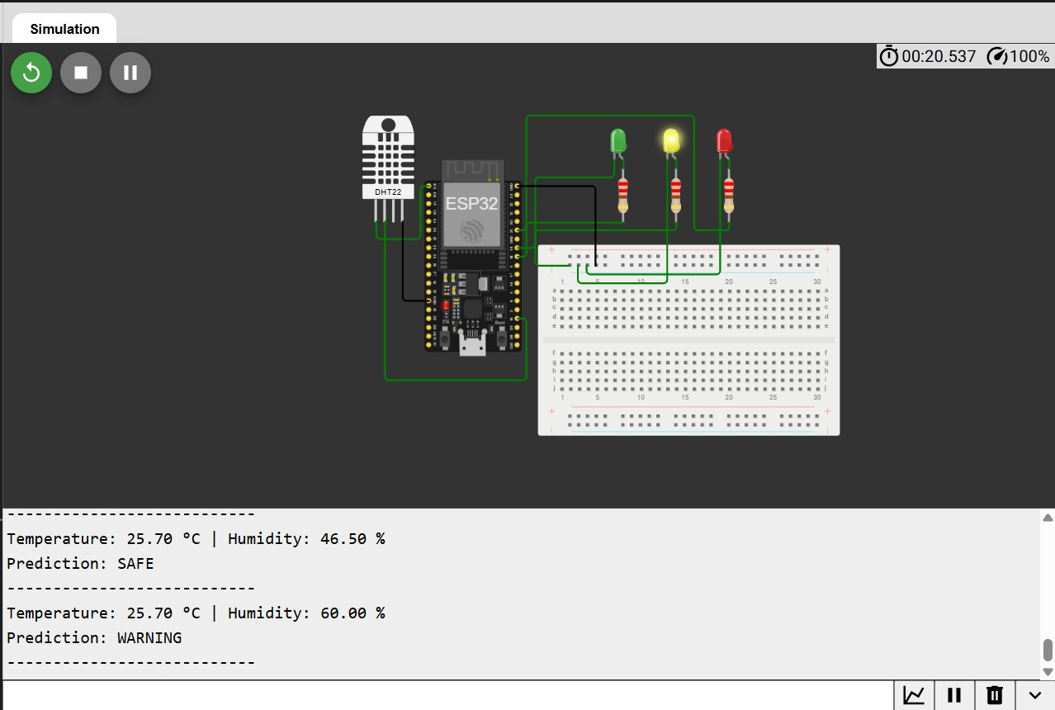
4. CRITICAL Output (Red LED ON)
