Water Level Indicator Using Arduino
Project Type: Embedded Systems / Technical Coding Project

Objective
To detect low, medium, and high water levels using Arduino UNO, LEDs, buzzer, and potentiometer through Tinkercad simulation.

Components Used
- Arduino UNO
- Breadboard
- 3 LEDs (Red, Yellow, Green)
- 3 Resistors (220Ω)
- Piezo Buzzer
- Potentiometer (10kΩ)
- Jumper Wires

Circuit Diagram
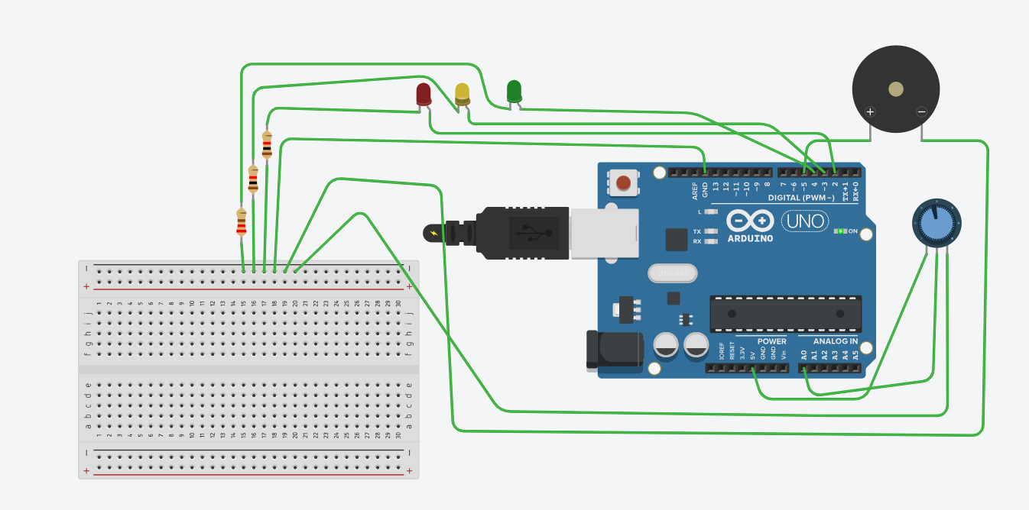

Working Principle
The potentiometer acts as a water level sensor. Arduino reads analog values from the potentiometer and activates different LEDs based on water level.
Water Level | LED Status | Buzzer
Low | Red LED ON | OFF
Medium | Yellow LED ON | OFF
High | Green LED ON | ON

Arduino Code and Circuit
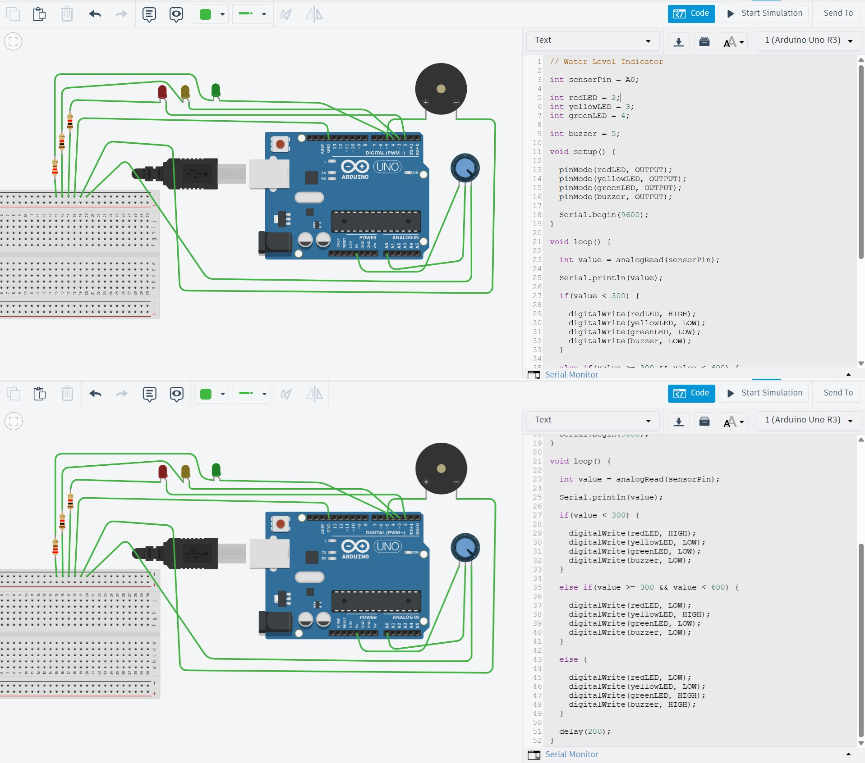

Output Images
Low Water Level Output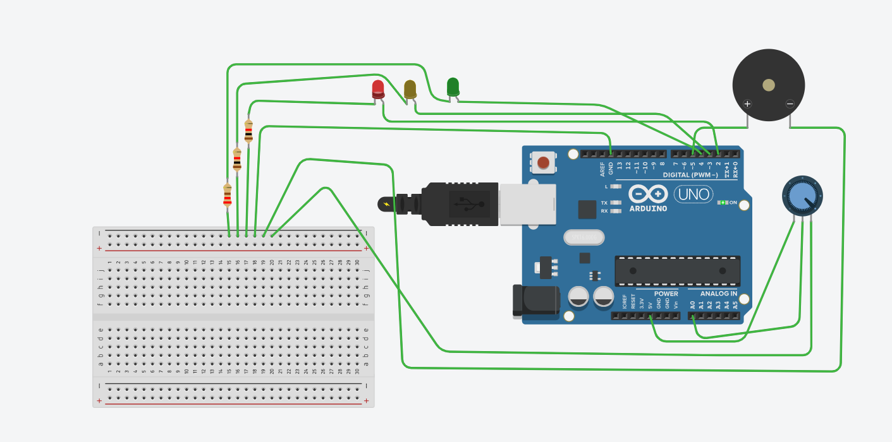

Medium Water level Output
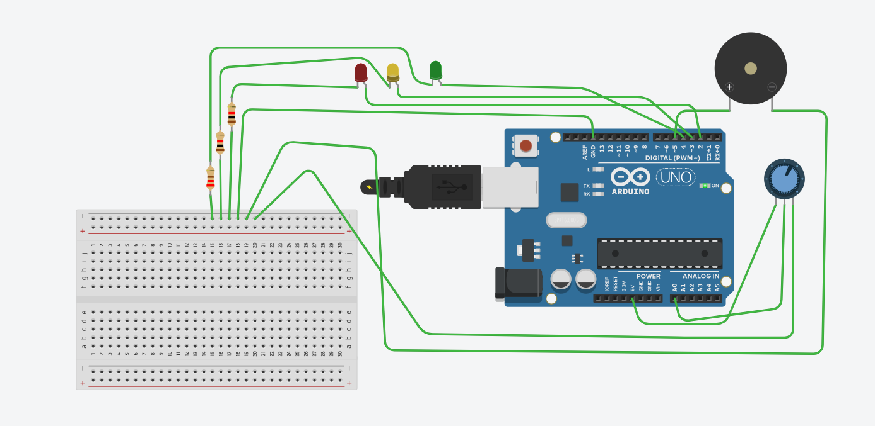

High Water Level with Buzzer Output
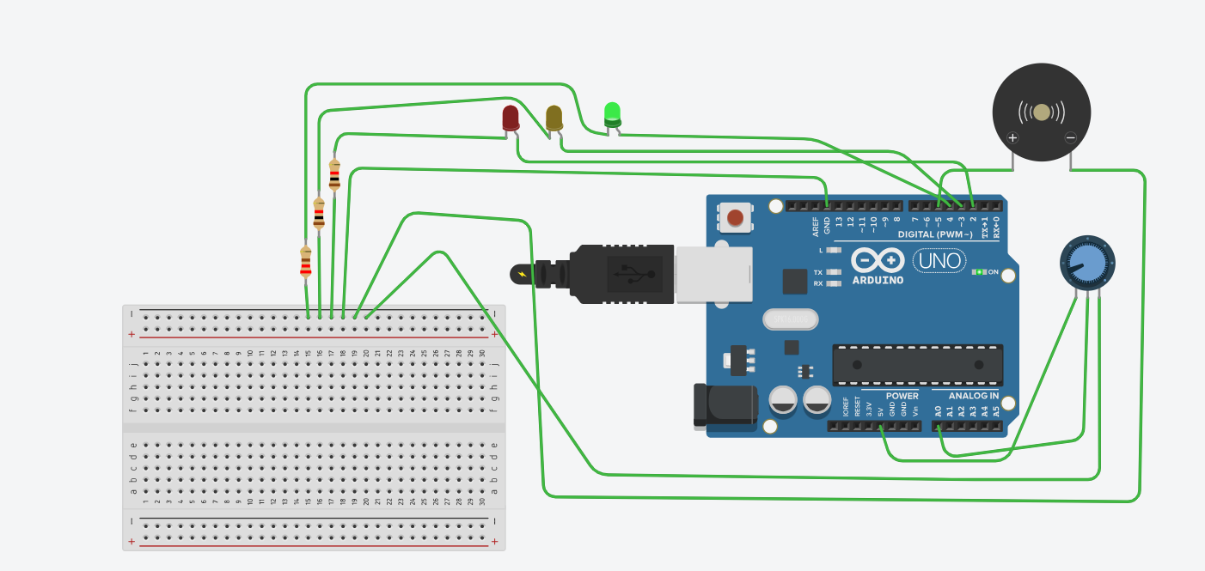

Conclusion
The Water Level Indicator project was successfully simulated using Tinkercad. The system effectively indicates low, medium, and high water levels using LEDs and buzzer.

