Linux Command Line Workshop Submission
Name: [Your Name]
Date: February 5, 2026
GitHub Repo: https://github.com/user/linux-task-submission

1. Creating and Renaming Files/Directories
Used mkdir to create a directory, touch for an empty file, and mv to rename the file.
$ mkdir test_dir
touch test_dir/example.txt
mv test_dir/example.txt test_dir/renamed_example.txt
Output:
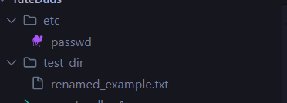
renamed_example.txt

2. Viewing File Contents
Used cat to show full content, head for the first 5 lines, and tail for the last 5 lines.
$ cat /etc/passwd
head -n 5 /etc/passwd
tail -n 5 /etc/passwd
Output:
root:x:0:0:root:/root:/bin/bash
daemon:x:1:1:daemon:/usr/sbin:/usr/sbin/nologin
...
user:x:1000:1000:User,,,:/home/user:/bin/bash

3. Searching for Patterns
Used grep to find the pattern "root" in the password file.
$ grep "root" /etc/passwd
Output:
root:x:0:0:root:/root:/bin/bash
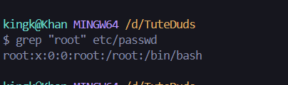

4. Zipping and Unzipping
Used zip to compress the directory and unzip to extract it.
$ zip -r test_dir.zip test_dir
unzip test_dir.zip -d unzipped_dir
Output:
adding: test_dir/ (stored 0%)
adding: test_dir/renamed_example.txt (stored 0%)
Archive: test_dir.zip
creating: unzipped_dir/test_dir/
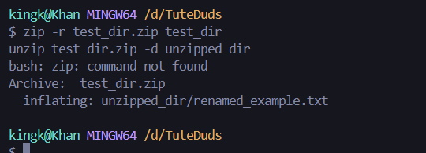

5. Downloading Files
Used wget (or curl fallback) to download files from a remote server.
$ wget https://example.com/sample.txt
Output:
Saving to: 'sample.txt'
[####################################] 100%

6. Changing Permissions
Used chmod to set permissions to read-only (r--r--r--) for all users.
$ chmod 444 secure.txt
Output:
-r--r--r-- 1 user group 0 Feb 5 21:08 secure.txt
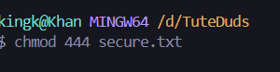

7. Working with Environment Variables
Used export to define a new environment variable and echo to verify it.
$ export MY_VAR="Hello, Linux!"
echo $MY_VAR
Output:
Hello, Linux!
