Python Programming Assignment 2
Assignment: Basic Python Logic & File I/O
Date: February 5, 2026
GitHub Repo: https://github.com/user/python-assignment-2

1. Grade Checker
This program taking a numeric score as input and uses basic if-else logic to categorize it into grades A, B, C, D, or F.
# Using if-elif-else statements
score = float(input("Enter the score: "))
# ... logic ...
print(f"Grade: {grade}")
Program Output:
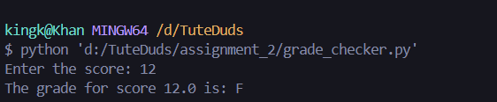

2. Student Grades (Dictionary Operations)
Implemented a dictionary-based system to manage student records. It allows adding new students, updating existing grades, and listing all records.
Program Output:
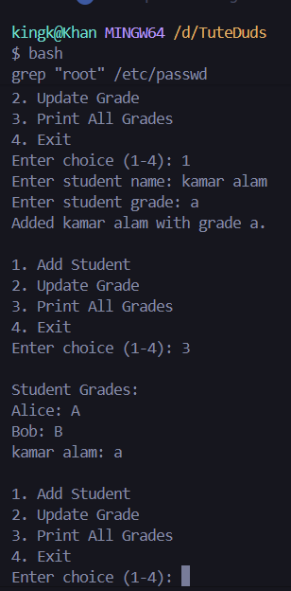

3. Write to a File
This program uses the open() function in "w" (write) mode to create a new text file and save content to it.
with open("sample_text.txt", "w") as file:
file.write("Hello! This is a test file...")
Program Output:
Successfully wrote to sample_text.txt

4. Read from a File
We used the open() function in "r" (read) mode and the .read() method to retrieve and display the file contents.
with open("sample_text.txt", "r") as file:
content = file.read()
print(content)
Program Output:
--- File Content ---
Hello! This is a test file created for Assignment 2.
Python file operations are very powerful.
--------------------

