GiftCompass
Final Design Document
Personalized gift recommendation for Jeddah · consent-based · budget-aware
One line: understand the recipient first, then find gifts that fit them inside the giver's budget — using only data the recipient chose to share.

1. Problem and users
People want to give a gift that lands, and they do not know what the recipient would genuinely like. They search across stores, find generic suggestions, discover the good option is over budget, and end up buying something safe that does not fit the person. Too much choice makes the decision harder, not easier.
Who | Role
Sender | Individuals in Jeddah buying for friends, partners, family, colleagues or classmates. Provides relationship, occasion and budget, and receives the recommendations.
Receiver | The person the gift is for. Optionally builds a Gift Profile by answering a few questions or donating their own platform export. They are the data subject, and consent is theirs to give.
Occasions | Birthday, graduation, anniversary, wedding, achievement, thank you, Eid, new job, or no occasion at all.
Main challenge: how can we help individuals in Jeddah find the right gift for their loved ones based on the recipient's personality, interests, and the giver's budget?

2. Data sources
The starting assumption — read the recipient's TikTok reposts — does not survive contact with reality. Platform terms forbid automated collection, TikTok's Research API is for approved academic researchers rather than apps, and profiling someone without consent conflicts with the Saudi PDPL. The design is therefore built around consent, not collection.
Source | Route | Decision
Quiz + manual input | The sender answers short questions about the recipient. | PRIMARY. Always available, needs no third party, and is the baseline every other source must beat.
TikTok export | The owner requests "Download your data" and uploads it themselves (data donation, P5/P6). | Optional enhancement. Richest TikTok signal legally available to us.
TikTok Login Kit | user.info.basic, video.list. | Not enough. Gives the owner's own posted videos, not likes or reposts.
Pinterest | OAuth, boards:read and pins:read. | Strong future option — boards are close to a wish list.
Spotify | OAuth, top artists and genres. | Prototype option only; development mode limits test users.
Snapchat / X / Instagram | Identity only / paid / business accounts only. | Not used.

2.1 Consent flow and retention
- The sender creates a Gift Profile request and sends the receiver a link.
- The receiver chooses: answer a few questions, donate an export, or decline. Declining is a first-class option.
- An uploaded export is parsed in the receiver's browser. Messages, location, login history and device data are never read.
- The receiver previews the inferred interests, removes anything that does not represent them, and only then approves.
- The raw file is deleted once the persona is built. Only the approved persona is stored, and it expires after 180 days.
- The surprise problem is solved by making the Gift Profile reusable: built once, shared with family and friends, so a request is not a signal that a gift is coming. If the receiver does not respond, the sender's quiz answers are used and the surprise is intact.
Enforced in code, not only in prose: the pipeline throws if a persona has no consent recorded, and the persona schema carries consent, receiver_reviewed, raw_data_deleted and expires_at as required fields.

3. Persona model
The persona is a structured, evidence-based interest profile of the receiver — never a paragraph of prose, and never a list of raw posts. Full schema: docs/schemas/persona.schema.json.
raw(i) = SUM over evidence of count x strength(signal) x 0.5^(age_days / 180)
weight(i) = raw(i) / (raw(i) + 2)

strength ladder posted 1.00 > reposted 0.90 > quiz 0.85 > saved 0.80
> manual 0.70 > liked 0.60 > followed 0.55 > watched 0.30
bands strong >= 0.66 medium 0.33-0.66 weak < 0.33
The saturating form is the "one repost is not an interest" rule expressed as arithmetic: a single signal lands in the weak band however strong its type, and only repeated evidence reaches strong. The 180-day half-life means last year's enthusiasm fades rather than competing with a current one.
- Every interest carries at least one piece of evidence. No evidence, no interest — that is what makes the preview screen possible.
- Sentiment is directional. A negative mention becomes a dislike and is used as an exclusion, not as a small penalty.
- Giftability is scored per interest, because liking football converts into a gift and liking memes does not.
- Blocked attributes, never inferred or stored: religion, religious_practice, health, medical_condition, politics, political_opinion, sexuality. P3 showed how much a handful of likes can expose; the answer is to refuse to look.

4. Matching and ranking
Products and personas meet through one shared vocabulary of 30 interest keys, so retrieval is a real join rather than fuzzy string matching.
Hard filters run BEFORE ranking, so an unaffordable or undeliverable gift is never ranked at all:
- price ≤ budget · delivery_days ≤ days left · age range overlaps · relationship_fit includes the relationship
- not in dislikes · not already owned · size not required unless the sender knows it · available in Jeddah
- embarrassment_risk ≤ the threshold for this relationship (colleague 0.20 … partner 0.70)
score = 0.40 * interest_match
+ 0.20 * giftability
+ 0.15 * budget_fit
+ 0.10 * novelty
- 0.15 * embarrassment_risk

interest_match = 0.6 * max(persona weight over shared keys) + 0.4 * cosine
budget_fit peaks at 75% of the budget
Then three rules shape the final list: a relevance gate (an item must be primarily about something they like, or connect to something they like strongly), a cap of two items per category, and interest coverage so the two strongest interests each get a slot. Output is up to five gifts — fewer if fewer qualify. Nothing is padded.
Role of the LLM, following P7: it is a profile generator and at most a list-wise re-ranker of the top 10, never the scorer. It may only reorder ids it was given; an invented id is discarded. No fine-tuning — prompting with structured JSON output, validated against the schema before use.

5. Architecture v2
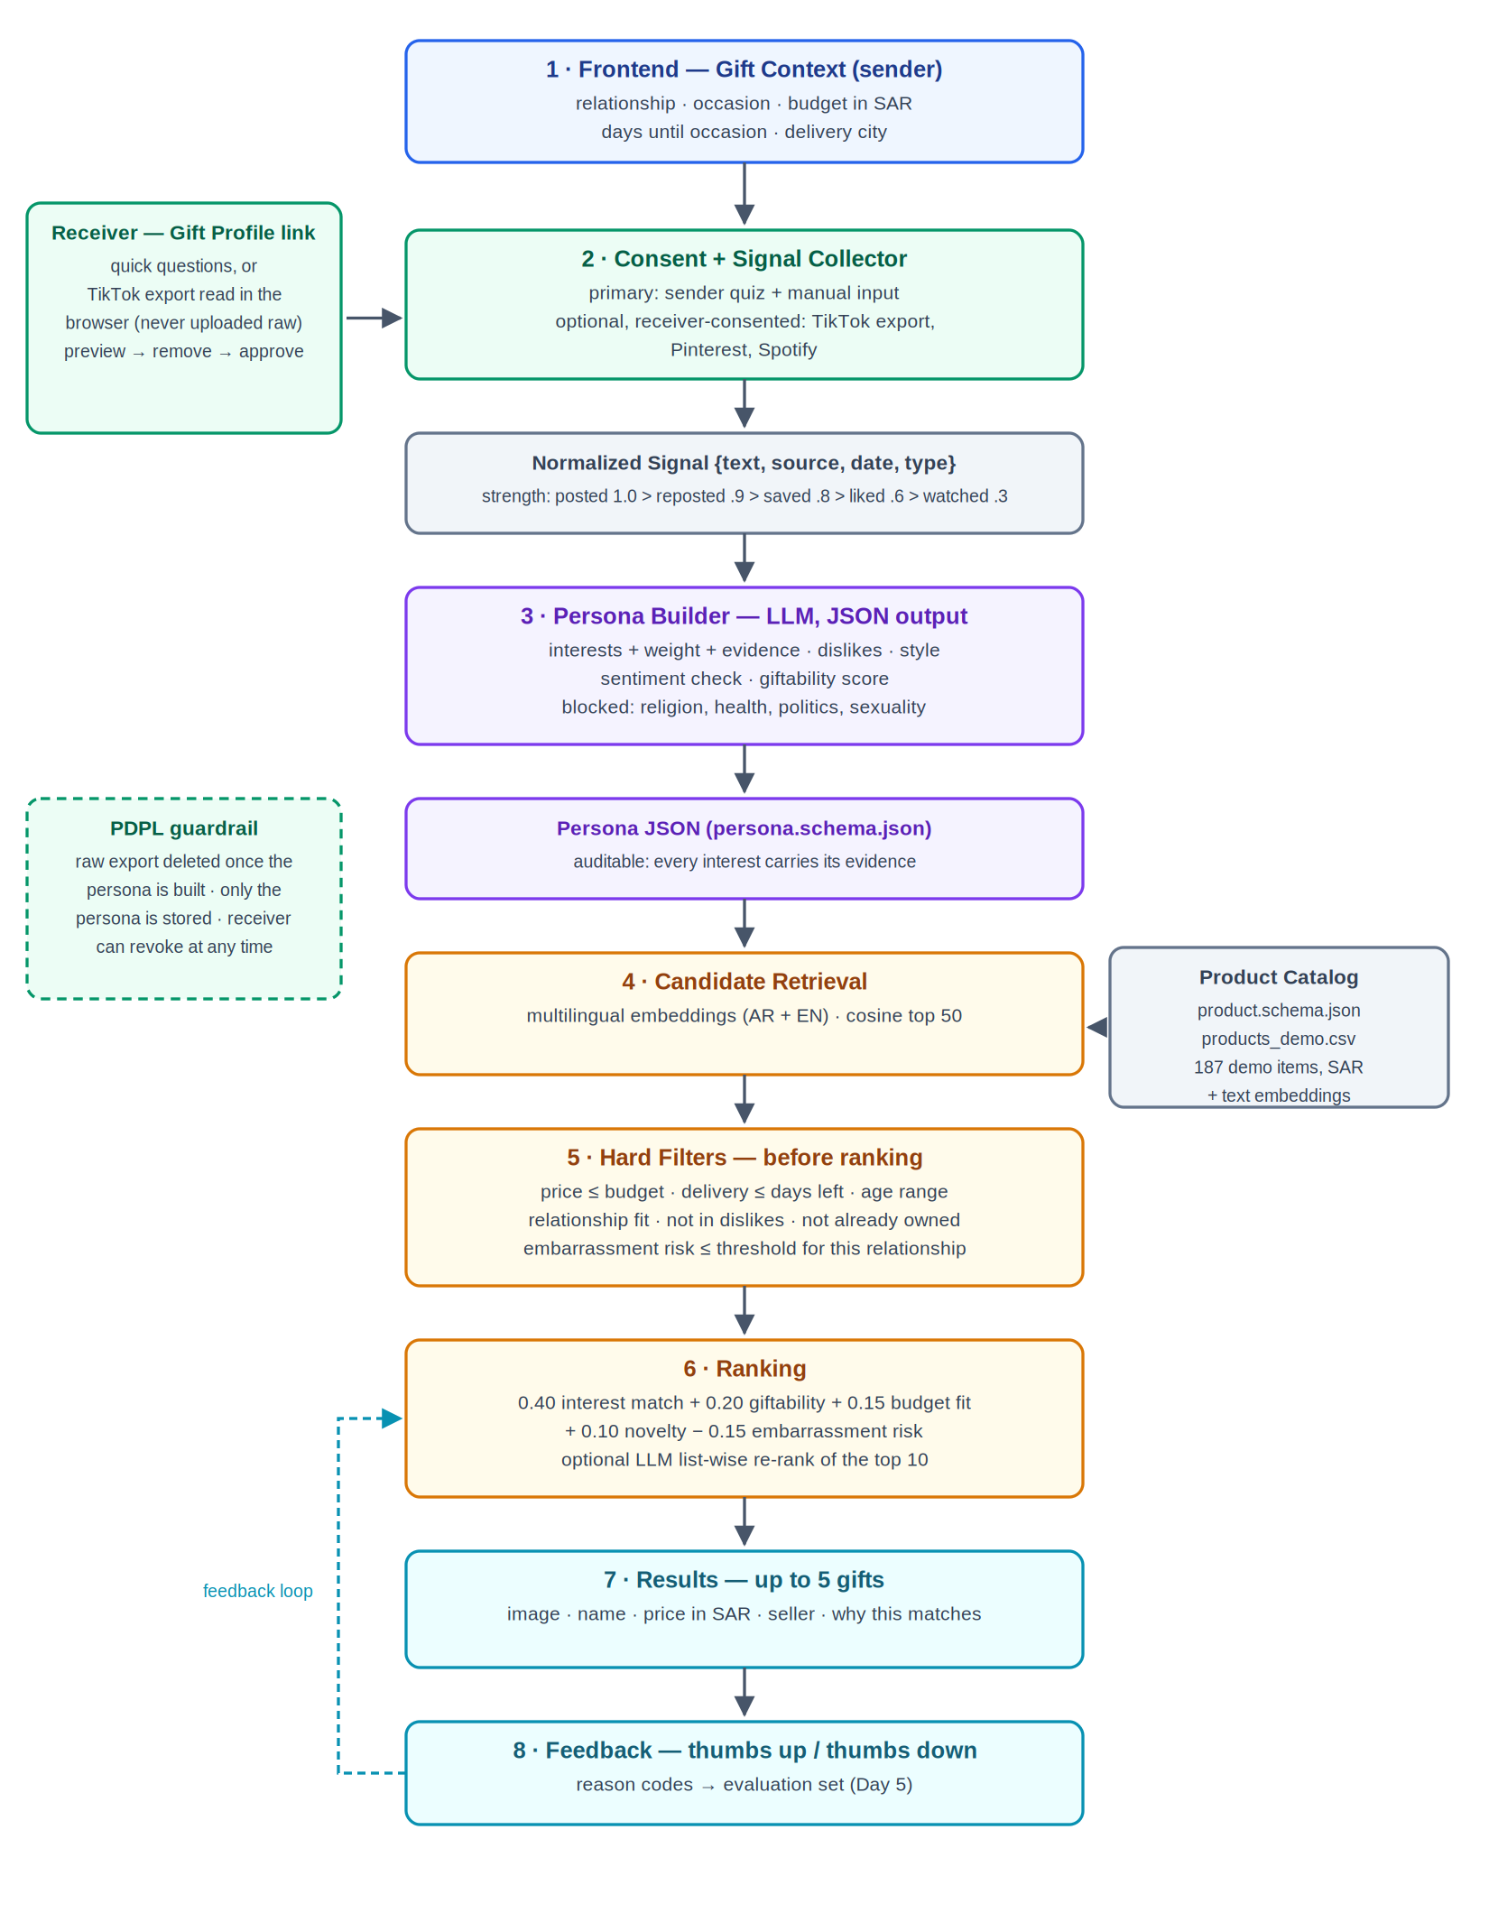
# | Layer | Technology | Owner
1 | Frontend — Gift Context | Next.js (App Router) + TypeScript + Tailwind | (assign)
2 | Consent + Signal Collector | Next.js routes; export parsed in the browser | (assign)
3 | Persona Builder | Deterministic today; hosted LLM in JSON mode behind the same interface | (assign)
4 | Product Catalog + embeddings | CSV today; PostgreSQL + pgvector when it grows | (assign)
5 | Candidate Retrieval | TF-IDF cosine today; multilingual sentence embeddings behind the same interface | (assign)
6 | Hard Filters | Deterministic code | (assign)
7 | Ranking + explanations | Deterministic score; optional LLM re-rank of the top 10 | (assign)
8 | Results + Feedback UI | Next.js | (assign)
— | Privacy / PDPL | Cross-cutting: consent, retention, deletion, blocked attributes | (assign)

6. Evaluation
Five synthetic recipients, each run twice: the full pipeline (quiz + donated signals) against a baseline built from the sender's quiz answers alone. Same catalog, same context, same code — the only difference is how much the system knows about the recipient.

6.1 Results that need no human judgement
Persona | System | Shown | Mean SAR | Budget use | Categories | Top-3 cover | Overlap
faisal | full | 5 | 446 | 0.45 | 3 | 1 | 0.6
faisal | baseline | 4 | 467.5 | 0.47 | 2 | 1 | 0.75
layla | full | 5 | 302 | 0.6 | 4 | 1 | 0.6
layla | baseline | 5 | 270 | 0.54 | 4 | 1 | 0.6
nouf | full | 5 | 327 | 0.65 | 3 | 0.67 | 0.4
nouf | baseline | 2 | 320 | 0.64 | 1 | 0.5 | 1
omar | full | 5 | 132 | 0.53 | 3 | 1 | 0.6
omar | baseline | 3 | 145 | 0.58 | 2 | 1 | 1
sara | full | 5 | 345 | 0.69 | 3 | 1 | 0.6
sara | baseline | 5 | 377 | 0.75 | 3 | 1 | 0.6
The finding that matters: the full pipeline returned 25 recommendations across the five recipients; the quiz-only baseline returned 19. Both stayed inside budget every time. The gap is not that the baseline ranks worse — it is that the baseline often cannot find five items it is confident enough to show, because a handful of quiz answers produce fewer and weaker interests. For Nouf the baseline managed two; the full persona reached five.
Overlap between the two lists runs 0.4–1.0, so the donated signals change between none and three of the five slots. Where the quiz already captured the main interest, the extra signals mostly confirm it. That is a fair result for the design: the quiz is the primary source by decision, and social signals are an enhancement.

6.2 The human evaluation — protocol, not results
These numbers do not exist yet, and this document will not invent them. The harness produced a blind rating sheet of 30 items (data/evaluation/rating-sheet.csv). It does not say which system produced an item, so a rater cannot favour the full pipeline; the mapping lives in a separate key file.
- Three teammates rate every item independently, without discussing.
- relevance 0–2 — 0 wrong for this person, 1 plausible, 2 clearly right.
- delightful y/n — would it be a pleasant surprise?
- embarrassing y/n — would it be awkward for this relationship?
Then npm run score joins the ratings back to the systems and fills this table. It refuses to compute anything until real ratings exist, and reports any invalid cell instead of guessing.
System | Mean relevance (0–2) | Delightful % | Embarrassing %
Full pipeline
Quiz-only baseline
Five recipients and three raters is a small sample, and the recipients are invented by the same team that built the system. Treat the outcome as an indication of direction, not as evidence of accuracy.

7. Worked example, end to end
Input — best friend, birthday, up to 500 SAR, 14 days away. 10 signals: 4 quiz answers and 6 donated TikTok activity items.
Persona (abbreviated):
{ "persona_id": "psn_layla",
"consent": { "consent_given": true, "granted_by": "receiver",
"receiver_reviewed": true, "raw_data_deleted": true },
"interests": [
{ "key": "matcha", "weight": 0.79, "strength": "strong", "giftability": 0.9 },
{ "key": "reading", "weight": 0.78, "strength": "strong", "giftability": 0.9 },
{ "key": "home_decor", "weight": 0.62, "strength": "medium", "giftability": 0.8 },
...
],
"dislikes": [{ "key": "makeup", "reason": "receiver_removed" }],
"already_owns": [{ "label": "electric milk frother" }] }
Pipeline: 187 products → 50 retrieved → 46 survive the hard filters → 5 shown.
# | Gift | SAR | Why this matches
1 | Matcha and tea gift hamper | 260 | They show a strong interest in matcha (11 signals). It also touches cafe culture. At 260 SAR it fits your birthday budget of up to 500 SAR.
2 | Matcha and pastry tasting for two | 260 | They show a strong interest in matcha (11 signals). It also touches cafe culture. It is an experience rather than an object. At 260 SAR it fits your birthday budget of up to 500 SAR.
3 | Arabic coffee dallah with finjan set | 380 | They show an interest in coffee (3 signals). It also touches home & room decor. At 380 SAR it fits your birthday budget of up to 500 SAR.
4 | Personalised name neon sign | 420 | They show an interest in home & room decor (5 signals). It can be personalised, which suits a keepsake gift. At 420 SAR it fits your birthday budget of up to 500 SAR.
5 | English bestseller bundle, 3 paperbacks | 190 | They show a strong interest in reading & books (15 signals). At 190 SAR it comes in well under your birthday budget of up to 500 SAR.
Prices come from the demo catalog. They are realistic for Jeddah but are not quoted prices, and no listing has been checked.

8. What we would do next
- Verify catalog rows against live listings and flip them to data_status = verified. The filter can already require it.
- Swap the deterministic persona builder for the LLM one and compare personas built from identical signals.
- Swap TF-IDF for multilingual sentence embeddings, which should help most on Arabic signals.
- Build the receiver Gift Profile flow — the invite link, in-browser parsing and the preview screen — after the TikTok feasibility check.
- Run the human evaluation, then decide whether a giftability floor is needed for thin candidate pools.

9. How this meets the grading criteria
Criterion | Where it is met
Correct use of ideas from the papers | P1 gift context (relationship, occasion, budget kept separate from the persona); P2 giftability, sentiment direction and embarrassment as a scored term with per-relationship thresholds; P3 the blocked-attribute list; P5 the donation route; P7 the LLM as profile generator and list-wise re-ranker only, never the scorer.
Data sources legal under PDPL and consent-based | No scraping anywhere. Quiz is primary; donation is opt-in and parsed on the receiver's device; consent, review and deletion are required schema fields, and the pipeline refuses a persona without consent.
Architecture clear and buildable | Eight layers, one module each, running today as a CLI and an HTTP endpoint. Two layers are stubs behind interfaces, and both stubs are named as such.
Persona structured, evidence-based, no sensitive traits | Published JSON Schema, weights computed from a documented formula, evidence required on every interest, blocked attributes enforced and covered by a test.
Prototype works and is evaluated against a baseline | Runs end to end over five recipients with 14 passing tests. Objective metrics are complete; the human ratings are collected by a blind sheet and are not yet filled in.

10. Sources
- P1. Gift recommendation systems: a review. Electronic Commerce Research (2023). doi: 10.1007/s10660-023-09790-6
- P2. Pavlidis et al. Anatomy of a gift recommendation engine powered by social media. ACM SIGMOD '12. doi: 10.1145/2213836.2213950
- P3. Kosinski, Stillwell & Graepel. Private traits and attributes are predictable from digital records of human behavior. PNAS 110(15), 2013.
- P4. Fiesler, Beard & Keegan. No Robots, Spiders, or Scrapers. ICWSM 14(1), 2020.
- P5. Boeschoten et al. A framework for privacy preserving digital trace data collection through data donation. CCR 4(2), 2022.
- P6. Zannettou et al. Analyzing User Engagement with TikTok's Short Format Video Recommendations using Data Donations. CHI '24.
- P7. Wu et al. A Survey on Large Language Models for Recommendation. arXiv:2305.19860; World Wide Web 27(5), 60 (2024).
- Saudi Personal Data Protection Law (PDPL, Royal Decree M/19) and SDAIA implementing regulations.
- GiftCompass Day 1, Day 2 and Day 3 reports.

