Stability domain for the Euler Forward method

a)

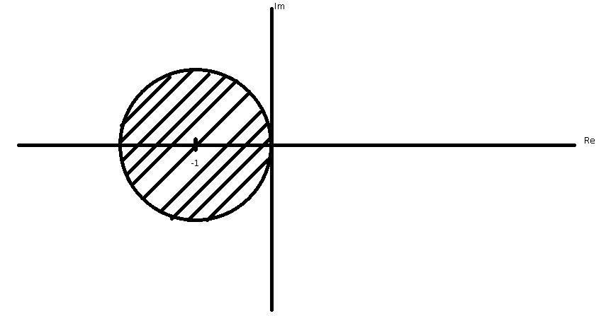

b)

Diagonal matrix which implies that the Eigenvalues are the diagonal. Largest Eigenvalue is $2$ and thus

$$-2≤-2h≤0$$

Or

$$0≤h≤1$$

Implying the largest value of $h$ is 1

c)

Again eigenvalues come directly from the diagonal, largest Eigenvalue is $100$

$$-2≤-100h≤0$$

$$\frac{1}{50}≤h≤0$$

The largest value that $h$ can take is $\frac{1}{50}$

2)

a)

Stability domain for the Euler Backwards method

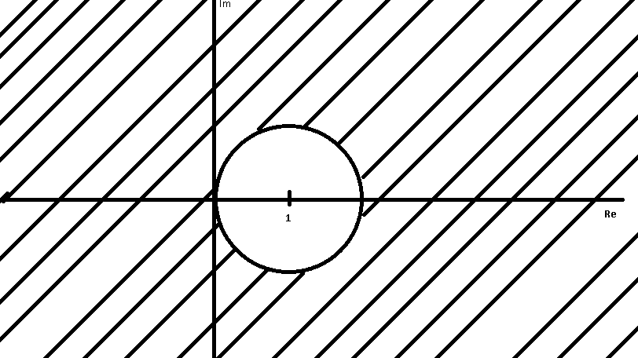

b)

Largest step size $h$

$$\left|hλ-1\right|≥1$$

Largest $λ$ is 2

$h$ does not have an upper bound

c)

$$h does not have an upper bound$$

3)

Find the linear stability domain for the Leap-Frog scheme

Leap-Frog: $y_{k+1}-y_{k-1}=2hf(t_{k},y_{k})$

$$\frac{dy}{dt}=λy$$

$$y_{k+1}-y_{k-1}=2hλy_{k}$$

$$z≡λh$$

$$y_{k+1}-2zy_{k}-y_{k-1}=0$$

Anzats $y_{k}=r^{k}$

$$r^{k+1}-2zr^{k}-r^{k-1}=0$$

$$r^{2}-2zr-1=0$$

$$r=e^{iθ}$$

$$e^{i2θ}-2ze^{iθ}-1=0$$

$$z=\frac{e^{iθ}-e^{-iθ}}{2}=\frac{\cos\left(θ\right)+i\sin\left(θ\right)-\cos\left(θ\right)+isin⁡(θ)}{2}=i\sin\left(θ\right)$$

$$θ∈\left[0,2π\right) implies z∈\left[-i,i\right]$$

4)

a) Find the largest step size $h$ for which the numerical solution of

$$\frac{du}{dt}=\left[\begin{matrix}0 & 1 \\ -1 & 0\end{matrix}\right]u$$

Is stable if using the Leap-Frog scheme

$$\left|\begin{matrix}-λ & 1 \\ -1 & -λ\end{matrix}\right|=λ^{2}-1; λ=±1$$

$$\left|z\right|=\left|hλ\right|≤1$$

$$largest stepsize allowed for the Leap-Frog method:h=0$$

It would require an imaginary step size

b)  
Find the largest stepsize $h$ for which the numerical solution of

$$\frac{du}{dt}=\left[\begin{matrix}0 & 1 \\ 1 & 0\end{matrix}\right]u$$

is stable if using the Leap-Frog scheme

$$\left|\begin{matrix}-λ & 1 \\ 1 & -λ\end{matrix}\right|=λ^{2}+1; λ=±i$$

$$\left|ih\right|≤1$$

$$-1≤h≤1$$

5)

Consider the BVP

$$y^{''}+9y=0$$

$$y\left(0\right)=0$$

$$y\left(\frac{π}{2}\right)=-1$$

Write down the linear system (but do not solve) for the discretized version of this equation. Use 6 equally spaced grid points in total (including the boundary points), but only write down the system for the 4 interior points. Use a second order approximation for the second derivative

The second derivative second order accurate stencil is $[1,-2,1]$

Finite difference:

$$\frac{y_{k+1}-2y_{k}+y_{k-1}}{h^{2}}+9y_{k}=0$$

$$\frac{y_{k+1}+(9h^{2}-2)y_{k}+y_{k-1}}{h^{2}}=0$$

The four equations:

$$\frac{u_{2}+\left(9h^{2}-2\right)u_{1}+u_{0}}{h^{2}}=0$$

$$\frac{u_{3}+\left(9h^{2}-2\right)u_{2}+u_{1}}{h^{2}}=0$$

$$\frac{u_{4}+\left(9h^{2}-2\right)u_{3}+u_{2}}{h^{2}}=0$$

$$\frac{u_{5}+\left(9h^{2}-2\right)u_{4}+u_{3}}{h^{2}}=0$$

6)

$$u_{t}=2u_{xx}, x∈\left[0,1\right]$$

$$u\left(x,0\right)=f(x)$$

$$u\left(0,t\right)=1$$

$$u\left(1,t\right)=2$$

a)

Discretize this equation using 6 equally spaced grid points (including the boundary points). Write down the recursion (as a matrix-vector recursion) for solving this equation using the Euler forward differencing scheme. (You only have to write down the recursion for the 4 interior grid points.)

$$x_{m}=\frac{m}{M}\frac{π}{2}: m=0,2,…,5, M=\max\left(m\right)=5$$

$$\frac{∂^{2}}{∂x^{2}}≈\frac{1}{h^{2}}\left[\begin{matrix}-2 & 1 & \begin{matrix}0 & 0\end{matrix} \\ 1 & -2 & \begin{matrix}1 & 0\end{matrix} \\ \begin{matrix}0 \\ 0\end{matrix} & \begin{matrix}1 \\ 0\end{matrix} & \begin{matrix}\begin{matrix}-2 \\ 1\end{matrix} & \begin{matrix}1 \\ -2\end{matrix}\end{matrix}\end{matrix}\right]≡L$$

$$\frac{du}{dt}=\frac{1}{h^{2}}Lu$$

Euler forward differencing:

$$u_{k+1}=u_{k}+hf(u_{k})$$

$$u_{m, n+1}=u_{m, n}+\frac{k}{h^{2}}Lu_{m, n}=u_{m, n}+αLu_{m, n}=u_{m, n}+α\left[u_{m+1, n}-2u_{m, n}+u_{m-1, n}\right]:n∈N∪0, α≡\frac{k}{h^{2}} , N=max⁡(n)$$

b)

What restriction on the time step do you have to impose in order for the scheme in a) to be stable?

We know that the Eigenvalues of $L$ are $λ_{m}=2\left[\cos\left(\frac{πm}{7}\right)-1\right];-4≤λ_{m}≤0$

$$\frac{k}{h^{2}}≤\frac{1}{2}$$

$$k≤\frac{h^{2}}{2}$$

c)

Discretize this equation using 6 equally spaced grid points (including the boundary points). Write down the linear system for solving this equation using the Euler backward differencing scheme. (You only have to write down the linear system for the 4 interior grid points.)

$$x_{m}=\frac{m}{M}\frac{π}{2}: m=0,2,…,5, M=\max\left(m\right)=5$$

$$\frac{du}{dt}=\frac{1}{h^{2}}Lu$$

$$y_{k+1}=y_{k}+hLy_{k+1}$$

$$u_{m,n+1}=u_{m,n}+\frac{2}{h^{2}}\left[u_{m-1,n}-2u_{m,n}+u_{m+1,n}\right]$$

System of equations:

$$u_{1,n+1}=\left(\frac{2k}{h^{2}}\right)u_{0,n}\left(1-\frac{4k}{h^{2}}\right)u_{1,n}+\frac{2k}{h^{2}}u_{2,n}$$

$$u_{2,n+1}=\left(\frac{2k}{h^{2}}\right)u_{1,n}\left(1-\frac{4k}{h^{2}}\right)u_{2,n}+\frac{2k}{h^{2}}u_{3,n}$$

$$u_{3,n+1}=\left(\frac{2k}{h^{2}}\right)u_{2,n}\left(1-\frac{4k}{h^{2}}\right)u_{3,n}+\frac{2k}{h^{2}}u_{4,n}$$

$$u_{4,n+1}=\left(\frac{2k}{h^{2}}\right)u_{3,n}\left(1-\frac{4k}{h^{2}}\right)u_{4,n}+\frac{2k}{h^{2}}u_{5,n}$$

d)

Since the Euler backwards scheme is stable for the complex plane outside of the unit circle centered at 1, the scheme is stable if (Sauer 382) $\left|1+2\frac{k}{h^{2}}\cos\left(\frac{πj}{m+1}\right)\right|>1$ Which is true for all values of $m$ and $j$ and thus the scheme is unconditionally stable; $k$ is unconstrained.

7)

Discretize the equation from Problem 6 above using 6 equally spaced grid points (including the boundary points). Write down the linear system for solving this equation using the Crank-Nicolson scheme. (You only have to write down the system for the 4 interior grid points.)

Crank – Nicolson:

$$u_{xx}≈\frac{1}{2h^{2}}\left(u_{m-1,n}-2u_{m,n}+u_{m+1,n}\right)+\frac{1}{2h^{2}}\left(u_{m-1,n-1}-2u_{m,n-1}+u_{m+1,n-1}\right)$$

$$u_{t}=\frac{1}{k}\left(u_{m,n}-u_{m,n-1}\right)$$

$$\frac{1}{k}\left(u_{m,n}-u_{m,n-1}\right)=\frac{1}{h^{2}}\left(u_{m-1,n}-2u_{m,n}+u_{m+1,n}\right)+\frac{1}{h^{2}}\left(u_{m-1,n-1}-2u_{m,n-1}+u_{m+1,n-1}\right)$$

$$\left(u_{m,n}-u_{m,n-1}\right)=\frac{k}{h^{2}}\left(u_{m-1,n}-2u_{m,n}+u_{m+1,n}\right)+\frac{k}{h^{2}}\left(u_{m-1,n-1}-2u_{m,n-1}+u_{m+1,n-1}\right)$$

$$\left(2\frac{k}{h^{2}}+1\right)u_{m,n}+\left(2\frac{k}{h^{2}}-1\right)u_{m,n-1}=\frac{k}{h^{2}}\left(u_{m-1,n}+u_{m+1,n}\right)+\frac{k}{h^{2}}\left(u_{m-1,n-1}+u_{m+1,n-1}\right)$$

The set of equations

$$\left(2\frac{k}{h^{2}}+1\right)u_{1,n}+\left(2\frac{k}{h^{2}}-1\right)u_{1,n-1}=\frac{k}{h^{2}}\left(u_{0,n}+u_{2,n}\right)+\frac{k}{h^{2}}\left(u_{0,n-1}+u_{2,n-1}\right)$$

$$\left(2\frac{k}{h^{2}}+1\right)u_{2,n}+\left(2\frac{k}{h^{2}}-1\right)u_{2,n-1}=\frac{k}{h^{2}}\left(u_{1,n}+u_{3,n}\right)+\frac{k}{h^{2}}\left(u_{1,n-1}+u_{3,n-1}\right)$$

$$\left(2\frac{k}{h^{2}}+1\right)u_{3,n}+\left(2\frac{k}{h^{2}}-1\right)u_{3,n-1}=\frac{k}{h^{2}}\left(u_{2,n}+u_{4,n}\right)+\frac{k}{h^{2}}\left(u_{2,n-1}+u_{4,n-1}\right)$$

$$\left(2\frac{k}{h^{2}}+1\right)u_{4,n}+\left(2\frac{k}{h^{2}}-1\right)u_{4,n-1}=\frac{k}{h^{2}}\left(u_{3,n}+u_{5,n}\right)+\frac{k}{h^{2}}\left(u_{3,n-1}+u_{5,n-1}\right)$$

8)

Could we design a differencing scheme based on Leap-Frog in time for solving parabolic equations? Why or why not

Leapfrog takes the form:

$$\frac{1}{2k}u_{m,n+1}-\frac{1}{2k}u_{m,n-1}=f(t_{n},y_{m,n})$$

$$f\left(t_{k},y_{k}\right)=u_{xx}≈\frac{1}{h^{2}}(u_{m+1, n}-2u_{m, n}+u_{m-1, n})$$

$$\frac{1}{2k}u_{m,n+1}-\frac{1}{2k}u_{m,n-1}=\frac{1}{h^{2}}(u_{m+1, n}-2u_{m, n}+u_{m-1, n})$$

So yes, we can make the scheme, it will need another method to start it, as previously