Question 1_1 : Input and Output :

Input : 10101010, 10101000

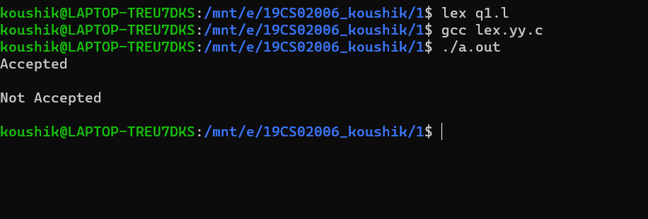

Question 1_3: Input and Output :

Input : 10101010

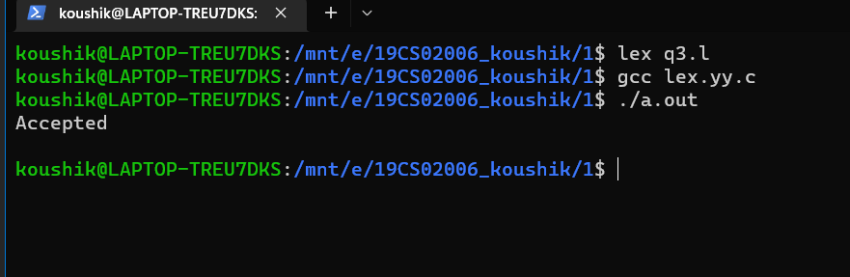

Question 2 : INPUT : if x then y<=10 else y <> invalid

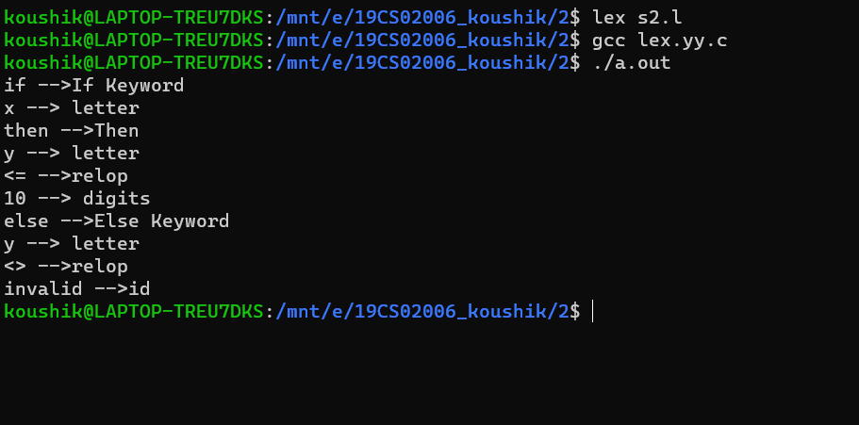

Question 3 : INPUT : main()

{

INT i=0;

INT total=0;

FLOAT count;

read(count);

for(i=0;i<10;i++)

{

read(x);

total= total+x;

}

print(total);

}

OUTPUT : 