**Exp No: 2** **Date: 23/03/2021**

**Creating XML Schema**

**Aim:**

1) Create a XML schema for resume.xml

2) Create a XML schema for personal book review management system.

**Theory:**

What is XSD ?

An XML schema is a description of a type of XML document, typically expressed in terms of constraints on the structure and content of documents of that type, above and beyond the basic syntactical constraints imposed by XML itself. These constraints are generally expressed using some combination of grammatical rules governing the order of elements, Boolean predicates that the content must satisfy, data types governing the content of elements and attributes, and more specialized rules such as uniqueness and referential integrity constraints.

There are languages developed specifically to express XML schemas. The document type definition (DTD) language, which is native to the XML specification, is a schema language that is of relatively limited capability, but that also has other uses in XML aside from the expression of schemas. Two more expressive XML schema languages in widespread use are XML Schema (with a capital S) and RELAX NG.

The mechanism for associating an XML document with a schema varies according to the schema language. The association may be achieved via mark-up within the XML document itself, or via some external means.

XSD (XML Schema Definition), a recommendation of the World Wide Web Consortium (W3C), specifies how to formally describe the elements in an Extensible Markup Language (XML) document. It can be used by programmers to verify each piece of item content in a document. They can check if it adheres to the description of the element it is placed in.

Like all XML schema languages, XSD can be used to express a set of rules to which an XML document must conform in order to be considered "valid" according to that schema. However, unlike most other schema languages, XSD was also designed with the intent that determination of a document's validity would produce a collection of information adhering to specific data types. Such a post-validation info set can be useful in the development of XML document processing software.

**Program:**

1. Resume.xsd

<?xml version = "1.0" encoding = "utf-8"?>

<xs:schema attributeFormDefault="unqualified" elementFormDefault="qualified" xmlns:xs="http://www.w3.org/2001/XMLSchema">

<xs:element name = "resume">

<xs:complexType>

<xs:sequence>

<xs:element name = "personal-details">

<xs:complexType>

<xs:sequence>

<xs:element name = "name">

<xs:complexType>

<xs:sequence>

<xs:element name = "firstname" type = "xs:string"/>

<xs:element name = "middlename" type = "xs:string"/>

<xs:element name = "surname" type = "xs:string"/>

</xs:sequence>

</xs:complexType>

</xs:element>

<xs:element name = "address">

<xs:complexType>

<xs:sequence>

<xs:element name = "hno" type = "xs:string"/>

<xs:element name = "landmark" type = "xs:string"/>

<xs:element name = "city" type = "xs:string"/>

<xs:element name = "zip-code" type = "xs:string"/>

<xs:element name = "state" type = "xs:string"/>

<xs:element name = "country" type = "xs:string"/>

</xs:sequence>

</xs:complexType>

</xs:element>

<xs:element name = "phno">

<xs:complexType>

<xs:sequence>

<xs:element name = "country-code" type = "xs:string"/>

<xs:element name = "area-code" type = "xs:positiveInteger"/>

<xs:element name = "no" type = "xs:positiveInteger"/>

</xs:sequence>

</xs:complexType>

</xs:element>

<xs:element name = "profile">

<xs:complexType>

<xs:sequence>

<xs:element name = "email" type = "xs:string"/>

<xs:element name = "medium" type = "xs:string"/>

<xs:element name = "github" type = "xs:string"/>

<xs:element name = "linkedin" type = "xs:string"/>

</xs:sequence>

</xs:complexType>

</xs:element>

</xs:sequence>

</xs:complexType>

</xs:element>

<xs:element name = "education-details">

<xs:complexType>

<xs:sequence>

<xs:element name = "school" maxOccurs="unbounded">

<xs:complexType>

<xs:sequence>

<xs:element name = "name" type = "xs:string"/>

<xs:element name = "duration">

<xs:complexType>

<xs:sequence>

<xs:element name = "start-year" type = "xs:string"/>

<xs:element name = "end-year" type = "xs:string"/>

</xs:sequence>

</xs:complexType>

</xs:element>

<xs:element name = "specialisation" type = "xs:string"/>

<xs:element name = "summary" type = "xs:string"/>

</xs:sequence>

</xs:complexType>

</xs:element>

</xs:sequence>

</xs:complexType>

</xs:element>

<xs:element name = "project-details">

<xs:complexType>

<xs:sequence>

<xs:element name = "project" maxOccurs="unbounded">

<xs:complexType>

<xs:sequence>

<xs:element name = "title" type = "xs:string"/>

<xs:element name = "project-summary" type = "xs:string"/>

<xs:element name = "duration">

<xs:complexType>

<xs:sequence>

<xs:element name = "start-date" type = "xs:string"></xs:element>

<xs:element name = "end-date" type = "xs:string"></xs:element>

</xs:sequence>

</xs:complexType>

</xs:element>

</xs:sequence>

</xs:complexType>

</xs:element>

</xs:sequence>

</xs:complexType>

</xs:element>

<xs:element name = "interest-details">

<xs:complexType>

<xs:sequence>

<xs:element name = "core-interests">

<xs:complexType>

<xs:sequence>

<xs:element name = "interest" maxOccurs ="unbounded"/>

</xs:sequence>

</xs:complexType>

</xs:element>

<xs:element name = "other-interests">

<xs:complexType>

<xs:sequence>

<xs:element name = "interest" maxOccurs ="unbounded"/>

</xs:sequence>

</xs:complexType>

</xs:element>

</xs:sequence>

</xs:complexType>

</xs:element>

</xs:sequence>

</xs:complexType>

</xs:element>

</xs:schema>

1. Book Review Management System.xsd

<?xml version="1.0" ?>

<xs:schema attributeFormDefault="unqualified" elementFormDefault="qualified" xmlns:xs="http://www.w3.org/2001/XMLSchema">

<xs:element name = "books">

<xs:complexType>

<xs:sequence>

<xs:element name = "book" maxOccurs="unbounded">

<xs:complexType>

<xs:sequence>

<xs:element name = "title" type ="xs:string"/>

<xs:element name = "authors">

<xs:complexType>

<xs:sequence>

<xs:element name = "author" maxOccurs="unbounded"/>

</xs:sequence>

</xs:complexType>

</xs:element>

<xs:element name = "publisher" type = "xs:string"/>

<xs:element name = "category" type ="xs:string"/>

<xs:element name = "genres">

<xs:complexType>

<xs:sequence>

<xs:element name = "genre" maxOccurs="unbounded"/>

</xs:sequence>

</xs:complexType>

</xs:element>

<xs:element name = "duration">

<xs:complexType>

<xs:sequence>

<xs:element name = "start-date">

<xs:complexType>

<xs:sequence>

<xs:element name = "day" type = "xs:string"/>

<xs:element name = "month" type = "xs:string"/>

<xs:element name = "year" type = "xs:string"/>

</xs:sequence>

</xs:complexType>

</xs:element>

<xs:element name = "end-date">

<xs:complexType>

<xs:sequence>

<xs:element name = "day" type = "xs:string"/>

<xs:element name = "month" type = "xs:string"/>

<xs:element name = "year" type = "xs:string"/>

</xs:sequence>

</xs:complexType>

</xs:element>

</xs:sequence>

</xs:complexType>

</xs:element>

<xs:element name = "quotes">

<xs:complexType>

<xs:sequence>

<xs:element name = "quote" maxOccurs="unbounded"/>

</xs:sequence>

</xs:complexType>

</xs:element>

<xs:element name = "characters">

<xs:complexType>

<xs:sequence>

<xs:element name = "character" maxOccurs="unbounded"/>

</xs:sequence>

</xs:complexType>

</xs:element>

<xs:element name = "related-articles">

<xs:complexType>

<xs:sequence>

<xs:element name = "article" maxOccurs="unbounded">

<xs:complexType>

<xs:sequence>

<xs:element name = "source" type = "xs:string"/>

<xs:element name = "link" type = "xs:string"/>

</xs:sequence>

</xs:complexType>

</xs:element>

</xs:sequence>

</xs:complexType>

</xs:element>

<xs:element name = "summary">

<xs:complexType>

<xs:sequence>

<xs:element name = "positive-points">

<xs:complexType>

<xs:sequence>

<xs:element name = "positive-point" maxOccurs="unbounded"/>

</xs:sequence>

</xs:complexType>

</xs:element>

<xs:element name = "negative-points">

<xs:complexType>

<xs:sequence>

<xs:element name = "negative-point" maxOccurs="unbounded"/>

</xs:sequence>

</xs:complexType>

</xs:element>

</xs:sequence>

</xs:complexType>

</xs:element>

<xs:element name = "rating" type = "xs:string"/>

<xs:element name = "review" type = "xs:string"/>

</xs:sequence>

</xs:complexType>

</xs:element>

</xs:sequence>

</xs:complexType>

</xs:element>

</xs:schema>

**Output:**

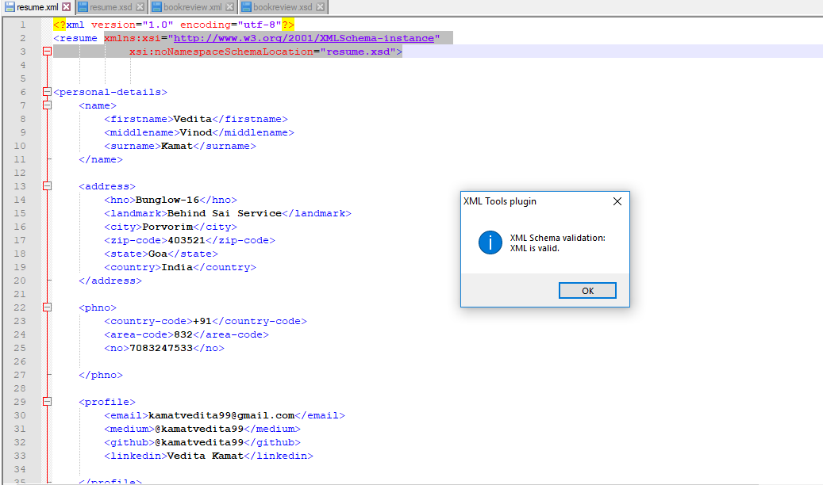

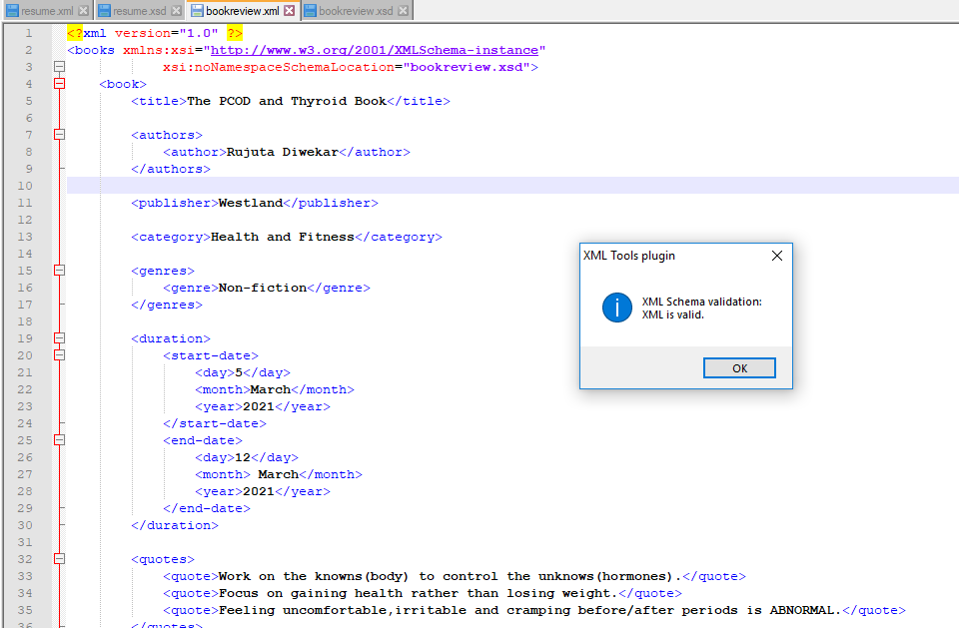

**Conclusion:** XML schema for resume and personal book review management system were created and validated successfully.