VAPV versus open field: crop productivity, nitrate leaching, soil water and soil carbon
Quantitative summary with substrip-level detail – Study 2 (agronomic management), Value4Farm vertical agrivoltaic trial, Foulum, Aarhus University
Draft for internal review · 10 November 2026 · Data: pipeline snapshot of 15–17 September 2026 (yield 2023–2025; NO₃ leaching 13 Sep 2024–1 Apr 2026; TDR 2024–2025; soil carbon 2024–2025)

1. Summary
This report compares plots between the vertical PV rows (VAPV) with the open-field reference in the same strips, first for each outcome overall and then position by position (west / centre / east) across the strip. All effects are VAPV relative to open field, averaged over the four fertiliser × residue treatments. Confidence intervals (CI) are 95% and computed at the level of nests (sub-strips), the sampling cluster, not individual plots, cups or samples.
- Productivity. Averaged over all crop-years, yield between the PV rows was −8% [−15, −1] of open field. Winter wheat grain yield was lower (−13% [−21, −4]); soybean −25% (CI [−55, +23], only 3 nests per location); grass-clover (annual sum of cuts) was unchanged (+1% [−3, +6]). Winter wheat grain N concentration was 0.20 percentage points higher(1.45 vs 1.64% N).
- Nitrate leaching. Over 566 days VAPV cups leached 33.2 vs 18.6 kg N/ha in open field (+71% [+2, +186]; strips A2 and A3 combined, 6 vs 6 nests); in the winter-wheat strip A2 58.3 vs 33.8 kg N/ha. The whole excess accrued in winter 2024/25 (+24.8 kg N/ha in A2); in winter 2025/26 the two locations did not differ.
- Soil water. VAPV was not drier than open field. In 2024 there was no difference (+0.0 / +0.3 percentage points at 20 / 50 cm). In 2025, when open-field soil was much drier, VAPV was wetter (+1.6 / +3.4 pp; wetter on 12 / 14 of 15 dates). This is not distinguishable at nest level because only three open-field nests were monitored.
- Soil carbon. SOC was 0.06 pp higher under VAPV (+3.5%, CI [−0.5, +7.6]), but the gap was already present in the 2024 survey (+0.07 pp) and did not widen (−0.01 pp [−0.09, +0.07]). A separate baseline survey shows a larger gap at depth. There is no evidence of a PV effect on SOC, and the data cannot yet show SOC change.
- Substrip level. Effects are not uniform across the strip. The winter wheat yield deficit sits at the West and East positions (2024: −19%, −2%, −23% at West / Centre / East); soybean losses were largest at East (−40%). Open-field positions themselves differ strongly in leaching (strip A2: 22 kg N/ha at Centre vs 41 and 39 at West / East), so position-level VAPV effects depend on the reference position.
- Main limits. VAPV vs open field is a contrast between strip halves with 1–3 strip pairs per crop-year, so intervals are optimistic; winter wheat 2025 yield (the strip with the largest leaching difference) is not yet entered; leaching assumes identical drainage in both locations; soil carbon was sampled at different points each round (Section 8).

Table 1. Headline comparison, VAPV vs open field. Percent difference is the ratio of geometric means of nest values, with a 95% CI from a Welch t-test on the log scale (strip-adjusted linear model for ‘both strips’). Bold = CI excludes 0.
Domain | Metric | Open field | VAPV | Diff. | VAPV vs open (%) [95% CI] | Nests O / V | p
Productivity | Winter wheat grain yield | – | – | – | −13% [−21, −4] | 9 / 9 | 0.007
 | Soybean grain yield | – | – | – | −25% [−55, +23] | 3 / 3 | 0.132
 | Grass-clover biomass (annual) | – | – | – | +1% [−3, +6] | 9 / 9 | 0.552
 | Spring barley green biomass | – | – | – | −9% [−25, +10] | 6 / 6 | 0.297
 | Ryegrass biomass (undersown) | – | – | – | +14% [−24, +72] | 3 / 3 | 0.415
 | All crops pooled (relative yield) | – | – | – | −8% [−15, −1] | 15 / 15 | 0.021
Nitrate leaching | NO₃-N leached, strip A2 (kg N/ha) | 33.8 | 58.3 | +24.5 | +79% [−20, +302] | 3 / 3 | 0.096
 | NO₃-N leached, strip A3 (kg N/ha) | 3.4 | 5.7 | +2.3 | +64% [−51, +443] | 3 / 3 | 0.318
 | NO₃-N leached, both strips (kg N/ha) | 18.6 | 33.2 | +14.6 | +71% [+2, +186] | 6 / 6 | 0.043
Soil water | Water content, 20 cm probe (vol-%) | 20.6 | 21.9 | +1.3 | +6% [−14, +30] | 3 / 9 | 0.401
 | Water content, 50 cm probe (vol-%) | 22.4 | 24.4 | +2.0 | +9% [−7, +28] | 3 / 9 | 0.159
Soil carbon | SOC, IUNG, 3 rounds (% C) | 1.86 | 1.94 | +0.06 | +3.5% [−0.5, +7.6] | 9 / 9 | 0.078
 | Total C 0–30 cm, baseline survey (%) | 1.86 | 2.17 | +0.32 | +18.5% [+4.7, +34.0] | 10 / 10 | 0.007
Yield rows are relative (open field = 100%); absolute yields are in Table 3. Soil-water row: nest-level contrast with 3 open-field vs 9 VAPV nests. Soil-carbon rows use nest means (IUNG: 9 vs 9 nests; baseline survey: 10 vs 10 West/East nests).

2. Site, data and methods

2.1 Design
The trial is at Aarhus University, Foulum (56°29′N, 9°33′E), under a vertical bifacial PV installation. Five main strips (A1–A5) each have an open-field half and a half between the PV rows (VAPV). Each half carries three nests (sub-strips N1–N30; West, Centre, East across the strip), and each nest has four plots of about 1.5 × 1.5 m with the four combinations of fertiliser (biogas digestate / mineral) and residue (removed / retained). The soil is a coarse sandy soil (Danish JB 4, clay about 8% in the topsoil). All comparisons here pool the four management combinations, which are present in every nest; fertiliser and residue effects are reported in the manuscript figures. The distance of each position from the panel rows is not recorded in the datasets used, so position effects are described, not explained geometrically.
Table 2. Data used, with coverage and the replication unit of each dataset.
Domain | Data | Period | Amount | Unit | Gaps / notes
Crop productivity | Dry-matter yield of primary product (grain; biomass for grass-clover, barley, ryegrass) | 2023-2025 seasons | 180 plot-yields (8 crop-years) | Plot (1 of 4 treatment plots per nest) | Winter wheat 2025 not yet entered; grass-clover 2023 = 3 cuts only
Crop productivity | Total N in harvested product (tissue N, %) | 2024 only | 84 plot values | Plot | Winter wheat, soybean, grass-clover only
Nitrate leaching | Suction-cup NO₃-N at 1 m + Daisy drainage (Drainage-Linear method) | 13 Sep 2024 to 1 Apr 2026 | 47 cups, 27 sampling dates | Cup (4 per nest; 12 nests) | Only strips A2 and A3; one drainage series per strip (same for VAPV and open field)
Soil water | TDR volumetric water content (20 and 50 cm probes) | 33 paired sampling dates, Mar-Aug 2024 and May-Sep 2025 | 456 nest-date values, 12 nests | Nest (2-4 plots each) | Open field = centre-position nests only (3 nests); no winter data
Soil carbon | Soil organic carbon, IUNG laboratory (3 survey rounds) | 2024 survey; 2025 T1 and T2 | 114 samples, 18 nests | Sample (distinct points per round) | Different physical points each round; no sampling dates in dataset
Soil carbon | Baseline soil survey, total C by depth (Aarhus University lab) | Winter 2024-25 | 20 nests x 3 depths | Nest | West and East nests only (no centre); single survey, no repeat
Raw inputs bundled in 1_input_data/ have not changed since the pipeline targets were built (file dates checked). Grass-clover yield is the sum of all cuts in the year per plot.

2.2 Statistics
- Descriptive numbers (tables and figures) are means ± SE of the stated unit (plot, cup, sample or nest). Individual observations are shown behind every mean in the figures.
- Inference for VAPV vs open field is done at nest level: values are averaged within each nest, log-transformed, and compared with a Welch t-test (a linear model with strip as a factor for the two leaching strips). The result is a ratio of geometric means expressed as a percent difference with a 95% CI. For soil water the paired difference per date (VAPV nests minus the open-field nest of the same strip) is also given. Absolute differences (percentage points) use the raw scale.
- Substrip (position) numbers use plots, cups or samples within one nest per position and strip. They are descriptive and exploratory: position is confounded with nest identity, and open-field positions show how large natural variation between nests is.
- No adjustment for multiple comparisons is made. ‘Clear’ means the 95% CI excludes 0; wide CIs from 3 vs 3 nests mean ‘not distinguishable’, not ‘no effect’. Because each strip half is a single experimental unit, even nest-level intervals understate the true uncertainty.

3. Crop productivity
Winter wheat grain yield was lower between the PV rows in both years with data: −8% in 2023 (3 vs 3 single-plot nests) and −15% [−24, −6] in 2024 (7.05 vs 6.02 Mg DM/ha). Winter wheat 2025 has no yield data yet (Section 8). Soybean 2024 yielded 1.28 vs 1.69 Mg DM/ha (−25%), but with 3 nests per location the CI is wide [−55, +23]. Grass-clover annual biomass did not differ (+7% in 2023, −3% in 2024, +0% in 2025). Spring barley green biomass was −9% (CI includes 0) and undersown ryegrass +14% at very low yields (about 1 Mg DM/ha; CI [−24, +72]). Pooled over crops, relative yield was −8% [−15, −1] (15 vs 15 nests).
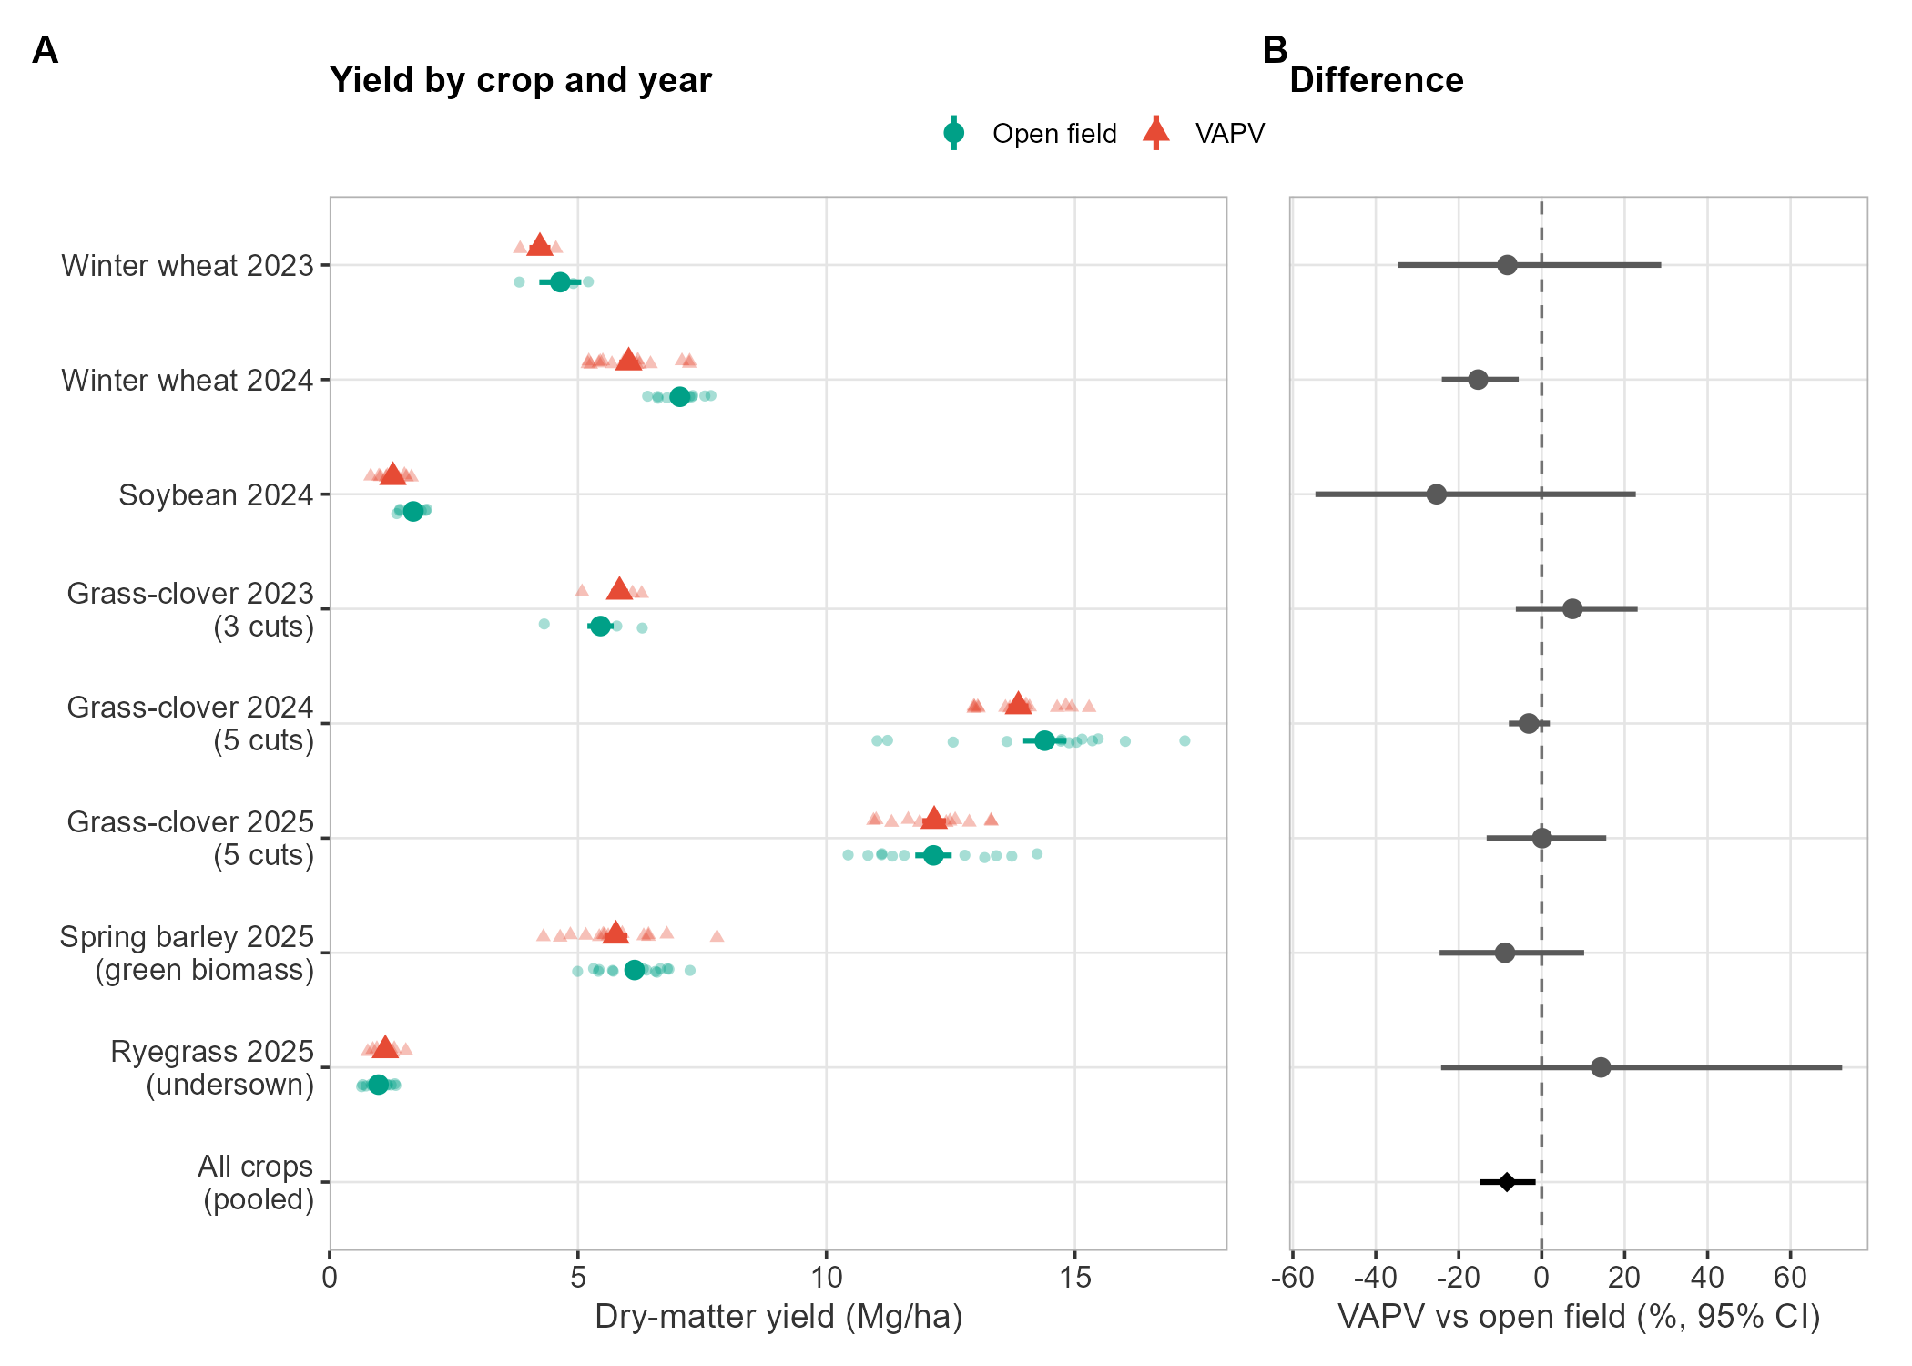
Figure 1. Dry-matter yield of each crop’s primary product by crop-year. (A) Plots (faint) and mean ± SE; (B) VAPV vs open field as percent difference with 95% CI from nest-level Welch tests; the bottom row is the pooled relative yield over all crop-years.
Table 3. Yield by crop-year, VAPV vs open field (Mg DM/ha; mean ± SE of plots).
Crop-year | Plots O / V | Nests O / V | Open field | VAPV | Diff. | VAPV vs open (%) [95% CI] | p
Winter wheat 2023 | 3 / 3 | 3 / 3 | 4.64 ± 0.42 | 4.23 ± 0.21 | −0.41 | −8% [−35, +29] | 0.481
Winter wheat 2024 | 15 / 15 | 6 / 6 | 7.05 ± 0.09 | 6.02 ± 0.19 | −1.03 | −15% [−24, −6] | 0.010
Soybean 2024 | 12 / 12 | 3 / 3 | 1.69 ± 0.06 | 1.28 ± 0.07 | −0.41 | −25% [−55, +23] | 0.132
Grass-clover 2023 (3 cuts) | 6 / 6 | 6 / 6 | 5.45 ± 0.26 | 5.84 ± 0.17 | +0.38 | +7% [−6, +23] | 0.259
Grass-clover 2024 (5 cuts) | 15 / 15 | 6 / 6 | 14.39 ± 0.43 | 13.86 ± 0.20 | −0.53 | −3% [−8, +2] | 0.196
Grass-clover 2025 (5 cuts) | 12 / 12 | 3 / 3 | 12.15 ± 0.37 | 12.17 ± 0.24 | +0.01 | +0% [−13, +16] | 0.984
Spring barley 2025 (green biomass) | 15 / 15 | 6 / 6 | 6.14 ± 0.17 | 5.76 ± 0.23 | −0.38 | −9% [−25, +10] | 0.297
Ryegrass 2025 (undersown) | 12 / 12 | 3 / 3 | 0.99 ± 0.07 | 1.12 ± 0.06 | +0.14 | +14% [−24, +72] | 0.415
Percent difference and p use nest means (geometric); ‘Diff.’ is the difference of arithmetic plot means, so the two can differ slightly. Grass-clover 2025 uses strip A4 only (strip A1 lacks cut 1). Bold = CI excludes 0.

Tissue N
Total N in the harvested product exists for 2024 only. Winter wheat grain was richer in N between the PV rows (1.64 vs 1.45% N; +0.20 pp [+0.12, +0.27]), which fits its lower yield. Soybean (−0.13 pp [−0.41, +0.16]) and grass-clover (+0.07 pp [−0.07, +0.20]) did not differ.

Substrip level
The yield deficit was not uniform across the strip (Figure 2, Table 4). In winter wheat 2024 it was −19% at West and −23% at East but only −2% at Centre; soybean losses occurred at all three positions and were largest at East (−40%; West −15%, Centre −19%). Spring barley was −15% / +8% / −11%. Grass-clover differences stayed within ±12% at every position and year. Open-field positions differed by at most 7% in winter wheat 2024, so the West and East deficits exceed natural position-to-position variation. The ryegrass West difference (+50%) mainly reflects a low open-field West reference (0.78 vs 1.11 Mg DM/ha at Centre). Whether the West/East deficit reflects shading, shelter or other panel effects cannot be resolved with these data.
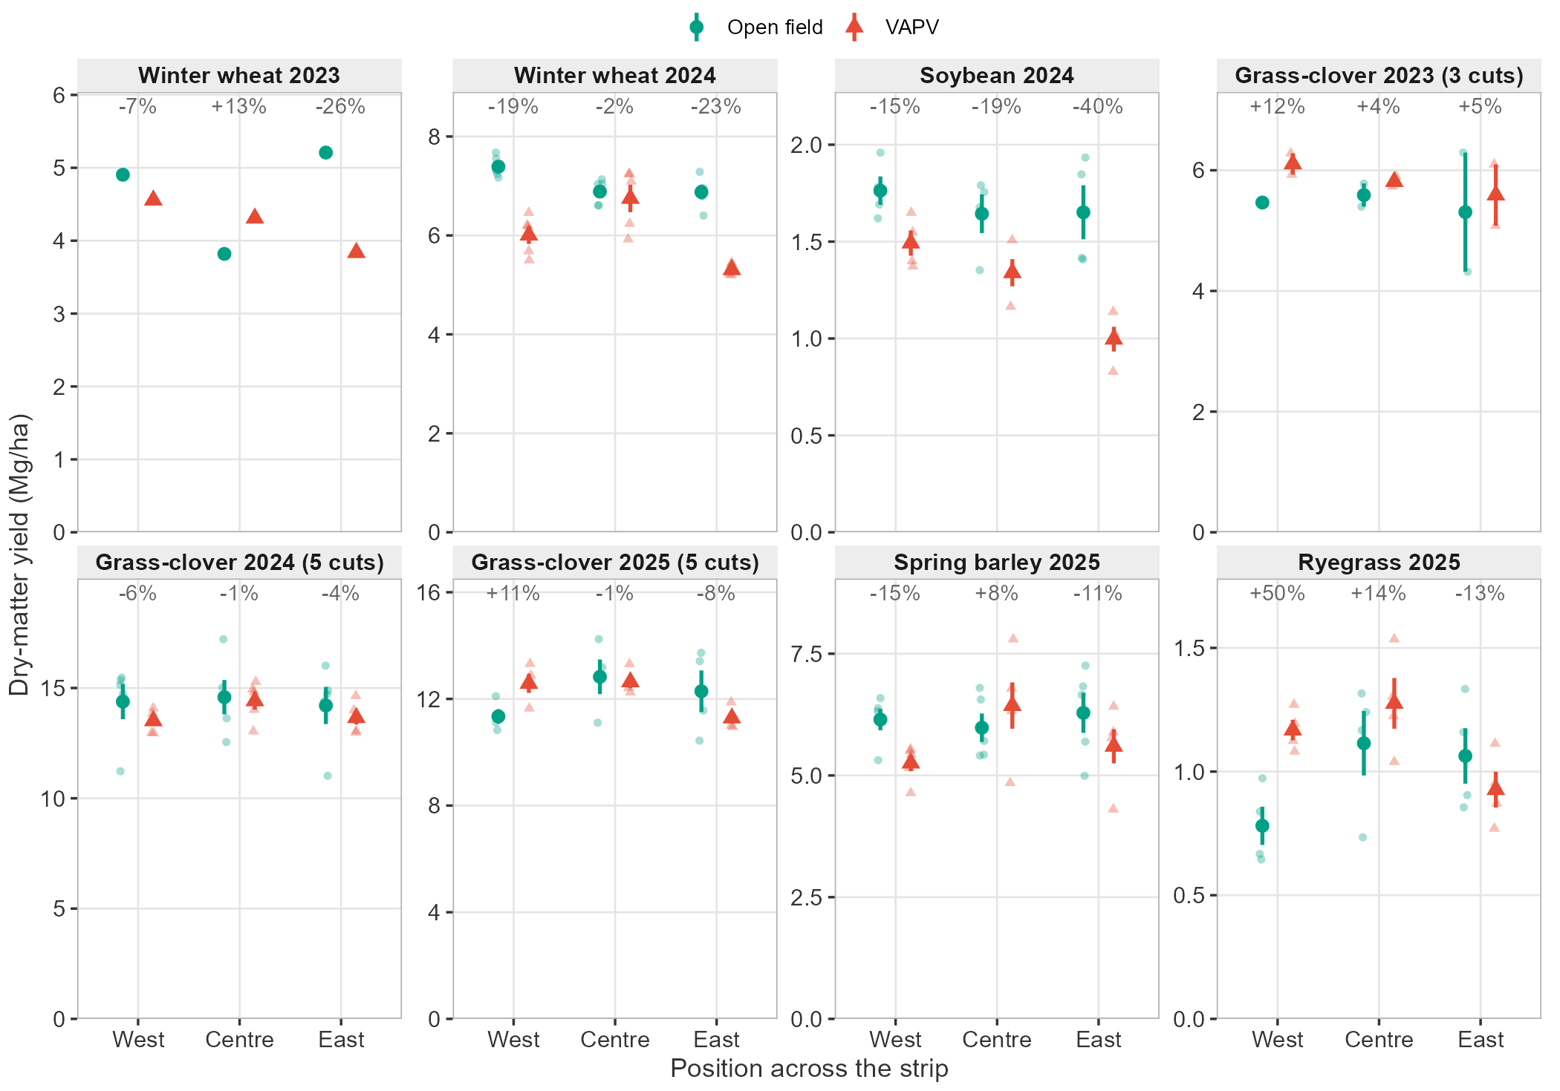
Figure 2. Yield by position across the strip (West, Centre, East), open field vs VAPV, for each crop-year (free y-axes). Faint symbols are plots; symbols with bars are mean ± SE. Numbers above each position give the VAPV vs open difference of the means. Winter wheat 2023 has one plot per cell.
Table 4. Yield by position: open vs VAPV mean (Mg DM/ha) and percent difference of the means.
Crop-year | West: open vs VAPV | West diff. | Centre: open vs VAPV | Centre diff. | East: open vs VAPV | East diff.
Winter wheat 2023 | 4.90 vs 4.56 | −7% | 3.82 vs 4.31 | +13% | 5.21 vs 3.84 | −26%
Winter wheat 2024 | 7.39 vs 6.01 | −19% | 6.89 vs 6.75 | −2% | 6.88 vs 5.31 | −23%
Soybean 2024 | 1.76 vs 1.49 | −15% | 1.64 vs 1.34 | −19% | 1.65 vs 1.00 | −40%
Grass-clover 2023 (3 cuts) | 5.47 vs 6.11 | +12% | 5.59 vs 5.81 | +4% | 5.31 vs 5.59 | +5%
Grass-clover 2024 (5 cuts) | 14.38 vs 13.51 | −6% | 14.58 vs 14.42 | −1% | 14.21 vs 13.66 | −4%
Grass-clover 2025 (5 cuts) | 11.34 vs 12.58 | +11% | 12.83 vs 12.64 | −1% | 12.29 vs 11.28 | −8%
Spring barley 2025 (green biomass) | 6.15 vs 5.25 | −15% | 5.98 vs 6.43 | +8% | 6.29 vs 5.60 | −11%
Ryegrass 2025 (undersown) | 0.78 vs 1.17 | +50% | 1.11 vs 1.28 | +14% | 1.06 vs 0.93 | −13%
n = 4–5 plots per cell (1 in 2023; 2 for grass-clover 2023) from a single nest per position and strip. Bold = plot-level 95% CI of the log ratio excludes 0 (exploratory only).

4. Nitrate leaching
NO₃-N leaching below 1 m was estimated with the Drainage-Linear method: suction-cup NO₃-N concentrations (linearly interpolated, 27 sampling dates) multiplied by Daisy-simulated daily drainage, summed from 13 Sep 2024 to 1 Apr 2026 (566 days). Strip A2 (winter wheat) carries nearly all of the leaching: 33.8 ± 4.0 kg N/ha in open field vs 58.3 ± 3.3 between the PV rows (+79%, CI [−20, +302] with 3 vs 3 nests). Strip A3 (grass-clover, then barley with undersown ryegrass) leached 3.4 vs 5.7 kg N/ha (+64%, CI [−51, +443]). Combining both strips with strip as a factor gives +71% [+2, +186] (p = 0.043, 6 vs 6 nests).
Table 5. NO₃-N leaching 13 Sep 2024–1 Apr 2026 (kg N/ha; mean ± SE of cups), Daisy drainage and flow-weighted concentration.
Strip | Open field | VAPV | Diff. | VAPV vs open (%) [95% CI] | Drain. (mm) | Conc. (mg N/L) open vs VAPV | Cups; nests O / V
A2 winter wheat | 33.8 ± 4.0 | 58.3 ± 3.3 | +24.5 | +79% [−20, +302] | 326 | 10.4 vs 17.9 | 12 / 12; 3 / 3
A3 grass-clover / barley | 3.4 ± 0.8 | 5.7 ± 1.4 | +2.3 | +64% [−51, +443] | 313 | 1.1 vs 1.8 | 12 / 11; 3 / 3
Both strips | 18.6 ± 3.7 | 33.2 ± 5.9 | +14.6 | +71% [+2, +186] | 319 | 5.7 vs 10.2 | 24 / 23; 6 / 6
Percent difference at nest level. Drainage is one Daisy series per strip, identical for both locations. Flow-weighted concentration = N leached / drainage. The EU drinking-water limit corresponds to 11.3 mg NO₃-N/L.
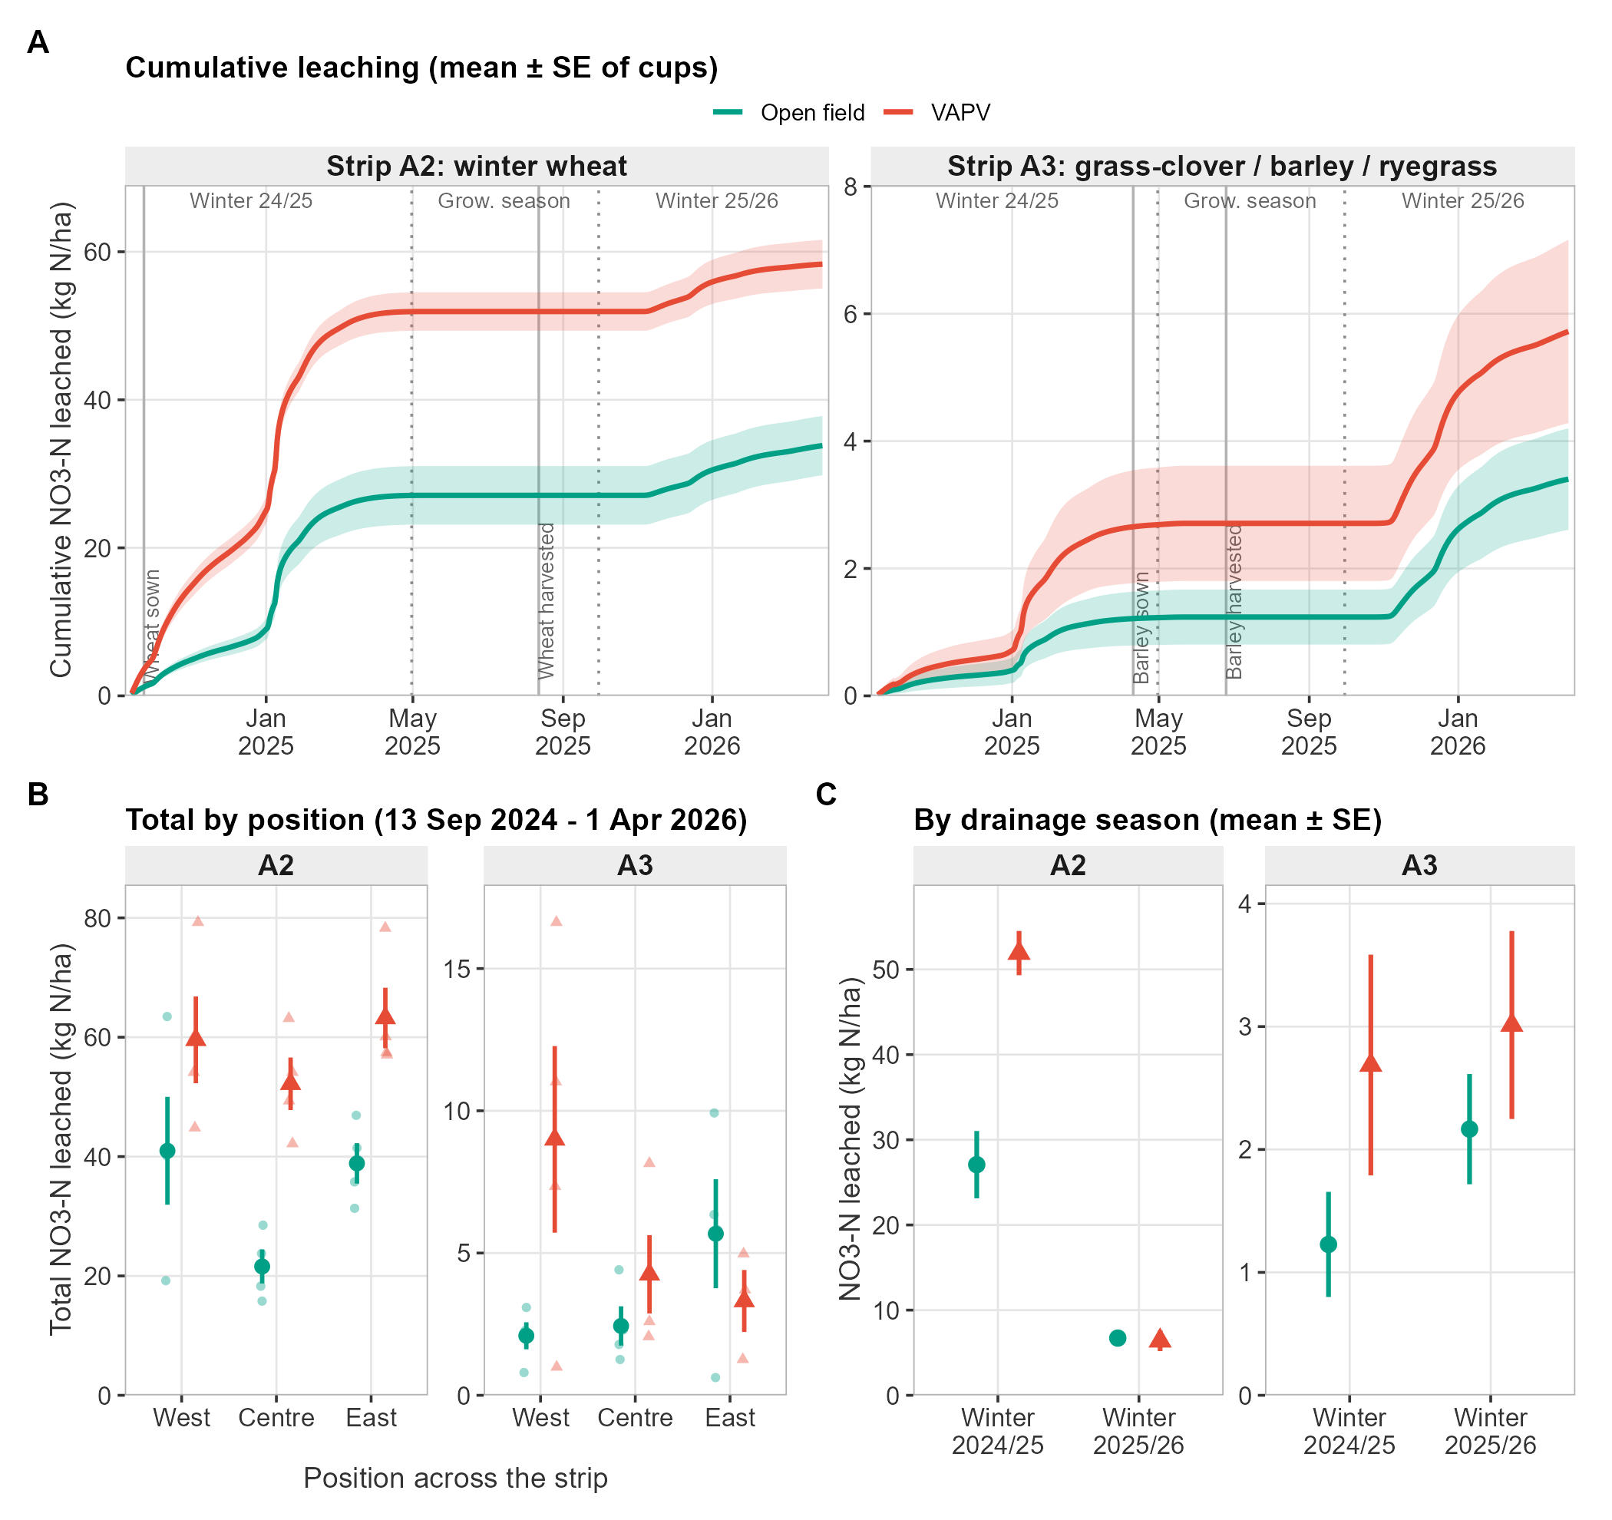
Figure 3. Nitrate leaching. (A) Cumulative NO₃-N leached, mean ± SE of cups, with crop events and drainage seasons; (B) total leached by position (faint symbols are cups); (C) leaching by drainage season (the growing season is ~0 kg N/ha in both locations and is omitted).
Timing. The VAPV excess in A2 arose entirely in winter 2024/25: 27.1 vs 51.9 kg N/ha (+24.8 [+1.3, +48.4]). In winter 2025/26 both locations leached about the same (6.7 vs 6.4 kg N/ha) and the growing season contributed almost nothing (drainage 0.2 mm). Concentration. In A2 the mean cup concentration was 16.2 mg N/L in VAPV vs 9.0 in open field, and 52% vs 27% of samples exceeded 11.3 mg N/L. Because both locations use the same drainage, the difference comes entirely from soil-water concentration.
Table 6. NO₃-N leaching by drainage season (kg N/ha; mean ± SE of cups) and nest-level difference.
Strip | Season | Drain. (mm) | Open field | VAPV | Diff. [95% CI]
A2 | Winter 2024/25 (13 Sep-30 Apr) | 223 | 27.1 ± 4.0 | 51.9 ± 2.6 | +24.8 [+1.3, +48.4]
A2 | Growing season 2025 (1 May-30 Sep) | 0 | 0.013 ± 0.003 | 0.015 ± 0.004 | +0.002 [−0.004, +0.009]
A2 | Winter 2025/26 (1 Oct-1 Apr) | 103 | 6.7 ± 0.6 | 6.4 ± 1.2 | −0.3 [−1.7, +1.1]
A3 | Winter 2024/25 (13 Sep-30 Apr) | 199 | 1.2 ± 0.4 | 2.7 ± 0.9 | +1.3 [−2.7, +5.3]
A3 | Growing season 2025 (1 May-30 Sep) | 2 | 0.010 ± 0.005 | 0.021 ± 0.008 | +0.010 [−0.024, +0.045]
A3 | Winter 2025/26 (1 Oct-1 Apr) | 111 | 2.2 ± 0.4 | 3.0 ± 0.8 | +0.8 [−2.9, +4.6]
W1 and W2 = drainage seasons; GS = growing season. Difference CIs use nest means (3 vs 3 per strip).

Substrip level
In A2 the open-field positions already differed twofold: 21.6 kg N/ha at Centre vs 41.0 at West and 38.9 at East, whereas VAPV positions were more even (59.6, 52.2, 63.2). The VAPV excess was therefore largest at Centre (+30.6 kg N/ha) and smaller at West (+18.6) and East (+24.4). In A3 amounts are small (≤9 kg N/ha) and the pattern is inconsistent between positions, with 3–4 cups each (Table 7).
Table 7. NO₃-N leached by position (kg N/ha; mean ± SE of cups; n cups in brackets).
Strip | Position | Open field | VAPV | Diff. | Diff. (%)
A2 | West | 41.0 ± 9.0 (4) | 59.6 ± 7.3 (4) | +18.6 | +45%
A2 | Centre | 21.6 ± 2.8 (4) | 52.2 ± 4.4 (4) | +30.6 | +142%
A2 | East | 38.9 ± 3.4 (4) | 63.2 ± 5.1 (4) | +24.4 | +63%
A3 | West | 2.1 ± 0.5 (4) | 9.0 ± 3.3 (4) | +6.9 | +330%
A3 | Centre | 2.4 ± 0.7 (4) | 4.3 ± 1.4 (4) | +1.8 | +74%
A3 | East | 5.7 ± 1.9 (4) | 3.3 ± 1.1 (3) | −2.4 | −42%

5. Soil water
Volumetric water content was measured with TDR probes of 20 and 50 cm length in 12 nests on 33 dates (Mar–Aug 2024 and May–Sep 2025; growing season only). Each VAPV nest is compared with the open-field nest of the same strip on the same date. Over both years VAPV was wetter by +0.7 pp [+0.1, +1.3] at 20 cm and +1.7 pp [+0.9, +2.4] at 50 cm (CI across dates), but the pattern depended on year. In 2024 (open-field mean 26–27 vol-%) the locations were equal. In 2025, when the open-field soil was much drier (mean 18 vol-%), VAPV was wetter by +1.6 pp (20 cm) and +3.4 pp (50 cm). With only three open-field nests, the nest-level contrasts (+1.3 pp [−2.8, +5.4] at 20 cm; +2.0 pp [−1.4, +5.4] at 50 cm) are consistent in sign but their CIs include 0.
Table 8. Paired VAPV minus open-field soil water content (percentage points) by year and probe; CI across sampling dates.
Probe (cm) | Year | Dates | Open field (vol-%) | VAPV (vol-%) | Diff. (pp) [95% CI] | Dates VAPV wetter
20 cm | 2024 | 18 | 25.8 | 25.8 | +0.0 [−0.6, +0.5] | 11 of 18 (61%)
20 cm | 2025 | 15 | 18.2 | 19.8 | +1.6 [+0.5, +2.7] | 12 of 15 (80%)
20 cm | Both years | 33 | 22.4 | 23.1 | +0.7 [+0.1, +1.3] | 23 of 33 (70%)
50 cm | 2024 | 18 | 26.7 | 27.0 | +0.3 [−0.5, +1.0] | 12 of 18 (67%)
50 cm | 2025 | 15 | 18.1 | 21.4 | +3.4 [+2.5, +4.2] | 14 of 15 (93%)
50 cm | Both years | 33 | 22.8 | 24.5 | +1.7 [+0.9, +2.4] | 26 of 33 (79%)
Duplicate records of the same measurement (324 date/nest/plot/probe combinations appear in more than one crop-labelled file) were averaged; using the first record only changes any row of this table by at most 0.7 pp (largest: 2025, 50 cm probe), without changing sign or conclusions. Bold = CI across dates excludes 0 (dates are not independent).

Substrip level
The contrast was smallest at the Centre of the VAPV strip (−0.4 pp at 20 cm, +0.9 pp at 50 cm) and larger at West (+1.6 / +2.4 pp) and East (+0.9 / +1.7 pp), where VAPV was wetter on most dates (Table 9). Only the centre position of the open field was instrumented, so open-field West/East values, and therefore natural spatial variation in soil water, are unknown; the position contrasts are against the open-field centre only.
Table 9. VAPV minus open-field centre soil water content by VAPV position (pp; mean over dates [95% CI]; share of dates VAPV wetter).
Probe (cm) | West | Centre | East
20 cm | +1.6 [+1.0, +2.2]; 85% | −0.4 [−1.1, +0.3]; 36% | +0.9 [−0.0, +1.9]; 61%
50 cm | +2.4 [+1.5, +3.4]; 85% | +0.9 [+0.2, +1.6]; 73% | +1.7 [+0.8, +2.5]; 79%
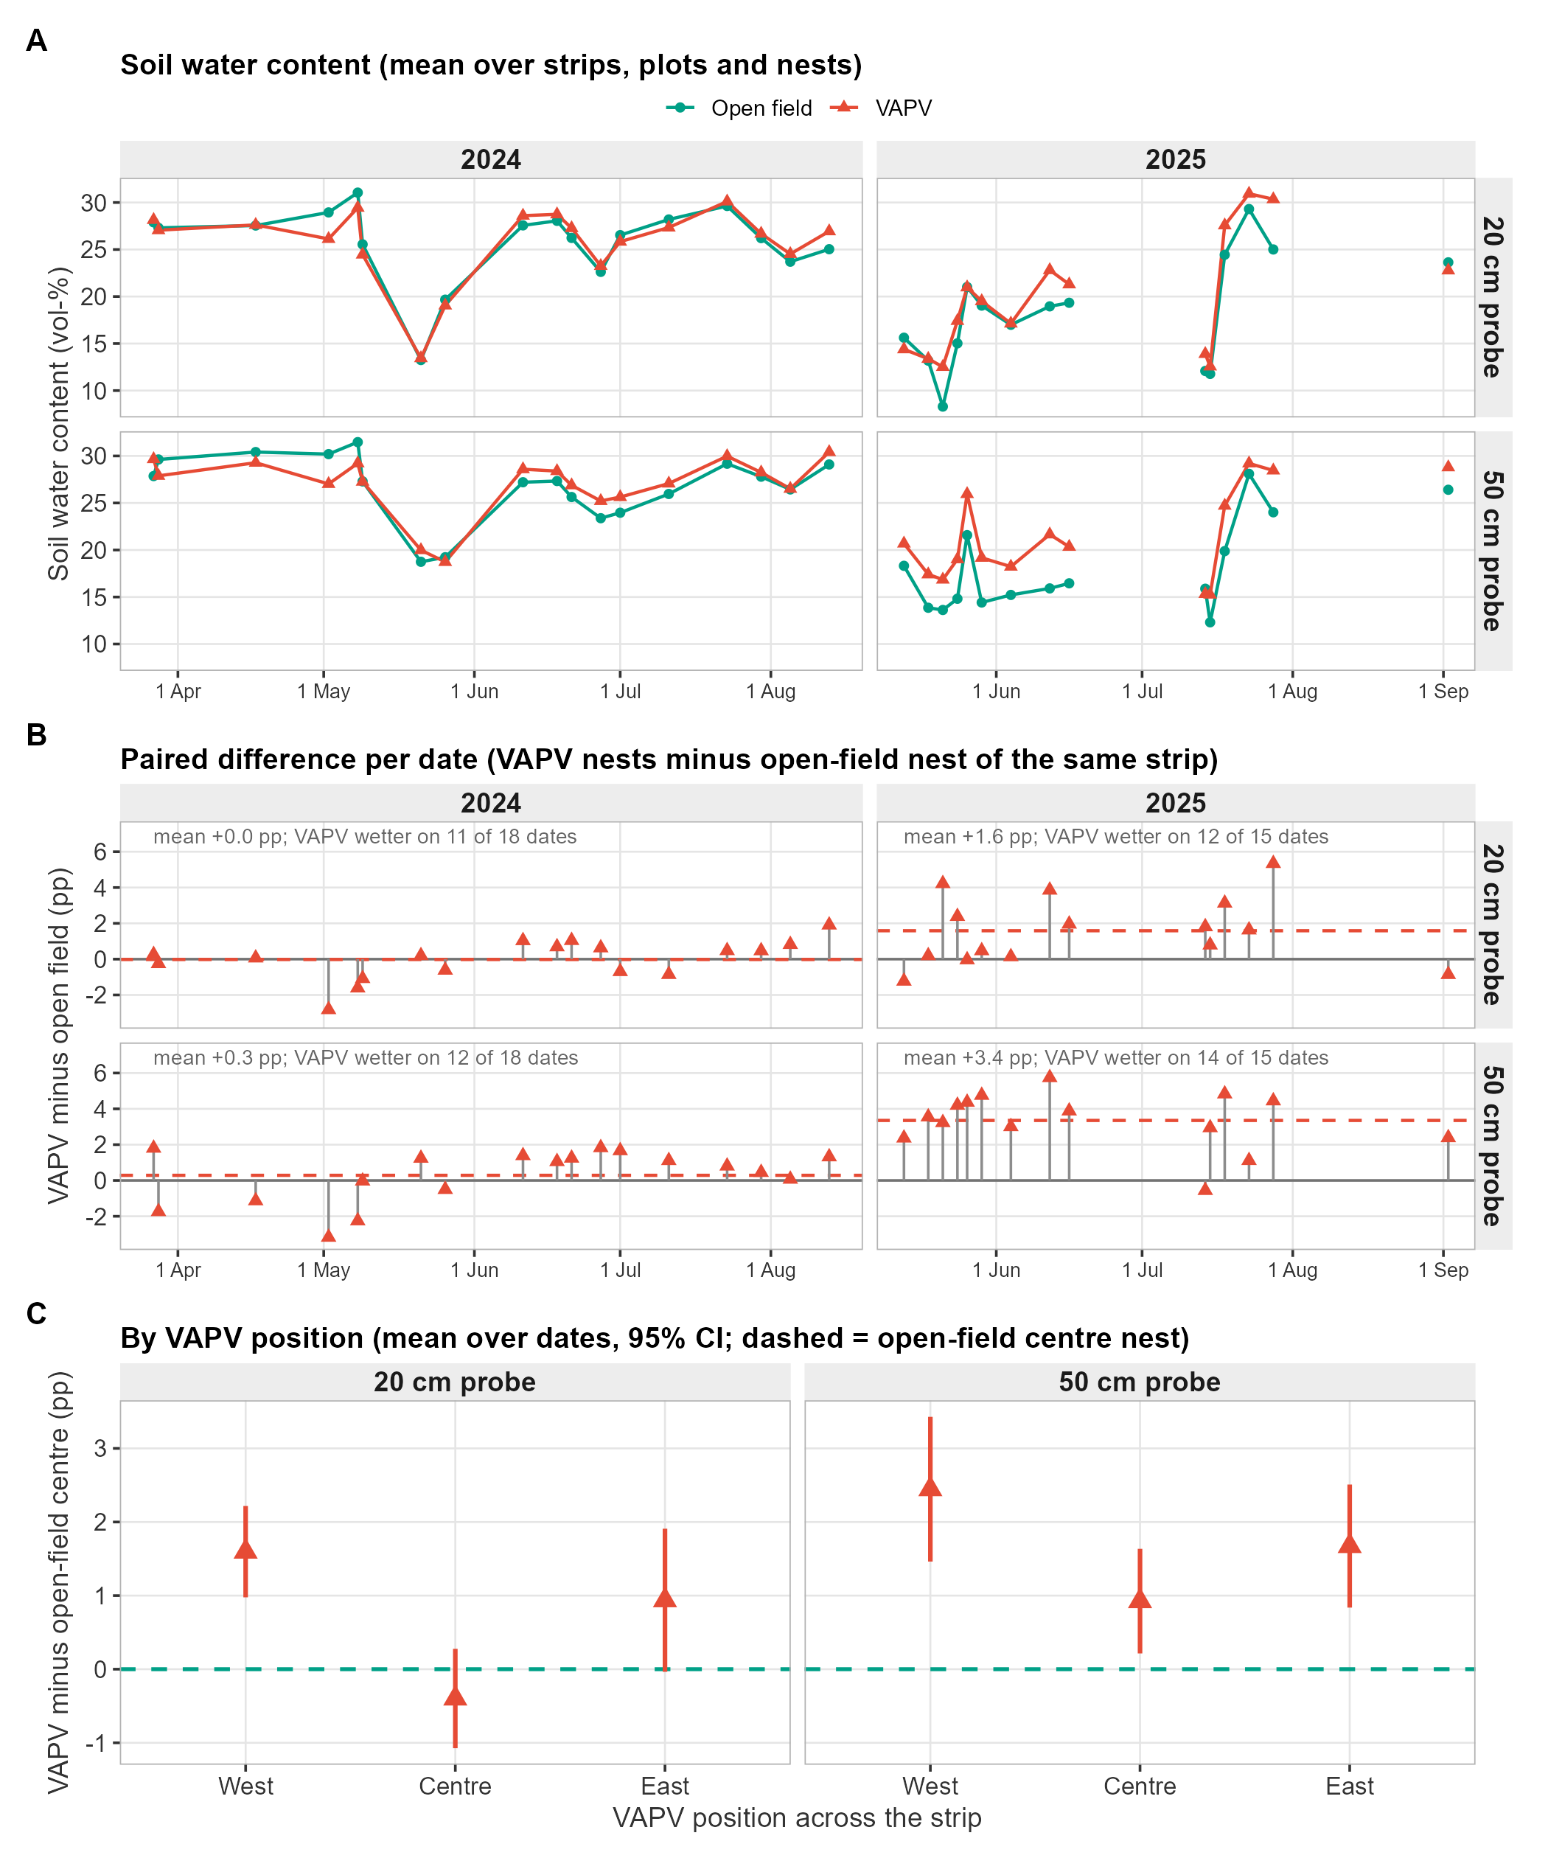
Figure 4. Soil water content (TDR). (A) Mean of open-field and VAPV nests per date (lines broken across gaps > 25 days); (B) paired VAPV minus open-field difference per date with the mean and the number of dates VAPV was wetter; (C) difference by VAPV position relative to the open-field centre nest (mean over dates, 95% CI).

6. Soil carbon
Soil organic carbon (SOC) from the IUNG laboratory was 1.94% under VAPV vs 1.86% in open field across the three rounds (+0.06 pp; +3.5% [−0.5, +7.6]; 9 vs 9 nests). The gap was already +0.07 pp [+0.01, +0.13] in the 2024 survey, +0.14 pp in 2025 T1 and +0.06 pp in 2025 T2. Nest means rose by similar amounts in both locations from the 2024 survey to 2025 T2 (open +0.079, VAPV +0.066 pp; difference −0.013 pp [−0.094, +0.068]), so there is no sign that the gap widened. Every round sampled different physical points, so these are comparisons of SOC levels, not measurements of SOC change.
A separate baseline survey (Aarhus University laboratory, winter 2024/25, West and East nests) shows larger gaps: total C at 0–30 cm was 2.17 vs 1.86% (+0.32 pp [+0.10, +0.53]) and at 30–60 cm 1.36 vs 0.63% (+0.73 pp [+0.25, +1.21]). A gap that is larger at depth, where management and PV effects over 1–2 seasons should be smallest, points to pre-existing differences in the soil between strip halves rather than a PV effect (clay at 30–60 cm also differed: 7.5% vs 9.6%). The two laboratories differ in method and depth, so absolute values are not directly comparable.
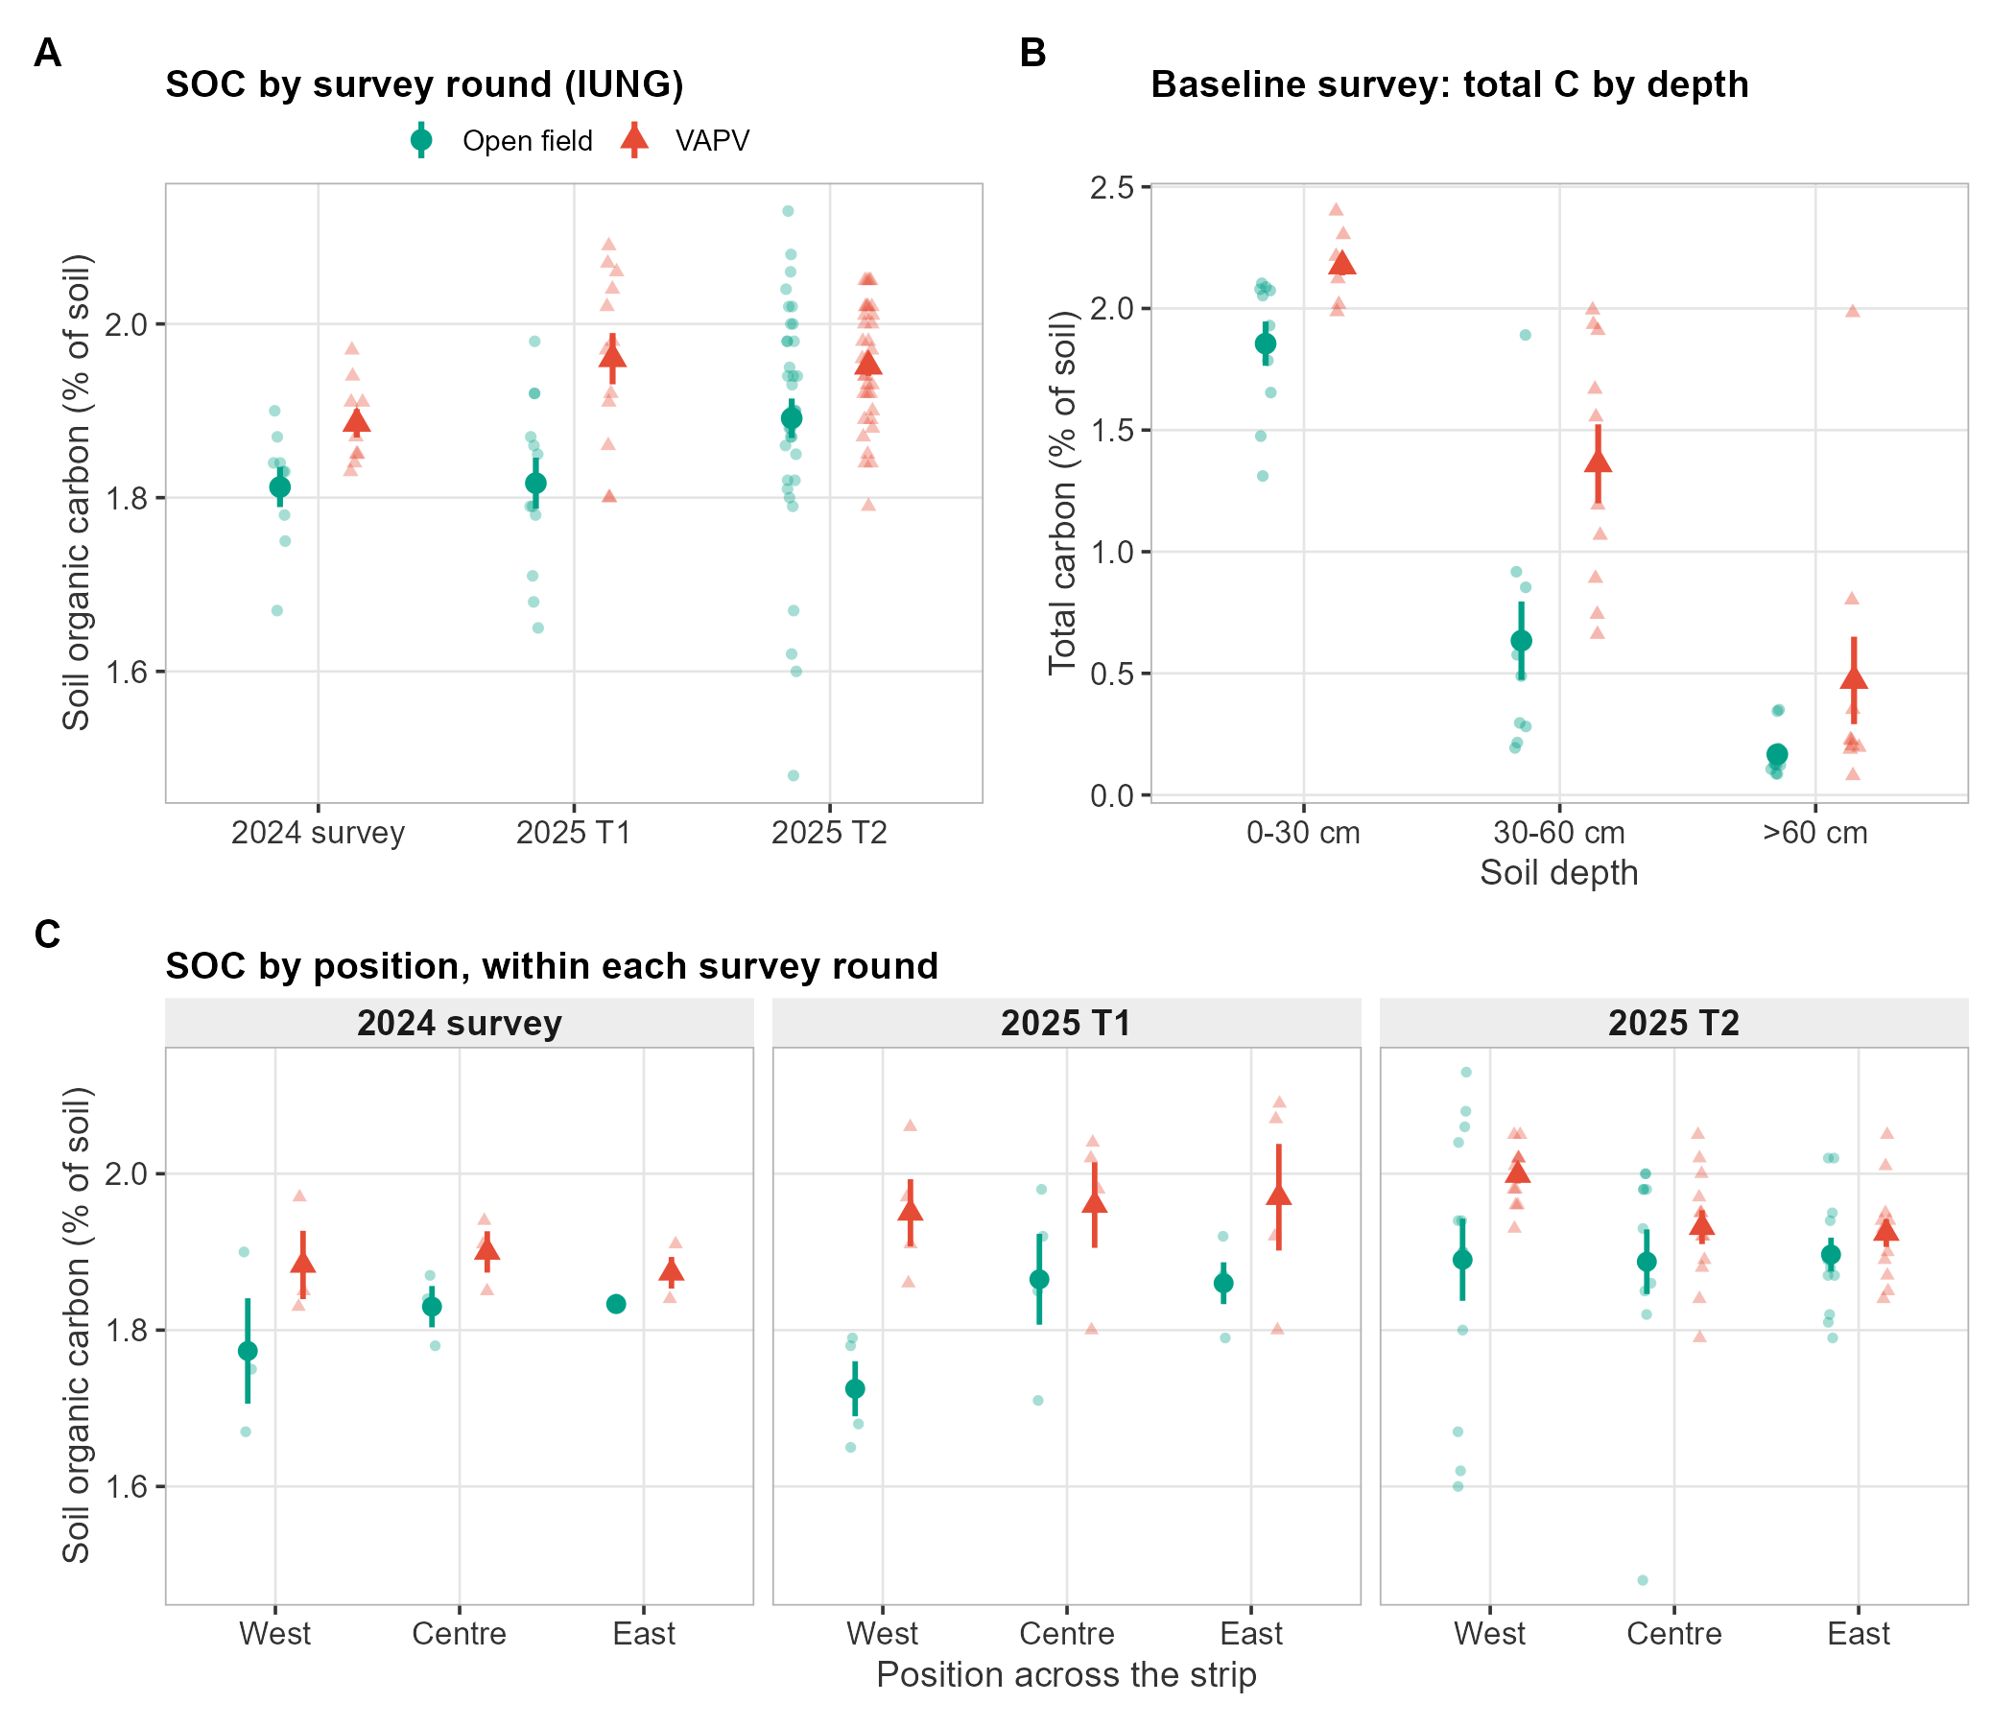
Figure 5. Soil carbon. (A) SOC by survey round (IUNG; faint symbols are samples); (B) baseline survey total C by depth (faint symbols are nests); (C) SOC by position within each round. Rounds sampled different points.
Table 10. SOC by survey round (IUNG; % of soil; mean ± SE of samples) with nest-level differences.
Round | Samples O / V | Nests O / V | Open field | VAPV | Diff. (pp) [95% CI] | Diff. (%) [95% CI] | p
2024 survey | 9 / 9 | 9 / 9 | 1.81 ± 0.02 | 1.89 ± 0.02 | +0.07 [+0.01, +0.13] | +4.1% [+0.7, +7.6] | 0.021
2025 T1 | 12 / 12 | 3 / 3 | 1.82 ± 0.03 | 1.96 ± 0.03 | +0.14 [−0.05, +0.34] | +8.0% [−3.1, +20.3] | 0.087
2025 T2 | 36 / 36 | 9 / 9 | 1.89 ± 0.02 | 1.95 ± 0.01 | +0.06 [−0.03, +0.15] | +3.3% [−1.7, +8.5] | 0.179
All rounds (nest means) | 57 / 57 | 9 / 9 | 1.86 ± 0.02 | 1.94 ± 0.01 | +0.06 [−0.01, +0.14] | +3.5% [−0.5, +7.6] | 0.078
The last row averages each nest over rounds first. Rows for single rounds use nest means within the round (2025 T1: 3 vs 3 nests).
Table 11. Baseline survey: total C (% of soil) by depth, nest level (10 vs 10 West/East nests).
Depth | Open field | VAPV | Diff. (pp) [95% CI] | Diff. (%) [95% CI] | p
0–30 cm | 1.86 ± 0.09 | 2.17 ± 0.04 | +0.32 [+0.10, +0.53] | +18% [+5, +34] | 0.007
30–60 cm | 0.63 ± 0.16 | 1.36 ± 0.16 | +0.73 [+0.25, +1.21] | +155% [+45, +348] | 0.005
>60 cm | 0.17 ± 0.03 | 0.47 ± 0.18 | +0.30 [−0.11, +0.71] | +110% [+5, +321] | 0.128

Substrip level
VAPV SOC exceeded open-field SOC at every position in every round (gaps 0.03 to 0.22 pp; Figure 5C, Table A3). The largest gap was at West in 2025 T1, partly because the open-field West position had the lowest SOC in the 2024 survey and 2025 T1 (1.77 and 1.73% vs 1.83–1.86% at Centre and East). In the baseline survey (0–30 cm) the gap was +0.41 pp at West and +0.23 pp at East. With 3–12 samples per cell (5 nests per cell in the baseline survey), position differences should not be over-read.

7. Substrip synthesis
Figure 6 puts the four outcomes on one scale by expressing each observation as a percent of the open-field mean of its own stratum (crop-year, strip, date or survey round). Three points stand out. (1) VAPV effects on yield, leaching and soil water differ between positions, whereas SOC is higher under VAPV at all three. (2) Natural variation among open-field positions is negligible for yield (98–101%) and SOC (99–101%) but large for leaching (68–141%), so position-level leaching differences are the least reliable. (3) VAPV West stands out for leaching (220%), soil water (115%) and SOC (106%), while VAPV East has the lowest yield (86%) and VAPV Centre is closest to open field for yield (102%) and soil water (104%). The West leaching value is driven partly by strip A3 (Table 7).
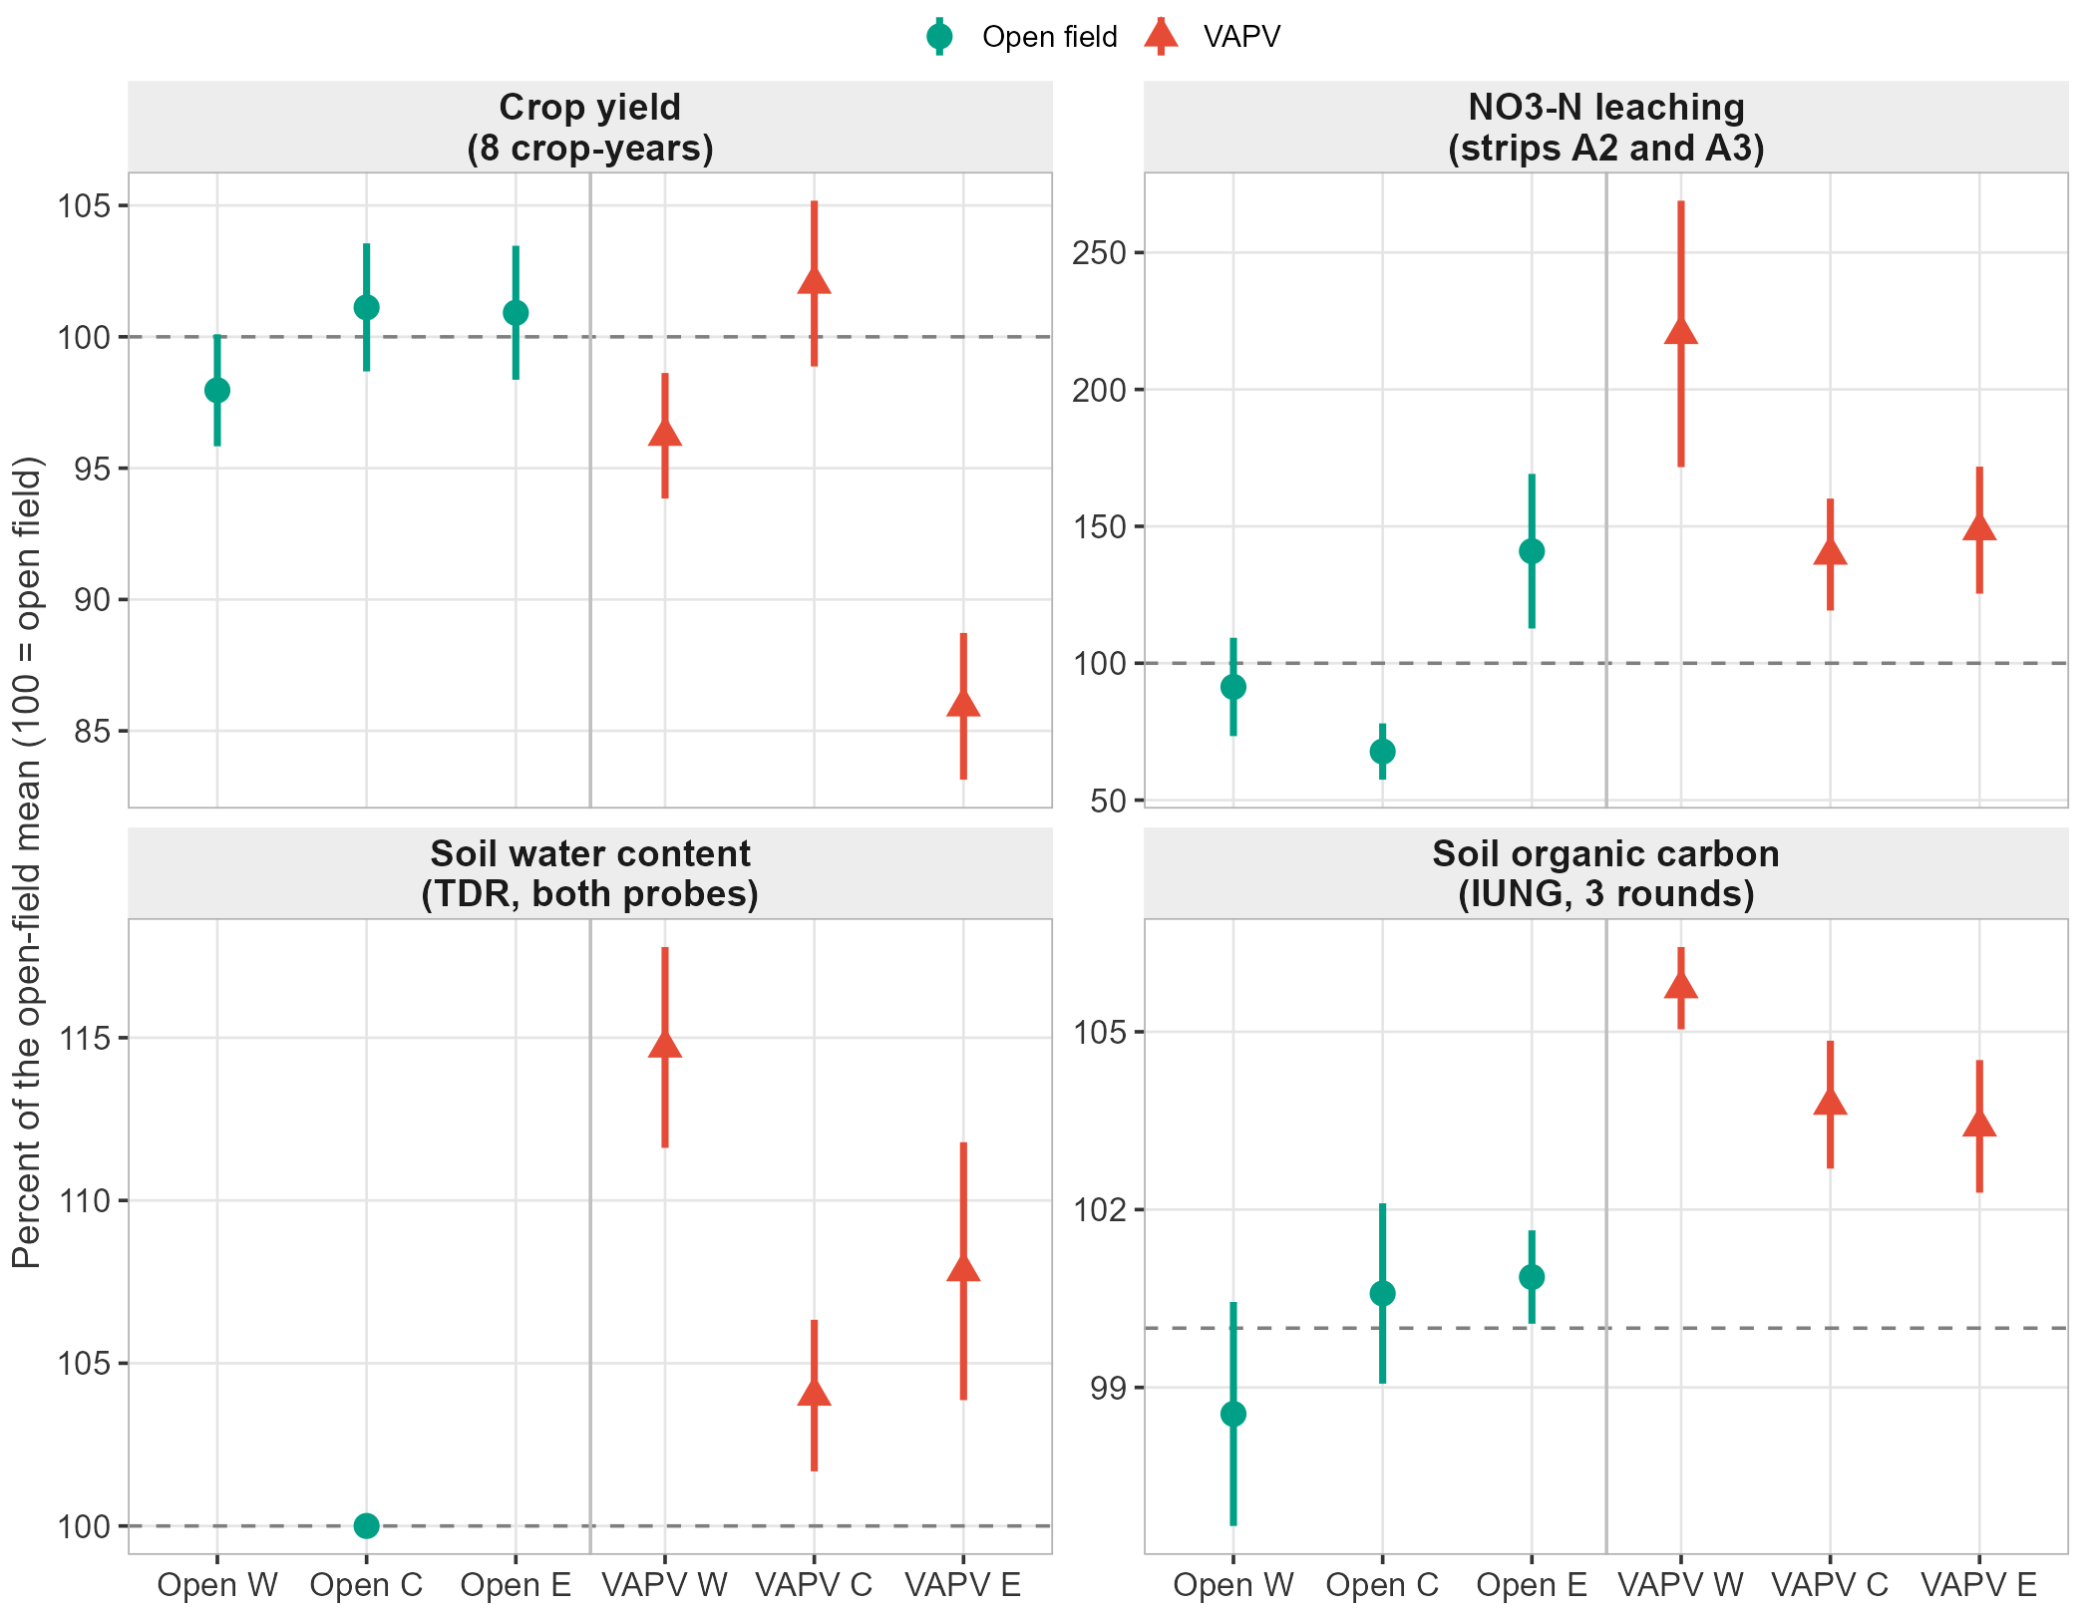
Figure 6. Substrip synthesis. Each point is mean ± SE of observations (plots, cups, nest-level date ratios or samples) as a percent of the open-field mean of the same stratum. W/C/E = West/Centre/East. The soil-water panel has only one open-field position (centre; reference = 100). Panels have different y-axis ranges.

8. Data gaps, caveats and next steps
The table lists what limits each conclusion above and what would most improve it.
Table 12. Limitations and suggested actions.
Area | Limitation | Suggested action
Replication | VAPV vs open field is a contrast between strip halves (1–3 strip pairs per crop-year); plots, cups and nests are subsamples. CIs are lower bounds on uncertainty. | Treat effects as indicative; add strip pairs or years; keep reporting nest-level CIs.
Winter wheat 2025 yield | All 24 winter wheat 2025 plots (strip A2) are blank in the yield workbook. This is the strip with the largest leaching difference, so leaching cannot yet be linked to crop N uptake. | Enter 2025 grain yield and N content, then compute N offtake and an N balance for A2.
Leaching method | One Daisy drainage series per strip is used for both locations, so differences come only from concentration; any PV effect on drainage is missed. DL vs Daisy agreement is moderate for A2 (R² 0.48) and poor for A3 (R² 0.07). Only two strips are monitored. | Re-run Daisy with PV-specific radiation, temperature and wind forcing; add suction-cup strips.
Soil water | Open-field TDR nests exist at the centre position only (3 nests); no winter data; the cleaned files contain duplicated records labelled with different crops. | Add open-field West/East nests; log year-round; de-duplicate the cleaned files at source.
Soil carbon | Each round sampled different points, no sampling dates are in the dataset, fertiliser identity resolves for 40 of 114 samples and residue not at all; baseline gaps (larger at depth) suggest pre-existing soil differences. | Re-sample the same points (IUNG); record dates and coordinates; use deeper layers as a covariate.
Positions | Position is confounded with nest identity (one nest per position and strip) and panel distance is not recorded. | Record distance to the nearest panel row for every nest and use it as a covariate.
Yield basis | Annual yield is the sum of cuts for grass-clover (3 cuts in 2023, strip A4 only in 2025); spring barley and ryegrass are green-biomass harvests; tissue N exists for 2024 only. | Digitise 2023 and 2025 quality data.

Appendix
Table A1. Data-quality log: what was found in the inputs and how it was handled.
Domain | Item | n | Handling
Yield | Winter wheat 2025 plots with no yield recorded (blank template in the raw workbook) | 24 | Excluded; winter wheat 2025 is absent from all yield results
Yield | Ryegrass 2025 duplicate placeholder rows without data | 24 | Dropped (one real record per plot remains)
Yield | Grass-clover 2025 plots without cut 1 (strip A1, nests N1-N6) | 6 | Plots excluded from annual totals (incomplete season); strip A4 only for GC 2025
NO₃ leaching | Suction-cup samples with no concentration value | 54 | Not used in concentration summaries; the DL method interpolates linearly between valid samples
NO₃ leaching | Suction-cup samples flagged below detection limit | 95 | Kept at the value stored by the pipeline (not set to zero)
Soil water (TDR) | Records missing a measurement-year field (date recovered from file name) | 34 | Date taken from the ddmmyy in the file name for all records
Soil water (TDR) | Records with no water-content value | 54 | Dropped
Soil water (TDR) | Date x nest x plot x probe combinations recorded in more than one file (crop-labelled copies) | 324 | Averaged to one value per combination; sensitivity check using first record only is in tbl_tdr_overall
Soil water (TDR) | Water-content values above 45 vol-% (near saturation for this sandy soil) | 1 | Retained (physically possible when wet); flagged only
Soil carbon (IUNG) | Samples in the IUNG dataset | 114 | Every sample code is a distinct physical point; rounds are NOT repeated measures at the same spot
Soil carbon (IUNG) | Samples with fertiliser identity resolved | 40 | Fertiliser / residue effects on SOC not analysed (too sparse, confounded with survey round)
Table A2. Cross-check with the plot-level generalised linear mixed models used for the manuscript figures (glmmTMB, Type II Wald tests; from the pipeline outputs, not re-fitted here).
Term tested | df | χ² | p
Yield (pooled model) | 1 | 9.2 | 0.002
Yield, location × crop | 4 | 8.3 | 0.080
Yield, position (6 levels) | 5 | 62.7 | <0.001
Tissue N (pooled model) | 1 | 0.9 | 0.337
NO₃-N leaching, VAPV vs open | 1 | 11.7 | <0.001
NO₃-N leaching, position (6 levels) | 5 | 24.8 | <0.001
These plot- and cup-level tests agree in direction with the nest-level results here for yield and leaching and give smaller p-values because they treat plots and cups as independent. The pooled tissue-N test (no VAPV main effect) averages over crops and does not capture the winter-wheat increase reported in Section 3.
Table A3. SOC (IUNG, % of soil) by position and round: mean ± SE (n samples).
Round | Open W | Open C | Open E | VAPV W | VAPV C | VAPV E
2024 survey | 1.77 ± 0.07 (3) | 1.83 ± 0.03 (3) | 1.83 ± 0.00 (3) | 1.88 ± 0.04 (3) | 1.90 ± 0.03 (3) | 1.87 ± 0.02 (3)
2025 T1 | 1.73 ± 0.04 (4) | 1.86 ± 0.06 (4) | 1.86 ± 0.03 (4) | 1.95 ± 0.04 (4) | 1.96 ± 0.05 (4) | 1.97 ± 0.07 (4)
2025 T2 | 1.89 ± 0.05 (12) | 1.89 ± 0.04 (12) | 1.90 ± 0.02 (12) | 2.00 ± 0.01 (12) | 1.93 ± 0.02 (12) | 1.92 ± 0.02 (12)

Reproducibility
Everything in this report is regenerated by the scripts in 4_outputs/reports/vapv_vs_openfield_summary/: 00_setup.R, 01_data_and_tables.R (tables/*.csv), 02_figures.R (figures/*.png) and build_report_docx.py (this document, reading the CSV tables). Run Rscript run_all.R from a terminal, then python build_report_docx.py. Inputs are the pipeline’s cached targets (yield, leaching, IUNG SOC) and the raw TDR, soil-survey and Daisy files in 1_input_data/.

