Grass-clover yield per cut, 2024
Value4Farm vertical agrivoltaic experiment, Foulum | Data for the green biorefinery group (LPC yield per ha)
Fresh and dry matter yield of the five 2024 cuts, by position relative to the PV rows (Between PV, Outside PV) and fertiliser (biogas digestate, mineral fertiliser). Means and standard deviations are pooled across the residue treatments and the three sub-strips, so each mean is based on n = 6 plots. Method notes follow the figure.
Table 1. Grass-clover yield per cut in 2024: mean and standard deviation (SD) of n plots.
 |  |  |  |  | Fresh matter yield  (t FM/ha) |  | Dry matter content  (%) |  | Dry matter yield  (t DM/ha)
Position | Fertiliser | Cut | Cut date | n (plots) | Mean | SD | Mean | SD | Mean | SD
Between PV | Biogas digestate | 1 | 22 May 2024 | 6 | 26.0 | 3.4 | 18.5 | 0.5 | 4.79 | 0.54
Between PV | Biogas digestate | 2 | 25 Jun 2024 | 6 | 19.9 | 1.7 | 16.2 | 1.2 | 3.21 | 0.19
Between PV | Biogas digestate | 3 | 25 Jul 2024 | 6 | 18.0 | 1.9 | 15.3 | 0.6 | 2.76 | 0.32
Between PV | Biogas digestate | 4 | 5 Sep 2024 | 6 | 14.9 | 1.9 | 15.7 | 0.5 | 2.34 | 0.32
Between PV | Biogas digestate | 5 | 14 Oct 2024 | 6 | 4.4 | 0.6 | 21.9 | 0.6 | 0.96 | 0.11
Between PV | Mineral fertiliser | 1 | 22 May 2024 | 6 | 27.2 | 5.0 | 18.3 | 2.0 | 4.90 | 0.59
Between PV | Mineral fertiliser | 2 | 25 Jun 2024 | 6 | 18.0 | 2.9 | 16.9 | 1.3 | 3.01 | 0.31
Between PV | Mineral fertiliser | 3 | 25 Jul 2024 | 6 | 15.6 | 1.7 | 16.9 | 1.2 | 2.62 | 0.21
Between PV | Mineral fertiliser | 4 | 5 Sep 2024 | 6 | 11.6 | 1.8 | 17.6 | 1.8 | 2.02 | 0.22
Between PV | Mineral fertiliser | 5 | 14 Oct 2024 | 6 | 3.6 | 0.6 | 22.9 | 1.1 | 0.83 | 0.14
Outside PV | Biogas digestate | 1 | 22 May 2024 | 6 | 24.5 | 5.2 | 18.7 | 2.1 | 4.53 | 0.78
Outside PV | Biogas digestate | 2 | 25 Jun 2024 | 6 | 19.0 | 3.0 | 17.9 | 1.5 | 3.36 | 0.35
Outside PV | Biogas digestate | 3 | 25 Jul 2024 | 6 | 15.2 | 3.8 | 16.4 | 1.1 | 2.47 | 0.48
Outside PV | Biogas digestate | 4 | 5 Sep 2024 | 6 | 13.6 | 3.6 | 16.9 | 1.7 | 2.26 | 0.45
Outside PV | Biogas digestate | 5 | 14 Oct 2024 | 6 | 3.2 | 1.5 | 23.0 | 1.6 | 0.72 | 0.32
Outside PV | Mineral fertiliser | 1 | 22 May 2024 | 6 | 32.8 | 5.0 | 16.9 | 1.5 | 5.50 | 0.60
Outside PV | Mineral fertiliser | 2 | 25 Jun 2024 | 6 | 20.4 | 4.0 | 16.9 | 1.2 | 3.43 | 0.62
Outside PV | Mineral fertiliser | 3 | 25 Jul 2024 | 6 | 17.0 | 2.6 | 16.7 | 0.9 | 2.82 | 0.28
Outside PV | Mineral fertiliser | 4 | 5 Sep 2024 | 6 | 14.3 | 1.4 | 17.1 | 0.6 | 2.44 | 0.21
Outside PV | Mineral fertiliser | 5 | 14 Oct 2024 | 6 | 3.5 | 1.3 | 22.3 | 0.7 | 0.79 | 0.30

Figure 1. Fresh matter (top) and dry matter (bottom) yield per cut by position and fertiliser. Bars are means, whiskers are ± 1 SD, dots are the individual plots (n = 6 per bar).
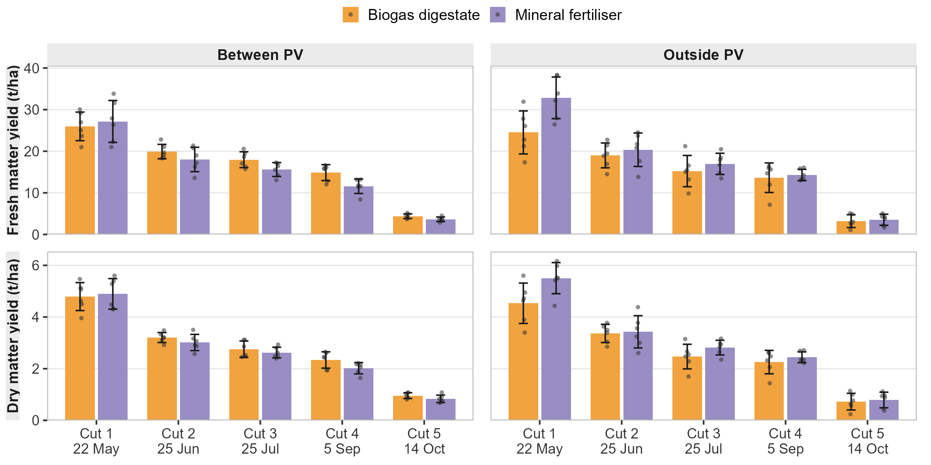
Method notes
Source: HYPERFARM_VALUE4FARM_YIELD_DATA_2024_v3.xlsx (sheet ALL_CROPS_COMBINED); Value4Farm grass-clover strip A3 (A3a = Outside PV, A3b = Between PV), vertical PV set-up; 4.5 m² harvested per plot.
Pooling: digestate = treatments A + C, mineral = treatments B + D; each is pooled across residue removed/retained and west/middle/east sub-strips. SD is the sample SD (n − 1) across those 6 plots, so it includes sub-strip and residue-treatment variation as well as plot-to-plot noise.
Dry matter yield: calculated per plot as fresh matter yield × dry matter content / 100, then averaged (so it is not the product of the two column means). In the source workbook the dry-weight columns for Value4Farm cut 5 are offset by one row from the fresh-weight and dry-matter-content columns, so dry matter yield here is recomputed rather than read from those columns.
Not included: the HYPERFARM strips (A5, B1, B3), whose 2024 field log records only potassium fertiliser (no digestate, no NPK), and the south-oriented PV set-up. Botanical composition (grass:clover ratio) was not recorded.

