Production Activation and Main-Domain Stabilisation
Controlled child-theme rollout, rollback preservation, cache correction, and responsive navigation acceptance
Executive milestone
The approved modern child theme was activated on the existing main-domain WordPress installation. WordPress core, the production database, plugins, uploads, parent theme, and legacy content were retained. The rollout switch remains the immediate presentation rollback mechanism.
Completed work
- Synchronized the reviewed Eduma child theme through certificate-verified FTPS without reinstalling WordPress.
- Enabled the modern redesign while retaining the 2026 catalogue and September pricing switches in the disabled state.
- Purged a stale LiteSpeed object that caused the unparameterized public URL to continue serving the legacy interface.
- Corrected desktop navigation flow, duplicate dropdown presentation, sticky-header spacing, logo separation, right-side balance, and mobile logo clipping.
- Preserved production rollback copies and exact desktop/mobile screenshot evidence outside temporary storage.
- Confirmed main-domain modern pages, course routes, logo, security headers, REST user protection, assistant surface, and HTTPS assets.
Deployment controls
Control | Recorded state
WordPress installation | Retained; no reinstall
Production database | Retained; demo database not imported
Modern redesign | Enabled
2026 catalogue | Disabled
September pricing | Disabled
Immediate rollback | Disable redesign switch and purge LiteSpeed
Accepted commit | 7f5c5b3 - Finalize production header layout
Validation and evidence
- Exact public homepage verified after cache purge, including subsequent LiteSpeed cache hits.
- Desktop acceptance covered 1440 and 1366 pixel layouts; mobile acceptance covered 390 pixels.
- HSTS, nosniff, frame, referrer, and permissions headers remained present.
- Temporary cPanel purge jobs, markers, activation scripts, and test credentials were removed after use.
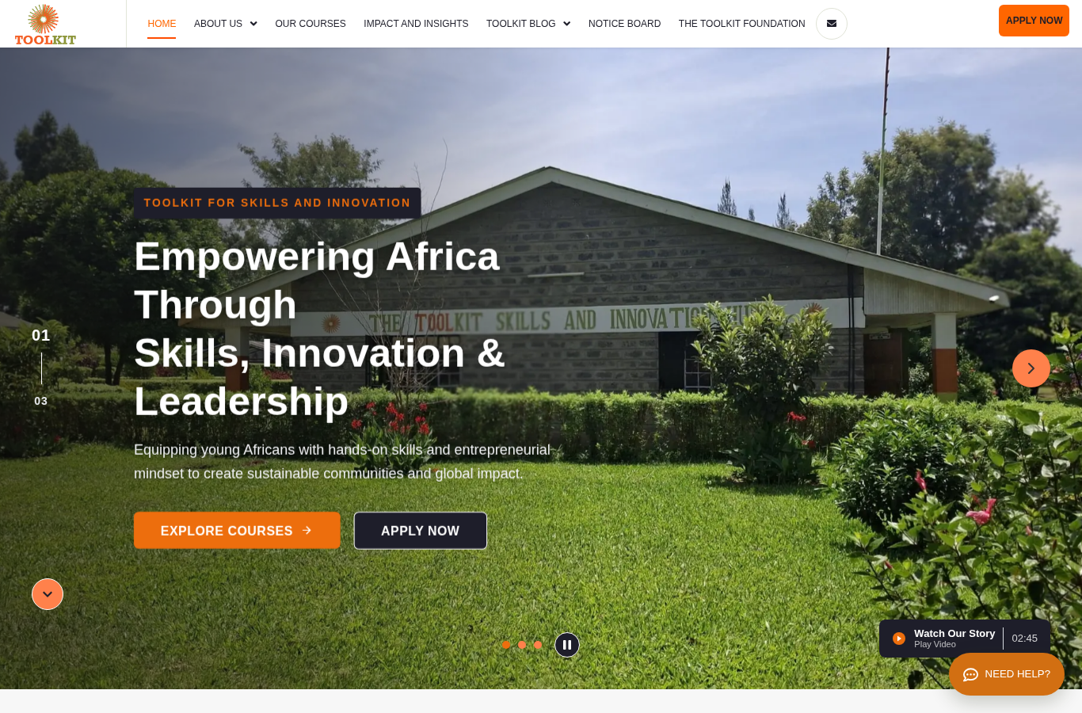
Accepted main-domain desktop header and hero, captured 20 July 2026.

Accepted main-domain mobile header and hero, captured 20 July 2026.
Residual work at close of date
- Authenticated visual acceptance of future Toolkit Control changes requires an existing WordPress administrator session.
- Search Console and Bing Webmaster ownership, query reporting, and search-performance ingestion remain separate follow-up work.
- The application adapter was not part of this production activation.

