
WEBSITE MODERNISATION PROGRAMME

SEO Milestones and Fixes
Weekly Milestone Report 08 | 17 July 2026
Report | WMR-08
Target | https://demo.toolkitafrica.ac.ke/
Release commits | 68dce70, c78c4d5, 6ef80f3
Status | Implemented, deployed and live-verified

Weekly outcome
The mobile PageSpeed score improved from 58 to 84. LCP reduced from 15.5 seconds to 3.1 seconds through responsive WebP delivery, legacy asset removal, targeted preloading, click-to-load video facades, corrected metadata, and verified LiteSpeed caching.

1. Executive Summary
This milestone addressed mobile performance, technical SEO, media delivery, structured metadata, and response-security findings raised during external audits of the demo environment. Corrections were implemented in the child theme, deployed through guarded FTPS, cache-purged, and verified against live response headers and HTML.

Measured Improvement
Metric | Baseline | After fixes | Outcome
Mobile performance | 58 | 84 | +26 points
First Contentful Paint | 2.0 s | 1.7 s | 15% faster
Largest Contentful Paint | 15.5 s | 3.1 s | 80% faster
Total Blocking Time | 350 ms | 60 ms | 83% lower
Cumulative Layout Shift | 0.007 | 0.045 | Still within pass threshold
Best practices | 92 | 96 | +4 points
SEO (PageSpeed) | 92 | 92 | Maintained

Primary Deliverables
- Responsive desktop and mobile WebP hero assets with media-specific high-priority preloads.
- Removal of unused Elementor, Contact Form 7, Thim eKit, Sina, and associated runtime assets from the custom homepage.
- Click-to-load YouTube facades for the pathways video and all three graduate testimonials.
- Keyword-focused title, standard meta description, self-canonical URL, Open Graph description, and dedicated 1200 x 630 social image.
- Meaningful image alternative text, HSTS response header, and live validation of SPF, robots.txt, sitemap, analytics, and cache behaviour.

2. Performance Evidence
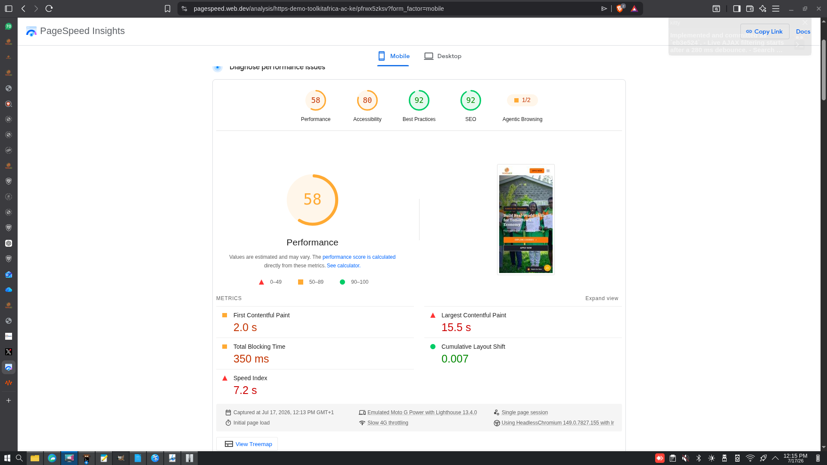
Baseline mobile PageSpeed result: performance 58 and LCP 15.5 seconds.

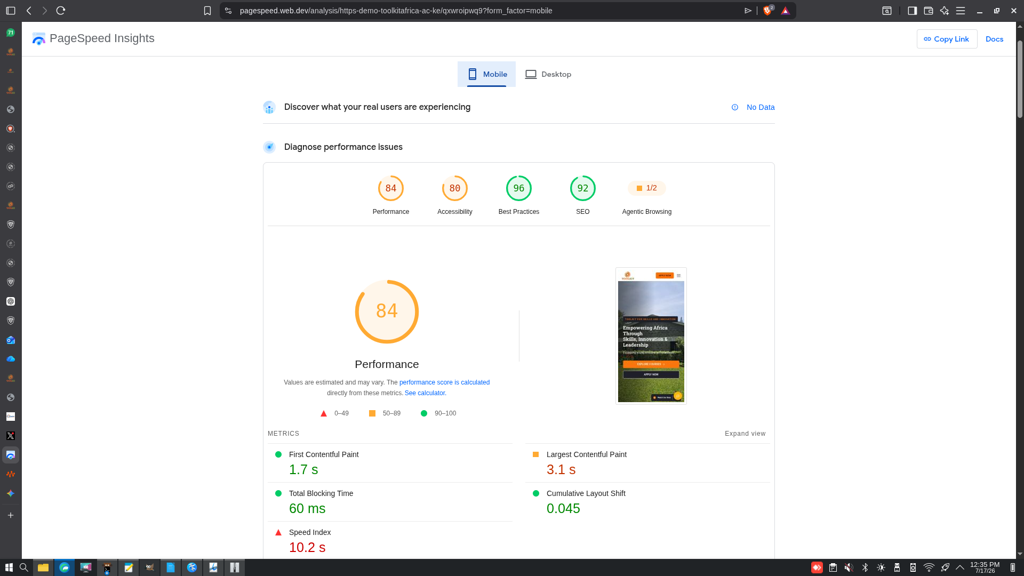
Post-deployment mobile PageSpeed result: performance 84 and LCP 3.1 seconds.
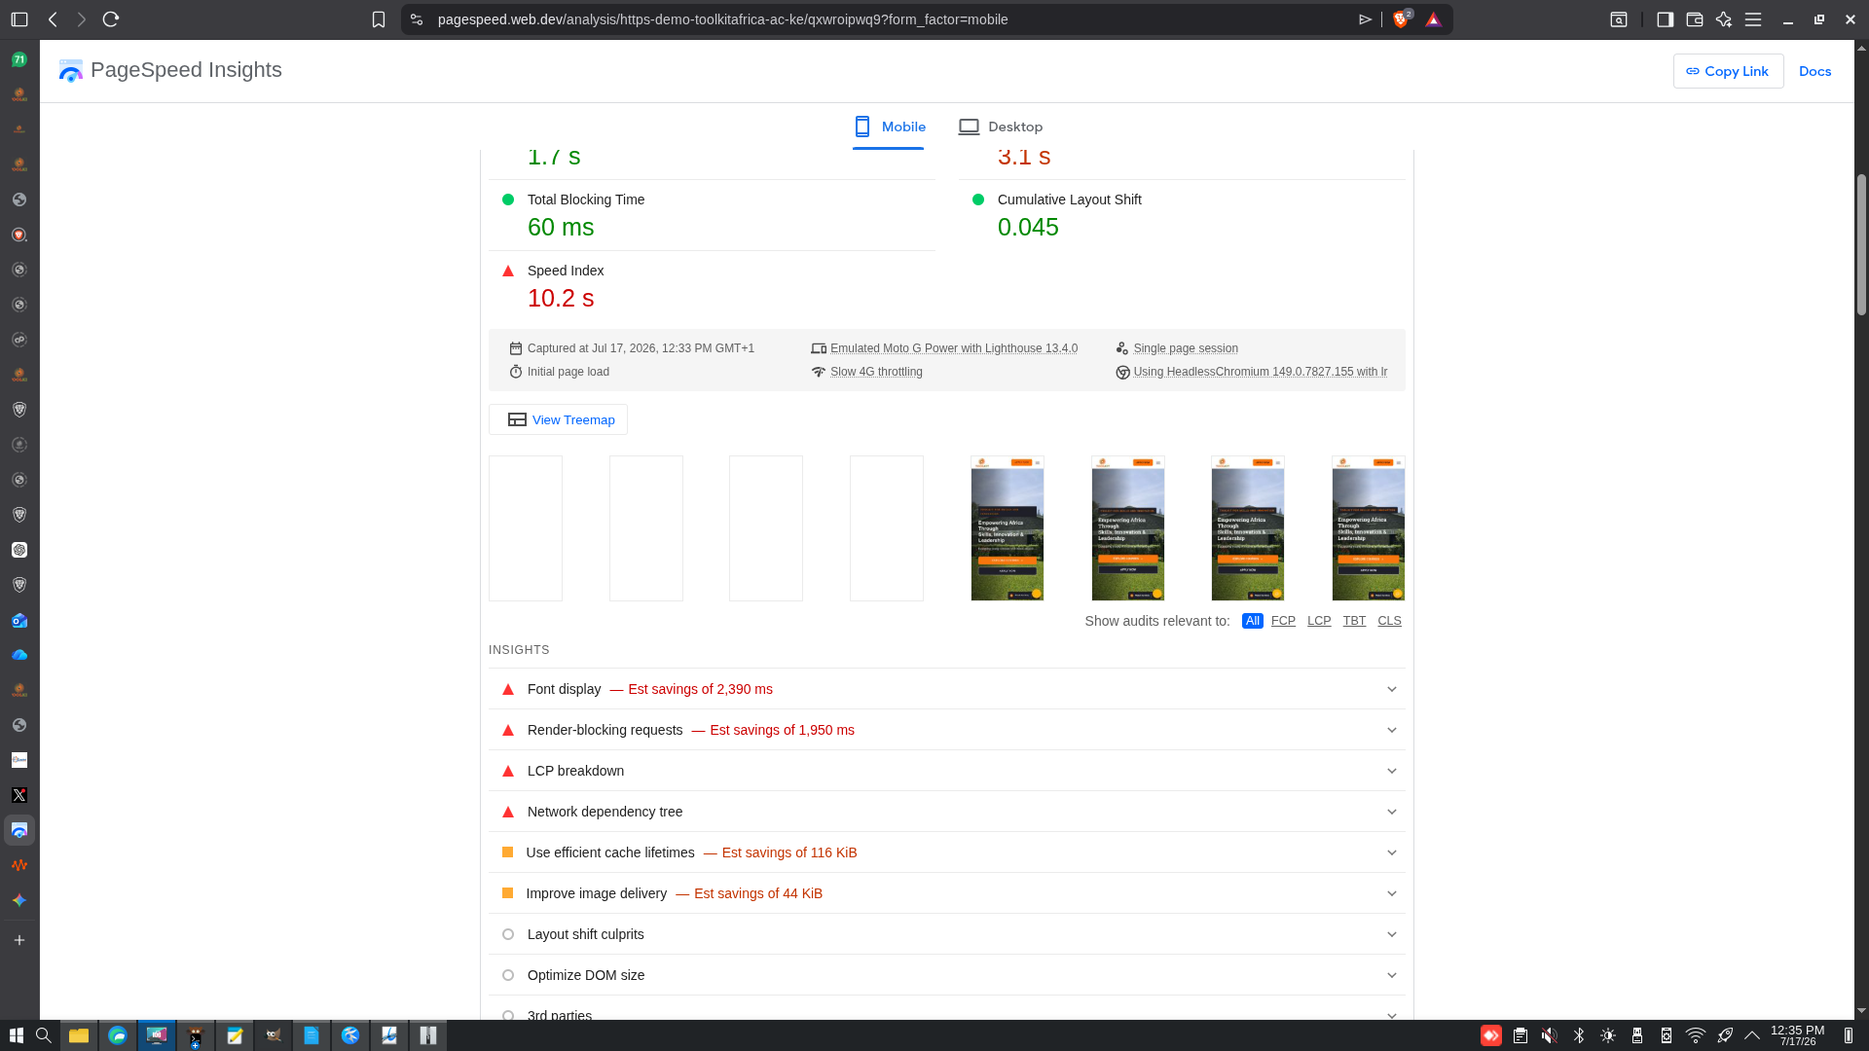
Post-deployment diagnostics showing reduced blocking and remaining font/render-path opportunities.

3. SEO and Technical Corrections
Finding | Action | Verified state
Missing meta description | Added curated homepage description through Yoast filters. | Present in live HTML.
Weak title/keyword alignment | Replaced generic title with practical-skills and Kenya context. | Live title updated.
Canonical mismatch | Canonical and Open Graph URL now use the active environment home URL. | Demo self-canonical verified.
Image formats and sizing | Introduced mobile/desktop WebP assets and a dedicated social image. | WebP delivery verified.
Missing alt attributes | Added descriptive alt text to video and story images. | No empty homepage alt attributes.
Heavy third-party embeds | Replaced initial iframes with accessible click-to-load facades. | Zero initial YouTube iframes.
Missing HSTS | Added one-year includeSubDomains policy on secure frontend responses. | Header verified live.

Audit Claims Rechecked
- SPF was reported missing but DNS returns v=spf1 include:spf.protection.outlook.com -all.
- robots.txt was reported as blocking content but its public user-agent group has an empty Disallow directive.
- The sitemap index returns HTTP 200.
- Unsafe target=_blank links were not present in current homepage HTML.
- Analytics is implemented through Toolkit's first-party metrics module rather than Google Analytics.

4. Deployment, Controls and Remaining Work

Deployment Controls
- Only changed child-theme files were uploaded; WordPress core, plugins, database, and uploads were untouched.
- Persistent rollback copies were refreshed under rollbacks/latest-demo before each release.
- Temporary token-protected cache purge files were removed immediately and verified as HTTP 404.
- LiteSpeed behaviour was verified as MISS on the first request and HIT on the next request.

Remaining Opportunities
- Reduce remaining font-display delay by consolidating parent-theme icon/font families.
- Further isolate critical header/footer CSS from the parent Eduma stylesheet after full regression testing.
- Retest PageSpeed across multiple runs because lab scores vary with network and test location.
- Review accessibility findings individually; the current PageSpeed accessibility score remains 80.
- Ads.txt is only required if Toolkit becomes an advertising publisher; it is not an SEO requirement for this site.
- The visible office email is retained intentionally for contact usability; anti-spam controls should not hide essential contact information.

Acceptance Statement
The high-impact performance and technical SEO corrections in this milestone are deployed and verified on the demo environment. The measured improvement is material and the remaining work is primarily parent-theme font/CSS reduction, accessibility refinement, and repeated monitoring before main-domain cutover.

