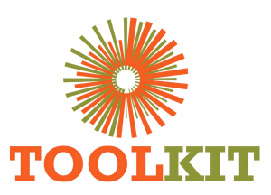
EXECUTIVE MEETING SUMMARY

Website Modernisation
Programme Update
Milestones from June to 17 July 2026
Purpose
Summarise the new demo experience, delivery progress, corrected course-page coverage, SEO and measurement foundations, and the controlled route to main-domain rollout.

Prepared for project and management review

Executive Position
The demo site has moved from a builder-heavy, visually inconsistent experience to a child-theme implementation with controlled templates, a defined brand system and measurable user journeys. The main domain has not been changed.
Area | Status | Meeting note
Homepage | Modernised | Hero, 2026 banner, Who We Are, impact metrics, video, pathways, testimonials and assistant.
About Us | Modernised | Institutional story, programme context and all 18 current team members.
Courses | Corrected | Directory plus eight public legacy course URLs now use the shared modern detail structure.
Blog / Notice Board | Modernised | Styled content discovery, working search and category filters.
Apply / Contact | Modernised | Clear admissions route, support details and measured conversion interactions.
SEO / Analytics | Implemented | Curated metadata, schema support, canonical handling and first-party engagement metrics.

Immediate correction completed
All eight public course-related URLs now resolve through the modern course-page renderer locally. This closes the gap where only Welding had received the intended redesign while other pages remained blank or legacy-styled.

Experience Transformation
CURRENT MAIN SITE | NEW DEMO SITE
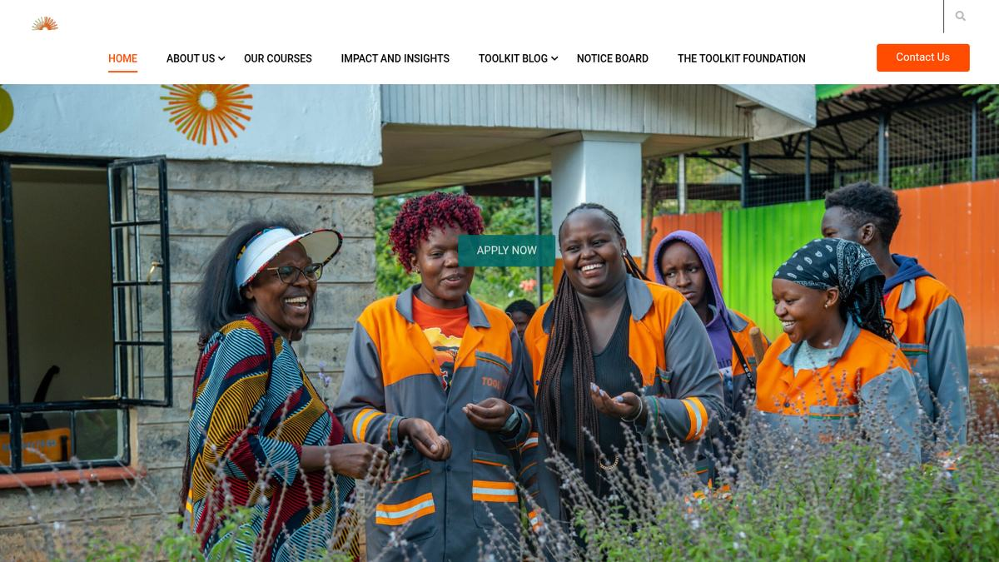 | 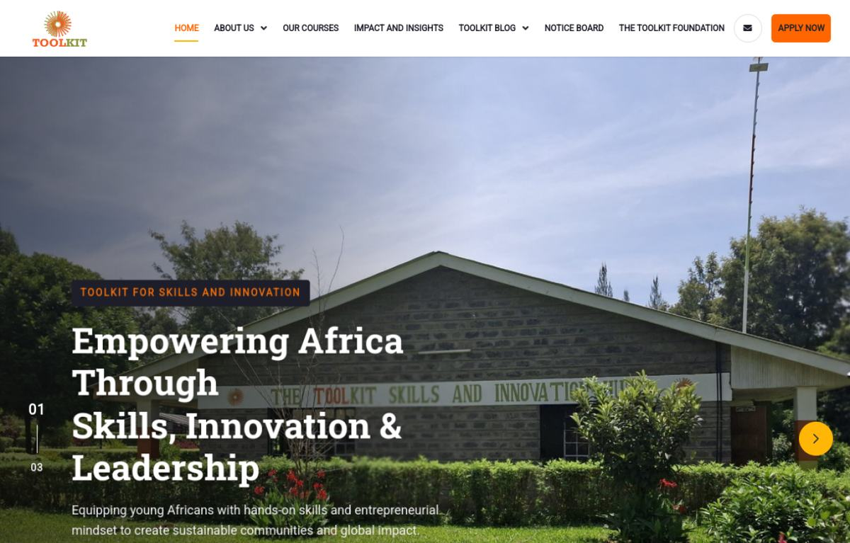
Homepage comparison: clearer hierarchy, deeper engagement flow and brand-led calls to action.

CURRENT MAIN SITE | NEW DEMO SITE
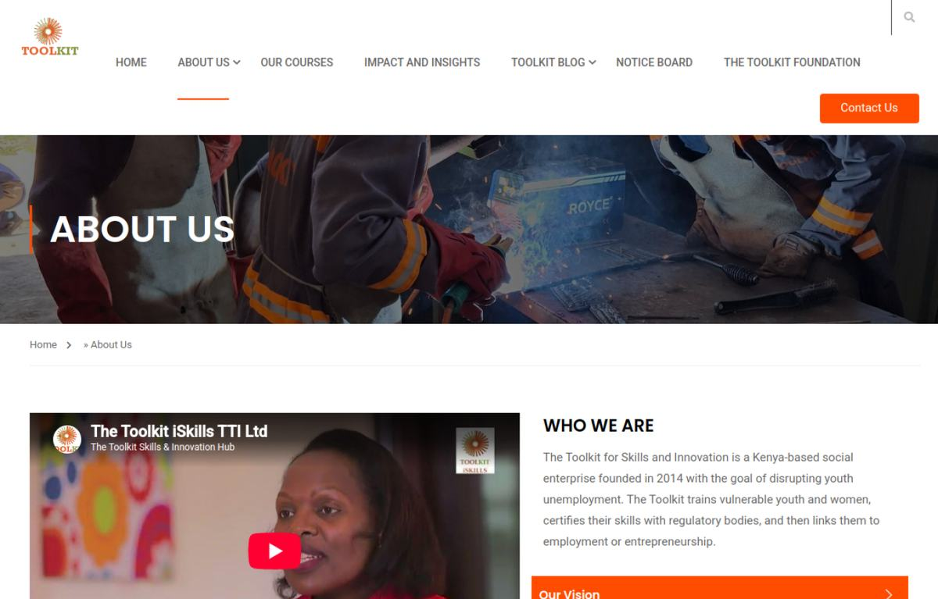 | 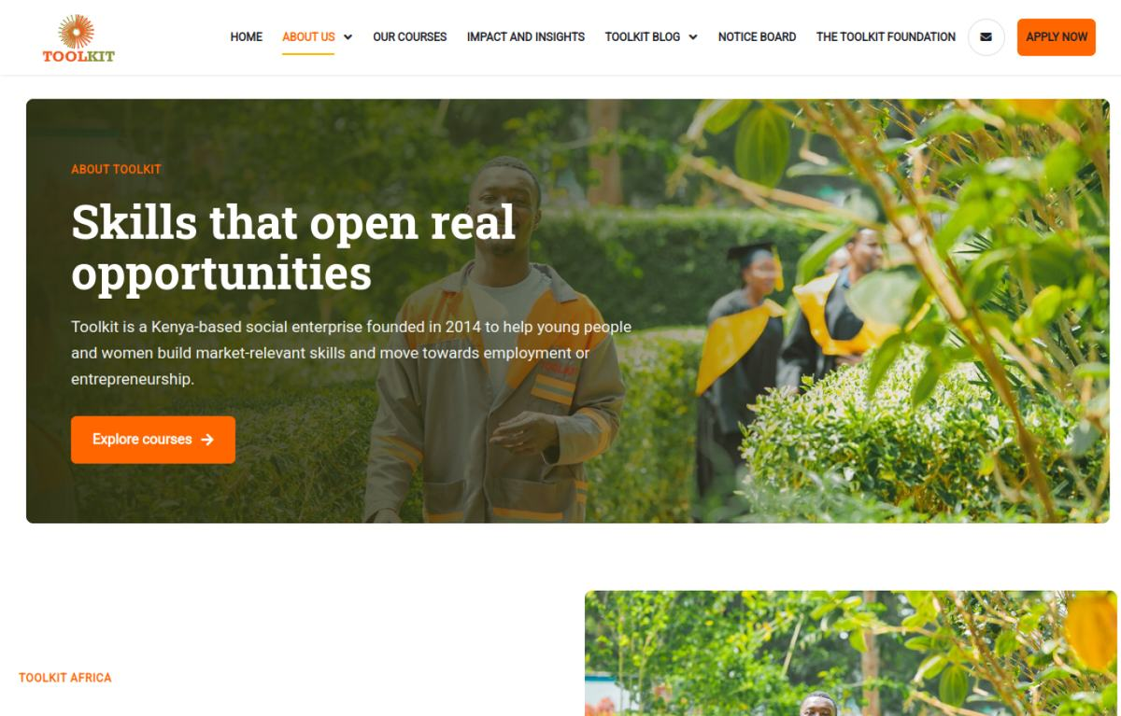
About comparison: stronger institutional narrative and a complete, modern Our Team presentation.

Courses and Admissions
CURRENT MAIN SITE | NEW DEMO SITE
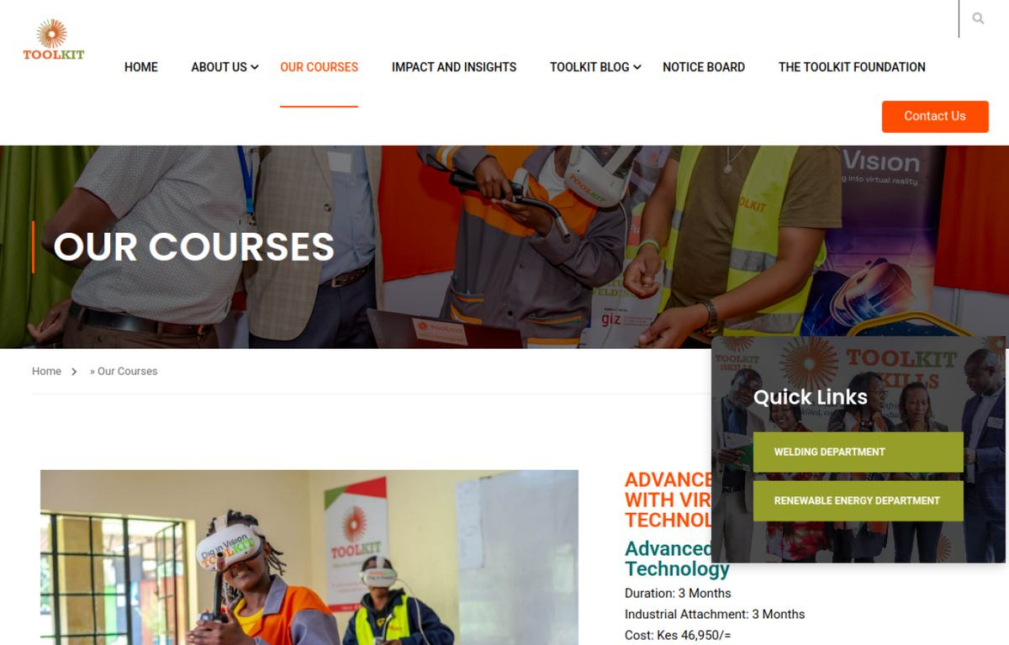 | 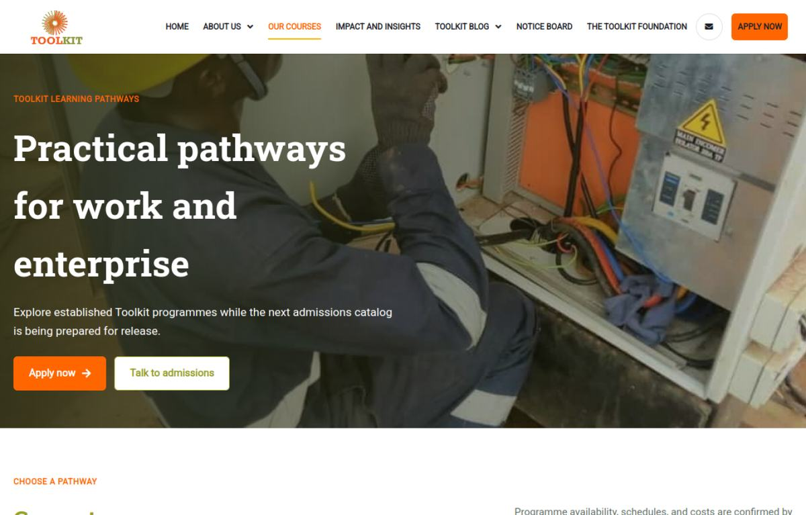
Course discovery comparison: focused directory, accurate imagery and consistent programme navigation.

Course pages covered
- Welding and Fabrication; Renewable Energy; Organic Farming Skills; Digital Skills.
- Recognition of Prior Learning; Consultancy and Research; Online Training Portal - Jielimishe.
- Training Welders with Virtual Reality, with welding-specific imagery and learning focus.
- Course names and existing URLs are retained. Pricing remains controlled separately so unapproved future fees are not exposed.

SEO, Performance and Measurement
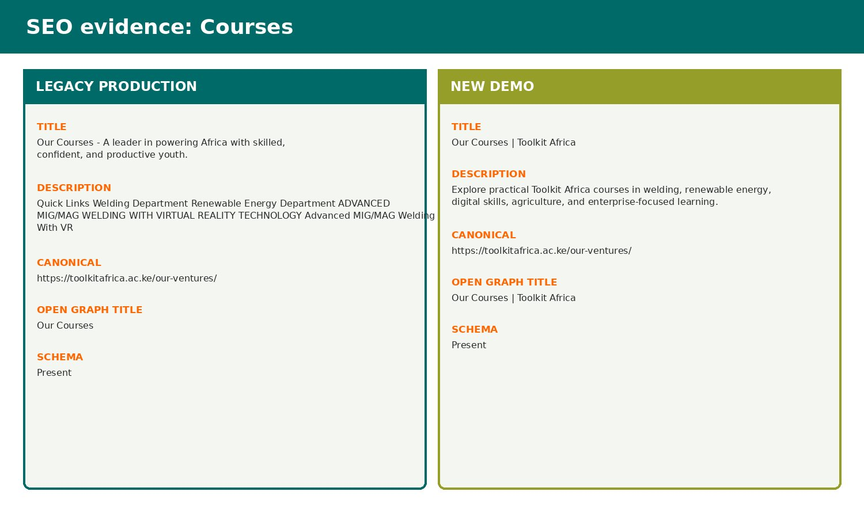 | Implemented foundation  Curated page titles and descriptions, canonical course URLs, breadcrumb hierarchy, social imagery and schema integration support stronger search interpretation and sharing.  - Legacy builder assets removed from rebuilt page payloads.  - First-party page view, scroll depth, dwell, interaction and performance events.  - Toolkit Control panel for feature switches and aggregate site metrics.

Course-page verification - 17 July 2026
Eight of eight local course URLs returned HTTP 200 with modern markup. Warm responses measured approximately 0.35-0.47 seconds and page HTML reduced to about 54 KB from roughly 155-205 KB on the legacy render. These are local smoke-test figures, not production Core Web Vitals.

Outreach Materials and Visual Assets
Existing campaign material supports the wider communications ecosystem. It is referenced here as a supporting asset source, not as a replacement for the website's approved content hierarchy.
 |  | 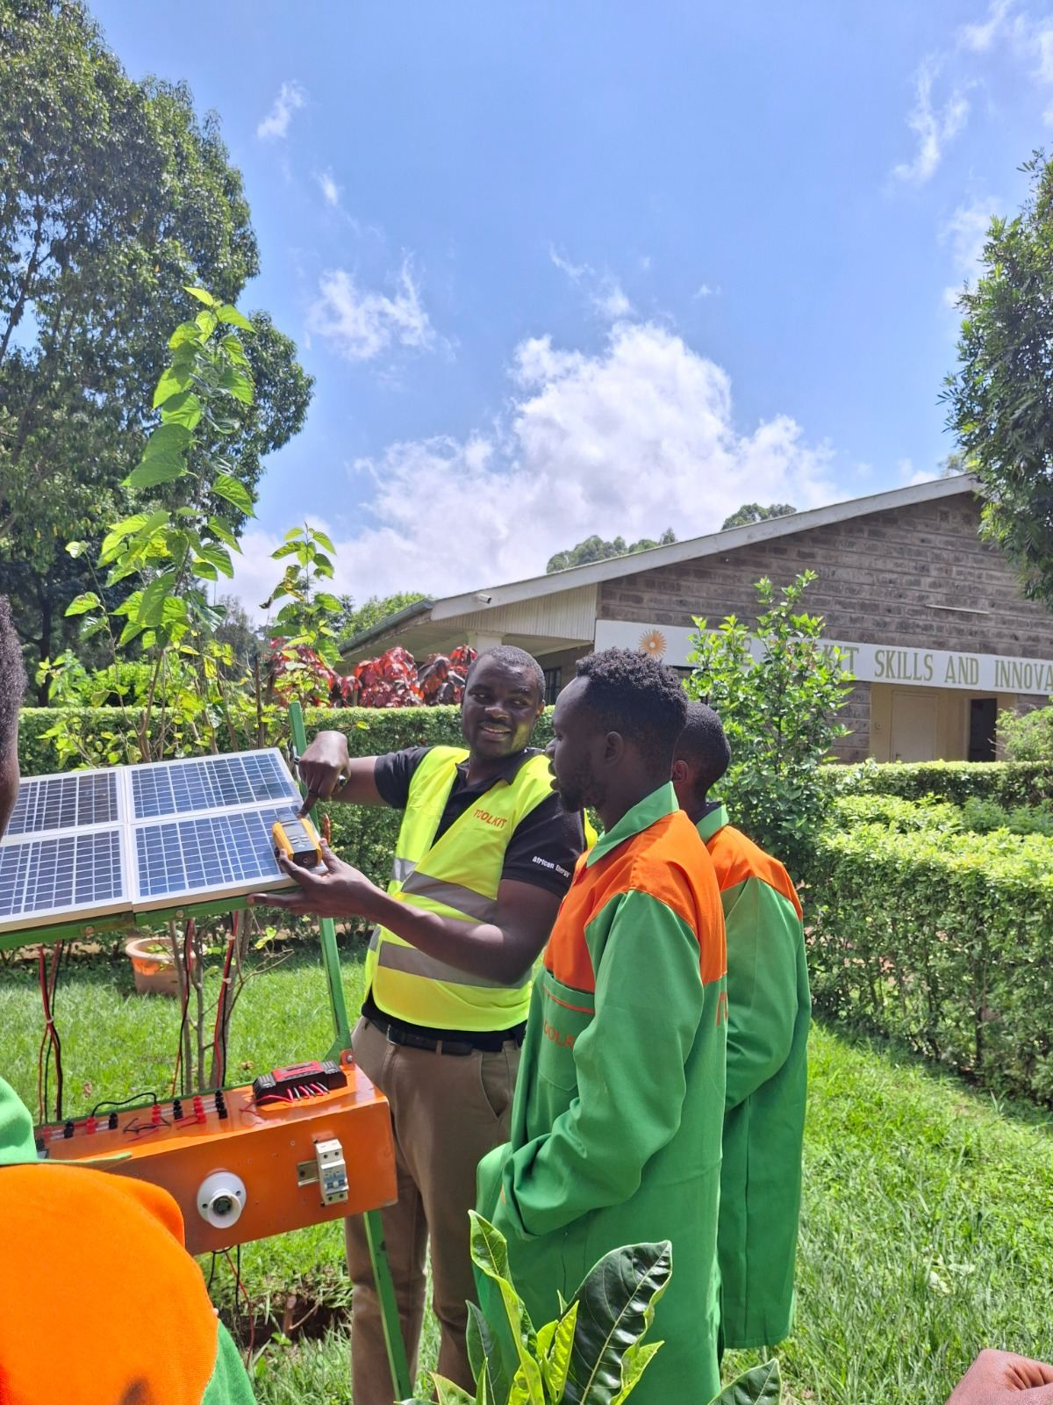
TVET/VTC poster  Training outreach | University welding poster  Welding awareness | Opportunity poster  Campaign support

Additional approved-use candidates
- High-resolution solar training photography for renewable-energy course pages and admissions stories.
- Virtual-reality workshop photography for advanced welding and VR-supported learning pages.
- Graduation photography for learner outcomes, impact stories and testimonial context.
- All selected web assets should be cropped for context, resized responsively, compressed, and supplied with accurate alternative text before publication.

Rollout Controls and Meeting Decisions

Deployment safeguards
- Demo changes are deployed only after local route, asset, syntax and visual checks.
- A persistent latest-demo rollback is retained locally outside temporary storage.
- The redesign, 2026 catalogue and future pricing each have separate switches.
- The main-domain redesign defaults off and can be returned to the existing site immediately without deleting WordPress content.
- Main-domain rollout requires a fresh files/database backup, route acceptance checks and explicit authorization.

Items requiring management confirmation
- Approve the corrected demo course-page presentation after visual review.
- Confirm final course visibility and current admissions wording before main-domain cutover.
- Approve the Mzizi field contract and a non-production submission test before building the application adapter.
- Schedule the controlled main-domain release only after demo acceptance is complete.

Recommended meeting outcome: approve the demo correction for inspection, retain the pricing gate, and continue through the documented main-domain readiness checklist.

