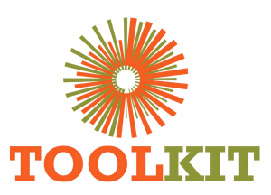
WEBSITE MODERNISATION PROGRAMME

Discovery, Crawl and Baseline Audit
01-07 June 2026
Report number | WMR-01
Issue date | 07 June 2026
Delivery status | Complete
Evidence note | Page captures were taken on 16 July 2026 for consistent comparison.

WEEKLY OUTCOME
Established the evidence base for redesign by crawling the production WordPress estate, documenting information architecture, technical dependencies, duplicate content and high-risk user journeys.

1. Executive Summary
Established the evidence base for redesign by crawling the production WordPress estate, documenting information architecture, technical dependencies, duplicate content and high-risk user journeys.

2. Milestone Status
Milestone | Status | Evidence / outcome
Production crawl | Complete | Sitemap, REST and HTML sources reconciled.
Risk register | Complete | Broken, duplicate and legacy routes documented.
Priority inventory | Complete | Core marketing, course, account and legal pages classified.

3. Work Completed
- Completed a sitemap, REST API and HTML crawl of toolkitafrica.ac.ke.
- Recorded 230 indexed URLs and 641 discovered URLs in the June baseline.
- Mapped core pages, venture hierarchy, account routes, blog content and media dependencies.
- Identified duplicate Foundation, Blog, account and team systems, including 37 overlapping team profiles.
- Flagged the broken application route, exceptionally long post slugs and unfinished /new/ redesign paths.

4. Visual Evidence
The left image shows the production baseline and the right image shows the redesigned demo. Captures use a consistent desktop viewport and were collected on 16 July 2026.

Visual comparison: Home
LEGACY PRODUCTION | NEW DEMO
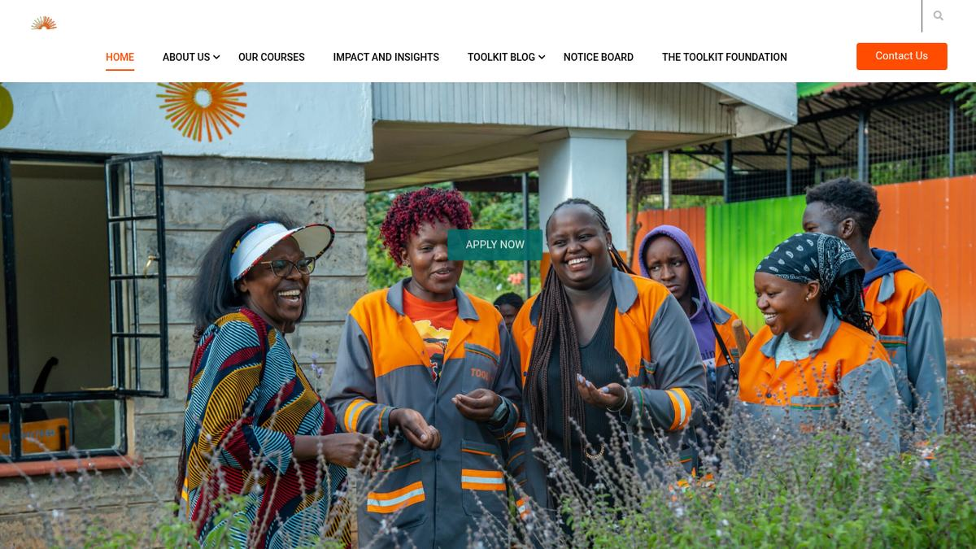  Baseline | 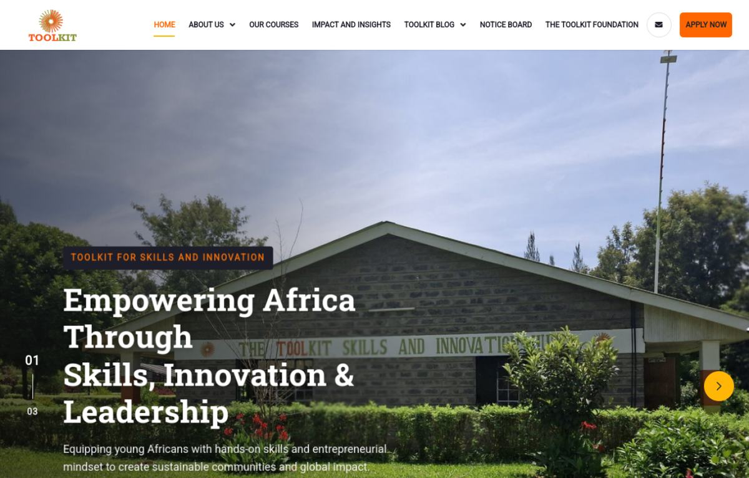  Modernised

Visual comparison: About
LEGACY PRODUCTION | NEW DEMO
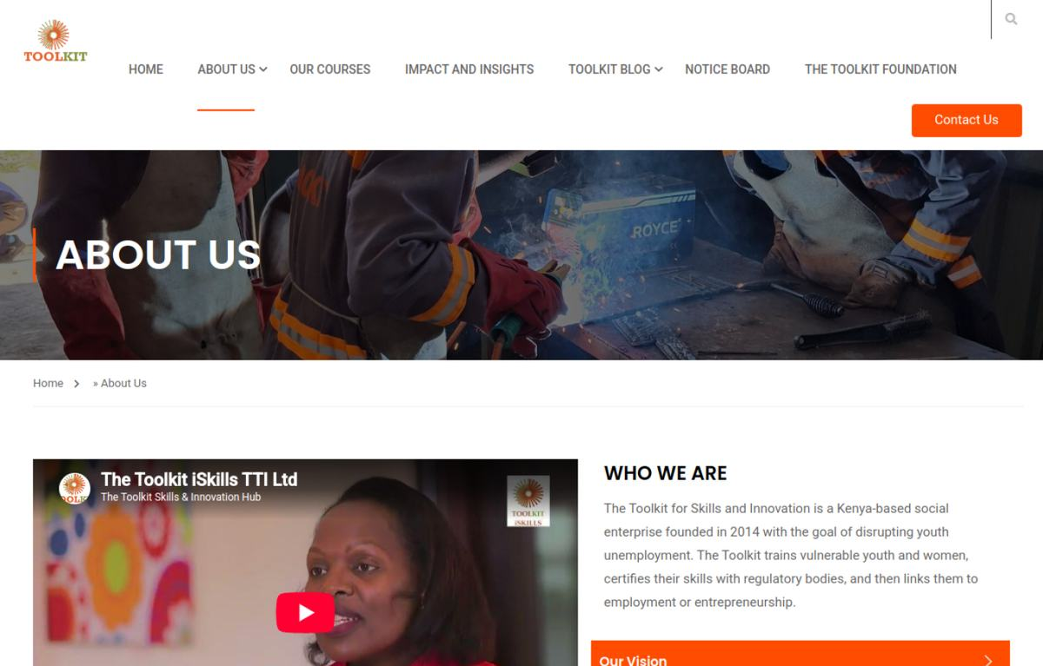  Baseline | 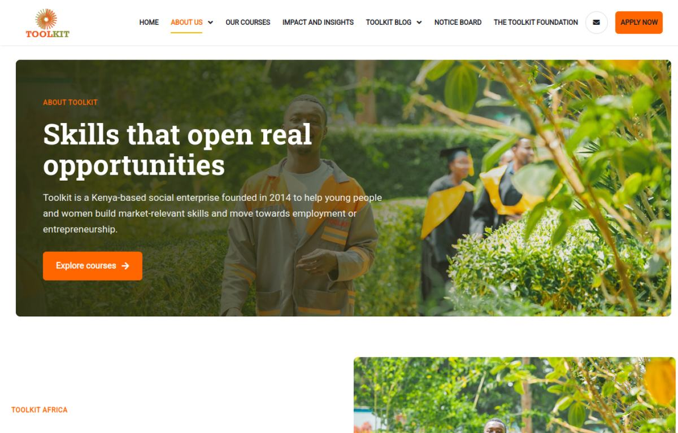  Modernised

Visual comparison: Courses
LEGACY PRODUCTION | NEW DEMO
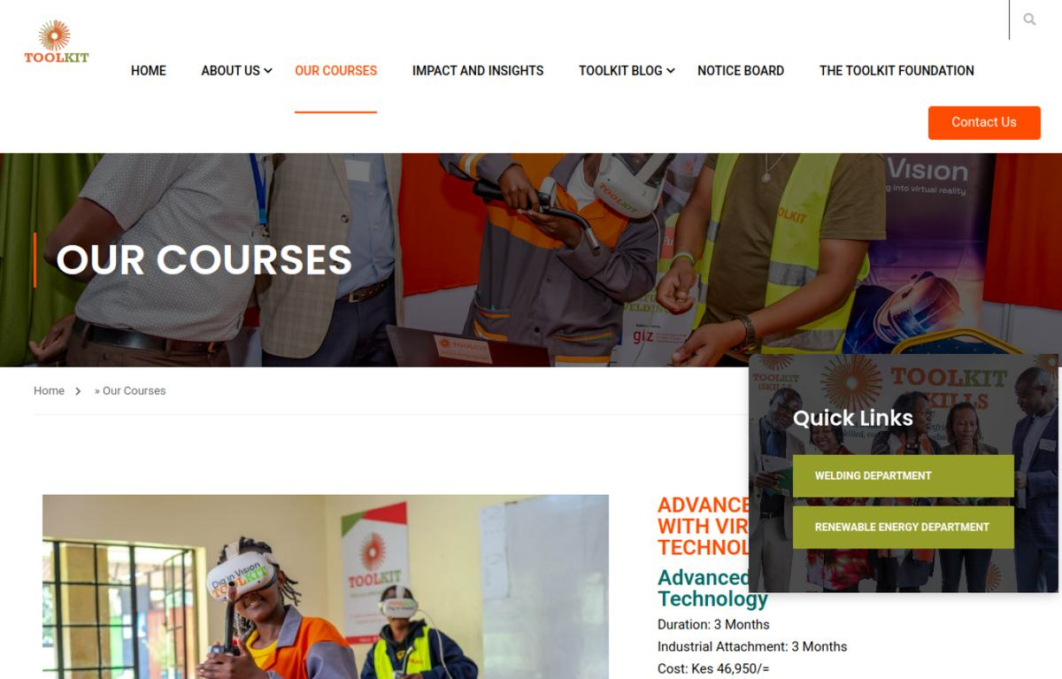  Baseline | 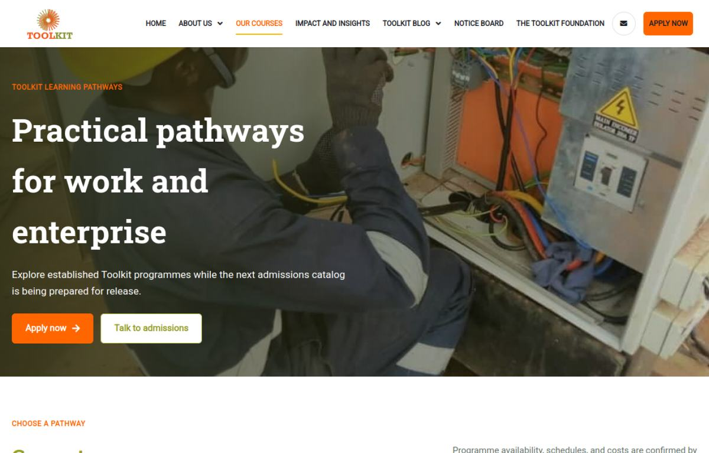  Modernised

5. Risks and Controls
- Existing URLs could not be removed without redirect and search-impact analysis.
- LearnPress, account, contact and Mzizi flows required preservation during visual work.

6. Next-Week Priorities
- Approve the design direction and convert the audit into a page-by-page implementation specification.

7. Verification Record
Milestone | Status | Evidence / outcome
Source chronology | Complete | June crawl/prototype records, Git history and project progress log reconciled.
Visual evidence | Complete | Production and demo page captures embedded and labelled.
Document quality | Complete | Toolkit logo, weekly dates, version control and consistent report format applied.

