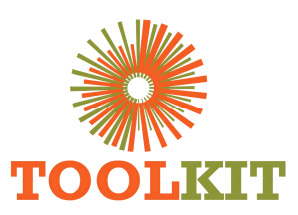
WEBSITE MODERNISATION PROGRAMME

Visual Direction and Experience Prototype
08-14 June 2026
Report number | WMR-02
Issue date | 14 June 2026
Delivery status | Complete
Evidence note | Page captures were taken on 16 July 2026 for consistent comparison.

WEEKLY OUTCOME
Translated the audit and supplied references into a modern visual direction, initial application experience and reusable brand/layout specifications.

1. Executive Summary
Translated the audit and supplied references into a modern visual direction, initial application experience and reusable brand/layout specifications.

2. Milestone Status
Milestone | Status | Evidence / outcome
Reference synthesis | Complete | UI references converted into structured requirements.
Prototype routes | Complete | Core page and application routes demonstrated.
Responsive specification | Complete | Desktop, tablet and mobile expectations recorded.

3. Work Completed
- Consolidated supplied hero, form, welding and notice-board references into a UI specification.
- Built an exploratory Laravel prototype to validate layout and route assumptions before the WordPress implementation decision.
- Introduced a Toolkit-led hero composition, application-first CTA and logo-based visual direction.
- Prototyped the application experience and the content hierarchy for programmes, notices and team content.
- Documented responsive breakpoints, typography, spacing, interaction and asset requirements.

4. Visual Evidence
The left image shows the production baseline and the right image shows the redesigned demo. Captures use a consistent desktop viewport and were collected on 16 July 2026.

Visual comparison: Home
LEGACY PRODUCTION | NEW DEMO
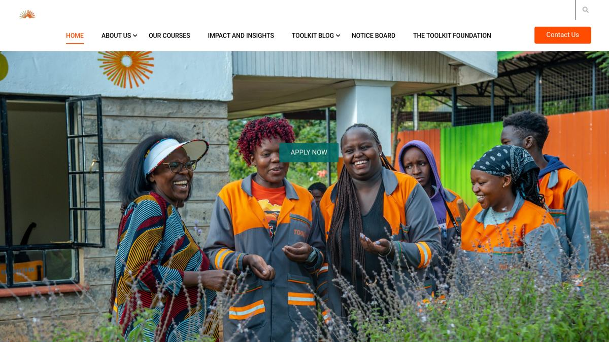  Baseline | 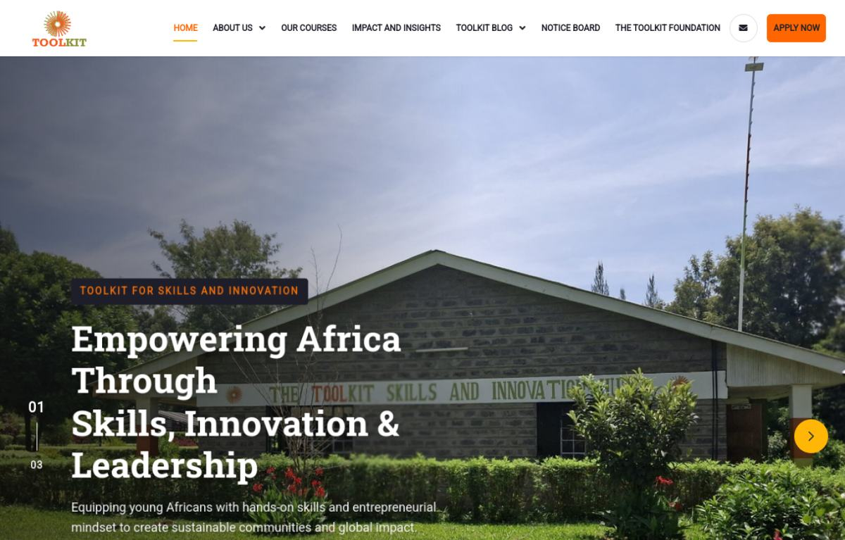  Modernised

Visual comparison: Application
LEGACY PRODUCTION | NEW DEMO
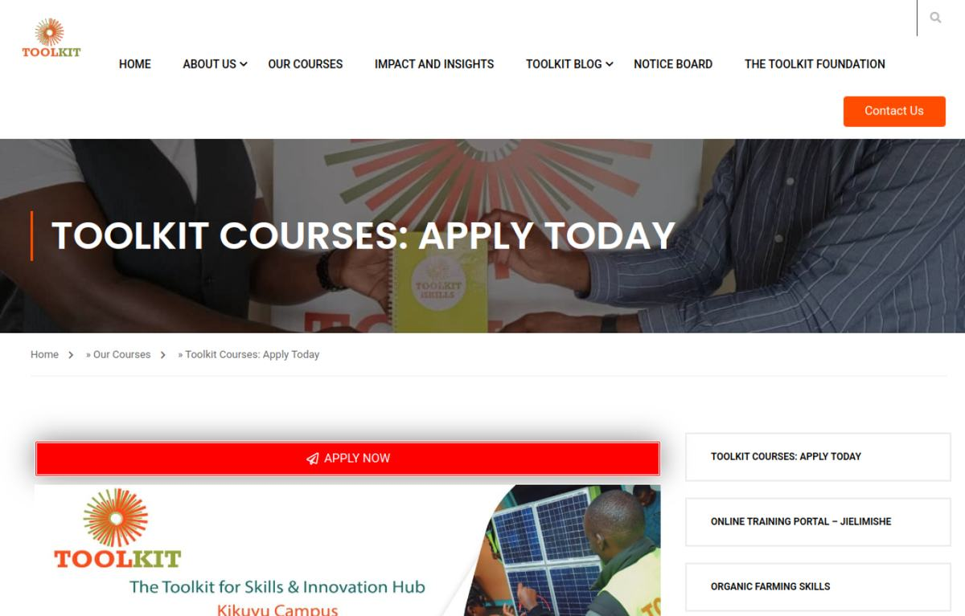  Baseline | 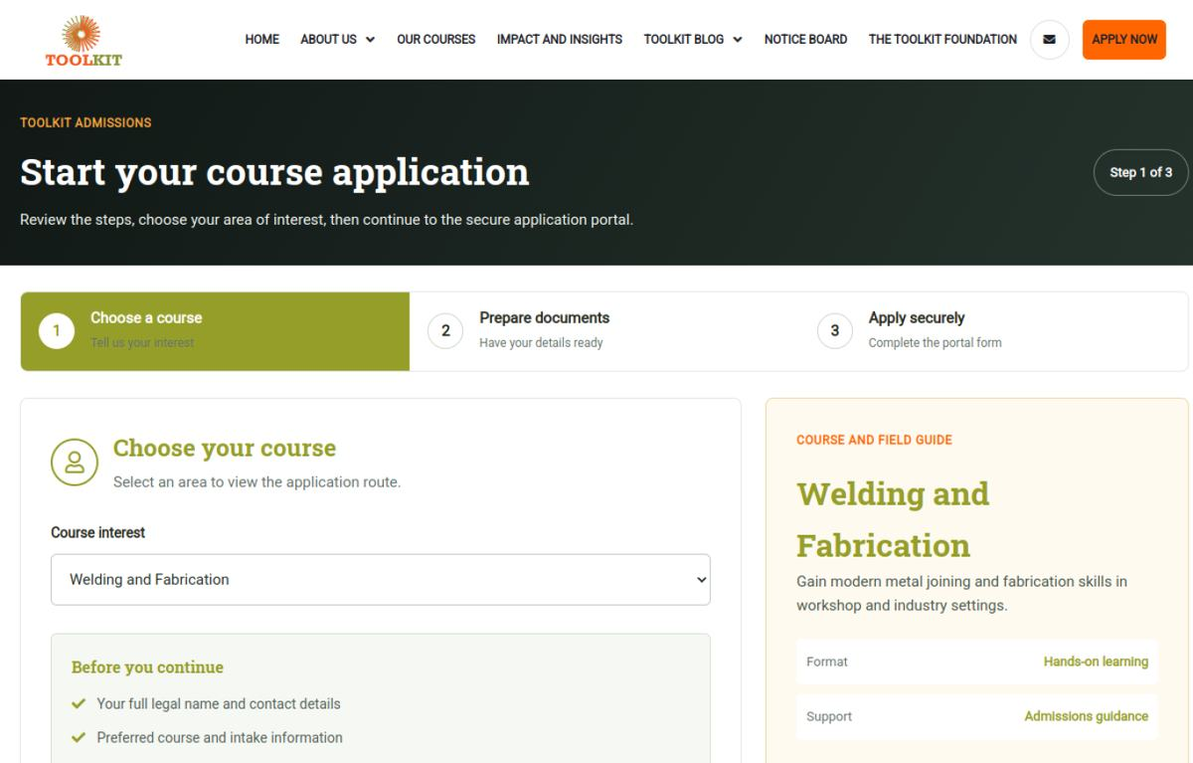  Modernised

5. Risks and Controls
- The prototype was not the production CMS and therefore could not replace WordPress content ownership.

6. Next-Week Priorities
- Retain the visual findings and move implementation into an update-safe WordPress child theme.

7. Verification Record
Milestone | Status | Evidence / outcome
Source chronology | Complete | June crawl/prototype records, Git history and project progress log reconciled.
Visual evidence | Complete | Production and demo page captures embedded and labelled.
Document quality | Complete | Toolkit logo, weekly dates, version control and consistent report format applied.

