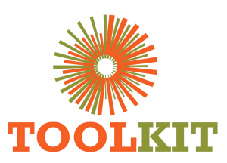
WEBSITE MODERNISATION PROGRAMME

WordPress Integration Architecture
15-21 June 2026
Report number | WMR-03
Issue date | 21 June 2026
Delivery status | Complete
Evidence note | Page captures were taken on 16 July 2026 for consistent comparison.

WEEKLY OUTCOME
Defined an implementation model that modernises the existing WordPress estate while preserving content, URLs, plugins and rollback capability.

1. Executive Summary
Defined an implementation model that modernises the existing WordPress estate while preserving content, URLs, plugins and rollback capability.

2. Milestone Status
Milestone | Status | Evidence / outcome
CMS decision | Complete | WordPress retained as the source of content and operations.
Rollback model | Complete | Child-theme switch and parent fallback specified.
Integration boundaries | Complete | Forms, LMS, accounts and uploads protected.

3. Work Completed
- Selected the Eduma child theme as the production integration boundary.
- Defined theme-owned templates and assets for priority pages while retaining WordPress content and forms.
- Established the requirement for host-aware rollout switches and parent-theme fallback.
- Separated current course data from future prospectus data and pricing activation.
- Defined the Mzizi adapter approach: Toolkit-hosted form, server-side validation and controlled forwarding.

4. Visual Evidence
The left image shows the production baseline and the right image shows the redesigned demo. Captures use a consistent desktop viewport and were collected on 16 July 2026.

Visual comparison: Courses
LEGACY PRODUCTION | NEW DEMO
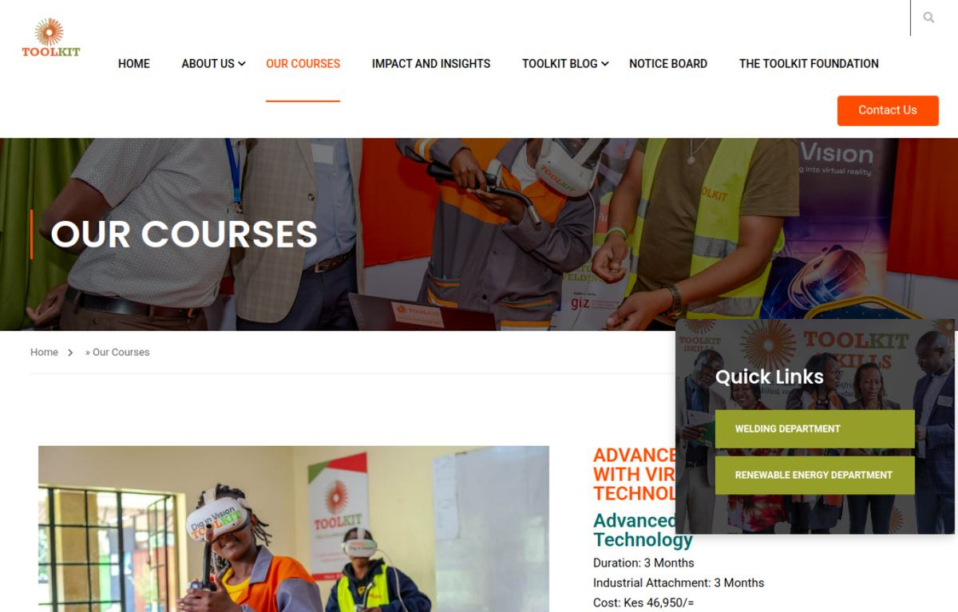  Baseline | 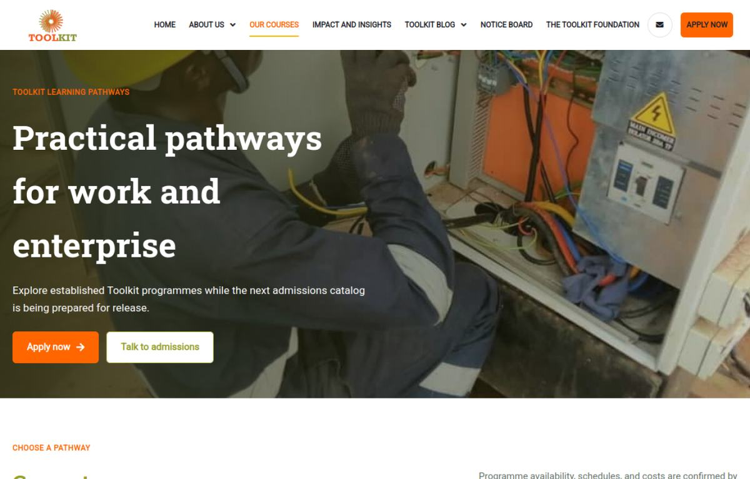  Modernised

Visual comparison: Application
LEGACY PRODUCTION | NEW DEMO
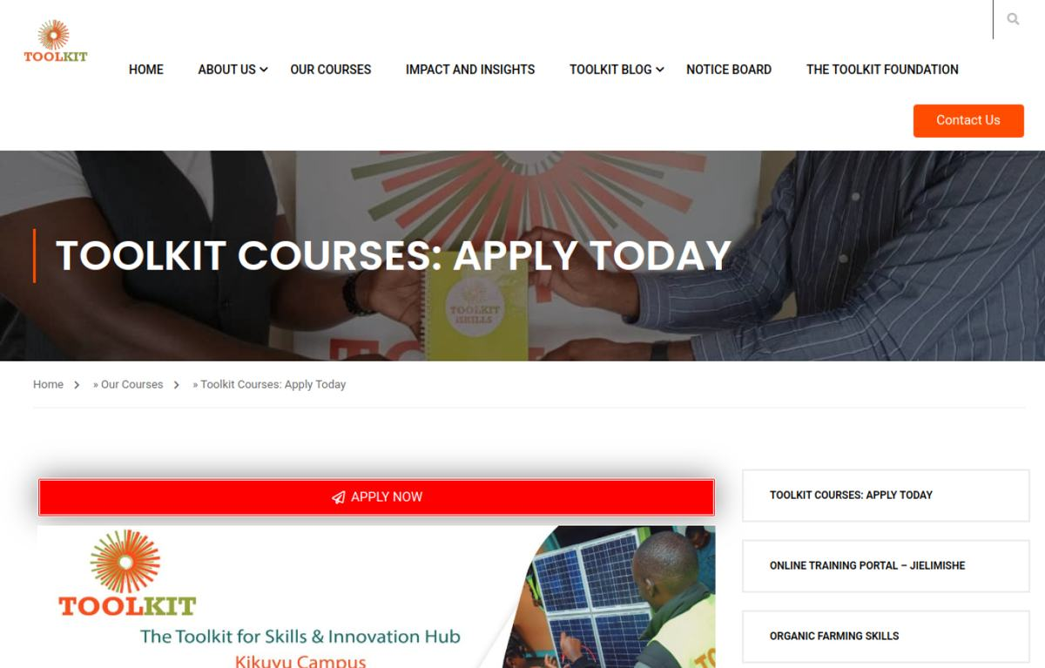  Baseline | 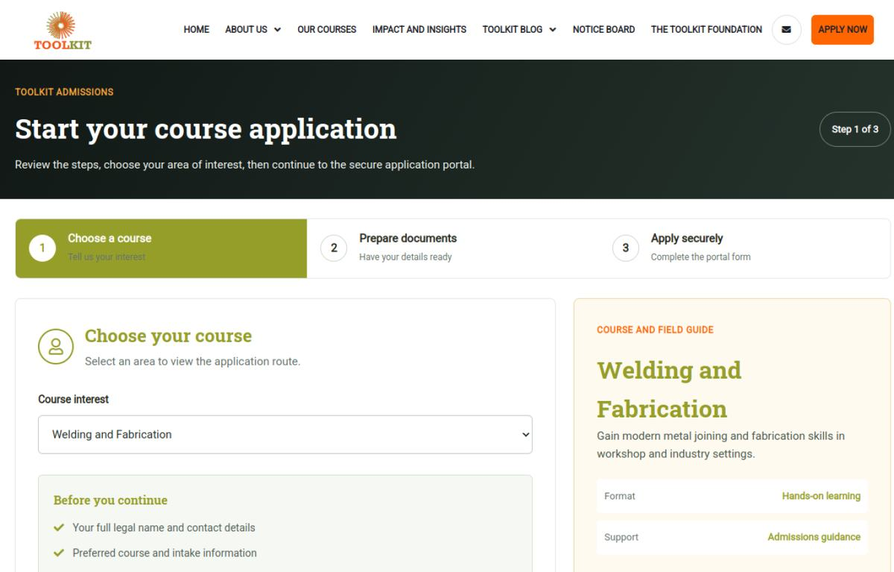  Modernised

5. Risks and Controls
- Production activation would require file, database, cache and route verification as separate gates.

6. Next-Week Priorities
- Prepare the build checklist, accessibility criteria and reproducible local WordPress environment.

7. Verification Record
Milestone | Status | Evidence / outcome
Source chronology | Complete | June crawl/prototype records, Git history and project progress log reconciled.
Visual evidence | Complete | Production and demo page captures embedded and labelled.
Document quality | Complete | Toolkit logo, weekly dates, version control and consistent report format applied.

