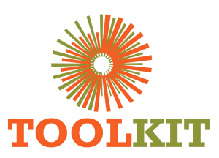
WEBSITE MODERNISATION PROGRAMME

Implementation Readiness and Acceptance Planning
22-28 June 2026
Report number | WMR-04
Issue date | 28 June 2026
Delivery status | Complete
Evidence note | Page captures were taken on 16 July 2026 for consistent comparison.

WEEKLY OUTCOME
Converted the architecture into a controlled delivery plan covering page priorities, evidence capture, accessibility, performance, SEO and deployment safety.

1. Executive Summary
Converted the architecture into a controlled delivery plan covering page priorities, evidence capture, accessibility, performance, SEO and deployment safety.

2. Milestone Status
Milestone | Status | Evidence / outcome
Page release plan | Complete | Priority routes and dependencies sequenced.
Quality gates | Complete | Syntax, visual, responsive, SEO and HTTP checks defined.
Deployment controls | Complete | Rollback-first FTPS workflow established.

3. Work Completed
- Prioritised Home, About, Courses, Welding, Notice Board, Application, Blog and Contact for the first release sequence.
- Defined desktop/mobile screenshot acceptance and asset verification requirements.
- Established semantic heading, keyboard, focus, reduced-motion and image-alt expectations.
- Specified deployment order: backup, assets/templates, functions last, cache purge and route checks.
- Separated visual acceptance from production cutover approval.

4. Visual Evidence
The left image shows the production baseline and the right image shows the redesigned demo. Captures use a consistent desktop viewport and were collected on 16 July 2026.

Visual comparison: Welding
LEGACY PRODUCTION | NEW DEMO
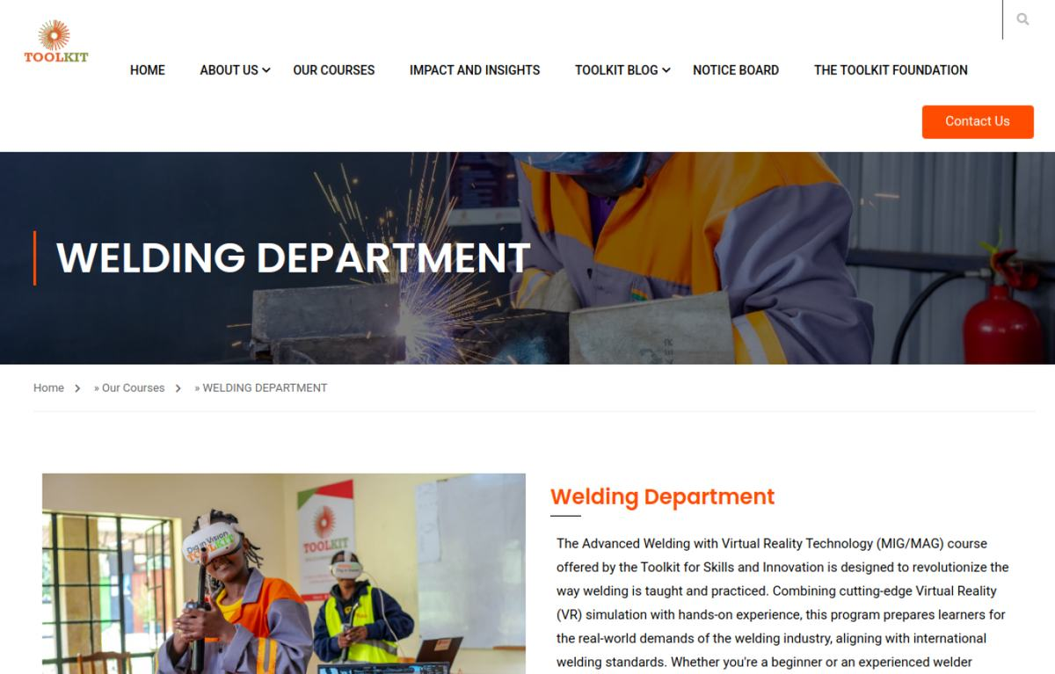  Baseline | 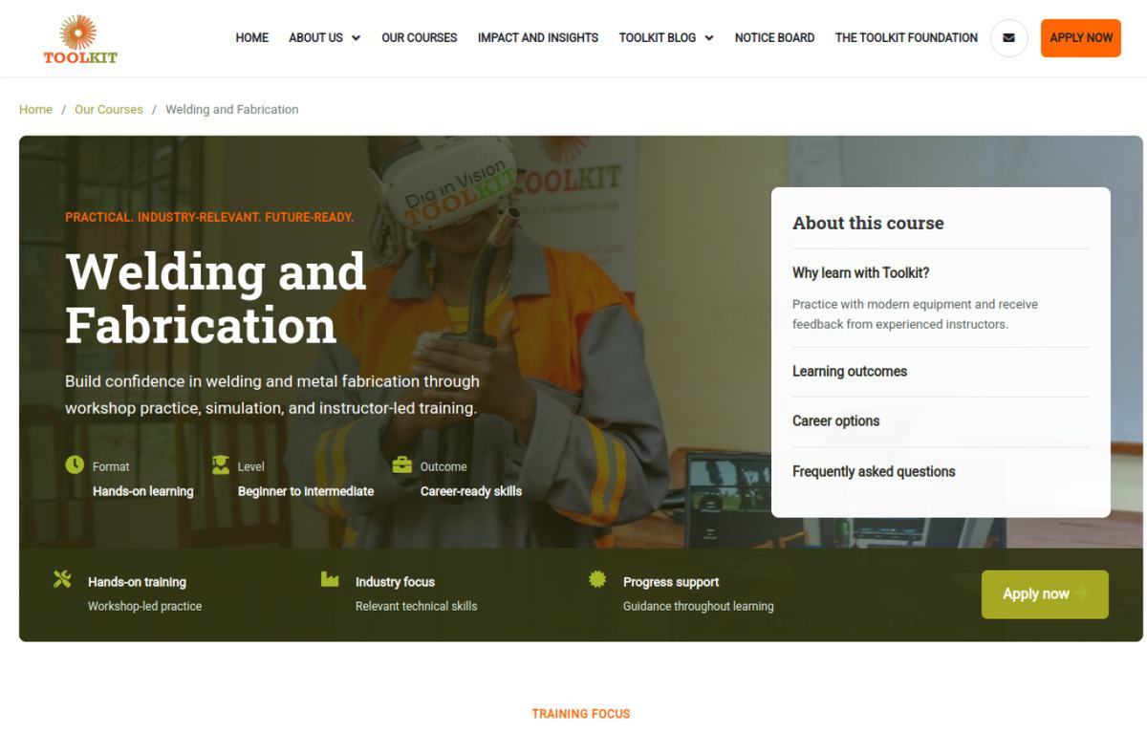  Modernised

Visual comparison: Notice
LEGACY PRODUCTION | NEW DEMO
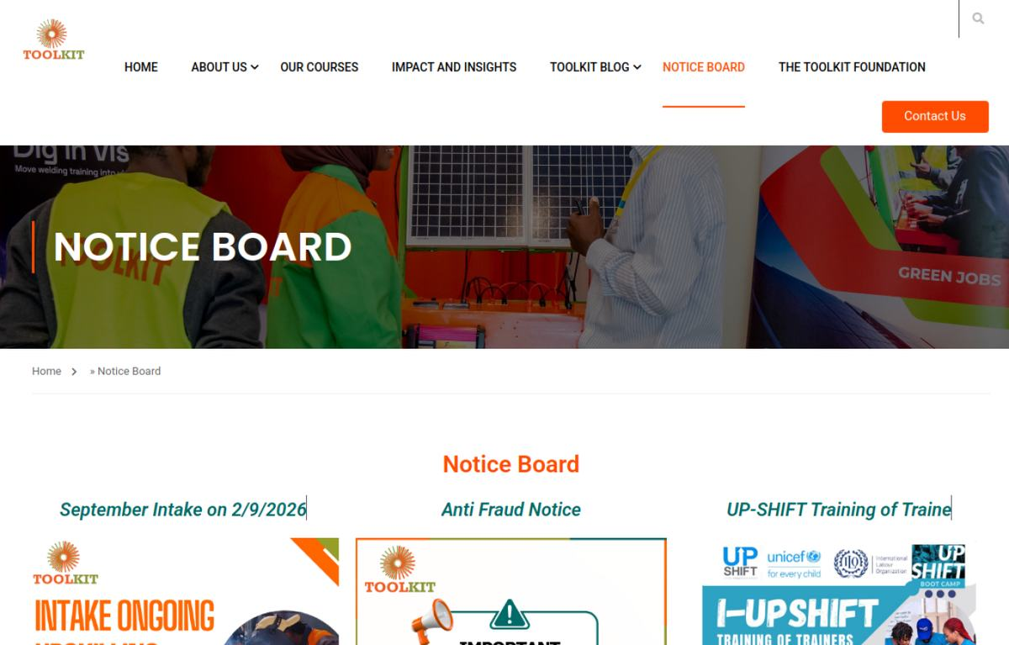  Baseline | 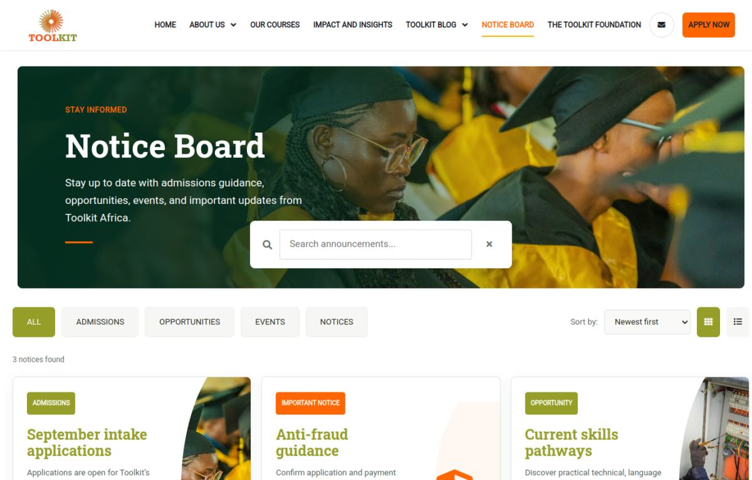  Modernised

5. Risks and Controls
- Builder-heavy production pages could create inconsistent performance and CSS conflicts.

6. Next-Week Priorities
- Begin the child-theme homepage, header and brand-token implementation.

7. Verification Record
Milestone | Status | Evidence / outcome
Source chronology | Complete | June crawl/prototype records, Git history and project progress log reconciled.
Visual evidence | Complete | Production and demo page captures embedded and labelled.
Document quality | Complete | Toolkit logo, weekly dates, version control and consistent report format applied.

