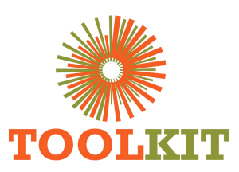
WEBSITE MODERNISATION PROGRAMME

Homepage, Header and Brand Foundation
29 June-05 July 2026
Report number | WMR-05
Issue date | 05 July 2026
Delivery status | Complete
Evidence note | Page captures were taken on 16 July 2026 for consistent comparison.

WEEKLY OUTCOME
Delivered the first production-shaped WordPress experience: modern hero, feature strip, stable header, brand tokens and a rebuilt Who We Are section.

1. Executive Summary
Delivered the first production-shaped WordPress experience: modern hero, feature strip, stable header, brand tokens and a rebuilt Who We Are section.

2. Milestone Status
Milestone | Status | Evidence / outcome
Hero system | Complete | Responsive carousel and dual CTA implementation.
Header/navigation | Complete | Primary menu and branded actions stabilised.
Who We Are | Complete | Existing organisational data retained in a modern layout.

3. Work Completed
- Implemented an accessible three-slide hero with Apply CTA, pagination, pause, keyboard and swipe controls.
- Added the feature strip and corrected counter, arrow, overlay and scroll-cue behaviour.
- Stabilised navigation selection, logo sizing, dropdown spacing and Apply Now placement.
- Created shared brand tokens and introduced consistent component spacing and button treatment.
- Rebuilt Who We Are with the existing vision, mission, quick links and five impact figures.

4. Visual Evidence
The left image shows the production baseline and the right image shows the redesigned demo. Captures use a consistent desktop viewport and were collected on 16 July 2026.

Visual comparison: Home
LEGACY PRODUCTION | NEW DEMO
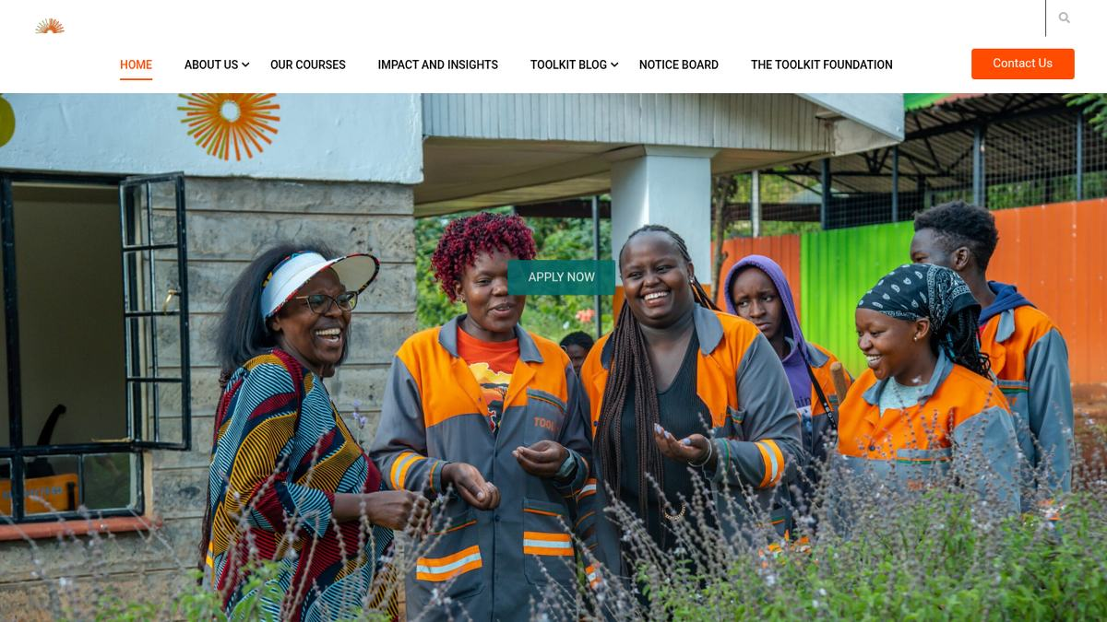  Baseline | 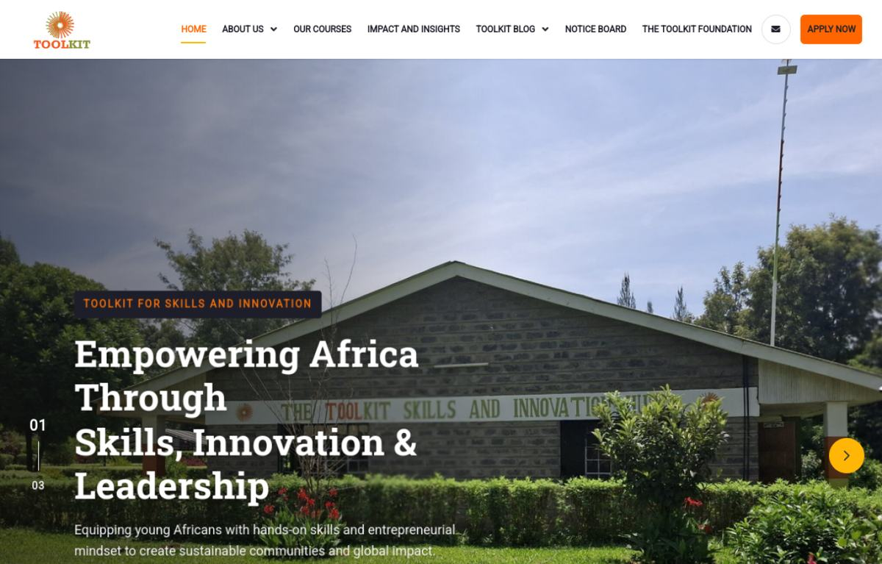  Modernised

Visual comparison: About
LEGACY PRODUCTION | NEW DEMO
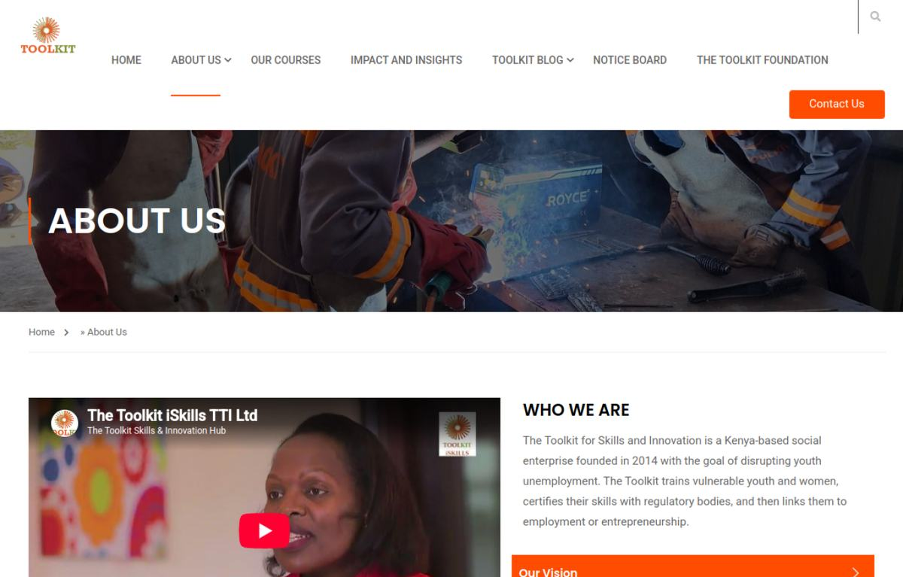  Baseline | 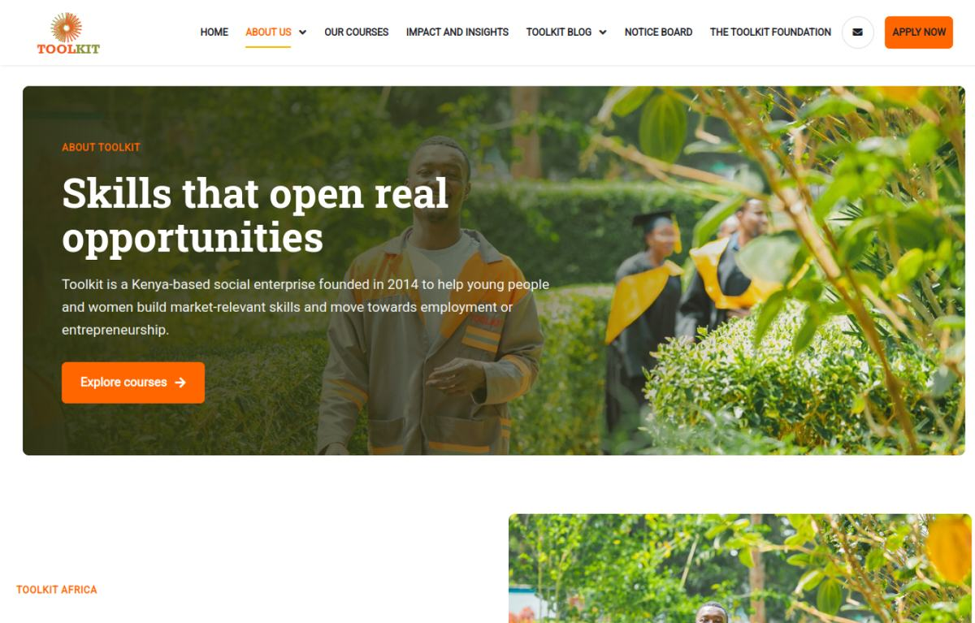  Modernised

5. Risks and Controls
- Legacy Elementor output still loaded behind the new homepage sections and required isolation.

6. Next-Week Priorities
- Harden the child-theme boundary, remove blocking preloaders and validate local runtime behaviour.

7. Verification Record
Milestone | Status | Evidence / outcome
Source chronology | Complete | June crawl/prototype records, Git history and project progress log reconciled.
Visual evidence | Complete | Production and demo page captures embedded and labelled.
Document quality | Complete | Toolkit logo, weekly dates, version control and consistent report format applied.

