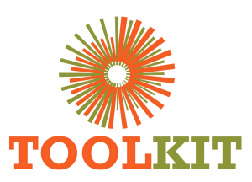
WEBSITE MODERNISATION PROGRAMME

Child-Theme Hardening and Runtime Performance
06-12 July 2026
Report number | WMR-06
Issue date | 12 July 2026
Delivery status | Complete
Evidence note | Page captures were taken on 16 July 2026 for consistent comparison.

WEEKLY OUTCOME
Made the redesign independent of fragile builder state, established a reproducible local runtime and removed major causes of slow or blocked rendering.

1. Executive Summary
Made the redesign independent of fragile builder state, established a reproducible local runtime and removed major causes of slow or blocked rendering.

2. Milestone Status
Milestone | Status | Evidence / outcome
Child-theme isolation | Complete | Homepage and priority layouts no longer depend on page-builder rendering.
Local runtime | Complete | Database import and PHP review server documented.
Progressive rendering | Complete | Blocking preload behaviour removed.

3. Work Completed
- Moved homepage ownership into the child theme and retained parent fallback when redesign is disabled.
- Converted homepage video to click-to-play to reduce initial network and layout cost.
- Disabled the blocking Eduma public preloader and removed stale preload body classes.
- Created the local MariaDB/PHP workflow and validated child-theme rendering at 127.0.0.1:8001.
- Reduced plugin and builder asset exposure on rebuilt routes and formalised database seeding.

4. Visual Evidence
The left image shows the production baseline and the right image shows the redesigned demo. Captures use a consistent desktop viewport and were collected on 16 July 2026.

Visual comparison: Home
LEGACY PRODUCTION | NEW DEMO
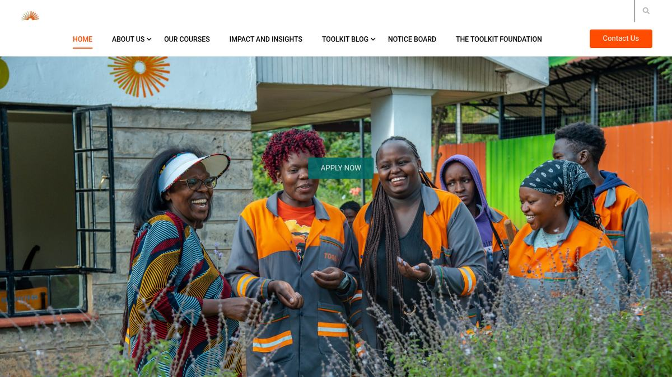  Baseline | 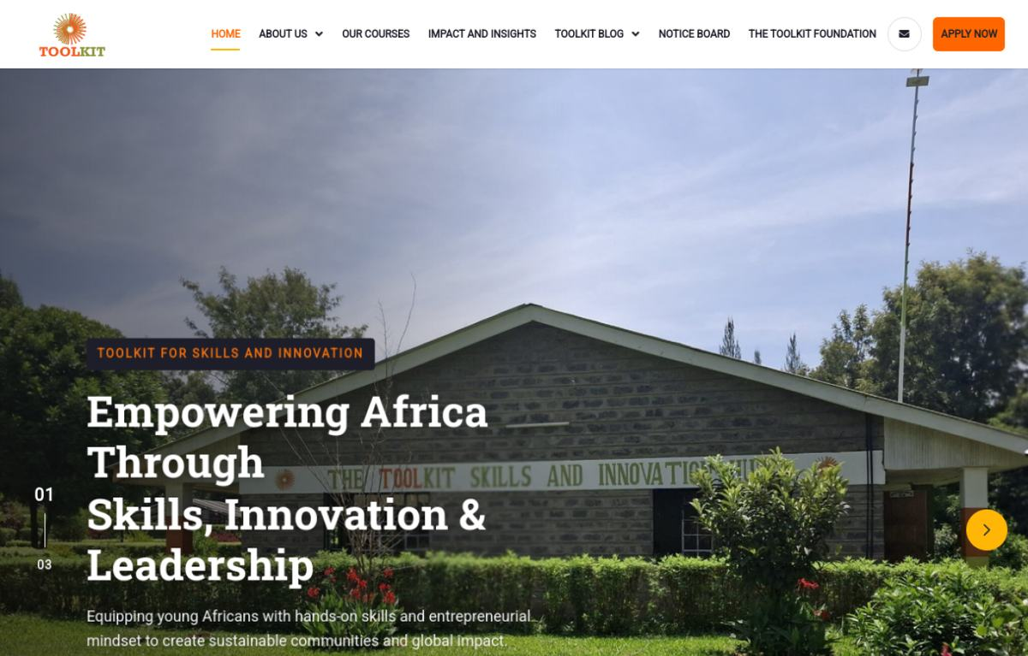  Modernised

Visual comparison: Contact
LEGACY PRODUCTION | NEW DEMO
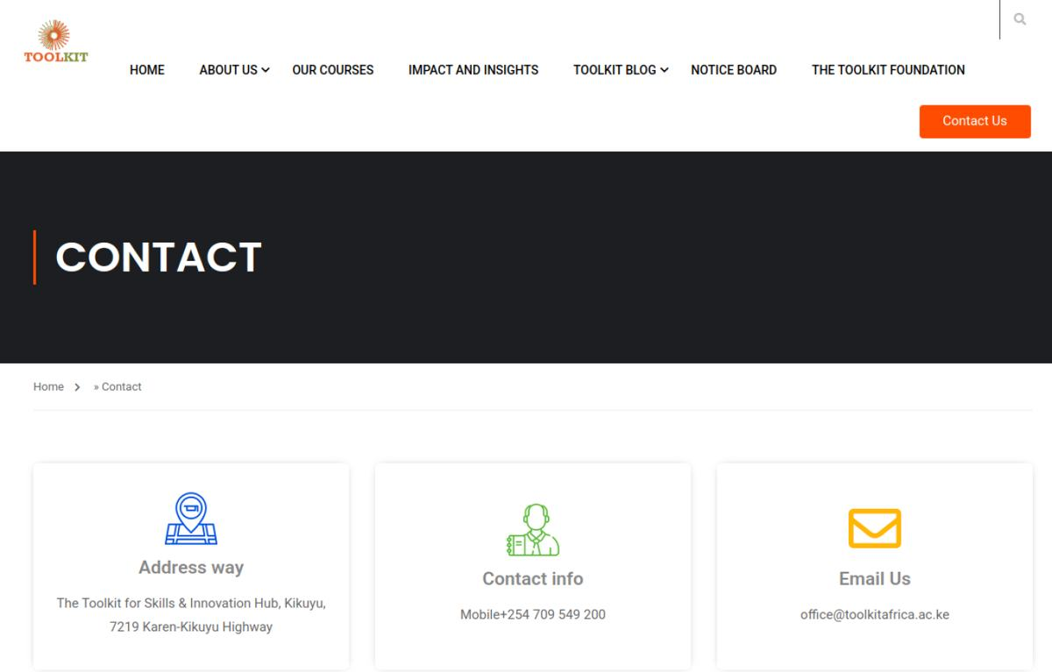  Baseline | 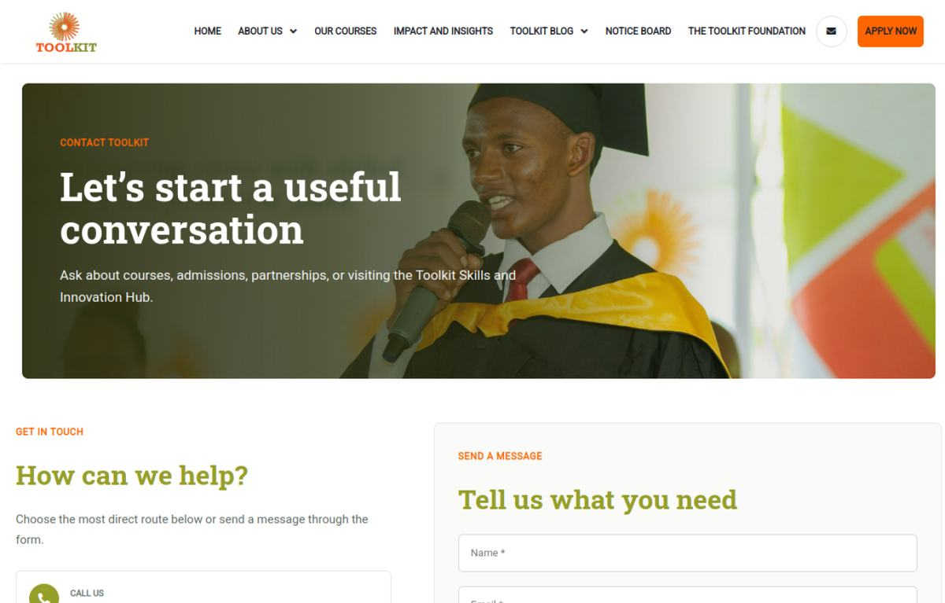  Modernised

5. Risks and Controls
- Uncached WordPress generation remained slower than warm LiteSpeed responses.

6. Next-Week Priorities
- Build and deploy the major-page templates, SEO layer, course catalogue and operational controls.

7. Verification Record
Milestone | Status | Evidence / outcome
Source chronology | Complete | June crawl/prototype records, Git history and project progress log reconciled.
Visual evidence | Complete | Production and demo page captures embedded and labelled.
Document quality | Complete | Toolkit logo, weekly dates, version control and consistent report format applied.

