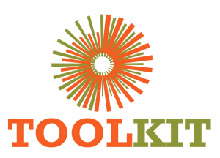
WEBSITE MODERNISATION PROGRAMME

Major Pages, SEO, Analytics and Demo Release
13-16 July 2026
Report number | WMR-07
Issue date | 16 July 2026
Delivery status | Complete through 16 July
Evidence note | Page captures were taken on 16 July 2026 for consistent comparison.

WEEKLY OUTCOME
Completed the first coherent demo release across major pages, data controls, SEO, analytics and rollback operations, with the production domain intentionally unchanged.

1. Executive Summary
Completed the first coherent demo release across major pages, data controls, SEO, analytics and rollback operations, with the production domain intentionally unchanged.

2. Milestone Status
Milestone | Status | Evidence / outcome
Major-page release | Complete | Eight priority routes redesigned and deployed to demo.
SEO implementation | Complete | Metadata, canonicals, social previews and schema controls added.
Operational controls | Complete | Metrics, feature switches, seeders and rollback workflow available.
Demo verification | Complete | HTTP, asset, syntax, cache and visual checks passed.
Main-domain cutover | Pending approval | Production remains unchanged pending credentials and final acceptance.

3. Work Completed
- Rebuilt Courses, Welding, Notice Board, Application, About, Impact, Foundation, Contact and Toolkit Blog templates.
- Restored all 18 team members with optimized local portraits and retained live-site organisational content.
- Expanded homepage depth with 2026 IIW, sector video, animated impact metrics, testimonials, stories and floating assistant.
- Implemented functional Notice Board search, filtering, sorting, result counts and grid/list views.
- Added curated titles, descriptions, canonicals, Open Graph metadata and structured-data hierarchy.
- Added first-party page, dwell, scroll, performance and interaction metrics with Toolkit Control in WordPress admin.
- Introduced redesign/catalog/pricing switches, persistent rollback storage and guarded FTPS deployment.
- Established main as the Git source-of-truth branch and removed the merged feature branch.

4. Visual Evidence
The left image shows the production baseline and the right image shows the redesigned demo. Captures use a consistent desktop viewport and were collected on 16 July 2026.

Visual comparison: Home
LEGACY PRODUCTION | NEW DEMO
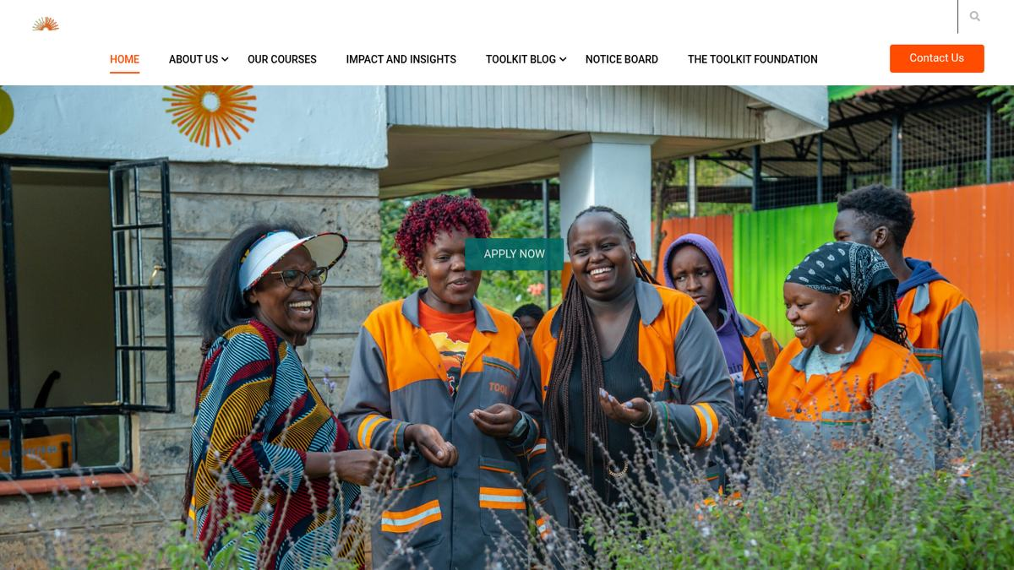  Baseline | 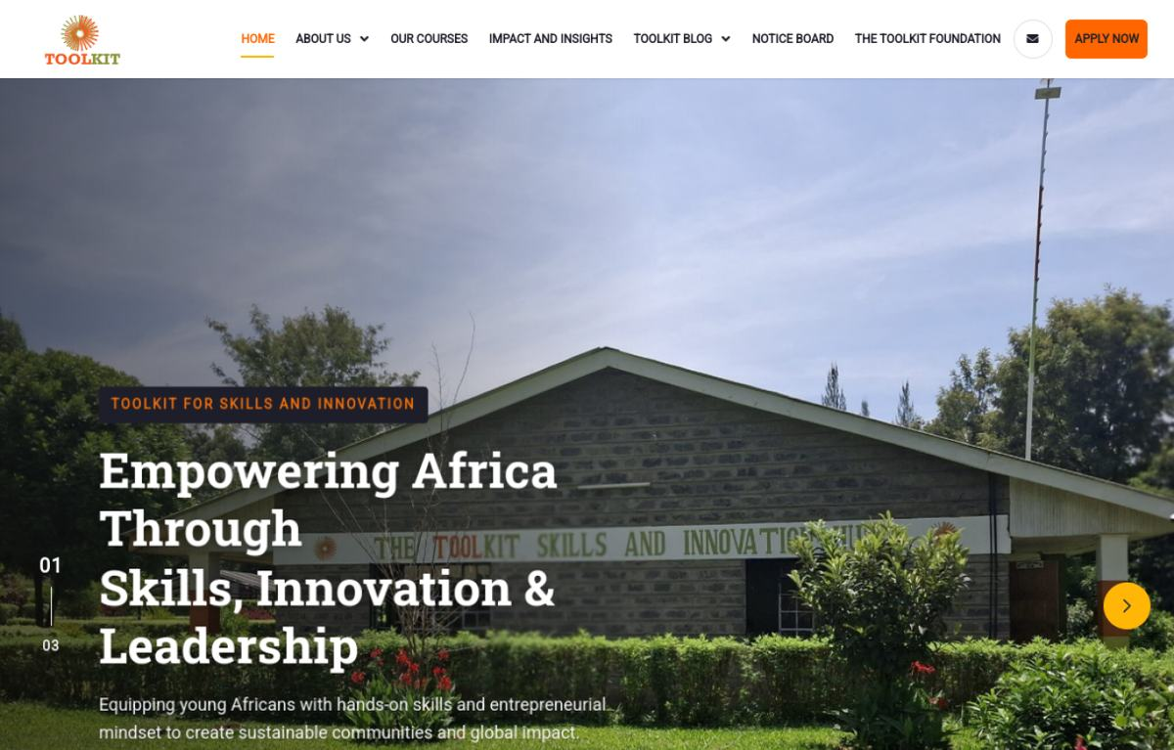  Modernised

Visual comparison: About
LEGACY PRODUCTION | NEW DEMO
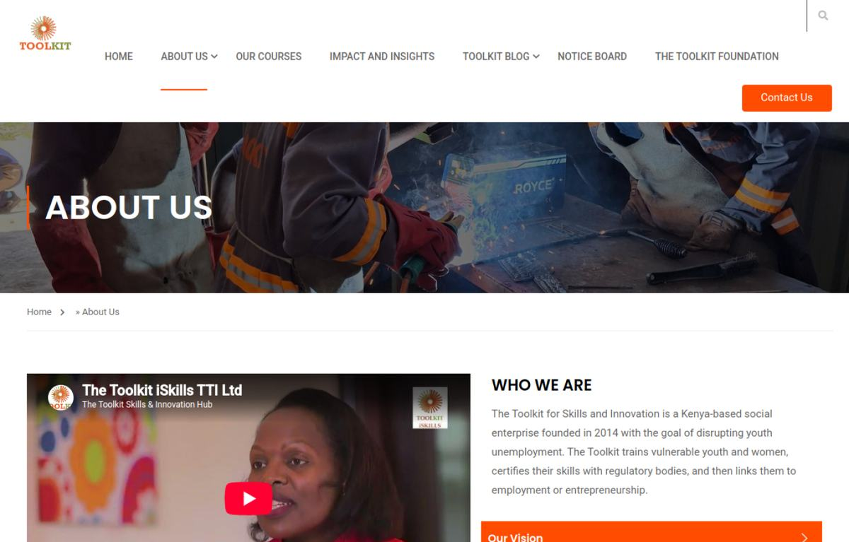  Baseline | 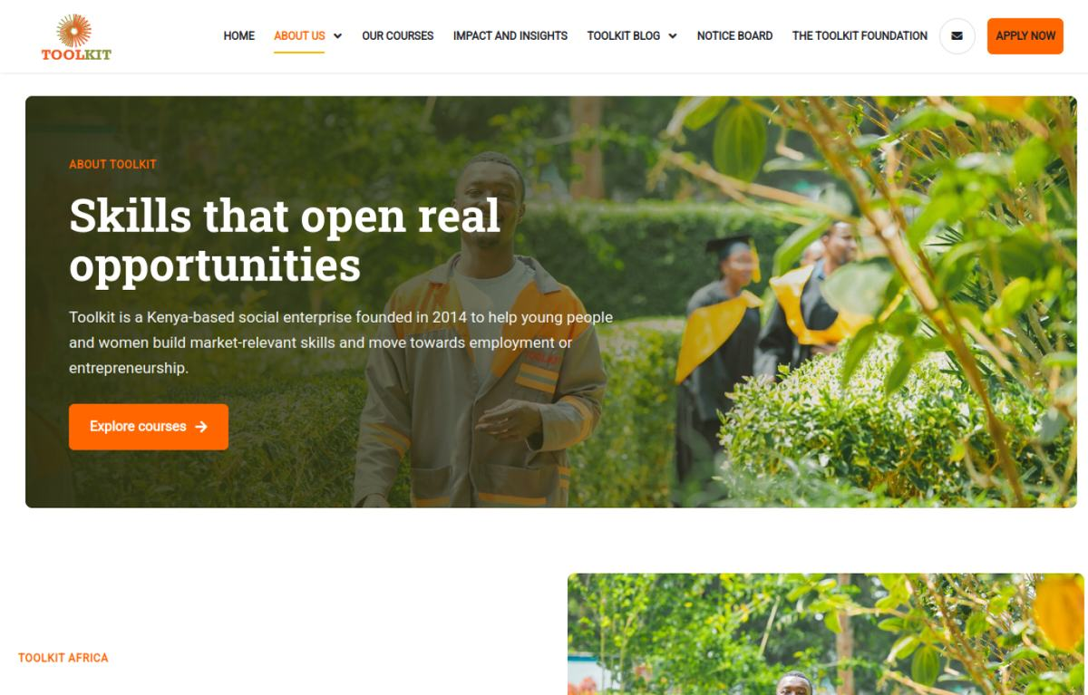  Modernised

Visual comparison: Courses
LEGACY PRODUCTION | NEW DEMO
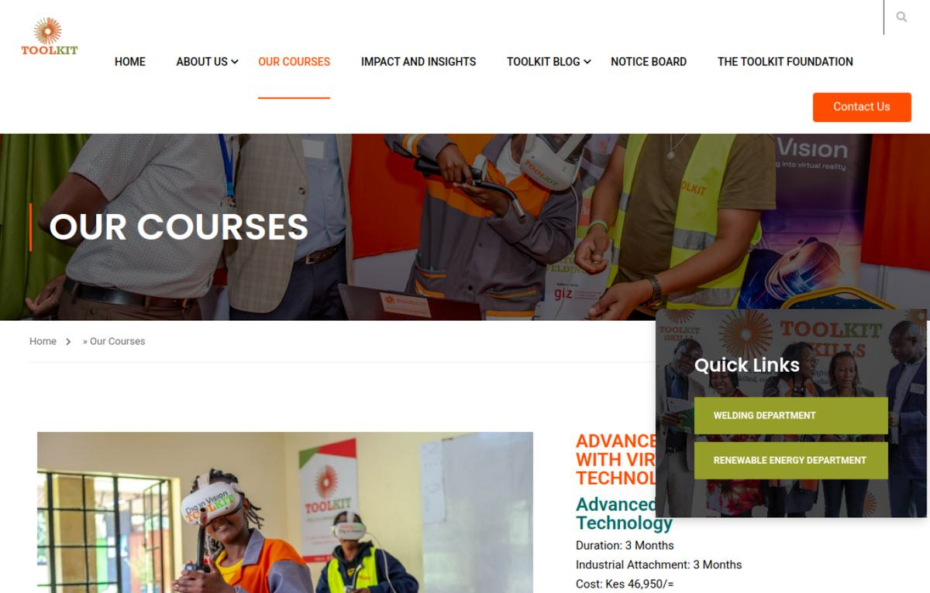  Baseline | 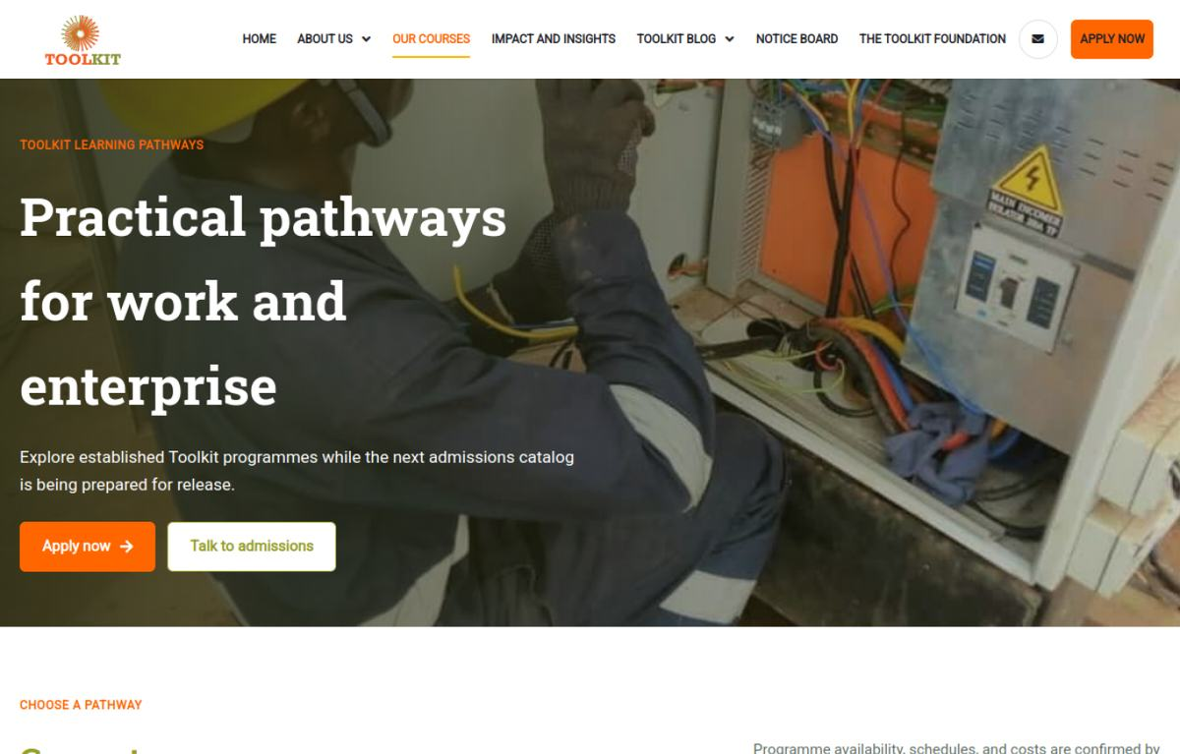  Modernised

Visual comparison: Welding
LEGACY PRODUCTION | NEW DEMO
  Baseline | 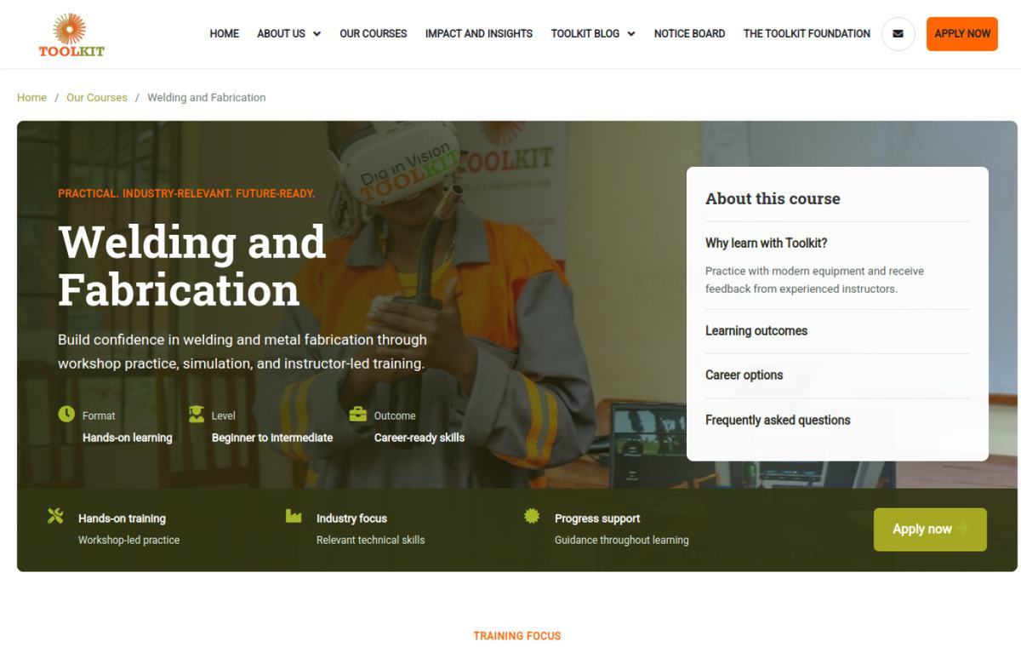  Modernised

Visual comparison: Notice
LEGACY PRODUCTION | NEW DEMO
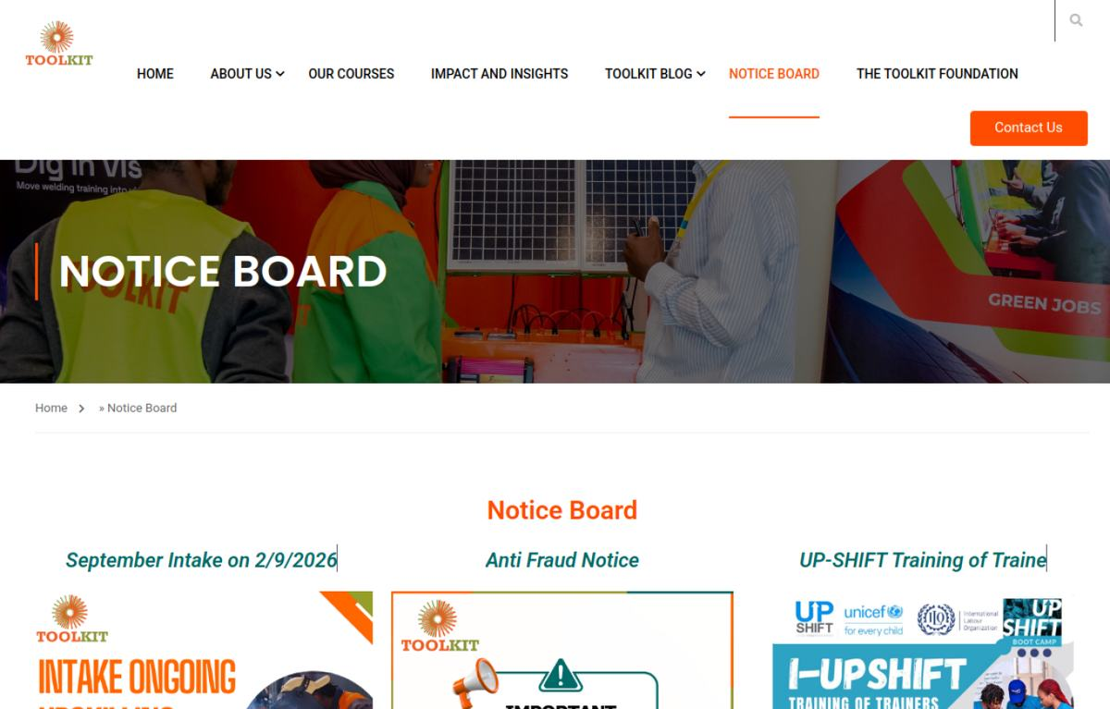  Baseline | 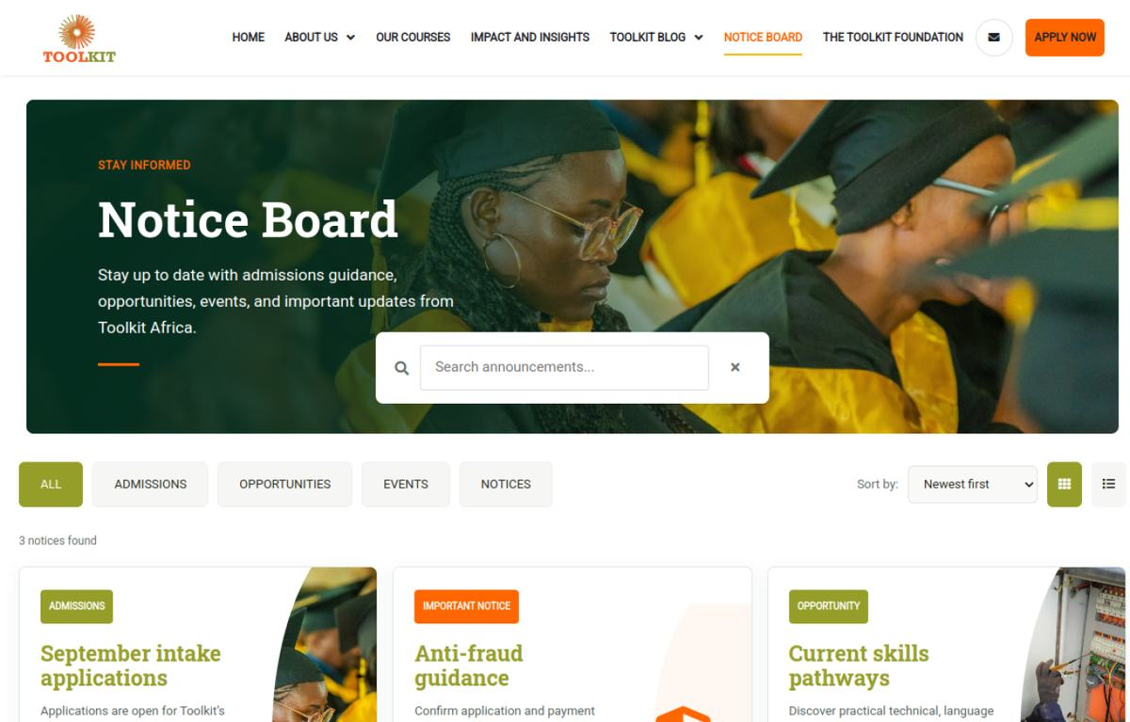  Modernised

Visual comparison: Application
LEGACY PRODUCTION | NEW DEMO
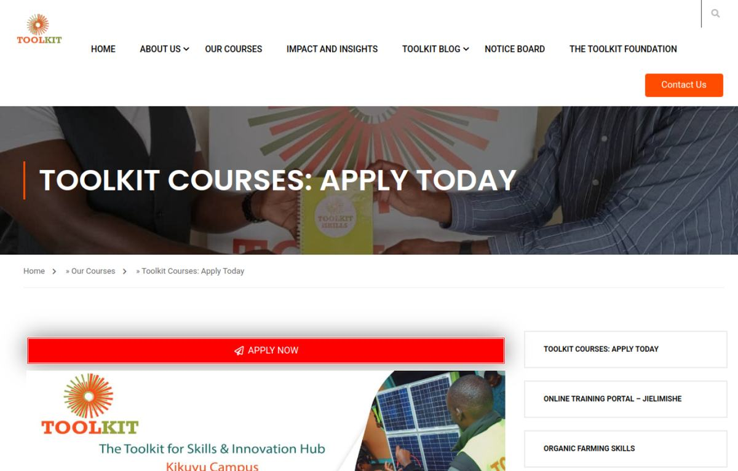  Baseline | 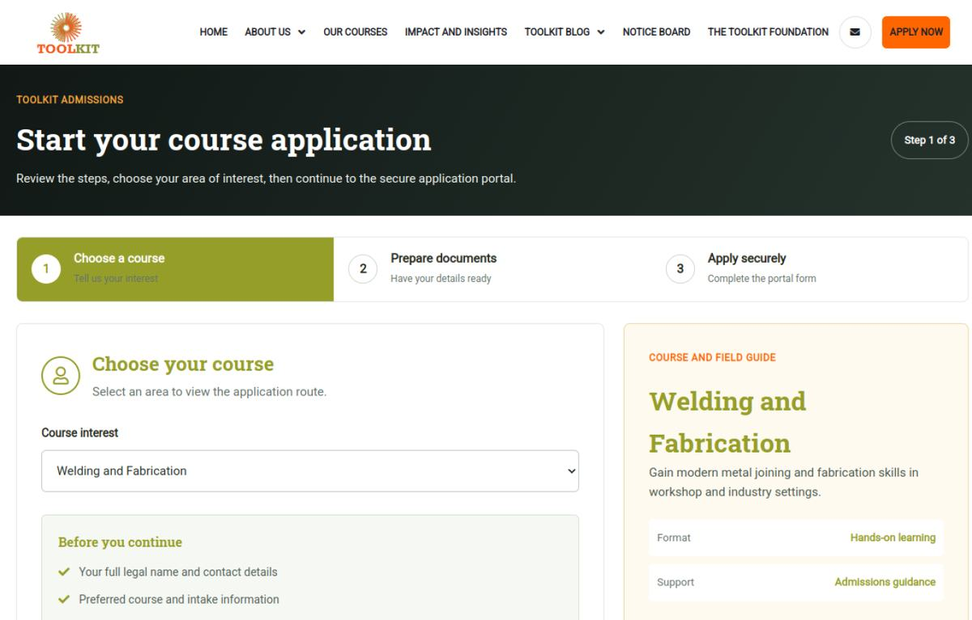  Modernised

Visual comparison: Blog
LEGACY PRODUCTION | NEW DEMO
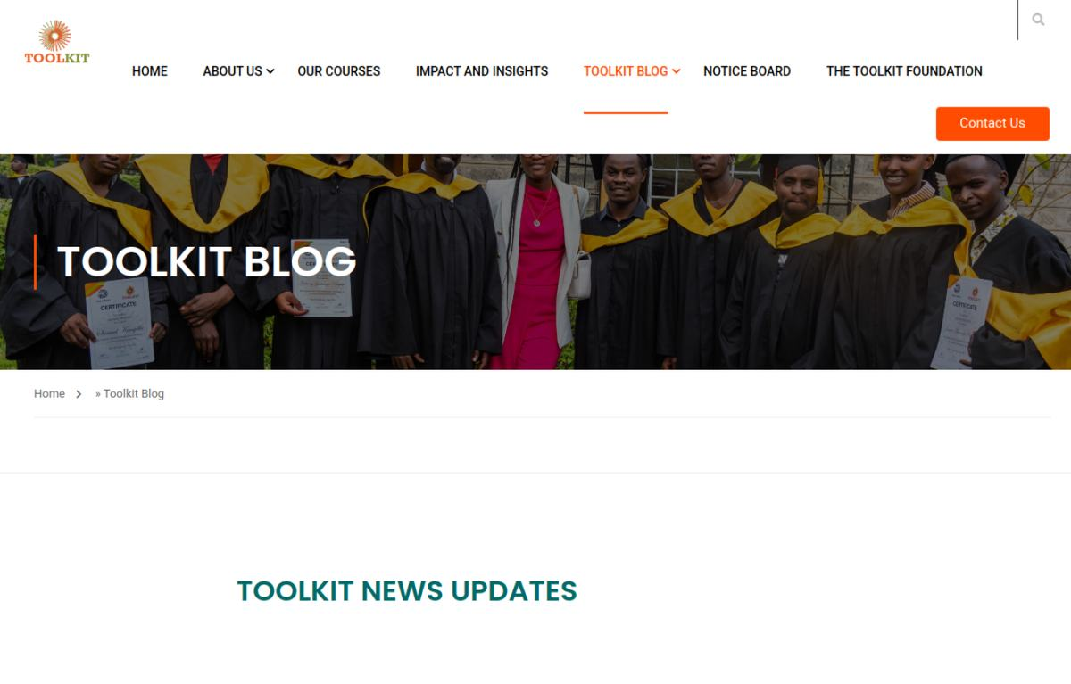  Baseline |   Modernised

Visual comparison: Contact
LEGACY PRODUCTION | NEW DEMO
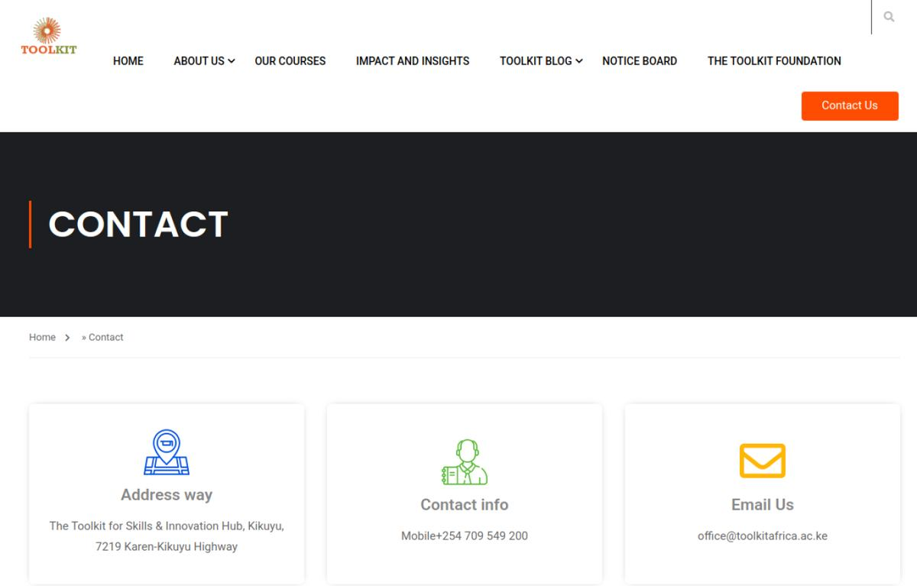  Baseline | 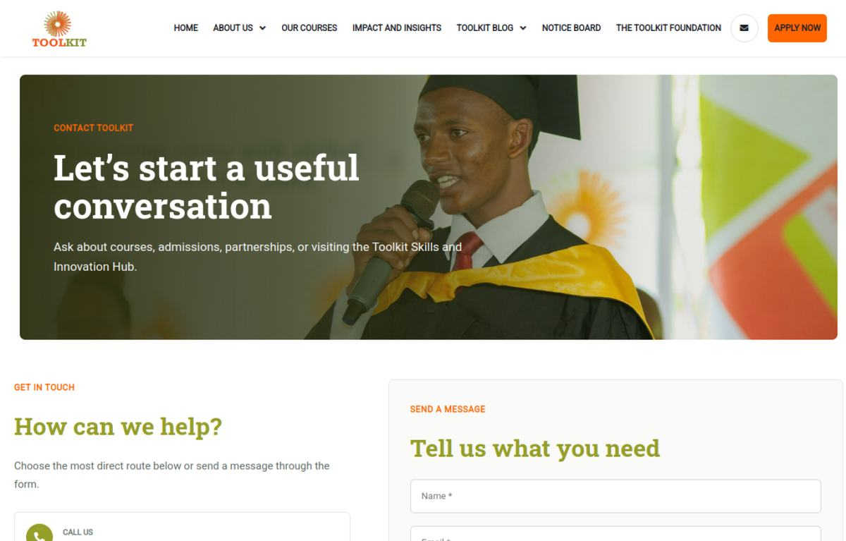  Modernised

5. SEO Evidence
The following panels reproduce public metadata captured from both environments. Demo canonicals intentionally resolve to the main domain to avoid indexing the staging host.

SEO comparison: Home
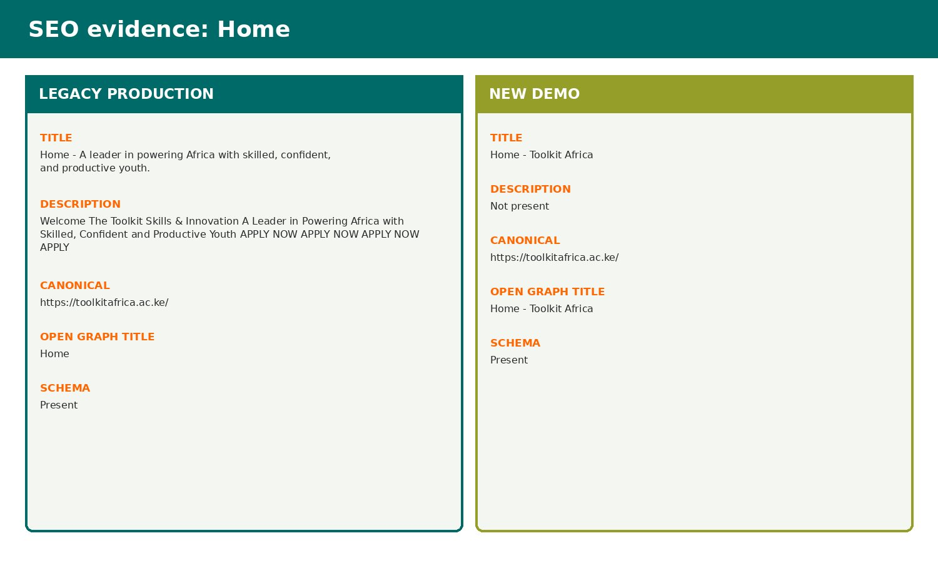
Live metadata capture: production baseline compared with the demo implementation.

SEO comparison: About
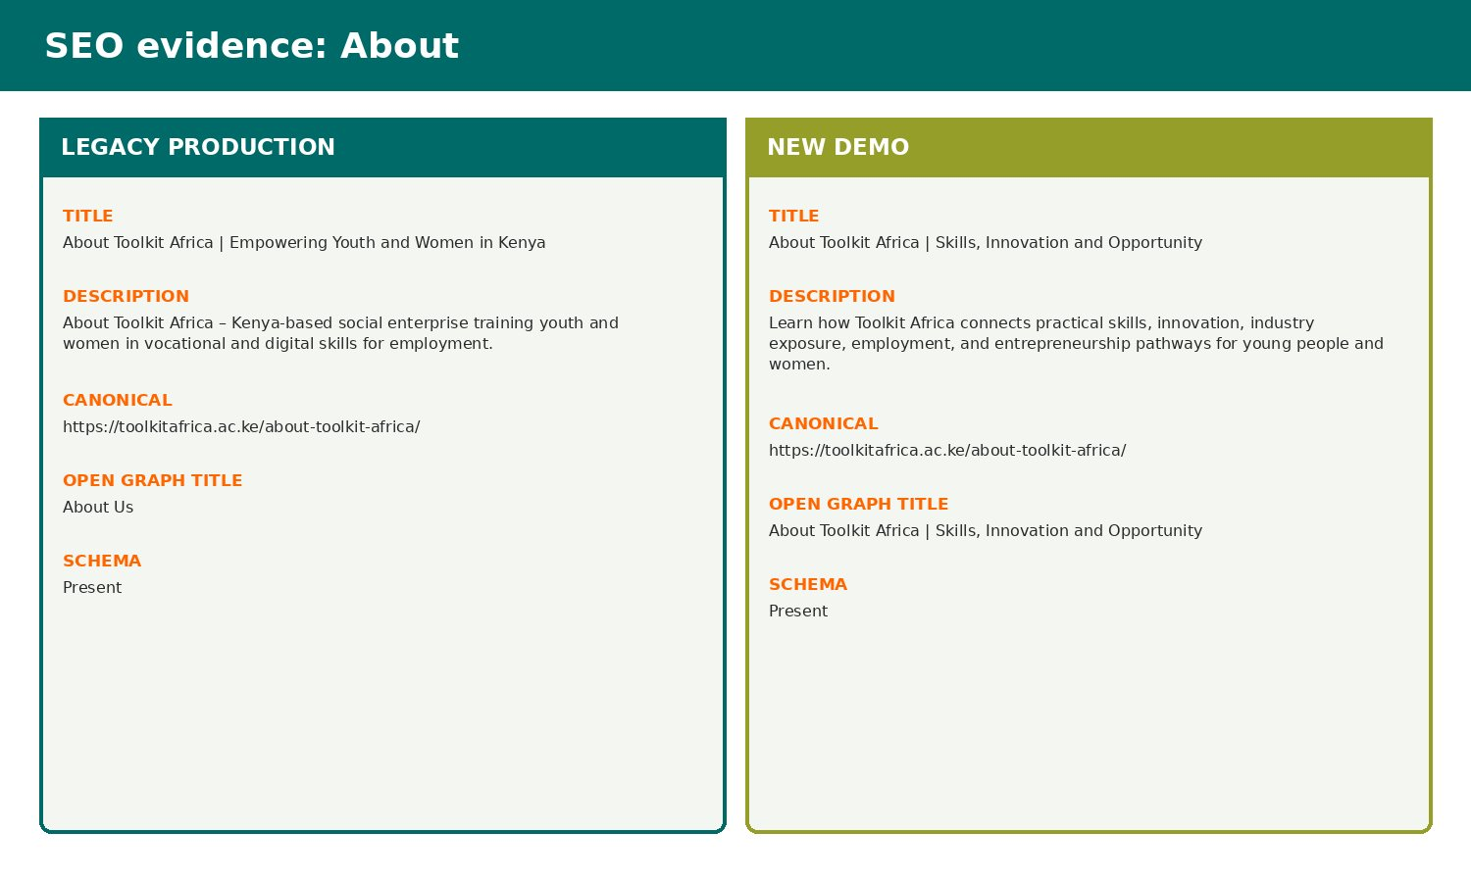
Live metadata capture: production baseline compared with the demo implementation.

SEO comparison: Courses
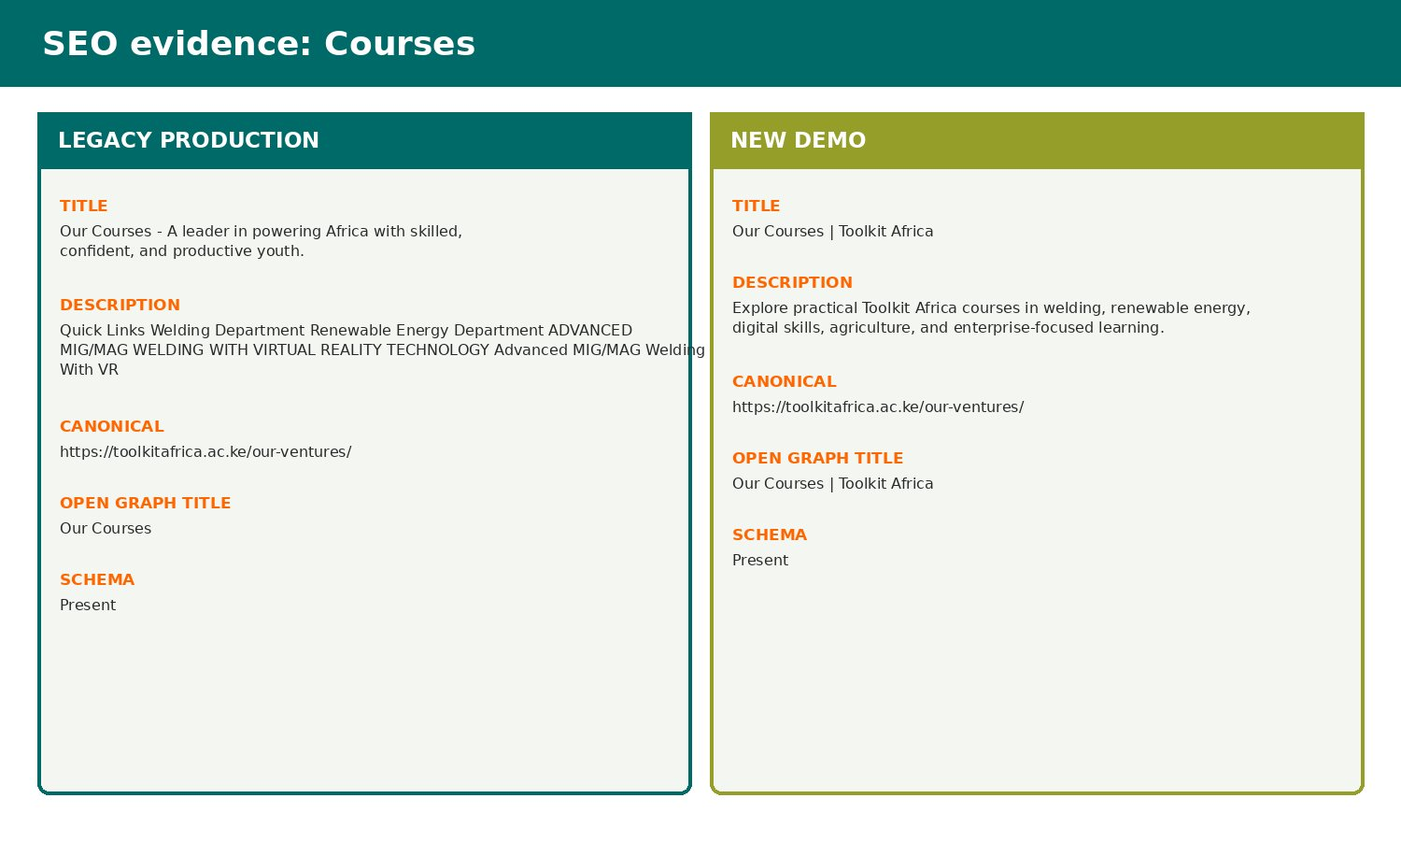
Live metadata capture: production baseline compared with the demo implementation.

SEO comparison: Welding
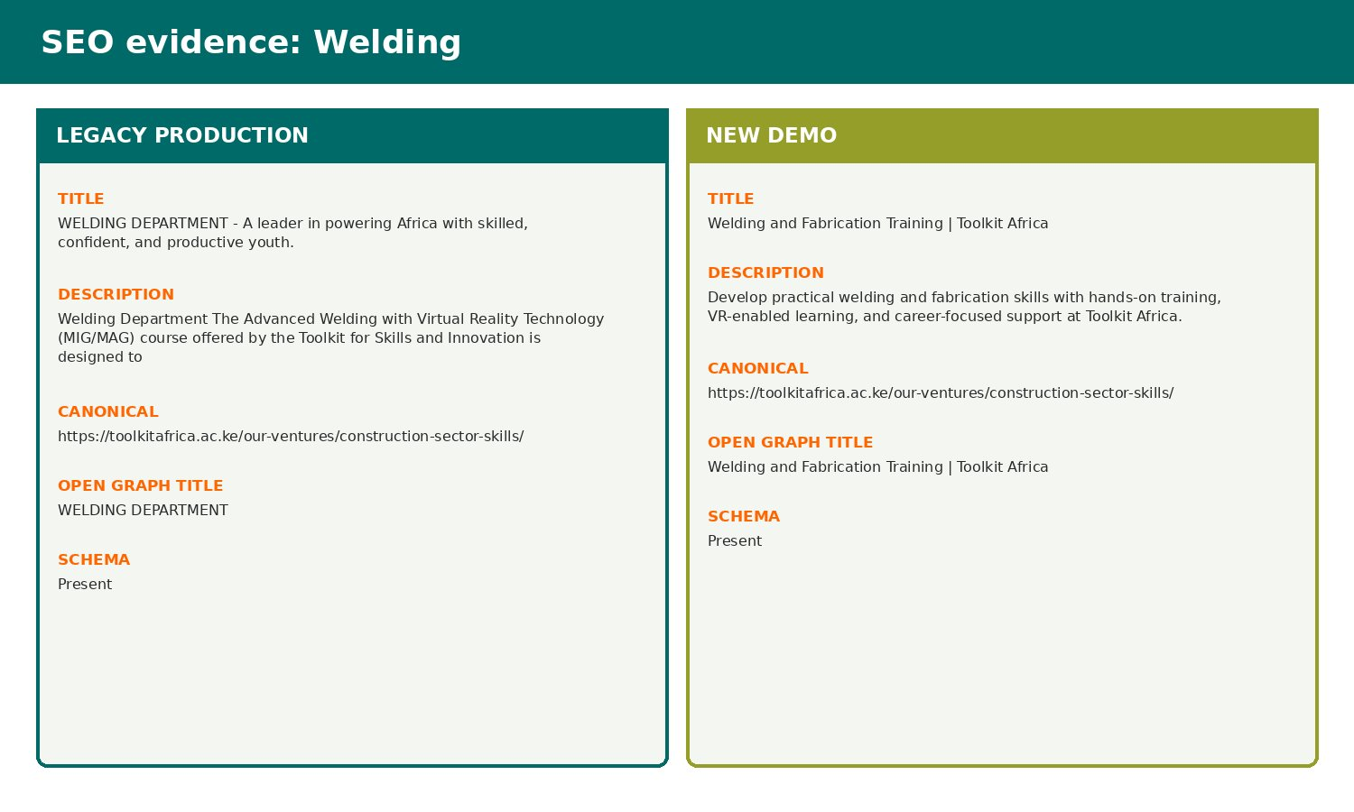
Live metadata capture: production baseline compared with the demo implementation.

SEO comparison: Notice
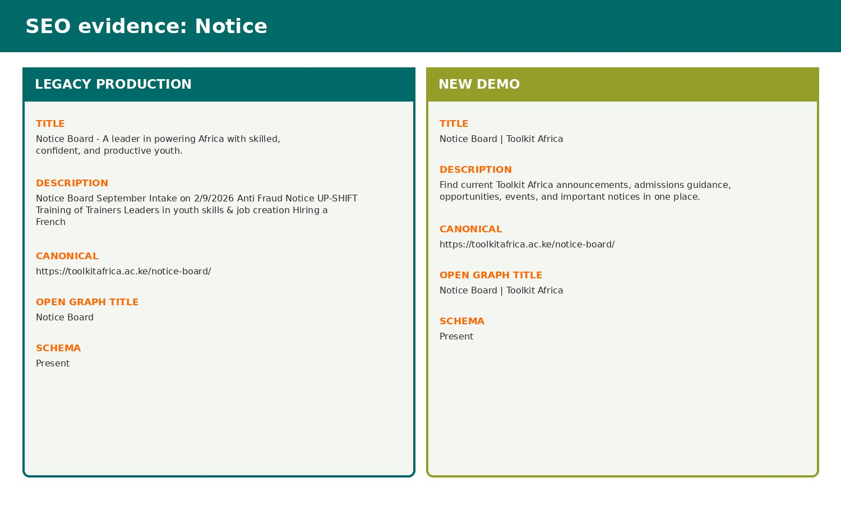
Live metadata capture: production baseline compared with the demo implementation.

SEO comparison: Application
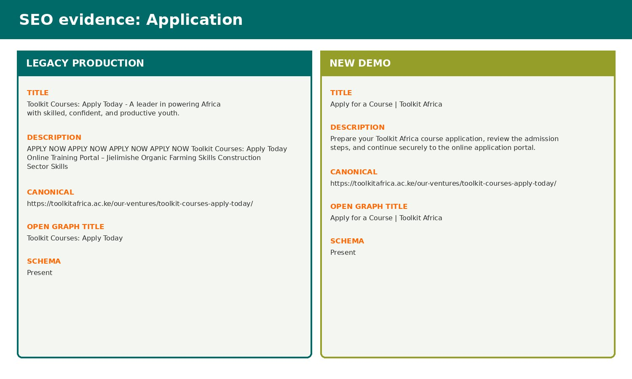
Live metadata capture: production baseline compared with the demo implementation.

SEO comparison: Blog
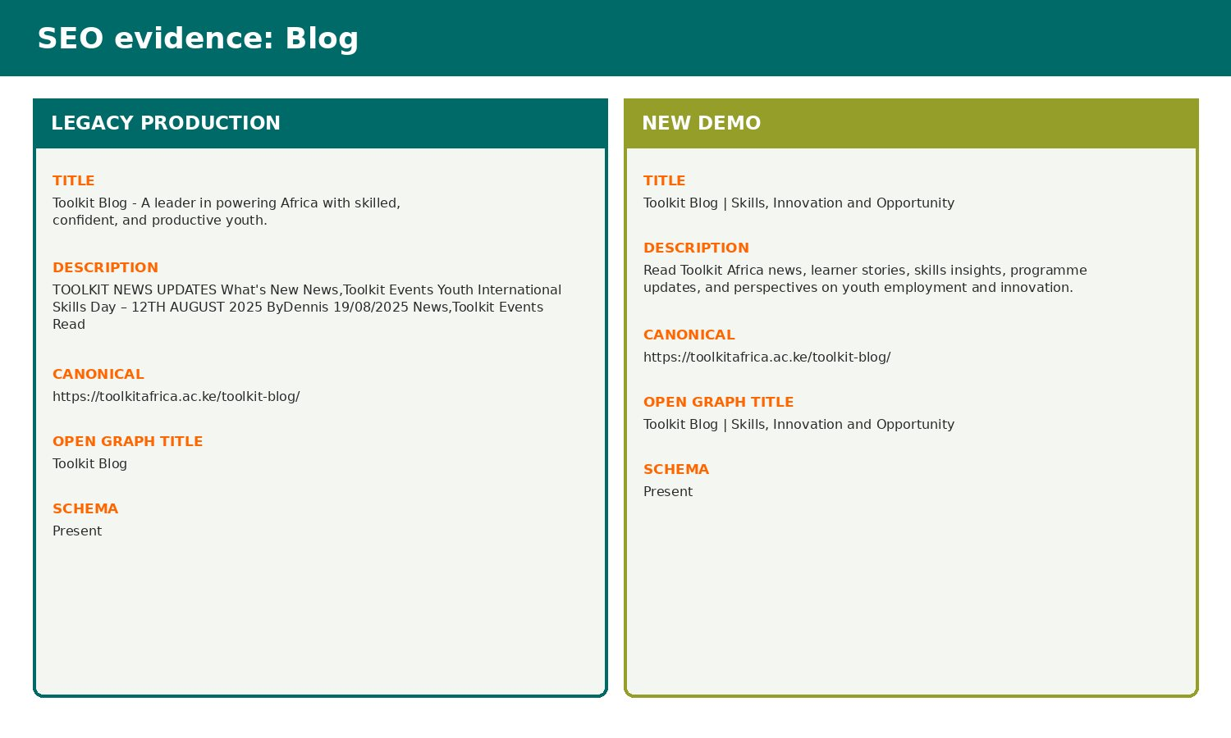
Live metadata capture: production baseline compared with the demo implementation.

SEO comparison: Contact
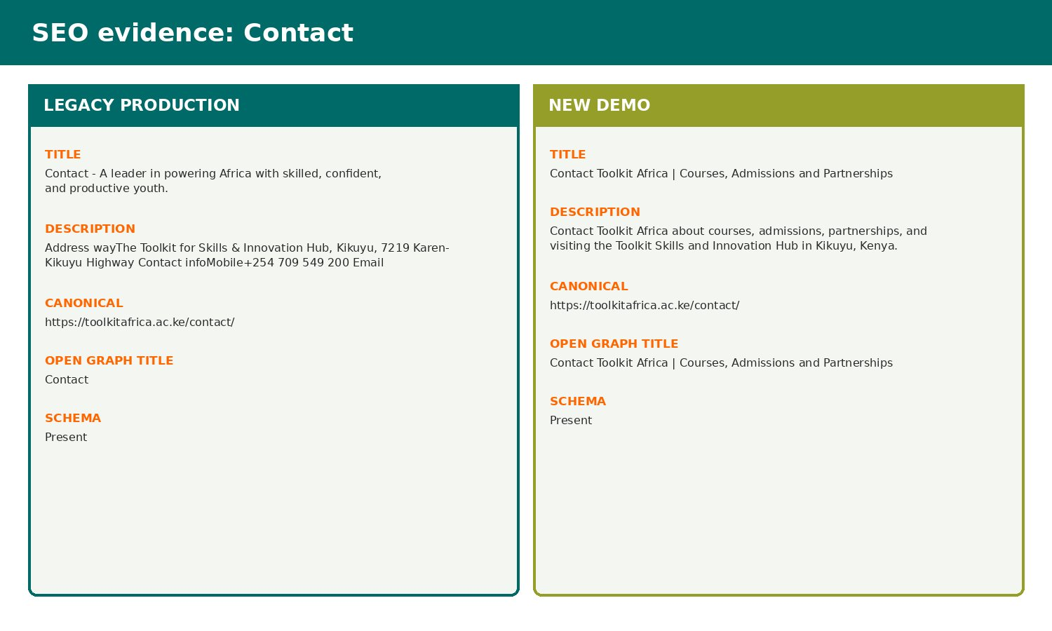
Live metadata capture: production baseline compared with the demo implementation.

6. Risks and Controls
- Main-domain activation must preserve 39 current page routes, approximately 150 post URLs, two team systems and account/LMS workflows.
- The Mzizi form adapter requires an approved field contract and non-production submission testing before implementation.
- September course pricing remains disabled until written admissions approval and the effective date.

7. Next-Week Priorities
- Complete stakeholder demo acceptance.
- Obtain production file/database access and take persistent backups.
- Sync the child theme with all switches off, activate legacy-compatible mode, verify routes, then enable the redesign under rollback control.

8. Verification Record
Milestone | Status | Evidence / outcome
Source chronology | Complete | June crawl/prototype records, Git history and project progress log reconciled.
Visual evidence | Complete | Production and demo page captures embedded and labelled.
Document quality | Complete | Toolkit logo, weekly dates, version control and consistent report format applied.

