- Keep API_CREDENTIALS.ini in Amibroker exe folder
[Config]
Endpoint=https://rama.kambala.co.in/NorenWClientTP/
ApiSecret=<your secret>
User=Userid
AuthClientId=oauth client

- Login to Web.

- Click API Key from Profile
- Configure as in screenshot . Primary IP is the static IP ( whatsmyip.com gives u the global static ip)
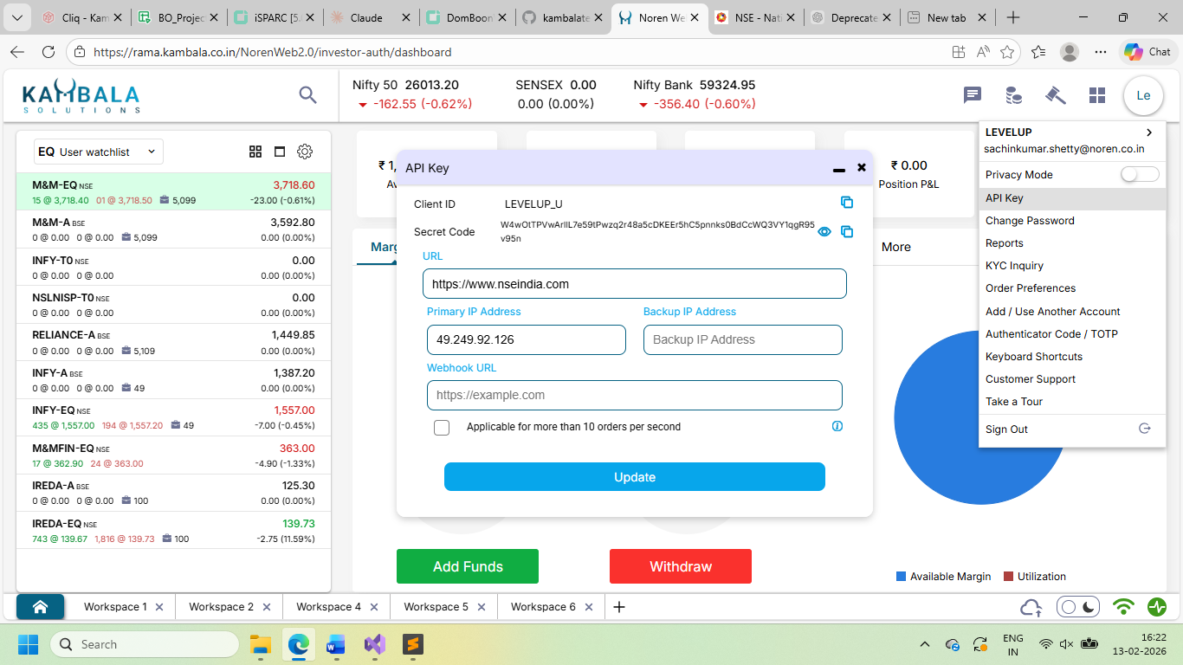
- Get the auth code by opening url https://rama.kambala.co.in/NorenWeb2.0/authorize/oauth?client_id=LEVELUP_U
Here
OAUTH_URL = https://rama.kambala.co.in/NorenWeb2.0/authorize/oauth?client_id=
OAUTH_CLIENT=LEVEL_UP
- The response will be
https://www.nseindia.com/?code=0c82126f-85ef-40ad-98c2-7099d6c82400

- Paste this auth_code to login. Only Right Click paste works not ctrl+V
- 