LAB 5
1) Creating a database and dropping through DROP command.
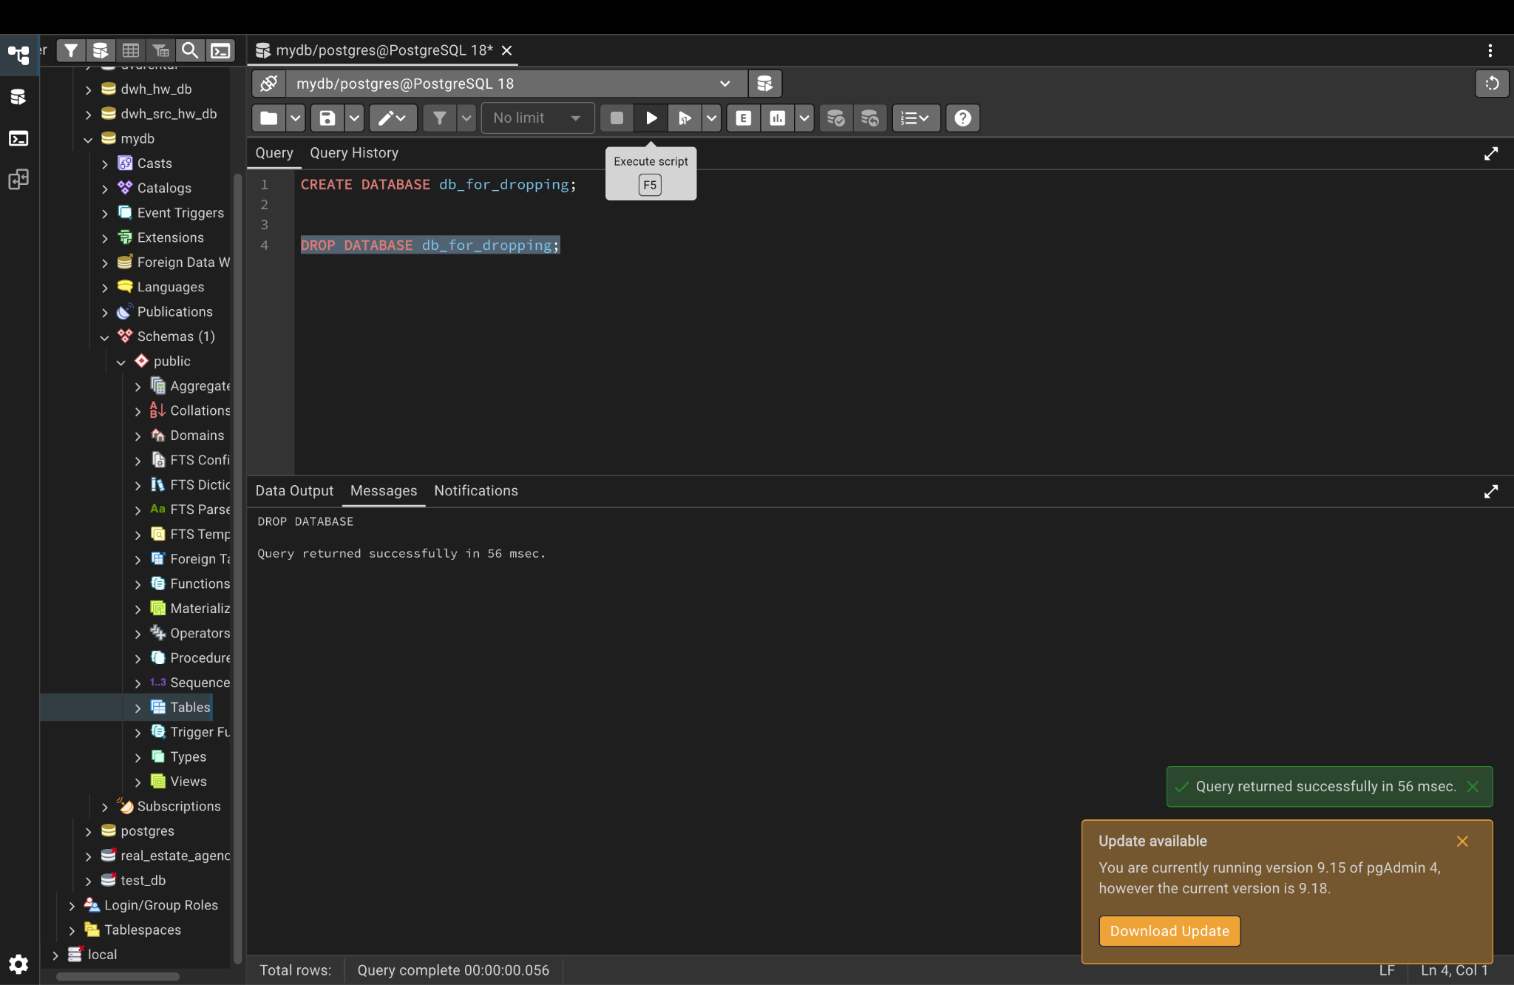
2)Switching between databases through psql commands:
