ASSESSMENT-1

1.Create a VM with availability set using the custom image with chrome Pre-installed

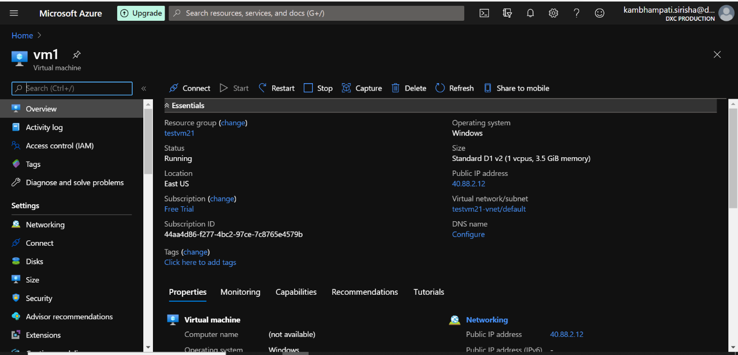

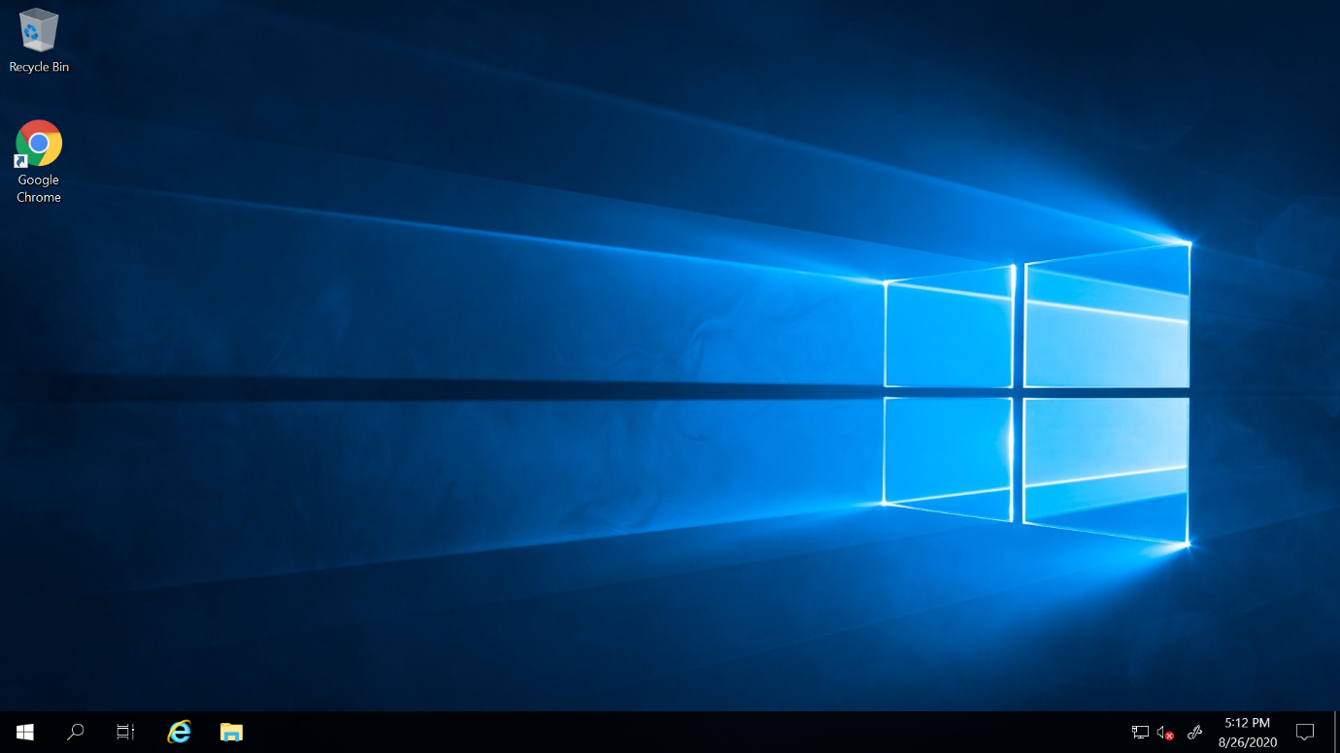

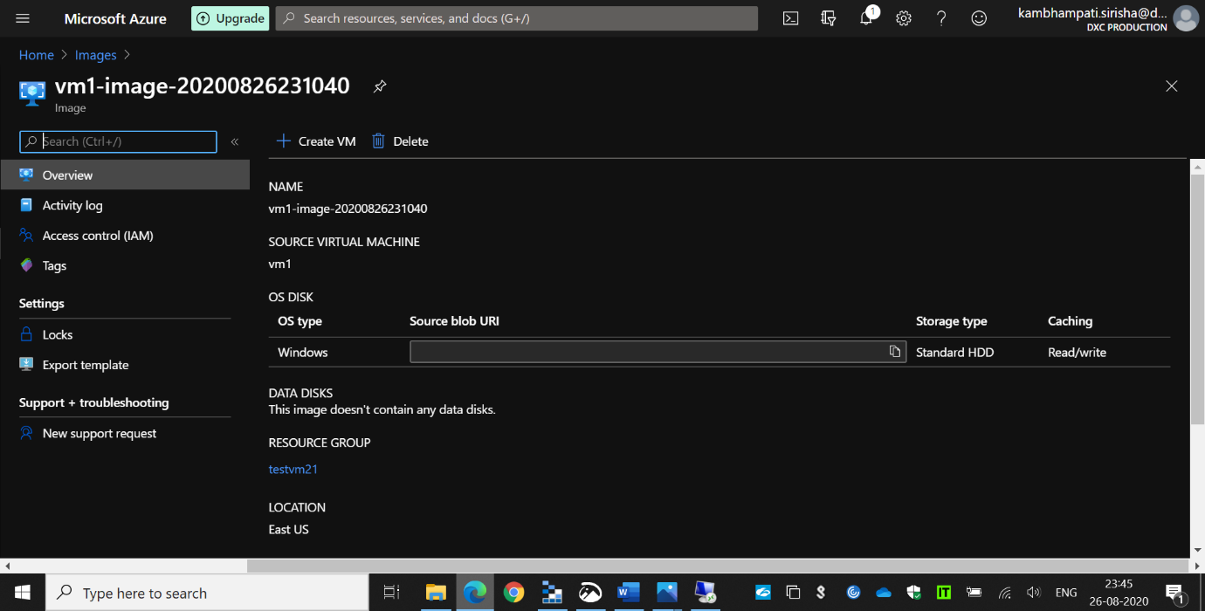

2.Create a Virtual machine scale set with DS1-v2 standard

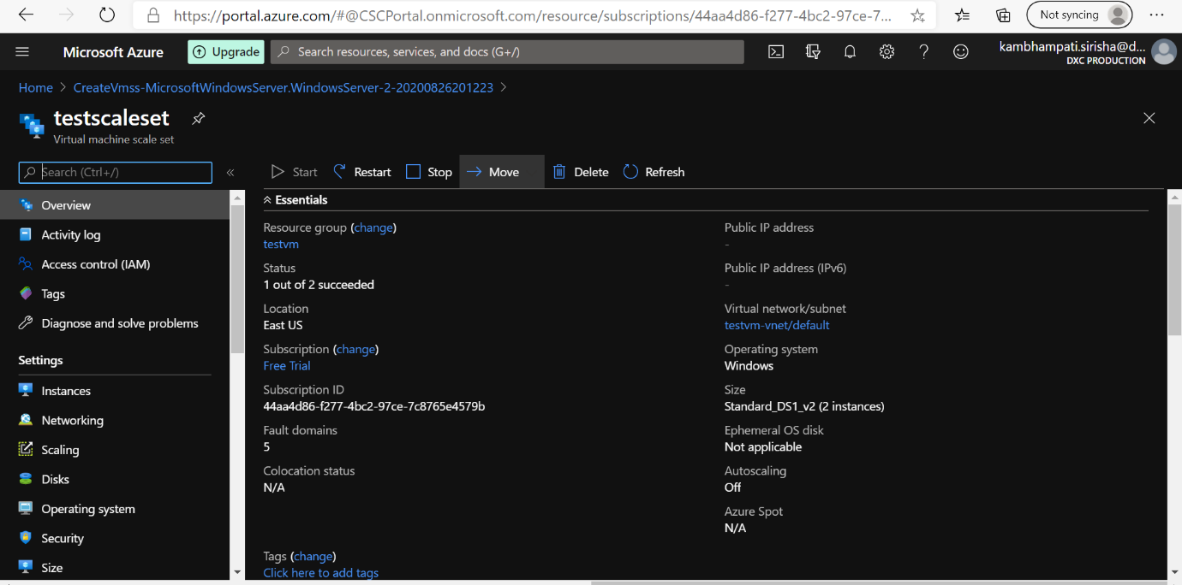

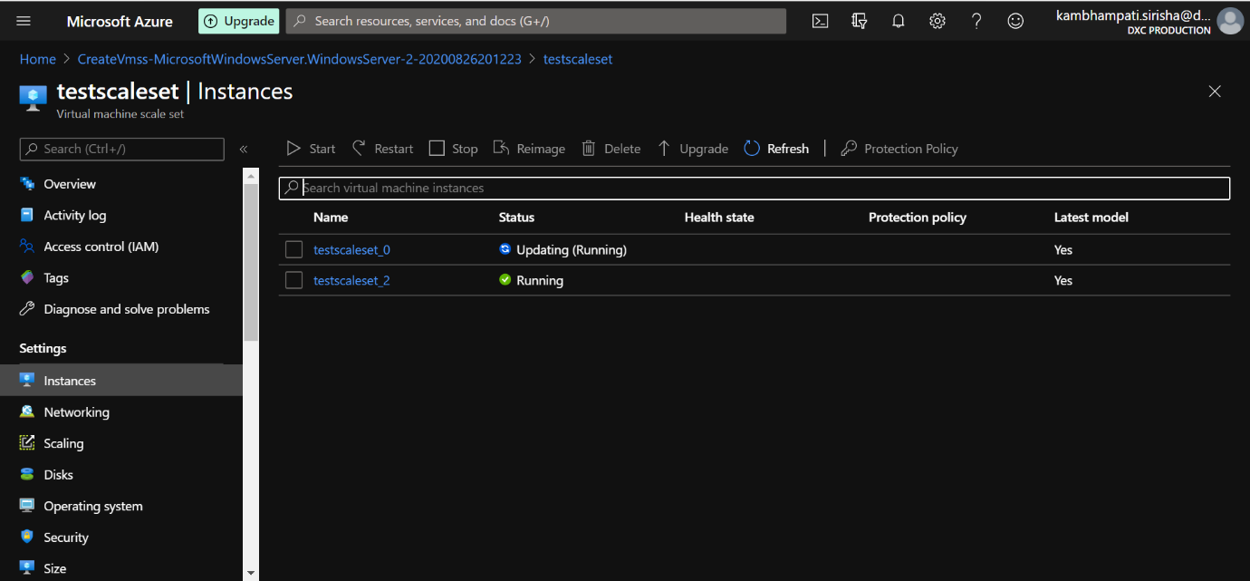

Here I create Virtual machine scale set named testscaleset with DS1-v2 standard.

3.Create a blob storage account with GRS standard and enable the blob soft delete with15 days retention period also it should be able to connect with azure storage explorer

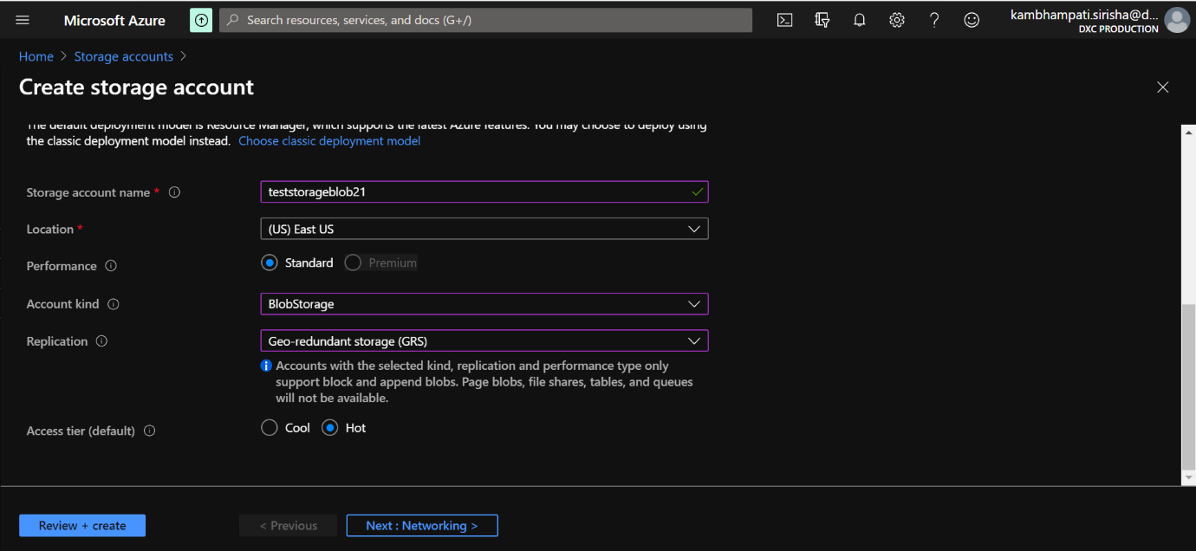

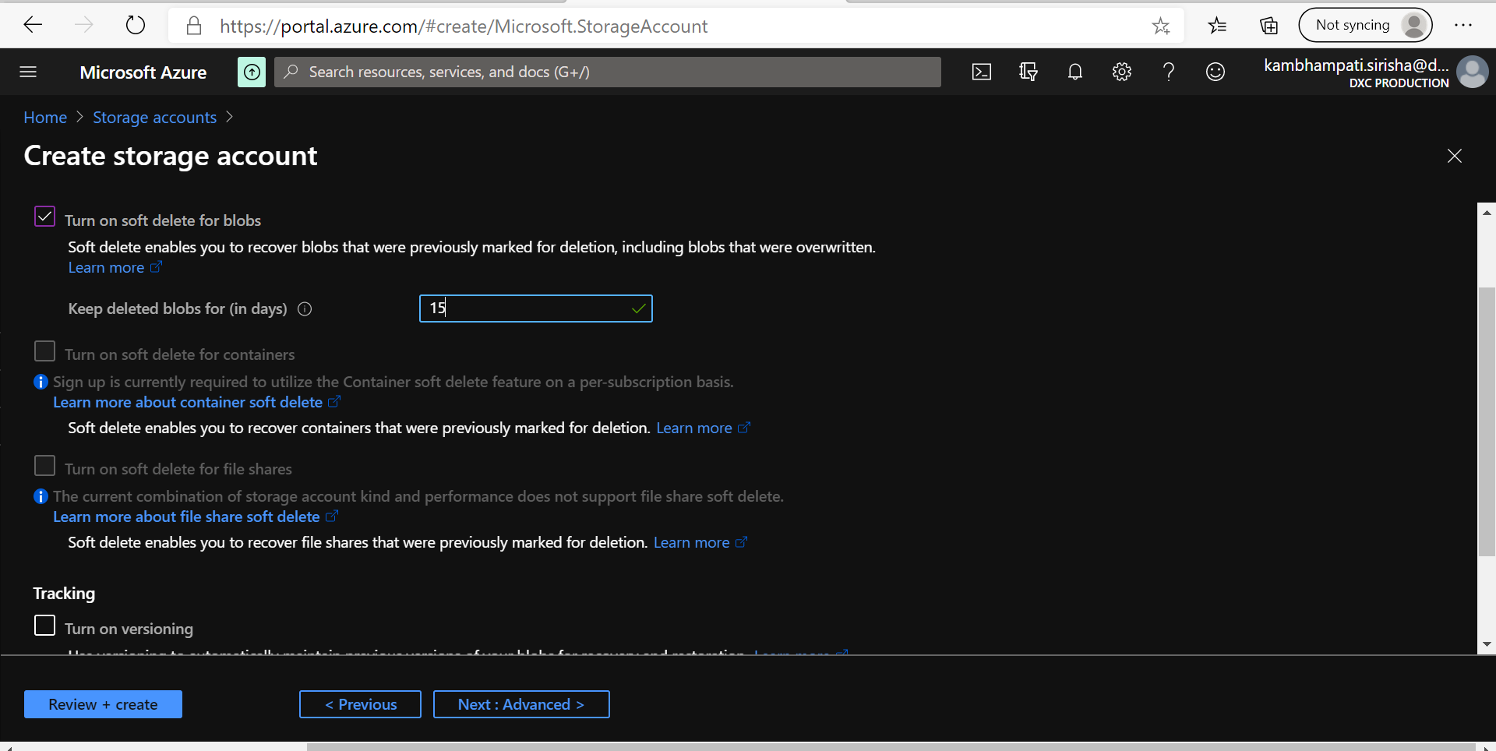

Here I create a storage account with GRS standard and enable the blob soft delete with 15 days retention period.

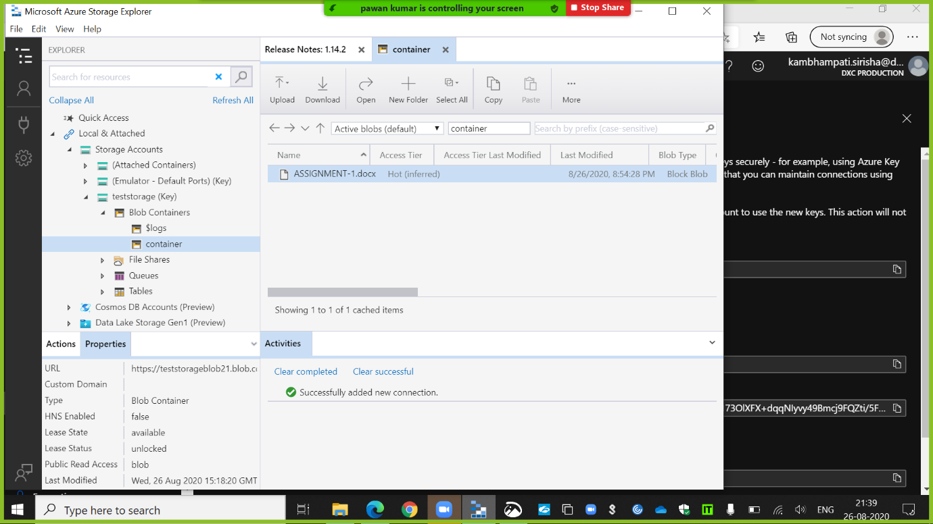

4.Configure the Vnet and create 3subnets in the Vnet

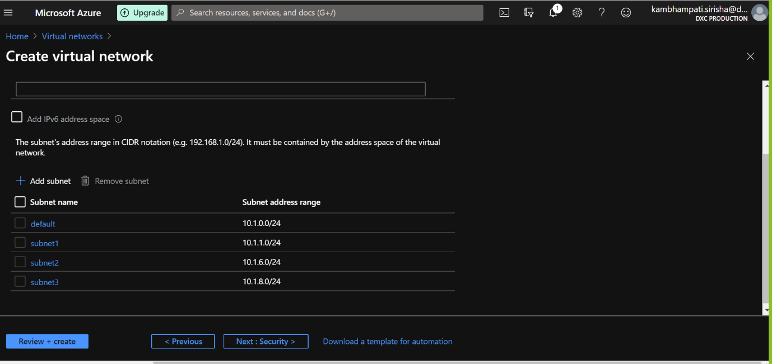

5.Create a traffic manager with performance routing method

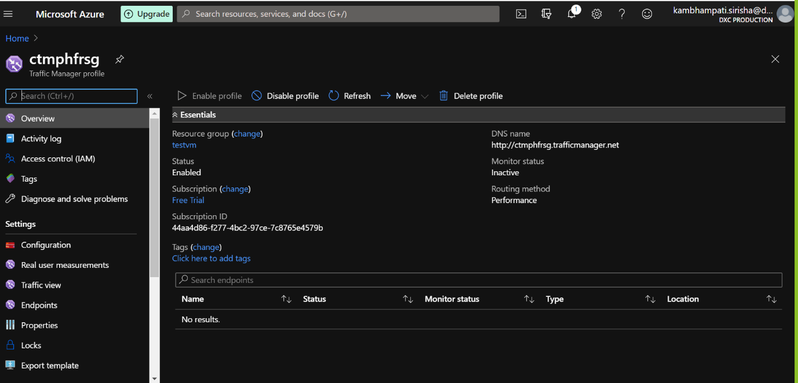

Here I create a traffic manager profile with performance routing method.