ASSIGNMENT-1

1.Creating a windows server 2019 VM with Ds1-V2 standard.

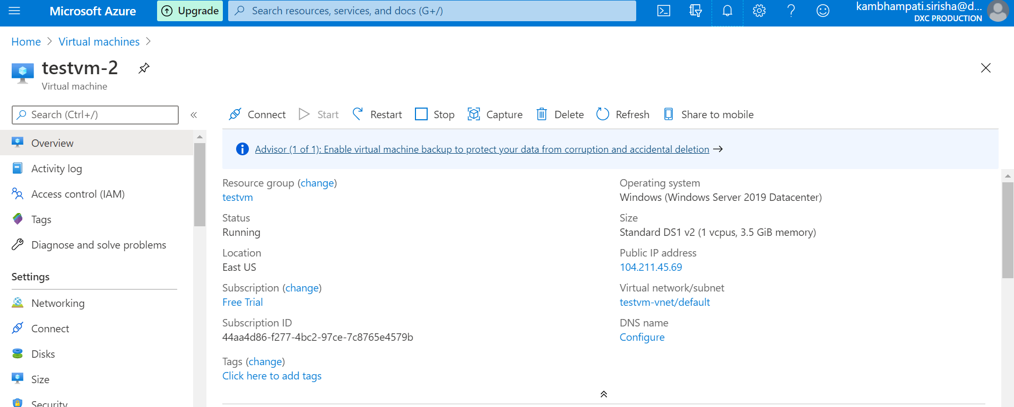

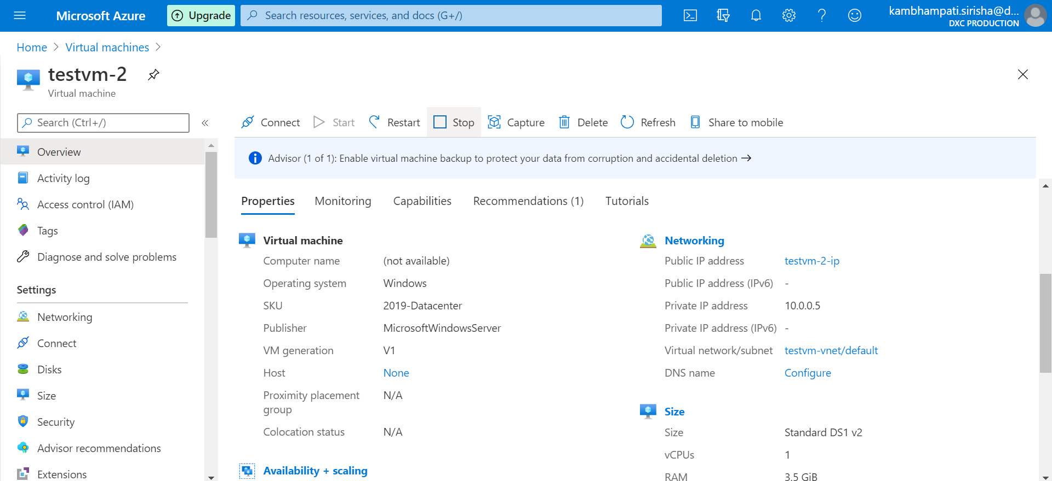

The above snips showing that I created a VM named testvm-2 with windows server 2019 Datacenter OS and Ds1 V2 standard. Username is server_admin.

2.Attach one data disk of size 50GB and split into 3 inside the VM

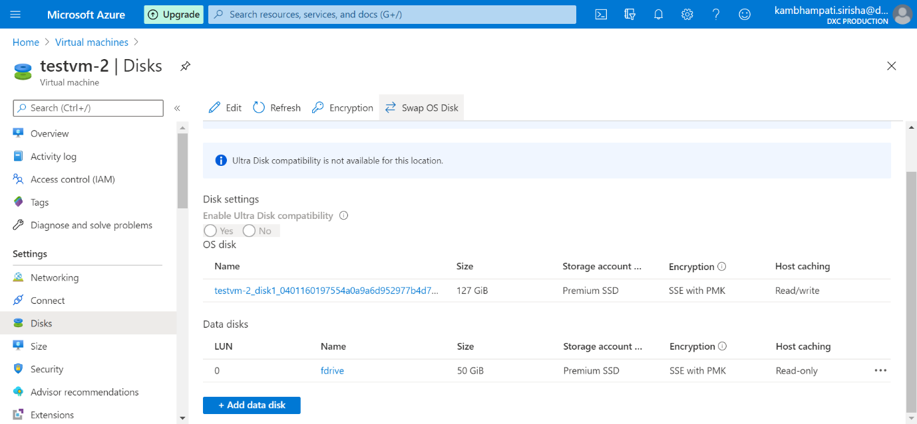

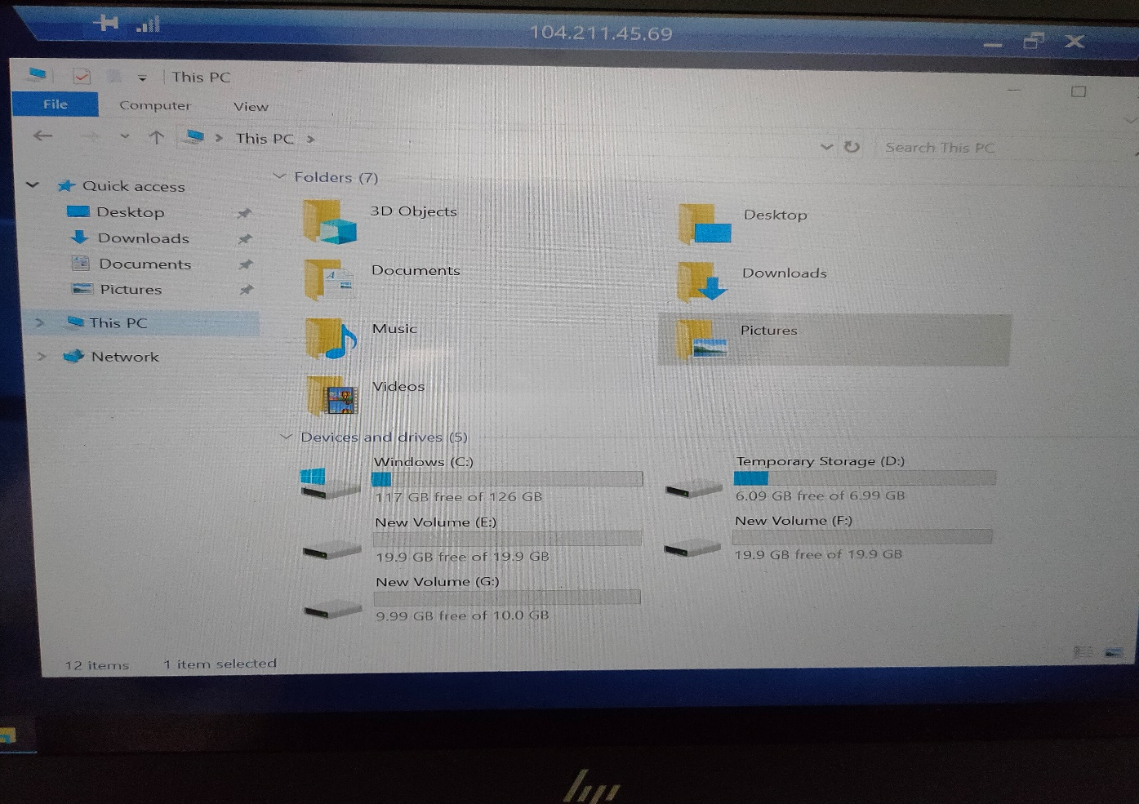

The above Pictures show that the 50GB created is split into 3 simple volumes.

3.The VM should have enabled auto shut down by 5:00PM IST before that it has trigger a notification to the mail id.

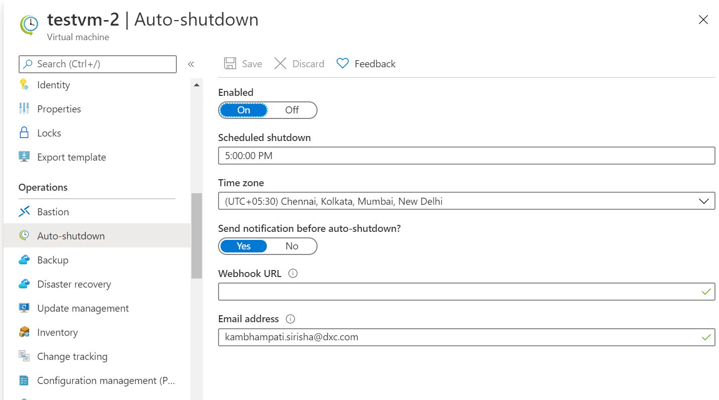

The image describes that I enabled auto shut down to testvm-2 by 5:00PM IST before that it has trigger a notification to mail

4.you should be able to login to the servers with two usernames

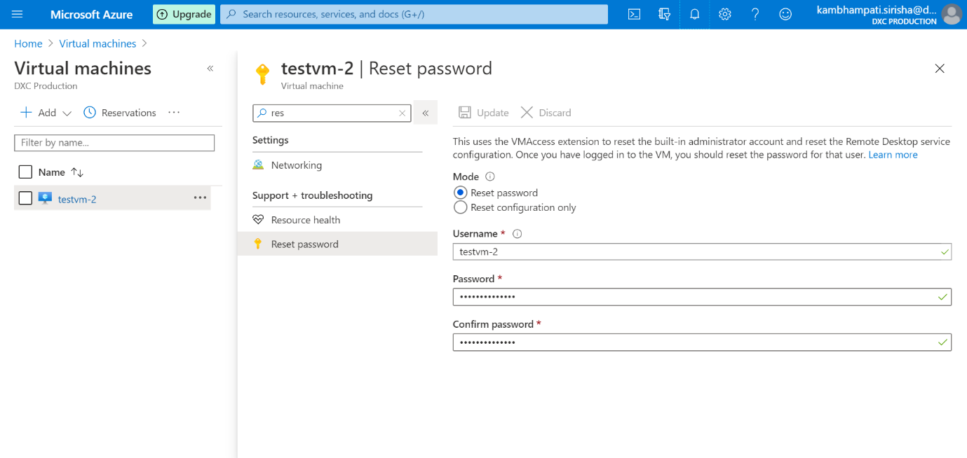

The above snip shows proof that I created another user named testvm-2 in the existing vm using reset password setting.

5.Install Microsoft antimalware extension in the VM

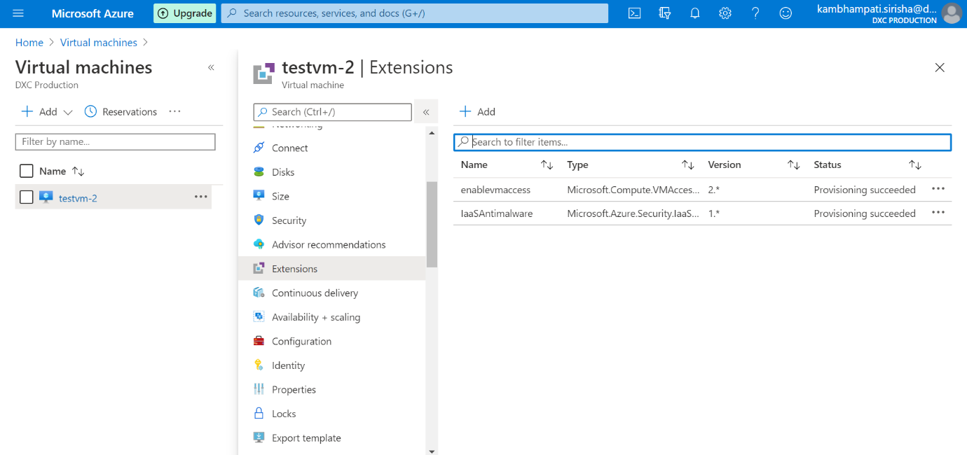

The above Pictures shows that I created a Microsoft Antimalware extension to testvm-2.