ASSIGNMENT-2

1.Create a scale set with windows OS

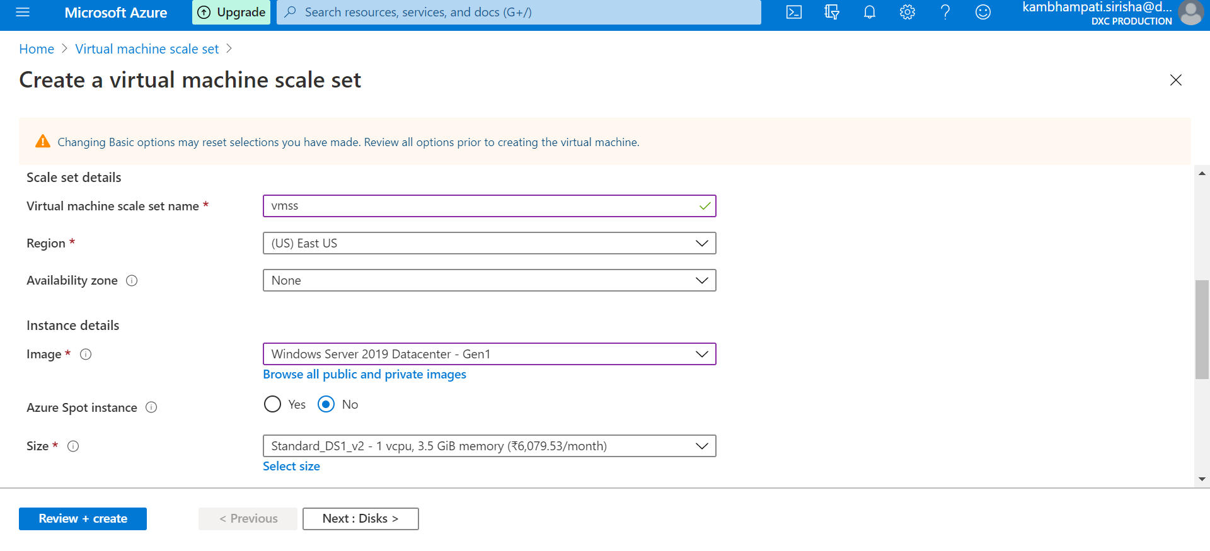

I create a scale set named sac20 with windows OS.

2.Write a scale out rule using CPU percentage of 70% threshold

3.Write a scale in rule using CPU percentage of 40% threshold

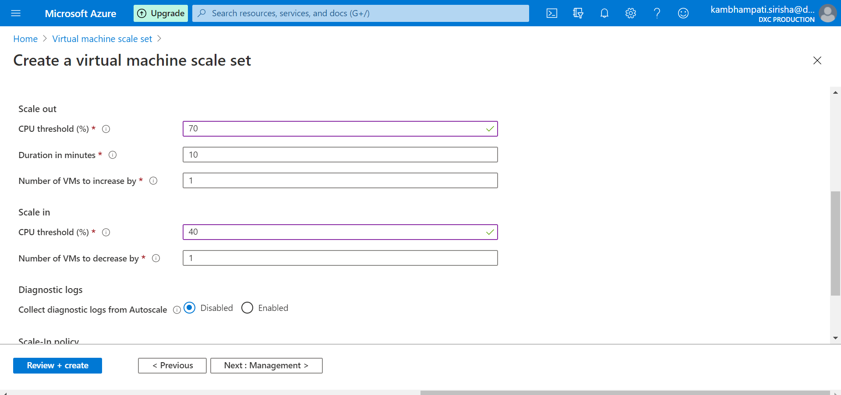

4.Create a storage account and containers with anonyms access, create a static website in the storage account

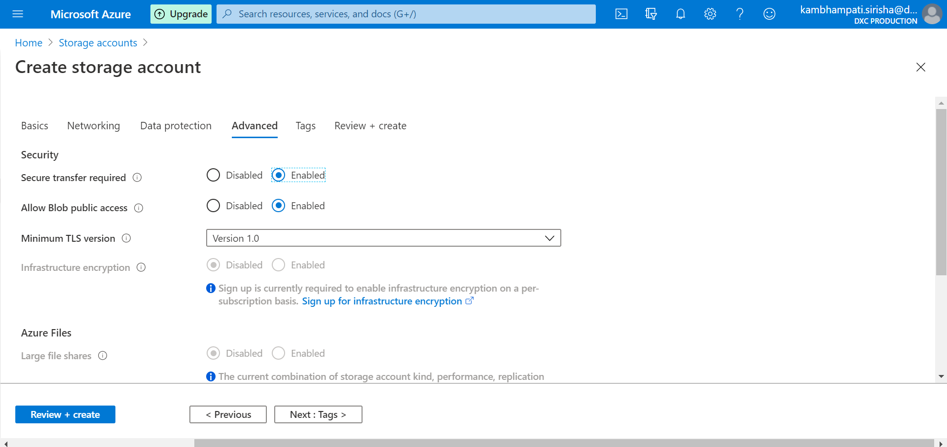

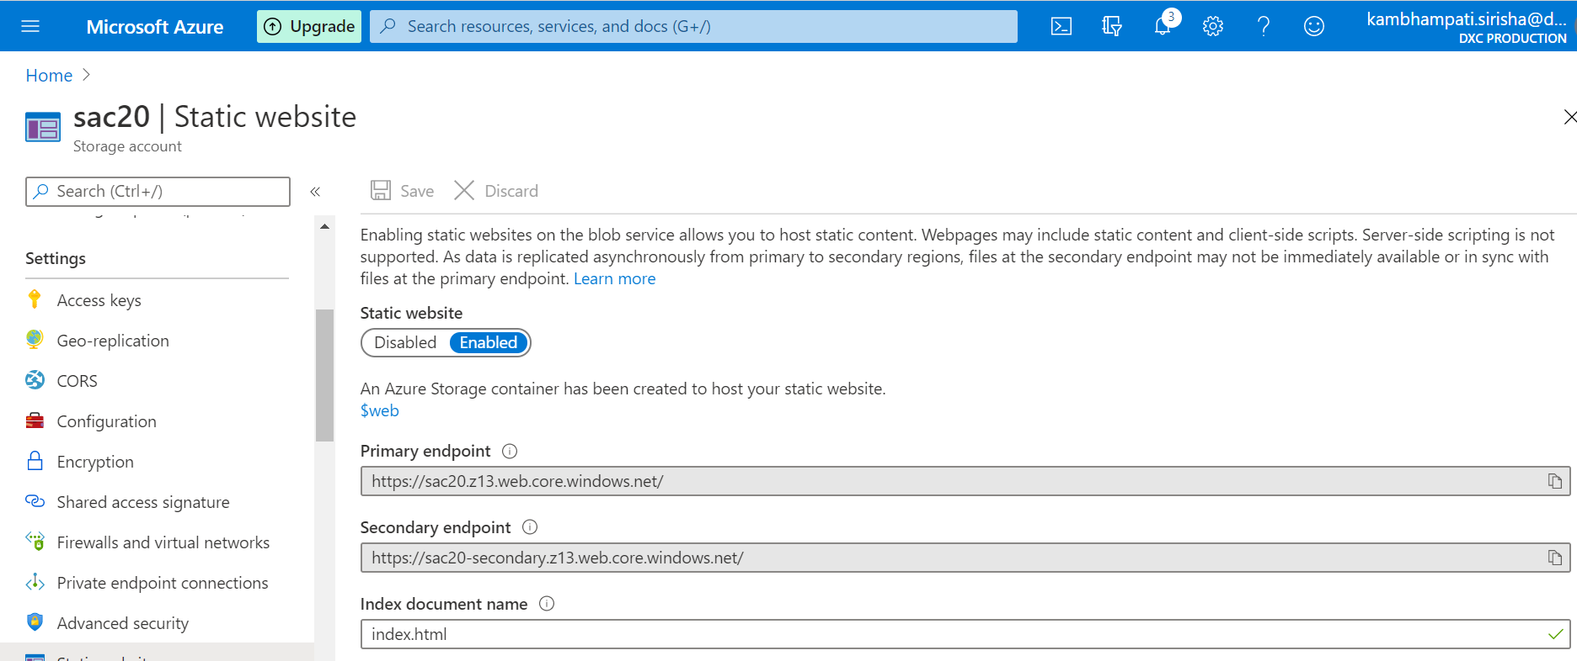

5.Create two virtual machines with no public ip’s

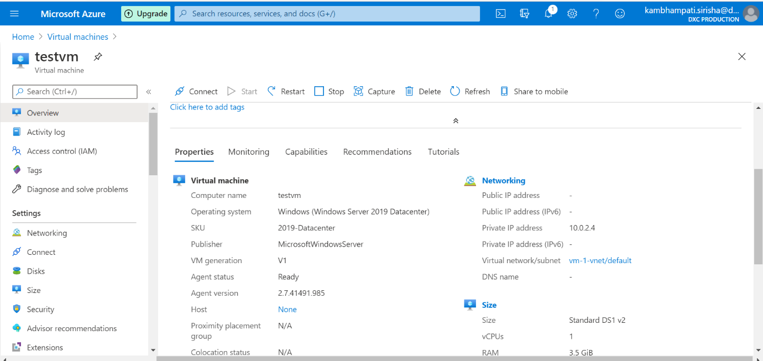

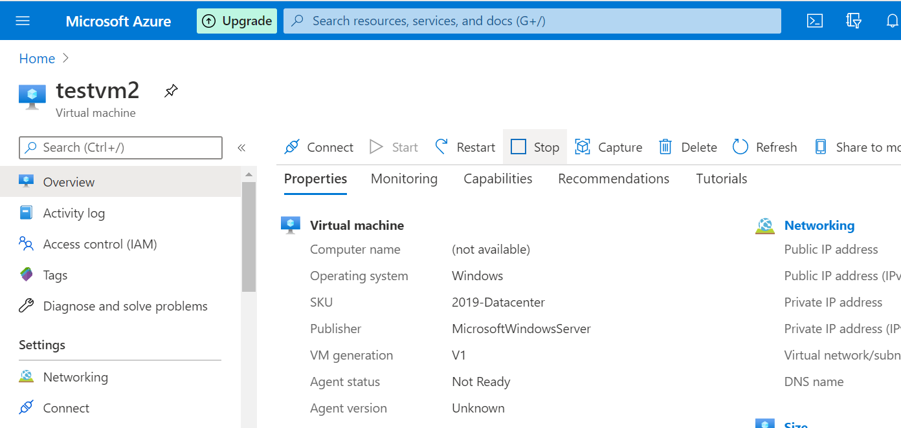

6.Attach the two VM’s to the load balancer and block the 3389port use 50010 instead

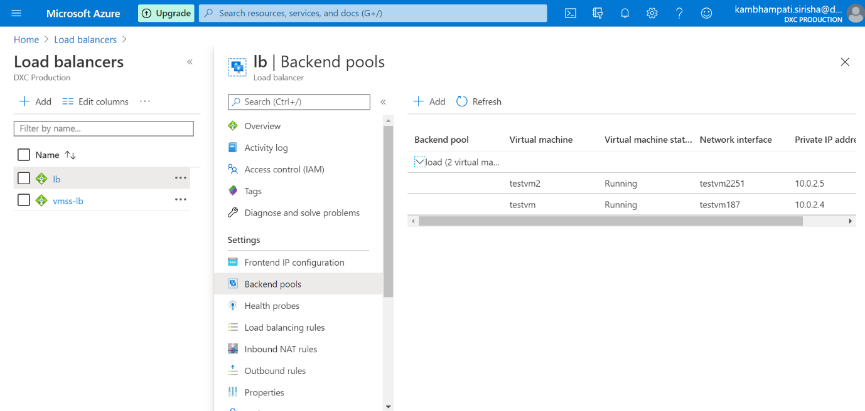

I attach the two VM’s to backend pool of load balancer named load.

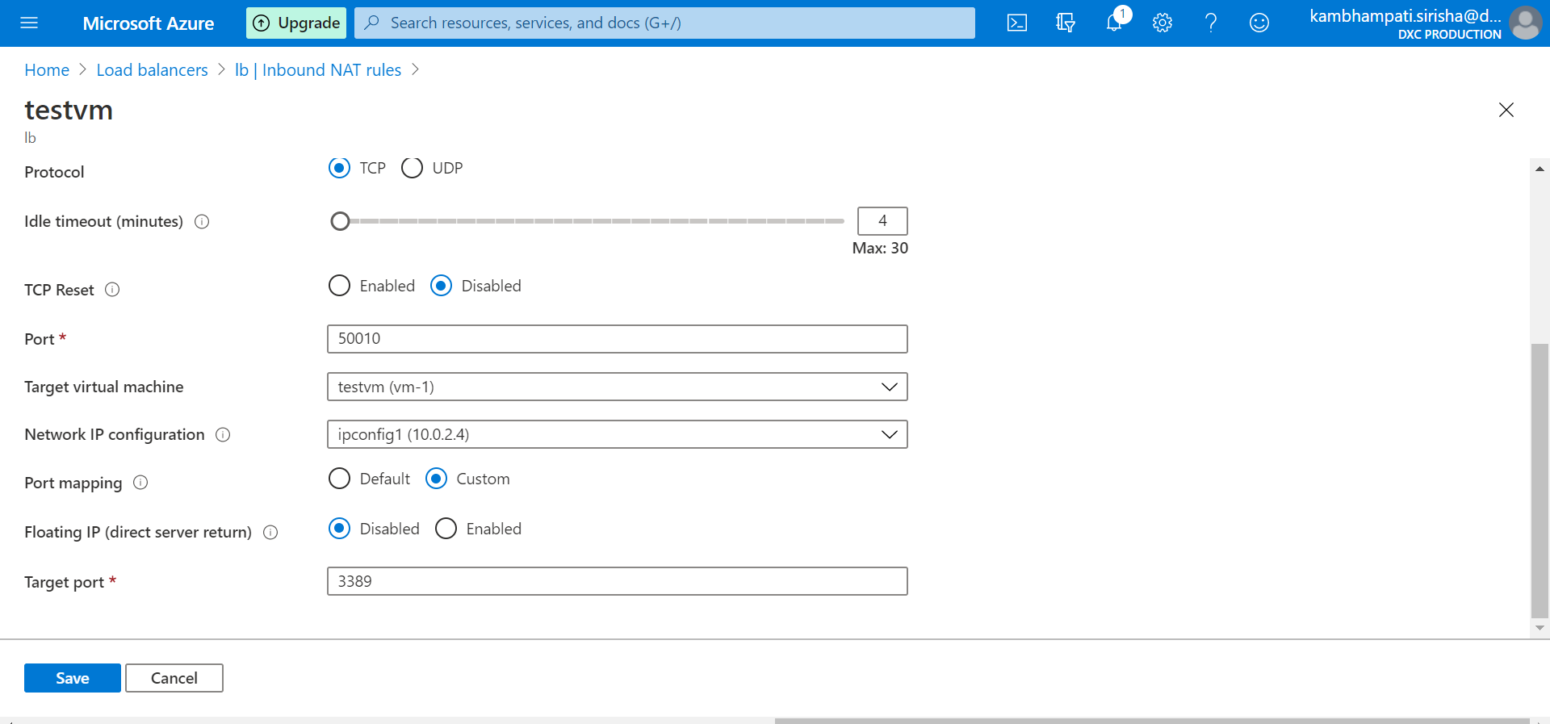

Here I use the 50010 port instead of 3389 port.

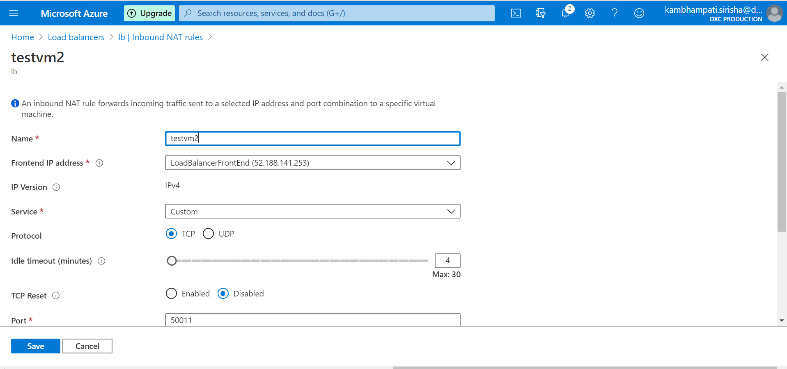

Here I use the 50011 port instead of 3389 port.

