**Effects of parameters P, I and D**

P:

If we assume Ki and Kd are fixed, as the following graph shows, low values of Kp will get to final value slowly and don’t overshoot. In case of our car, this means if there is a turn, the car is too slow to follow the curve and it will get out of the road. I observed this with Kp =0.1 and Ki and Kd of value 0.0.

High values of Kp cause overshoot. Setting Kp to 0.9 and Ki and Kd to 0.0, the car oscillates around the middle line of the road until it gets unstable and gets out of the road.

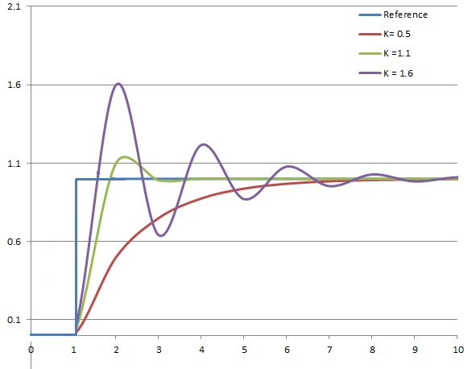

**Image from Wikipedia**

I:

As the following graph shows, the integral term accelerates the movement of the process towards setpoint and eliminates the residual steady-state error that may occur with a pure proportional controller. However, since the integral term responds to accumulated errors from the past, it can cause the present value to overshoot.

Setting Kp to 0.5, different values of Ki still cause overshoot and car gets off the road.

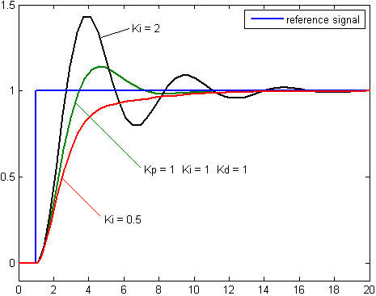

**Image from Wikipedia**

D:

As the following image shows, Kd factor improves setting time and stability of the system. Higher values of Kd will cause slower reaching the setpoint but less overshoot.

Setting Kp to 0.5 and Ki to 0.0 and Kd to 5.0 drives the car better than with only Kp factor is used but it still overshoots and gets off the road. Setting Kp to very high values like 200.00 although keeps the car on the road but it is too sensitive to errors and changes the wheel too much which cause car drive slower than the max speed it can drive with the given throttle. Setting Kp to 40.0 drives the car for the whole track in a stable way.

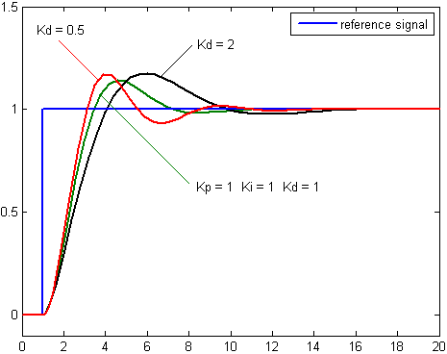

**Image from Wikipedia**

Considering the plots and discussion above, I tried to set the parameters manually.

First I kept Ki and Kd as zero and changed Kp to different values. At Kp around 0.6 the car drives stable when the road is straight but it starts having overshoots in curves until it gets off the road.

Then I started incrementing Pd that made the car more stable and controlled the overshoots. At Pd around 40, the car can drive the whole track in a stable way.

Increasing Pi even to 0.1 makes driving unstable very quickly. Setting Pi to a small value like 0.0005 keeps the driving stable while it may eliminate the offset from setpoint if any.

I also increased the throttle from original value of 0.3 to .05 and the car drive as fast as near 50 mph when the road is straight in a stable way.