**MSD 585 FALL 2022**

**Final Project 18**

**Checkpoint 1**

**Team Members:**

**Samhitha Kankanala (email:** [**samhitha@pdx.edu**](mailto:samhitha@pdx.edu)**)**

**Kiran Kamble (emai:** [**kamble@pdx.edu**](mailto:kamble@pdx.edu)**)**

**Hemanth Kumar Bolade (email:** [**bolade@pdx.edu**](mailto:bolade@pdx.edu)**)**

**Teams GITHUB repository:**

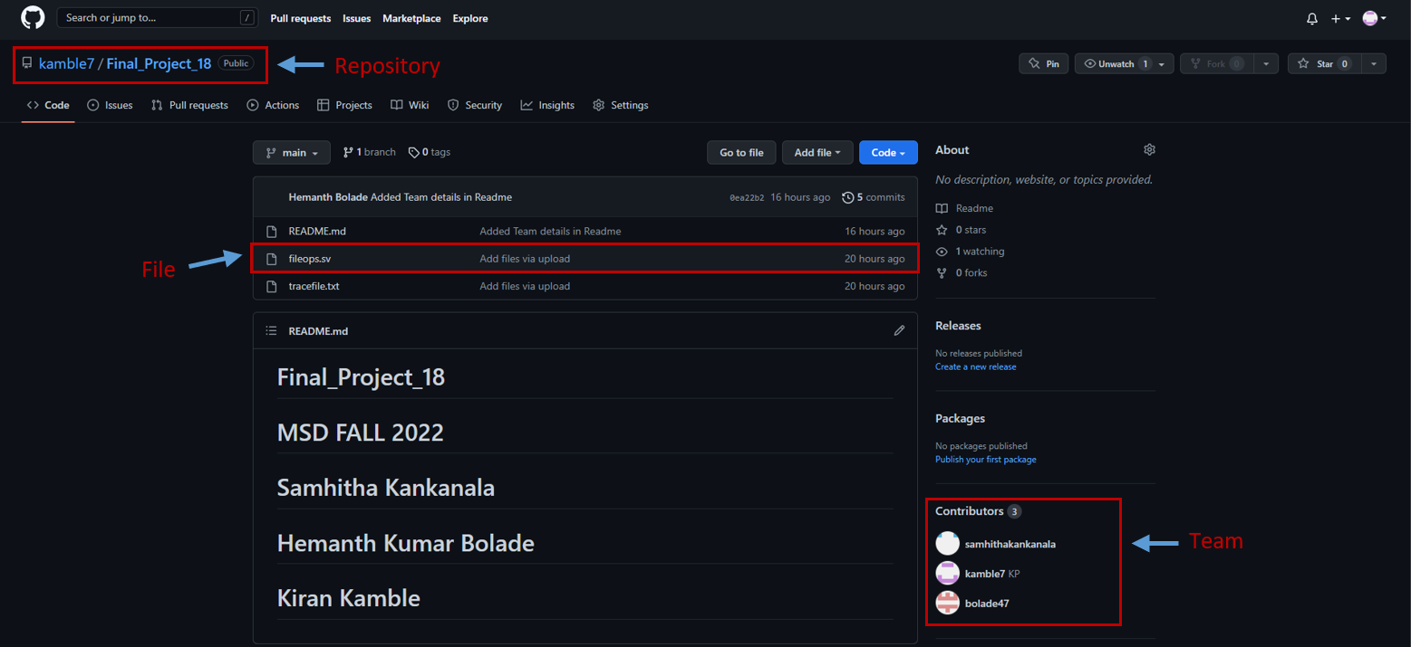

**code to open a user-specified trace file with ability to accept a runtime flag or command to determine silent or normal running mode and parse trace file contents into command and (hexadecimal) address (displaying each in debug mode)**

**Below is the Code, trace file and transcript:**

**Source Code:**

module fileops ();

string filename,mode,command,s;

integer address;

integer fd_r;

initial

begin

if ($value$plusargs ("filename=%s", filename))

$display ("Input File_name : %s",filename);

if ($value$plusargs ("mode=%s", mode))

$display ("Operating Mode : %s",mode);

fd_r = $fopen (filename,"r");

if (fd_r)

$display ("File %s is opened successfully", filename);

else

$display ("File %s is NOT opened successfully", filename);

while (!$feof(fd_r))

begin

$fscanf (fd_r,"%s",command);

$fscanf (fd_r,"%h",address);

$display ("command: %d, address: %h",command,address);

end

$fclose (fd_r); //closing file

end

**Trace File:**

2 408ed4

0 10019d94

2 408ed8

1 10019d88

2 408edc

**Transcript:**

# Compile of fileops.sv was successful.

vsim -voptargs=+acc work.fileops +filename=tracefile.txt +mode=normal

# vsim -voptargs="+acc" work.fileops "+filename=tracefile.txt" "+mode=normal"

# Start time: 14:13:04 on Nov 05,2022

# ** Note: (vsim-8009) Loading existing optimized design _opt

# Loading sv_std.std

# Loading work.fileops(fast)

# ** Warning: (vsim-PLI-3691) Expected a system task, not a system function '$fscanf'.

# Time: 0 ns Iteration: 0 Instance: /fileops File: //thoth.cecs.pdx.edu/Home04/bolade/Desktop/FALL 22/MSD 585/Proj/checkpoint1/Final_Project_18/fileops.sv Line: 25

# ** Warning: (vsim-PLI-3691) Expected a system task, not a system function '$fscanf'.

# Time: 0 ns Iteration: 0 Instance: /fileops File: //thoth.cecs.pdx.edu/Home04/bolade/Desktop/FALL 22/MSD 585/Proj/checkpoint1/Final_Project_18/fileops.sv Line: 26

run -all

# Input File_name : tracefile.txt

# Operating Mode : normal

# File tracefile.txt is opened successfully

# command: 2, address: 00408ed4

# command: 0, address: 10019d94

# command: 2, address: 00408ed8

# command: 1, address: 10019d88

# command: 2, address: 00408edc

**Uploads:**

Uploaded all the files and report in GitHUB.