Entity : table

Attribute : simple can’t be furthered divided

Composite: full name

Derived attributes: calculate dob from date

Multivalued : one person can have multiple phone number

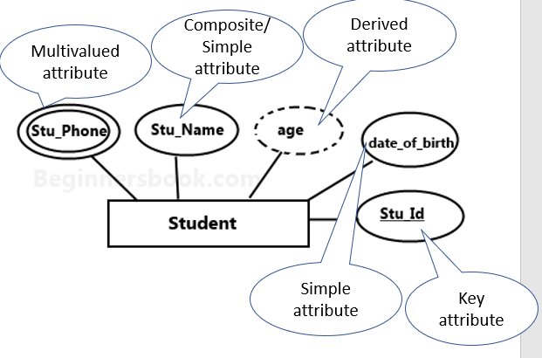 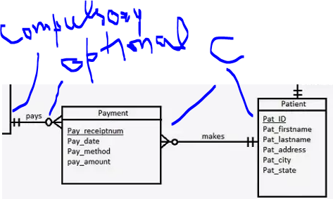

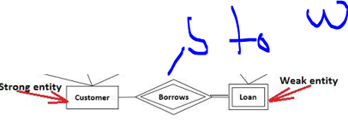

Strong to weak relation always represented by double diamond symbol.

Weak entity which can not be identified fully by its own . Only fully identified by foregin key.

Super class can be divided into further classes.

There are three constraints that may apply to a specialization/generalization:

* **Disjointness constraints :** an instance of supertype can be the subtype
* Completeness constraints
* Membership constraints