**# Docker-for-Developers-Core-Concepts**

https://www.linkedin.com/learning/docker-for-data-scientists/why-docker

yum install docker -y(Install Docker over AWS)

**To start docker engine**

* service docker status
* service docker start

------------------------------------------------------------------------------------

**To see all containers**

* docker ps -a
* on each docker run always create new container, image remain same

**only running**

* docker ps

---------------------------------------------------------------------------------

**To see all images locally**

docker images

**To find images from docker hub**

docker search jenkins

**To download images from docker hub**

* **centos – image name**

docker pull centos

**To give name to container**

* run - create and run docker,
* it – interactive terminal
* riki_container container name
* ubuntu_images – image name
* /bin/bash – to run on the terminal

docker run -it –name riki_container ubuntu_images /bin/bash/

**Docker start from container**

* **To start container(on exit from container it is automatically stop)**

docker start riki_container

* **To attach volume with container(only if container is running)**

docker attach bhupi

* **Run in background**

**To stop container(come out of container)**

docker stop bhupi

**Docker remove**

docker rm bhupi

**Difference between two containers**

docker diff container1

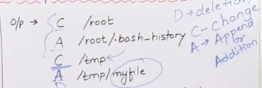

**Create image of container**

* Docker commit newcontainer updateimage

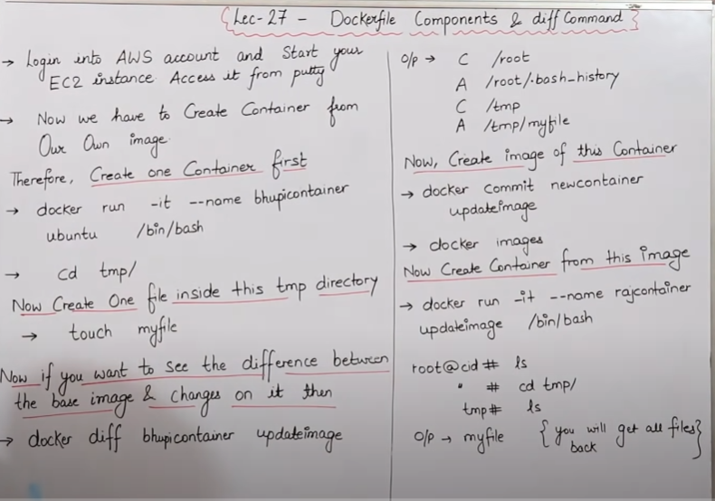

cat /etc/os-release

**Commit over Docker hub**

docker commit imagename

**Delete all conatiner**

docker container prune

docker image prune –all

Docker file components and commands:-

Docker image function:-

FROM - base image

RUN - to excute command, it will create layer in image

MAINTAINER - Author/Owner/Description

COPY - copy file from local( docker vm) not fom internet

ADD - Similar to copy but do from internet

EXPOSE - expose port

WORKDIR - set working directory for a container

CMD - excute command but during container creation time

ENTRYPOINT - Smilar to CMD

ENV - environment variables

ENV - future running containers.

ARG - building your Docker image

**After image file run below command:-**

docker build -t myimage .

docker ps -a

docker images

docker run -it --name myconatiner myimage bin/bash/

**Volume is simply directory**

* Firstly declare directory as volume thn share volume
* Even if container stop still we can access volume
* Volume can't create on existing container
* Volume can be sahred with any number of container
* Voolume will not be included when we update the image(running container)

