**PLSA:-**

Two types output -

1. one is Topical category characterization(sei)

2. topic covergae for each document(PI, what exntds topic is covered)

**Mixture model :-**

P(Oberserving model from Mix model)

lambda - percentage of background word(known)

coverage of topic Thetaj in doc data

prob of word in topic

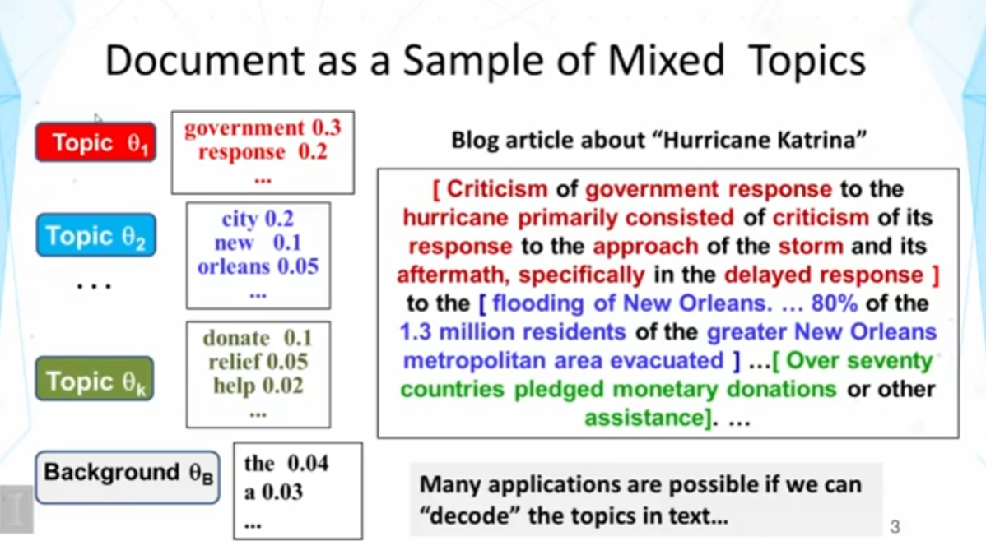

**Formal Definitios( One topic beside the topic, two way switch like flipping coin):-**

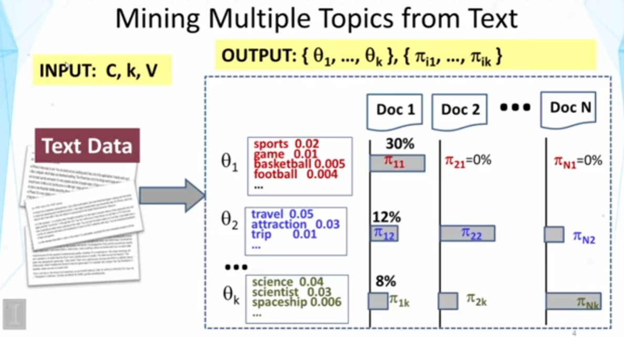

**Formal Definitios( Multi topic beside the topic, Multi way switch like flipping coin):-**

