Binary search : sorted list O(logn)

Key element to remember : def binary_search(ls, n, left, right):

# Bubble sort

Sort by pair wise first center two elements all along the list then take sorted list element and similar ways do two sorting again until sort all.

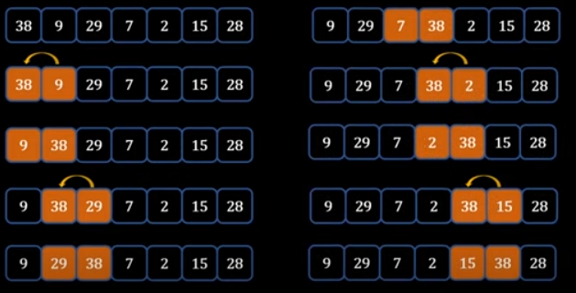

# Merge sort

Split list in to multiple smaller left and right list. Sort and merge smaller group into main array by maintaining the pointer.

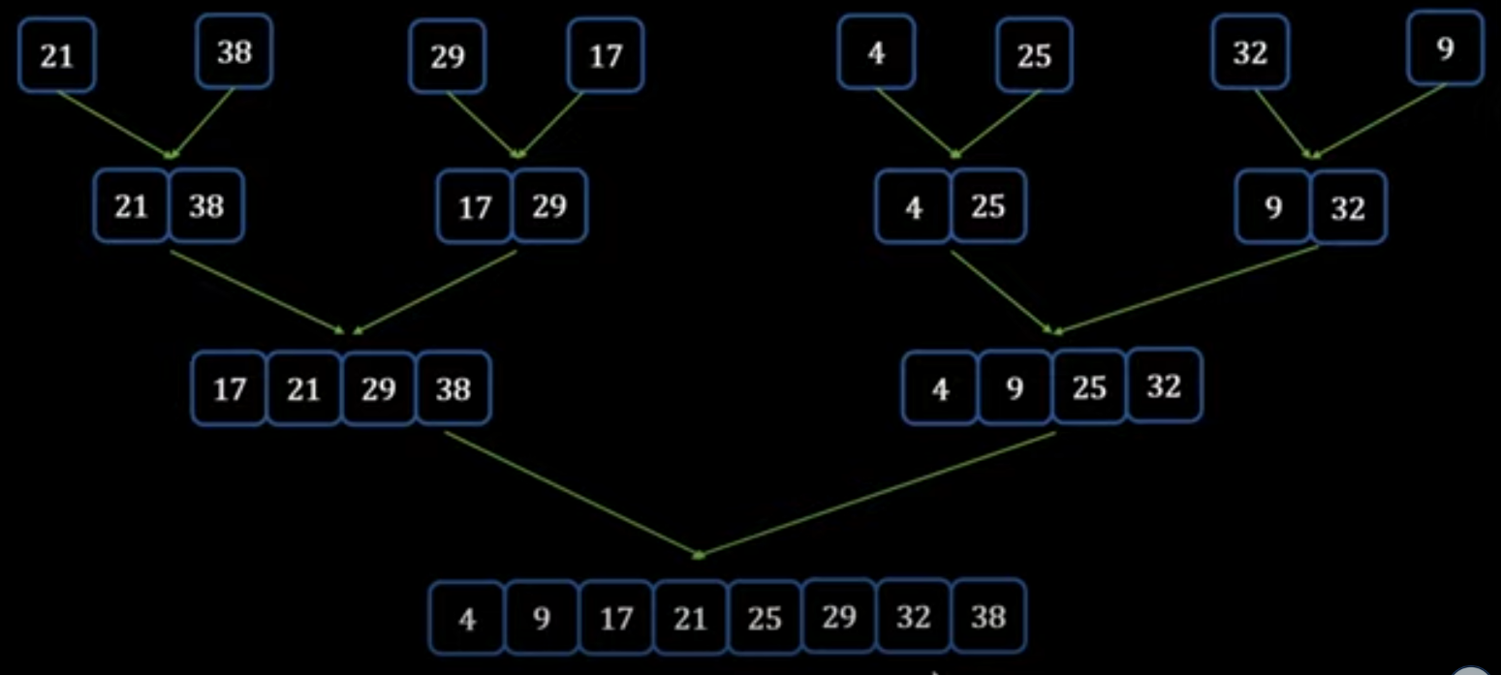

# Insert sort

Maintain same list and sort by maintaining pointer of list one by looping over the list.

