Keras Tuner is a library that **helps you pick the optimal set of hyperparameters for your TensorFlow program.**

[**https://www.tensorflow.org/tutorials/keras/keras_tuner**](https://www.tensorflow.org/tutorials/keras/keras_tuner)

import keras_tuner as kt

Hyperparameters are of two types:

1. **Model hyperparameters eg number and width of hidden layers**
2. **Algorithm hyperparameters ; eg like learning rate for sgd**

## **Define the model: The model you set up for hypertuning is called a *hypermodel*.**

Two approaches : 1. By using a model builder function

2. By subclassing the **HyperModel** class of the keras Tuner API

For computer vission two pre defind approaches :- HyperModel and HyperResNet

def model_builder(hp):

-----

-----

  # Tune the number of units in the first Dense layer  
  # Choose an optimal value between 32-512  
  hp_units = hp.Int('units', min_value=32, max_value=512, step=32)

-----

-----

  # Tune the learning rate for the optimizer  
  # Choose an optimal value from 0.01, 0.001, or 0.0001  
  hp_learning_rate = hp.Choice('learning_rate', values=[1e-2, 1e-3, 1e-4])

## **Instantiate the tuner and perform hypertuning**

Keras Tuner has four tuners available - RandomSearch, Hyperband, BayesianOptimization, and Sklearn

Hyperband tunner to optimize and maximum number of epoch to trian.

tuner = kt.Hyperband(model_builder,  
                     objective='val_accuracy',  
                     max_epochs=10,  
                     factor=3,  
                     directory='my_dir',  
                     project_name='intro_to_kt')

**check internal performance for memory allocations.?**

stop_early = tf.keras.callbacks.EarlyStopping(monitor='val_loss', patience=5)

tuner.search(img_train, label_train, epochs=50, validation_split=0.2, callbacks=[stop_early])  
# Get the optimal hyperparameters  
best_hps=tuner.get_best_hyperparameters(num_trials=1)[0]

## **Train the model**

# Build the model with the optimal hyperparameters and train it on the data for 50 epochs  
model = tuner.hypermodel.build(best_hps)  
history = model.fit(img_train, label_train, epochs=50, validation_split=0.2)

best_epoch = val_acc_per_epoch.index(max(val_acc_per_epoch)) + 1

Retrain the model

hypermodel = tuner.hypermodel.build(best_hps)  
  
# Retrain the model  
hypermodel.fit(img_train, label_train, epochs=best_epoch, validation_split=0.2)

eval_result = hypermodel.evaluate(img_test, label_test)

**Good eg to cover:**

<https://www.tensorflow.org/tutorials/keras/overfit_and_underfit>

**Epoch** : iteration over entire dataset

**Batch Size** : we have to divide the dataset into number of batches.

**Iteration**: if 1000 images and batch size 20 then 1000/20 = 50 iteration

**Model can be saved : .h5, .pkl, .pt, .tfjs**

**Inception** : For bigger network it is difficult to set filter becasuse larger filter work better for the image with information distributed globally while for image with smaller portion we requireed smaller filter.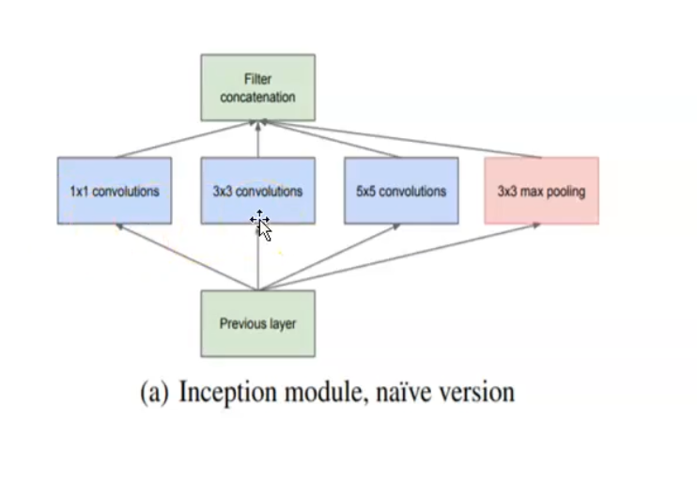

Padding = same

= (f-1)/2

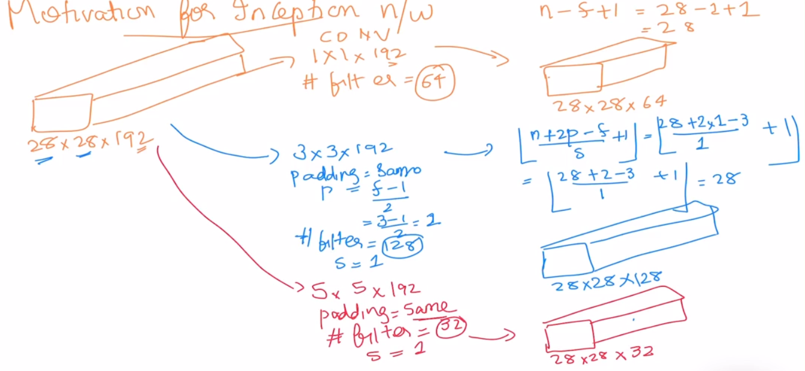

Computational cosat is very high:

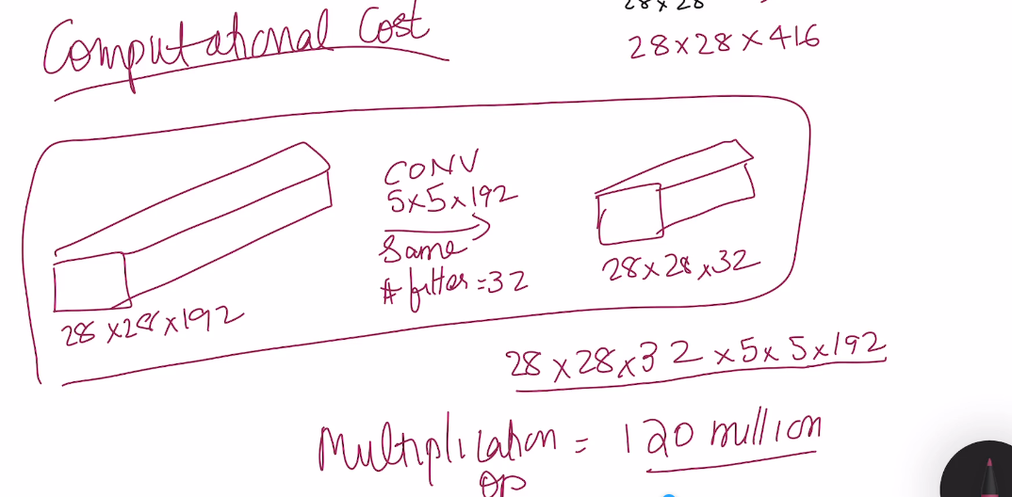

Computational cosat is very low as compared to previous version:

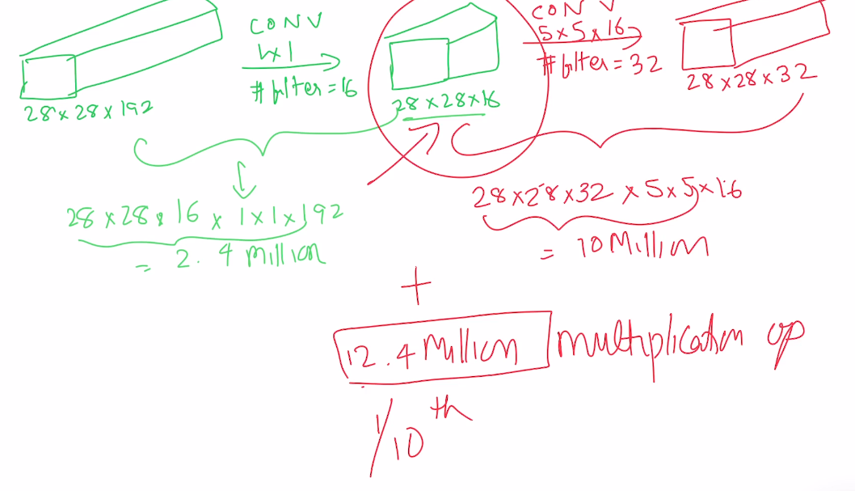

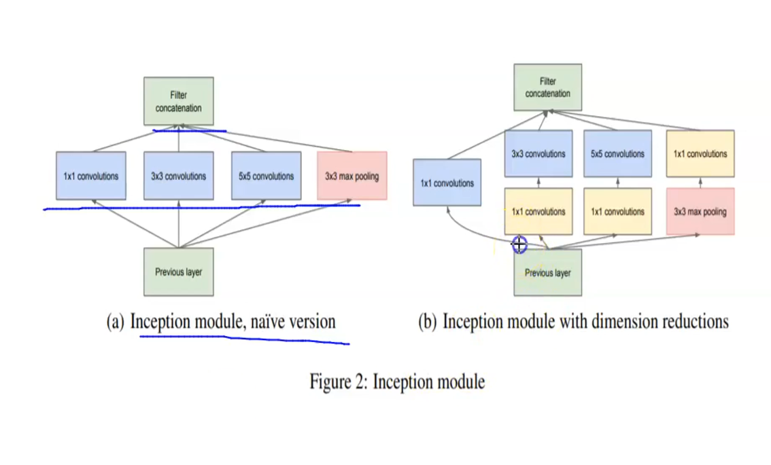

Train is 60000,28, 28

Keras take data in this format X_train.reshape(60000,28,28,1)

----------------------------

**Loss functions** help measure how well a model is doing

Huber Loss: The Huber loss function can be used **to balance between the Mean Absolute Error, or MAE, and the Mean Squared Error, MSE**. It is therefore a good loss function for when you have varied data or only a few outliers

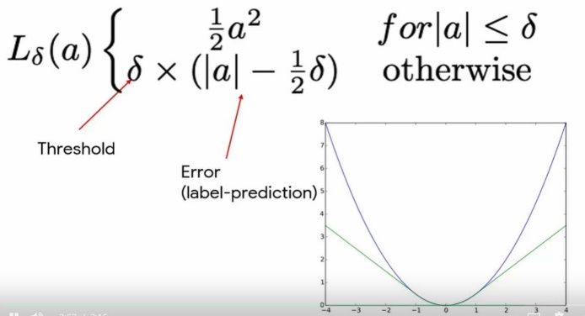

**Huber loss implemention:**

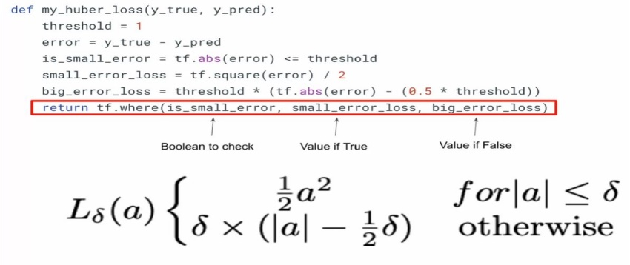

Class level implementation:-

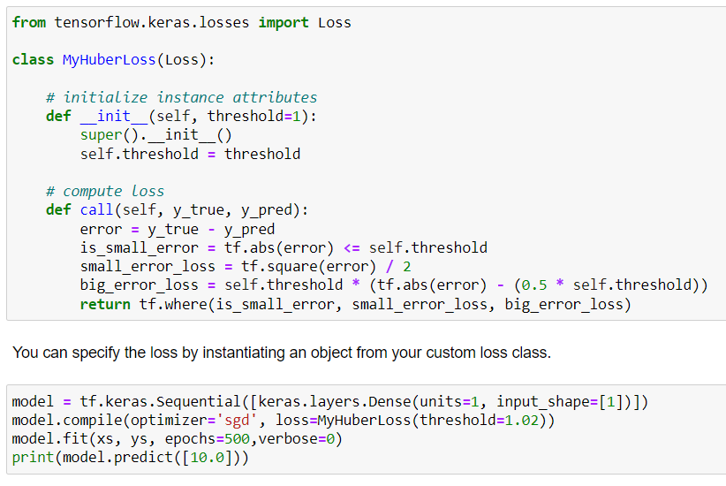

**Contrastive loss:** Used to find similarity between two vactors. Contrastive loss, like triplet and magnet loss, is used **to map vectors that model the similarity of input items**

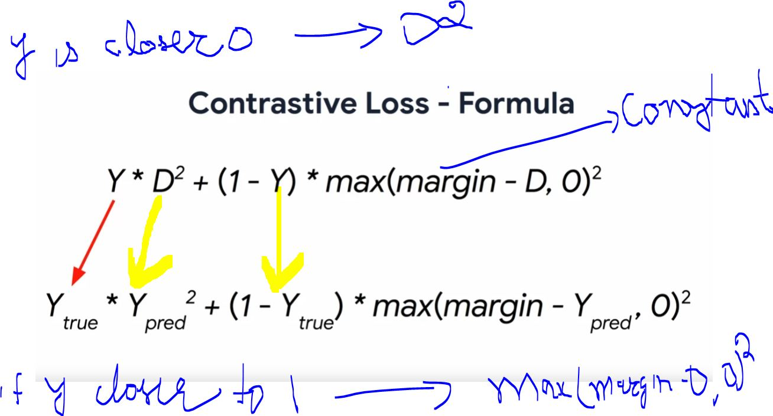

**Contrastive loss implementaions:**

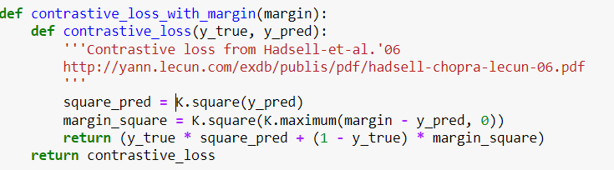

# measure the similarity of the two vector outputs

output = Lambda(euclidean_distance, name="output_layer", output_shape=eucl_dist_output_shape)([vect_output_a, vect_output_b])

# specify the inputs and output of the model

model = Model([input_a, input_b], output)

**Custom Dense Layer** will contain weights that can be updated during training.

 Requires three functions: __init__(), build() and call()

class SimpleDense(Layer):

# add an activation parameter

def __init__(self, units=32, activation=None):

def build(self, input_shape):

def call(self, inputs):

# pass the computation to the activation layer

return self.activation(tf.matmul(inputs, self.w) + self.b)

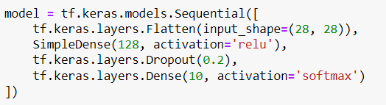

<https://www.coursera.org/learn/custom-models-layers-loss-functions-with-tensorflow/ungradedLab/laUcE/custom-dense-layer/lab?path=%2Fnotebooks%2FC1_W3_Lab_2_custom-dense-layer.ipynb%23Ungraded-Lab%3A-Building-a-Custom-Dense-Layer>

**Lambda layer** define a custom function that the Lambda layer will call

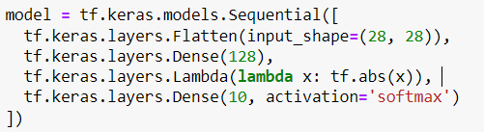

<https://www.coursera.org/learn/custom-models-layers-loss-functions-with-tensorflow/ungradedLab/AFDgQ/lambda-layer/lab?path=%2Fnotebooks%2FC1_W3_Lab_1_lambda-layer.ipynb>

**Test Implementation of calls from Utils layers:-**

import utils

utils.test_simple_quadratic(SimpleQuadratic)

# Coding a Wide and Deep Model

# inherit from the Model base class

class WideAndDeepModel(Model):

def __init__(self, units=30, activation='relu', **kwargs): # Initialize the instance attributes.

def call(self, inputs): ##build the network and return the output layers

# create an instance of the model

model = WideAndDeepModel()

<https://www.coursera.org/learn/custom-models-layers-loss-functions-with-tensorflow/ungradedLab/JB1Zr/build-a-basic-model/lab?path=%2Fnotebooks%2FC1_W4_Lab_1_basic-model.ipynb>

**Residual Networks** make use of skip connections to make deep models easier to train.

## Implement Model subclasses

class IdentityBlock(tf.keras.Model):

def __init__(self, filters, kernel_size):

super(IdentityBlock, self).__init__(name='')

def call(self, input_tensor):

<https://www.coursera.org/learn/custom-models-layers-loss-functions-with-tensorflow/ungradedLab/hStfq/build-a-resnet-model/lab?path=%2Fnotebooks%2FC1_W4_Lab_2_resnet-example.ipynb>

Sequential and Functional APIs have their limitations?

**Basic Tensor and Python points:-**

**__dict__ is a Python dictionary that contains the object's instance variables and values as key value pairs.**

If you call vars() and pass in an object, it will call the object's __dict__ attribute

# Format a string using f-string notation

i=1

print(f"var{i}")

# Format a string using .format notation

i=2

print("var{}".format(i))

**my_obj = MyClass()**

my_obj = MyClass()

my_obj.__dict__ # both will give same output

vars(my_obj) # both will give same output

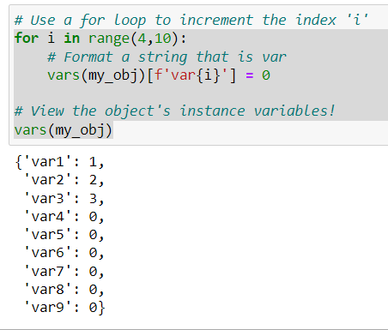

Important : vars can be shared across the different methods in the pyhton.

<https://www.coursera.org/learn/custom-distributed-training-with-tensorflow/ungradedLab/mDT5h/basic-tensors/lab>

a = tf.constant([[1 , 2],

[3, 4]])

tf.add(a, 1)

<tf.Tensor: shape=(2, 2), dtype=int32, numpy=array([[2, 3], [4, 5]], dtype=int32)>

Numpy interoperability

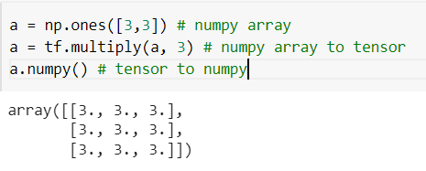 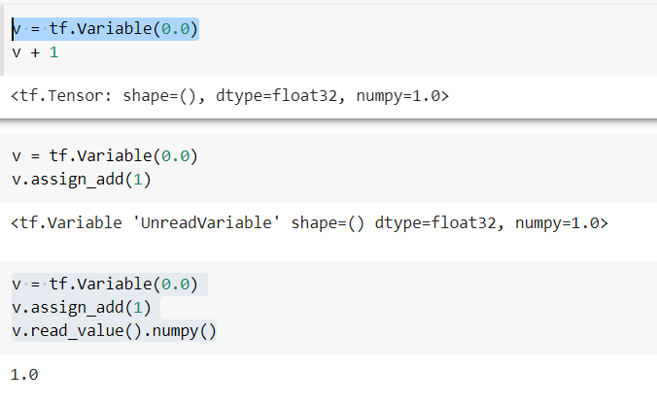

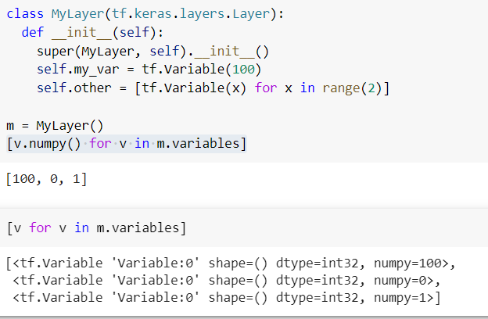

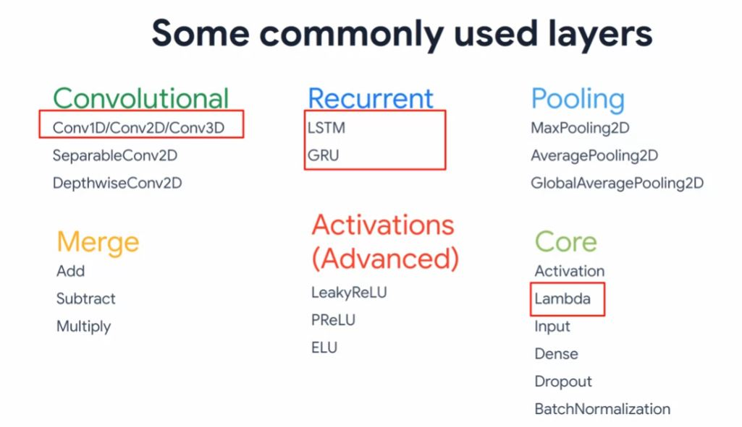

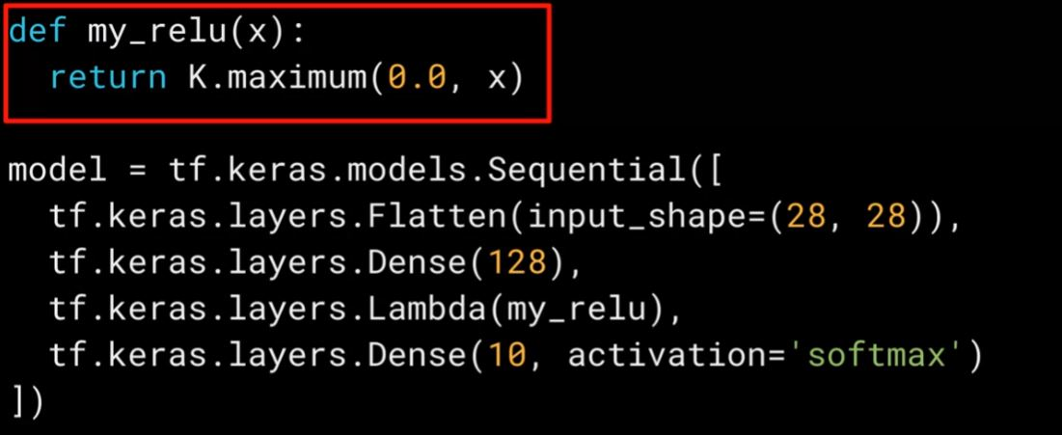

Example for implementing multiple loss and metrics:

model.compile(optimizer=rms,

loss = {'wine_type' : 'binary_crossentropy',

'wine_quality' : 'mean_squared_error'

},

metrics = {'wine_type' : 'accuracy',

'wine_quality': tf.keras.metrics.RootMeanSquaredError() } )

**VGG-16** : 16 layers, 3 * 3 kernel, 2 * 2 max pooling size.

ImageDataGenerator class supports a number of pixel scaling methods, as well as a range of data augmentation techniques.

ModelCheckpoint : model will be saved to disk only if the validation accuracy of the model in current epoch is greater than what it was in the last epoch.

Early Stopping : set patience to 5 which means that the model will stop to train if it doesn’t see any rise in Validation accuracy in 5 consecutive epochs.

**Eager vs Graph based Execution:**

Difference between  graph-based execution and eager execution in TensorFlow?

eager is user friendly

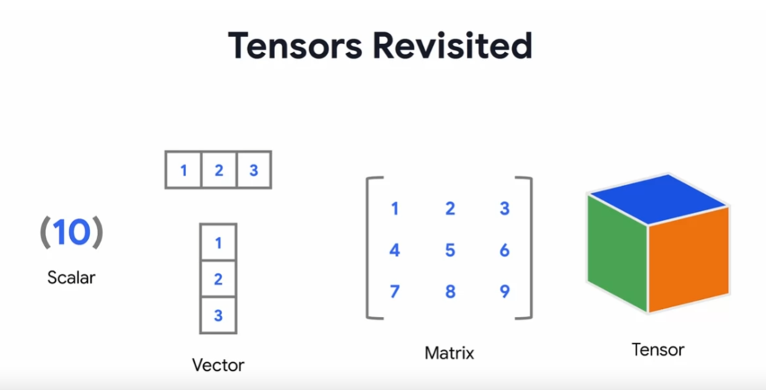 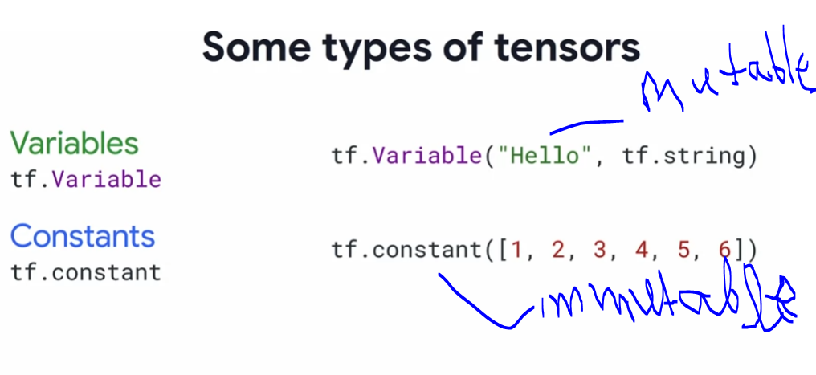

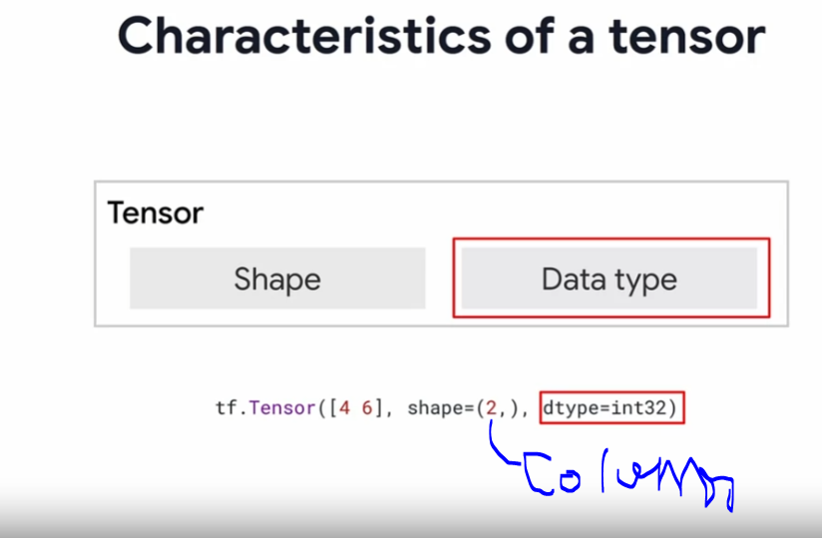 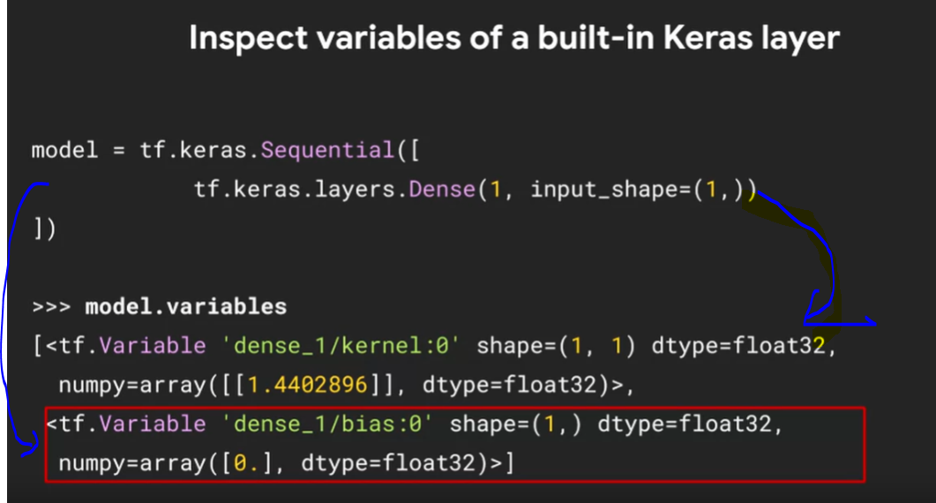

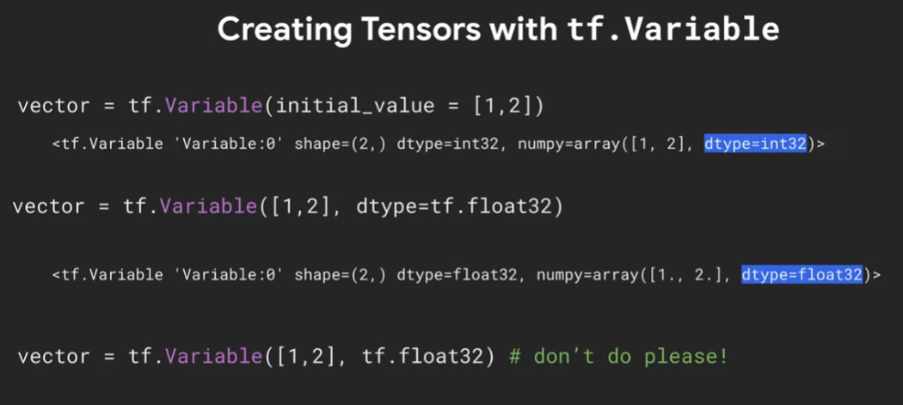 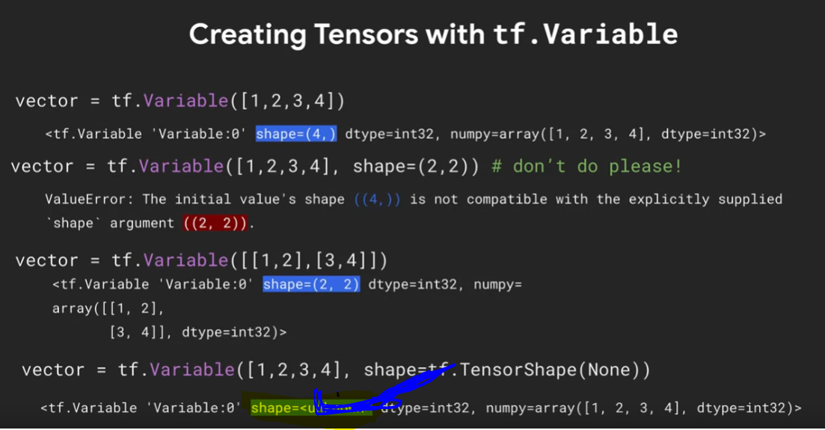

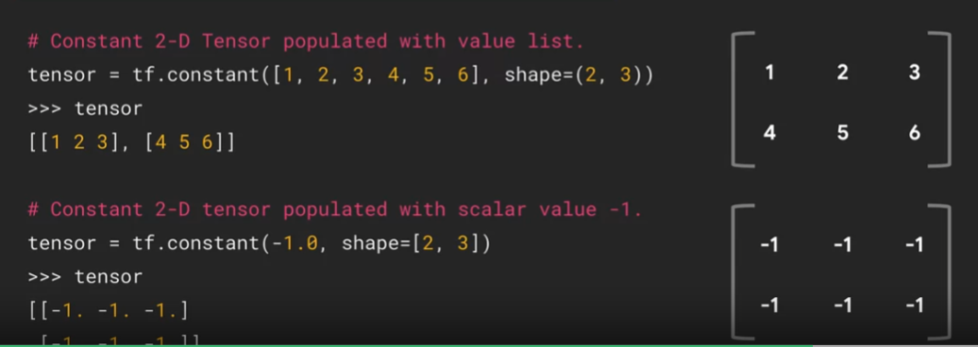

## An overview of callback methods:

tf.keras.callbacks.Callback – call back main class

Common methods for training/testing/predicting

For training, testing, and predicting, following methods are provided to be overridden.

### on_(train|test|predict)_begin(self, logs=None)

### on_(train|test|predict)_end(self, logs=None)

### on_(train|test|predict)_batch_begin(self, batch, logs=None)

### on_(train|test|predict)_batch_end(self, batch, logs=None)

### Training specific methods

on_epoch_begin(self, epoch, logs=None)

on_epoch_end(self, epoch, logs=None)

https://www.coursera.org/learn/custom-models-layers-loss-functions-with-tensorflow/ungradedLab/UaFHl/custom-callbacks/lab?path=%2Fnotebooks%2FC1_W5_Lab_2_custom-callbacks.ipynb

**Eager mode** : One type ovpaf mode in TensorFlow allows for immediate evaluation of values

**Gradient Tape**: Intensive flow optimizers are implemented using TensorFlow **automatic differentiation API call** **Gradient Tape**

**Basic gradient eg:- Basic gradient presistant = true eg:-**

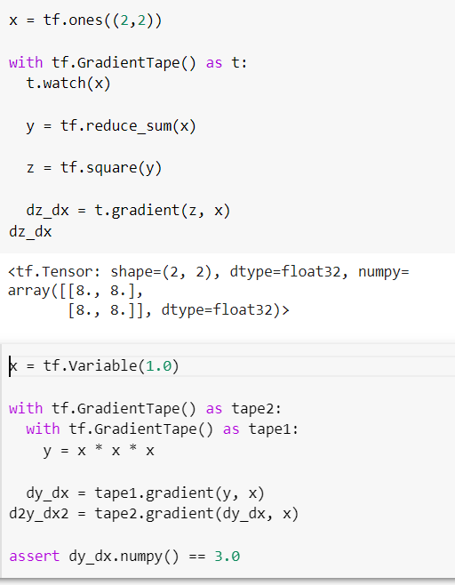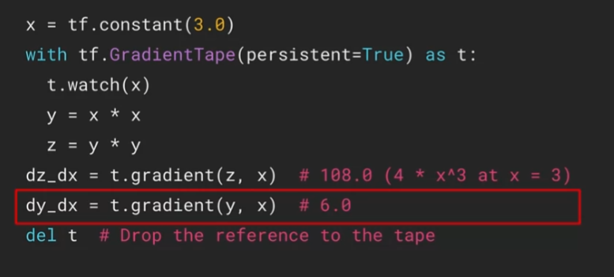

<https://www.coursera.org/learn/custom-distributed-training-with-tensorflow/ungradedLab/jKn7w/gradient-tape-basics/lab?path=%2Fnotebooks%2FC2_W1_Lab_2_gradient-tape-basics.ipynb>

<https://www.coursera.org/learn/custom-distributed-training-with-tensorflow/programming/TwjF2/basic-tensor-operations/lab?path=%2Fnotebooks%2FC2W1_Assignment.ipynb>

<https://www.youtube.com/watch?v=TudQZtgpoHk&t=1409s>

<https://www.geeksforgeeks.org/optimizers-in-tensorflow/#:~:text=Optimizers%20are%20techniques%20or%20algorithms,better%20accuracy%20of%20model%20faster>

**Graph mode:**

* How to Use decorators and tf.autograph to convert code into graph based code

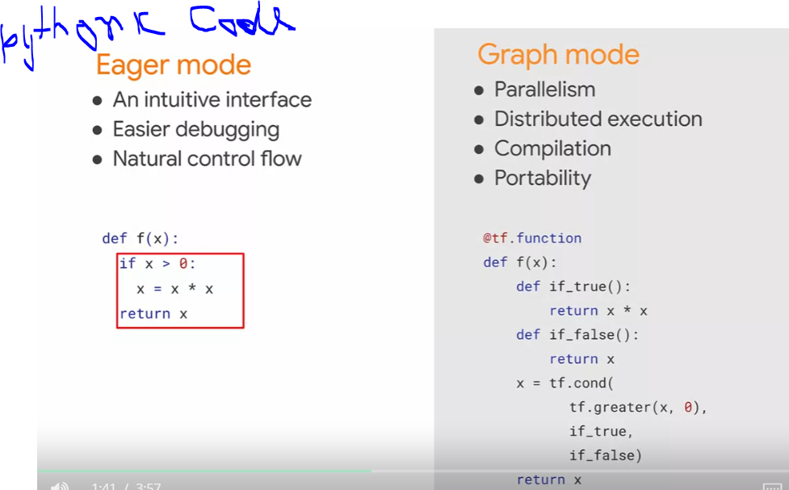 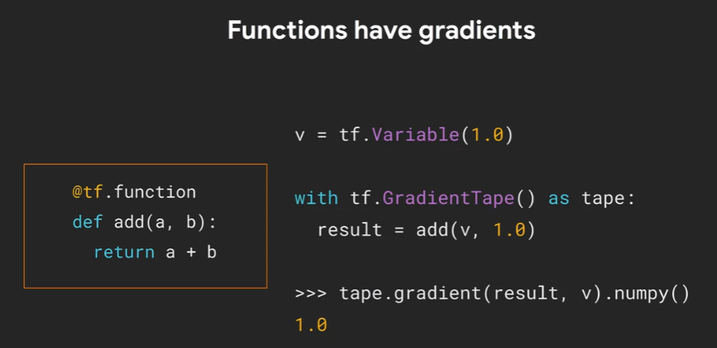

Function have gradients also work in graph mode.

@tf.function ## 1st step

def f(x,y): -----

print(f(1.0, 2.0))

print(tf.autograph.to_code(f.python_function))## 2nd step

http://wiki.c2.com/?FizzBuzzTest

Week 4:-

how distributed training is different from regular model training?

Mirrored Strategy to train a model on multiple GPUs on the same device?

TPU Strategy to train on multiple cores of a TPU?

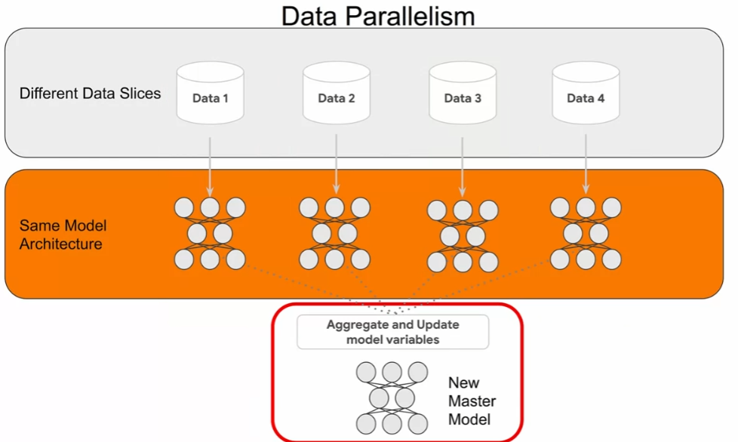 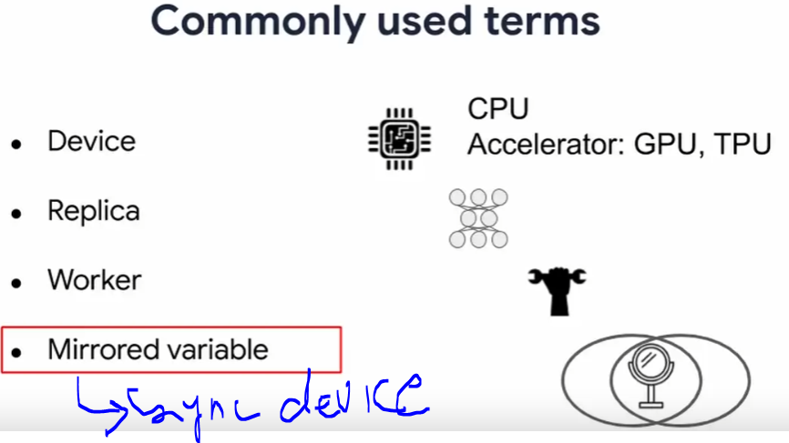

**Mirored variables** which we want to keep in sync across the different worker.

**Distribution stratergies:-**

* Tf.distribute.strategy
* High levels APIs
* Custom training loops
* Tensorflow 2: eager mode and graph mode
* Supported on multiple configurations
* Convenient to use with little to no code changes

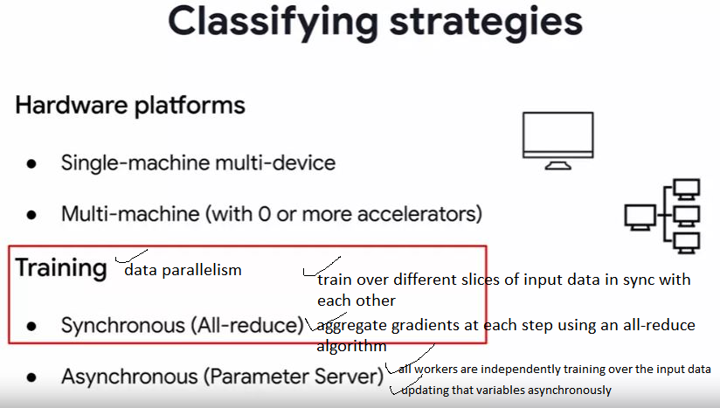

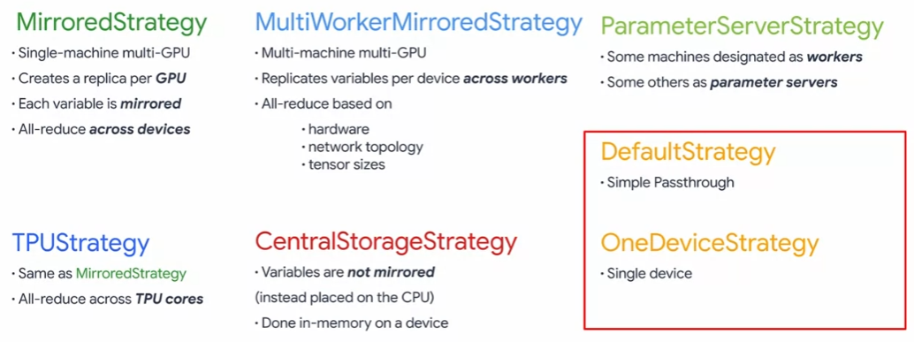

Mirored stratergy:-

* Model declaration
* Data preprocessing

**MirroredStrategy :-**

**tf.distribute.MirroredStrategy**

Synchronous training across multiple replicas on one machine.

**Parent class** : Strategy

1st part:

# Define the strategy to use and print the number of devices found

strategy = tf.distribute.MirroredStrategy()

2nd part:

# Use for Mirrored Strategy

BATCH_SIZE = BATCH_SIZE_PER_REPLICA * strategy.num_replicas_in_sync

# Set up the train and eval data set

train_dataset = mnist_train.map(scale).cache().shuffle(BUFFER_SIZE).batch(BATCH_SIZE)

eval_dataset = mnist_test.map(scale).batch(BATCH_SIZE)

3rd part:

# Use for Mirrored Strategy -- comment out `with strategy.scope():` and deindent for no strategy

with strategy.scope():

model = tf.keras.Sequential([

This strategy is typically used for training on one machine with multiple GPUs.

<https://www.tensorflow.org/api_docs/python/tf/distribute/MirroredStrategy>

<https://www.coursera.org/learn/custom-distributed-training-with-tensorflow/ungradedLab/alLiN/mirrored-strategy/lab?path=%2Fnotebooks%2FC2_W4_Lab_1_basic-mirrored-strategy.ipynb>

**tf.function:** Compiles a function into a callable TensorFlow graph. (deprecated arguments) (deprecated arguments)

## **Multiple GPU Mirrored Strategy:**

create a model with Custom Training?

how it splits the data training across GPUs?

how the aggregation of lost data is then managed?

Steps :

Create datsets form the batches

Create distributed datasets from the datasets

Custom disterubuted training set

Create the model architecture