# Autocorrelation

* We check dependency by looking at the correlation of a time with its lagged values of itself.
* We can use .shift to show the lagged data.
* Acf graph red shading indicates whether the correlations are significantly different froom zero.

# ACF

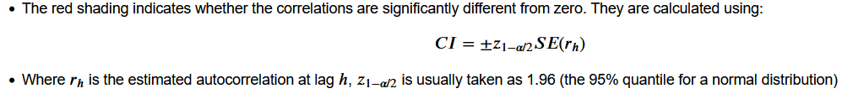

If mean remain same with oscilation then there will be no acf oscillation

EG

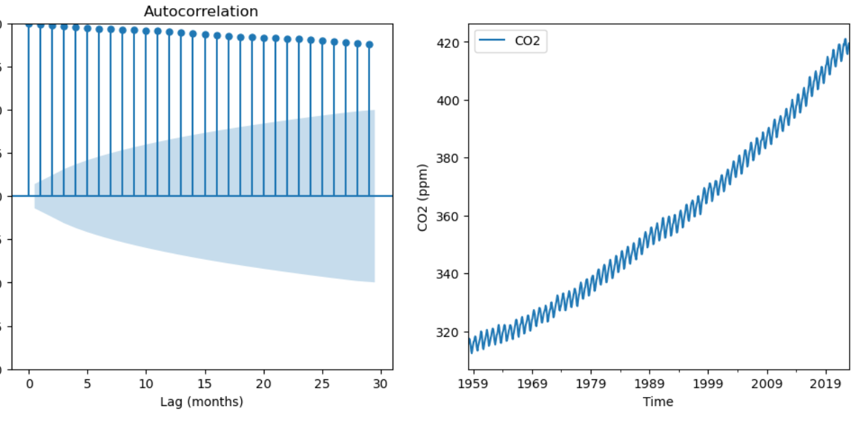

Autocorrelation measures the degree to which a time series is correlated with itself over time.

* Positive corr indicate current values are likely to be similar as past
* Negative corr indicate current values are not likely to be similar as past
* ACF help to indentify patterns and trend in the data.

Here are some points that explain how ACF helps in time series analysis:

* Identifying correlation
* Identifying seasonal patterns
* Identifying lagged effects
* Checking for stationarity
* Model selection

--------------------------------------------------------------

Time series pattens:

* Trends : long term increases or decrease in the seies.
* Seasonality : regular variation in the seires at some fixed intervals
* Cyclicity : it is fluctuations in the time series that occur at irregular intervals and are usually associated with economic or business cycles
* Irregular or random variation: This component is the residual part of the time series that cannot be explained by the trend, seasonality, or cyclical components. It is also called the noise or error component. For example, a sudden drop in sales of a product due to an unexpected event like a natural disaster can be considered as an irregular or random variation.

Time series are called white noise if:

* It has zero mean
* It has constant variance
* It has no autocorrelation

Estimating the trend cycle

* Curve fitting : statmodels.tsa.tsatools.detrends()
* Moving average : .rolling()

nan : appear at both end of the rolling data