1. Enable USB CDC Modem driver

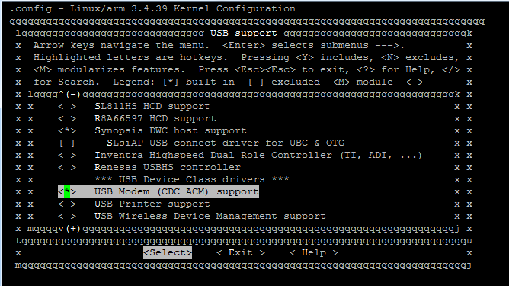

1. Enable TUN/TAP driver

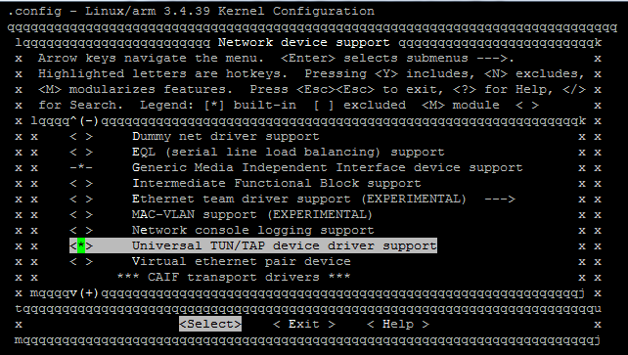

1. Enable 802.1d Ethernet Bridging

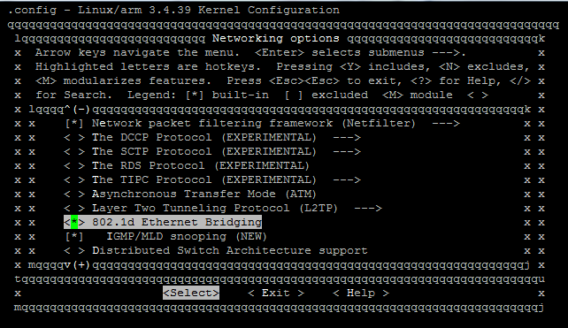

1. Config NAT64

Determine address IPv6 of Peer Router:

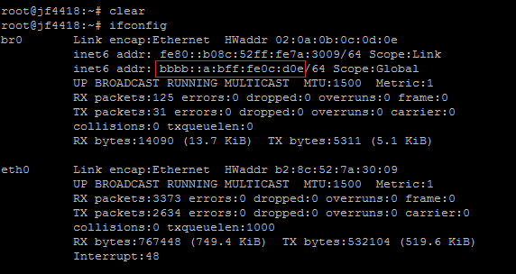

1. Configure Contiki NAT64

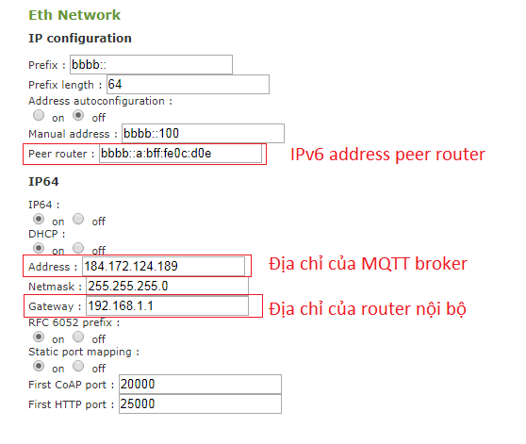

1. Thêm vào /etc/network/interfaces

auto br0

iface br0 inet dhcp

bridge_ports eth0

bridge_stp off

up echo 0 > /sys/devices/virtual/net/br0/bridge/multicast_snooping

post-up ip link set br0 address `ip link show eth0 | grep ether | awk '{print $2}'`

1. Tạo file cấu hình /etc/6lbr/6lbr.conf

MODE=ROUTER

#MODE=SMART-BRIDGE

#MODE=RPL-RELAY

#MODE=FULL-TRANSPARENT-BRIDGE

#MODE=NDP-ROUTER

#MODE=6LR

#MODE=RPL-ROOT

RAW_ETH=0

BRIDGE=1

CREATE_BRIDGE=1

DEV_BRIDGE=br0

DEV_TAP=tap0

DEV_ETH=eth0

#RAW_ETH_FCS=1

RAW_ETH_FCS=0

DEV_RADIO=/dev/ttyACM0 #2.4GHz USB Dongle will enumerate like ACM0

#DEV_RADIO=/dev/ttyUSB1 #SmartRF06EB+CC13xxEM will enumerate like USB1

BAUDRATE=115200

LOG_LEVEL=3