CSCI461: Introduction to Big Data
Assignment #2
MongoDB Queries & Hadoop MapReduce
Part One: MongoDB Queries
Database: moviesDB | Collection: moviesColl | Dataset: mds.json (1,401 records)

1. MongoDB Container Running



2. Import Command & Data Imported
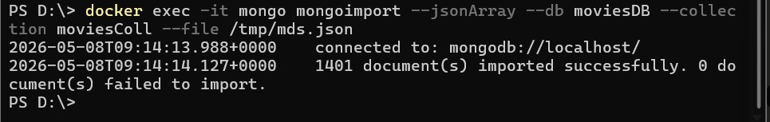

3. Database and Collection Verified

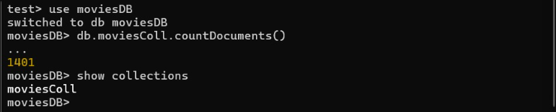

4. Query 1 — Index on name + Search by Name
Creates an index on the name field, then searches for a specific title by exact name
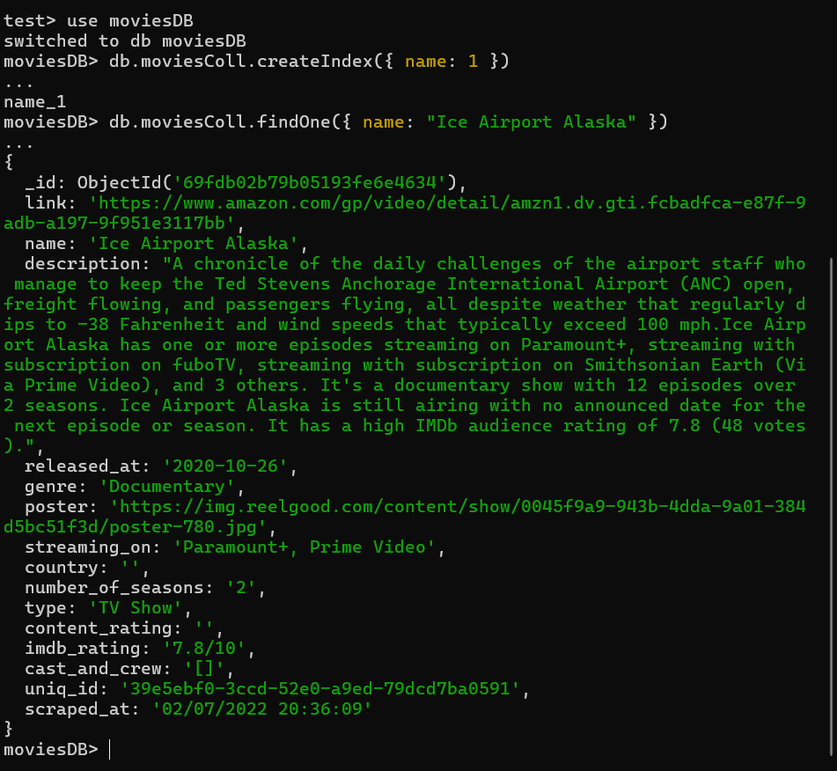

5. Query 2 — Movies with Drama or Documentary Genre
Finds all Movies where genre contains Drama or Documentary using $or and $regex.
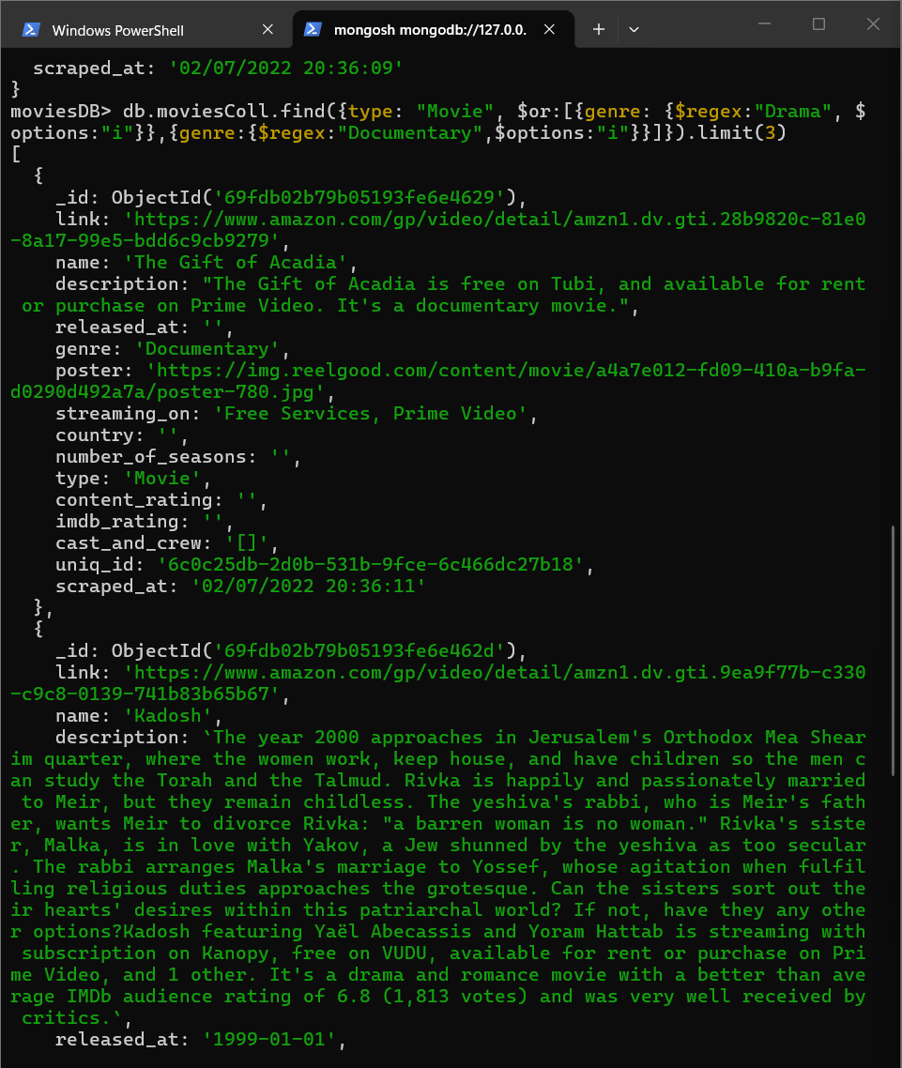

6. Query 3 — Count Titles per Type
Aggregation pipeline counting titles per type, sorted highest to lowest.
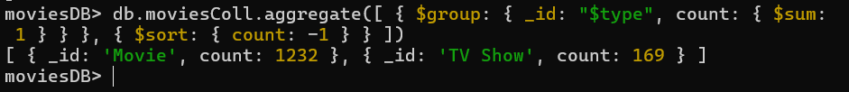

7. Query 4 — Top 5 Highest-Rated Movies
Top 5 highest-rated Movies after 2010 on Prime Video or Netflix, sorted by numeric IMDb rating.
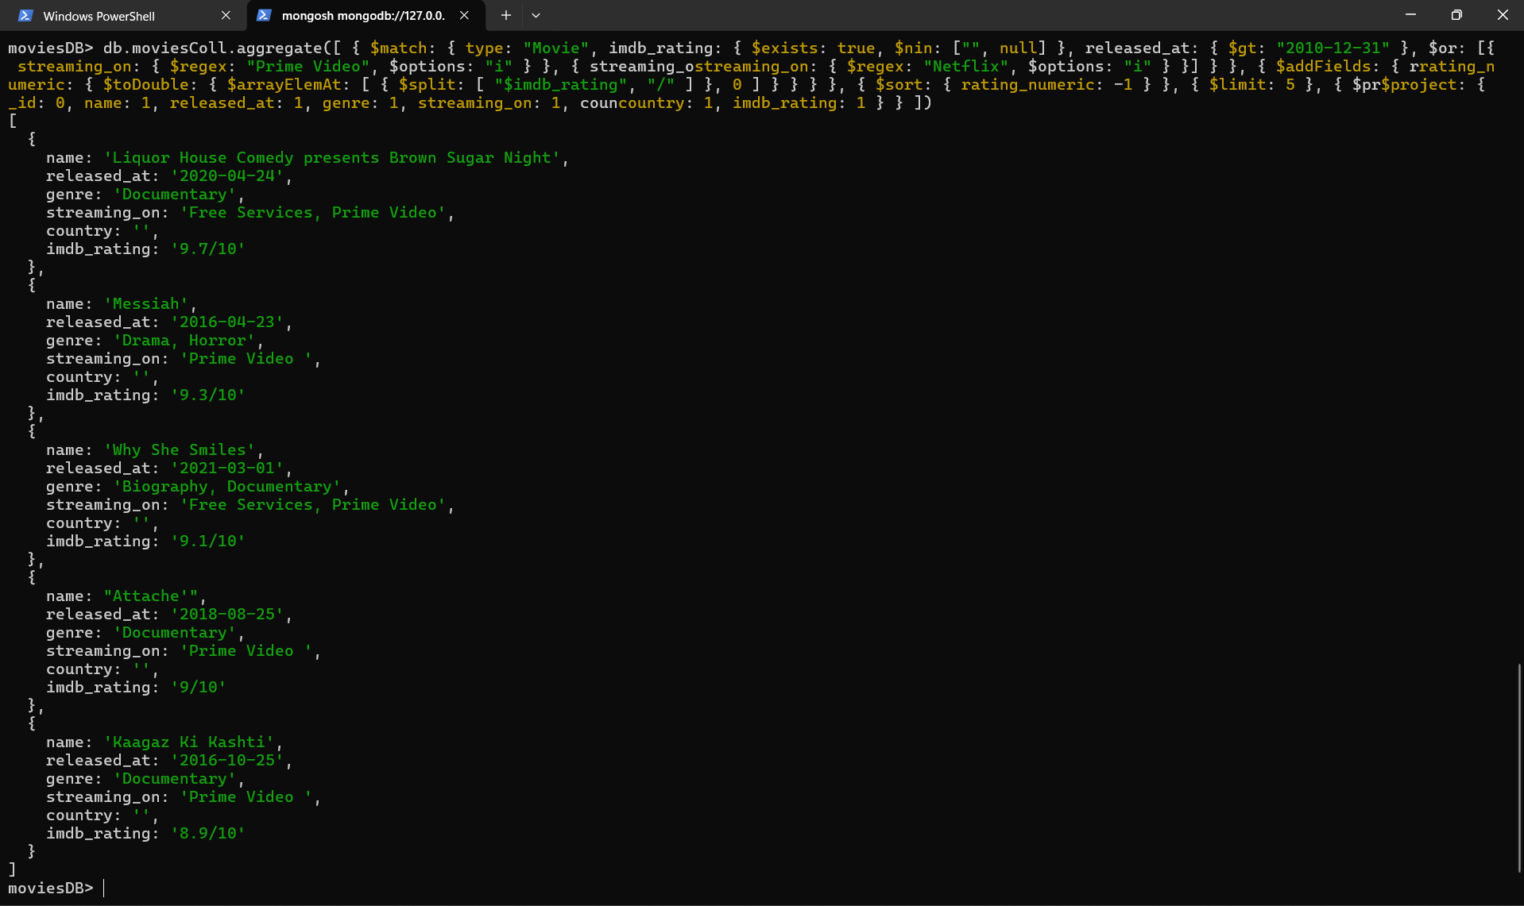

8. Query 5 (Bonus) — Advanced $facet Query
Uses $facet to run three aggregation sub-pipelines in a single pass over the collection.
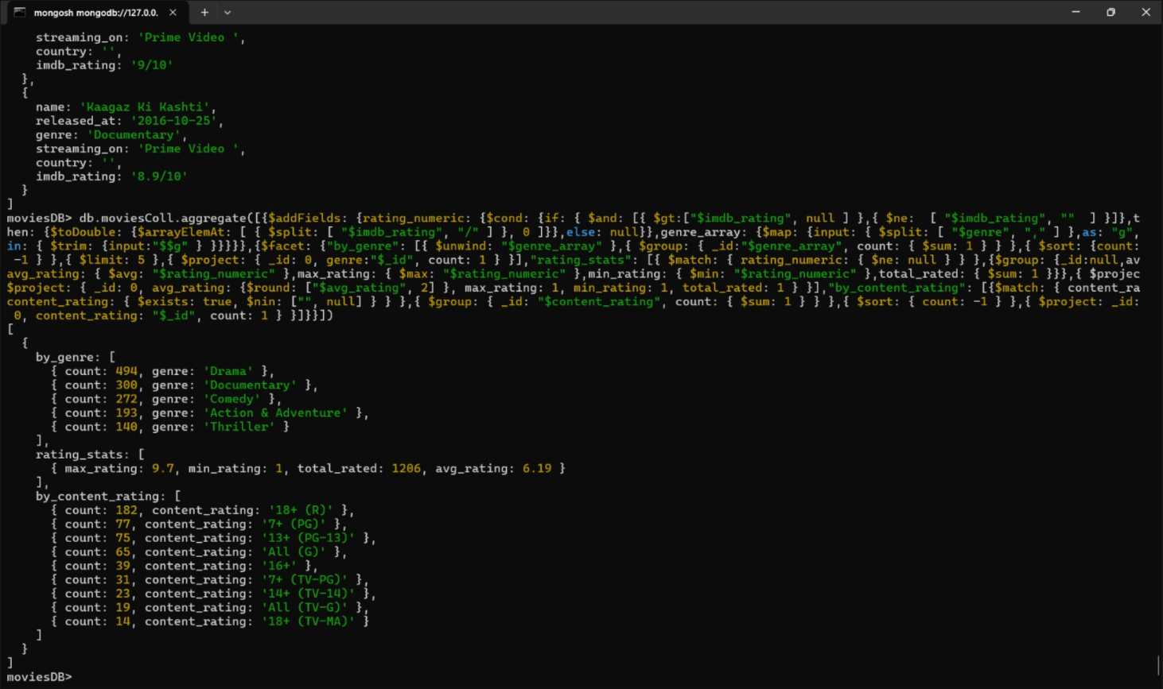

Part Two: Hadoop MapReduce
Input: mds.csv | Hadoop: 3.2.1 | Java class: ARDriver.java (Driver + Mapper + Combiner + Reducer)

1. CSV File Uploaded to HDFS
2. MapReduce Job Running & Completed

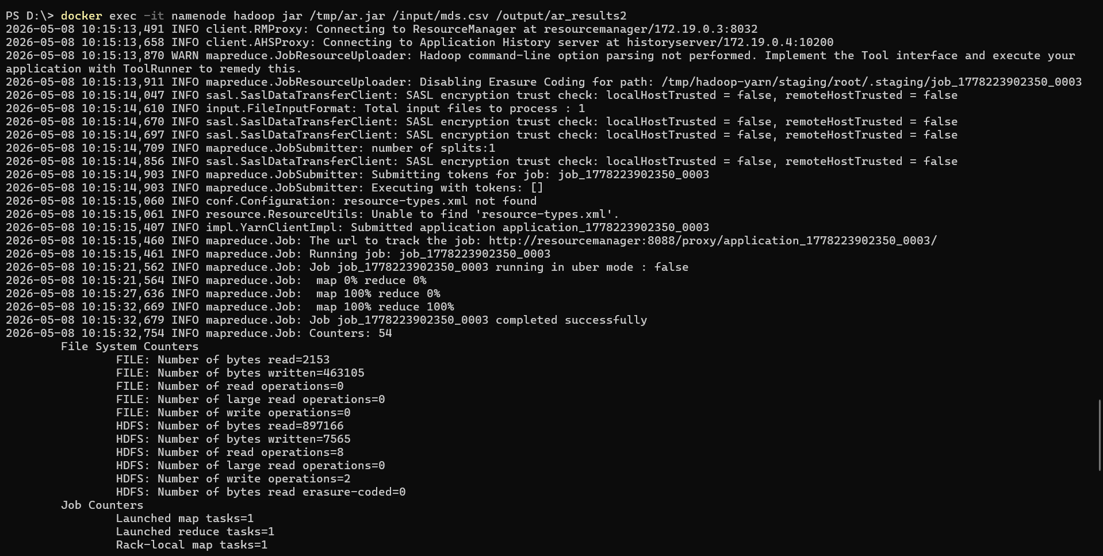

3. MapReduce Output — part-r-00000
Output format: Type, Genre, Decade, Count, AverageRating, MinRating, MaxRating
Total output groups: 176 | Combiner reduced 1,174 mapper records to 176 before Reducer
