 

|  |
| --- |
| **Credit Hours System- ELCN306** |

|  |
| --- |
| **Cairo University**  **Faculty of Engineering** |

**Communications 1**

**Final Assessment**

**Prepared by**: Kamel Mohsen Kamel Shehatah 1162325

Fatema Othman Mahmoud 1162040

Ahmed Nader Adel Assal 1162296

Rehab Ahmed Mohammed 1162297

Reem Emad Abdellatif 1164347

***Submitted to:*** Dr. Samy Soliman

Table of Contents

Table of Figures 3

Test Case 1 4

Givens 4

Results 4

Comments 7

Test Case 2 8

Givens 8

Results 8

Comments 11

Test Case 3 12

Givens 12

Results 12

Comments 15

Test Case 4 16

Givens 16

Results 16

Comments 19

# 

# Table of Figures

Figure 1_Test_Case_1_Sampler 4

Figure 2_Test_Case_1_Quantizer 5

Figure 3_Test_Case_1_Encoder_UniPolar 5

Figure 4_Test_Case_1_Resconstructed 6

Figure 5_Test_Case_1_Combined 6

Figure 6_Test_Case_2_Sampler 8

Figure 7_Test_Case_2_Quantizer 9

Figure 8_Test_Case_2_Encoder_Polar 9

Figure 9_Test_Case_2_Resconstructed 10

Figure 10_Test_Case_2_Combined 10

Figure 11_Test_Case_3_Sampler 12

Figure 12_Test_Case_3_Quantizer 13

Figure 13_Test_Case_3_Encoder_Polar 13

Figure 14_Test_Case_3_Resconstructed 14

Figure 15_Test_Case_3_Combined 14

Figure 16_Test_Case_4_Sampler 16

Figure 17_Test_Case_4_Quantizer 17

Figure 18_Test_Case_4_Encoder_Polar 17

Figure 19_Test_Case_4_Resconstructed 18

Figure 20_Test_Case_4_Combined 18

# Test Case 1

Givens:

* m(t) = 5 cos (2πfmt)
* fm = 10
* fs = 40
* μ = 0
* L = 8
* mp = 5
* Unipolar NRZ

Results:

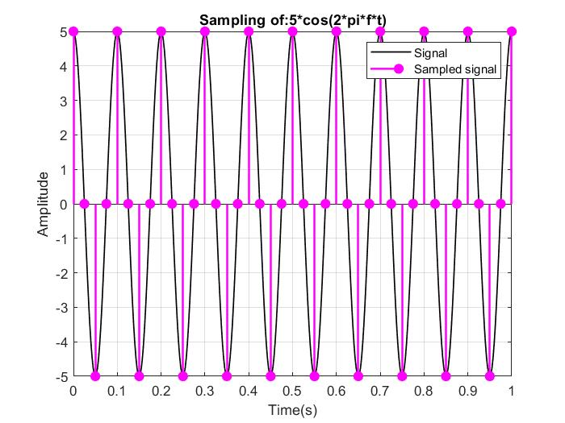

Figure 1_Test_Case_1_Sampler

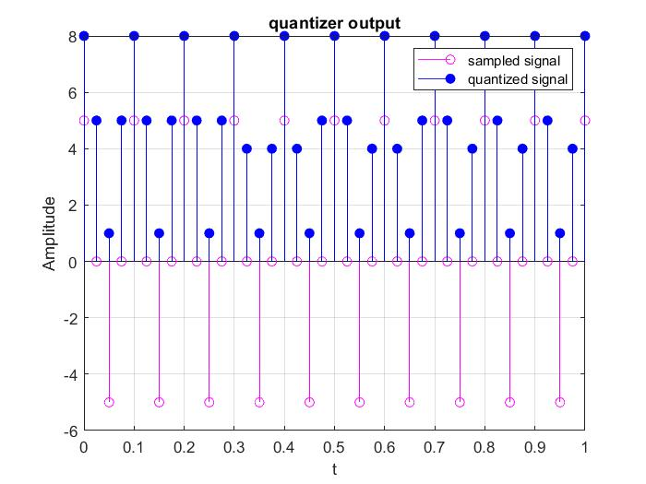

Figure 2_Test_Case_1_Quantizer

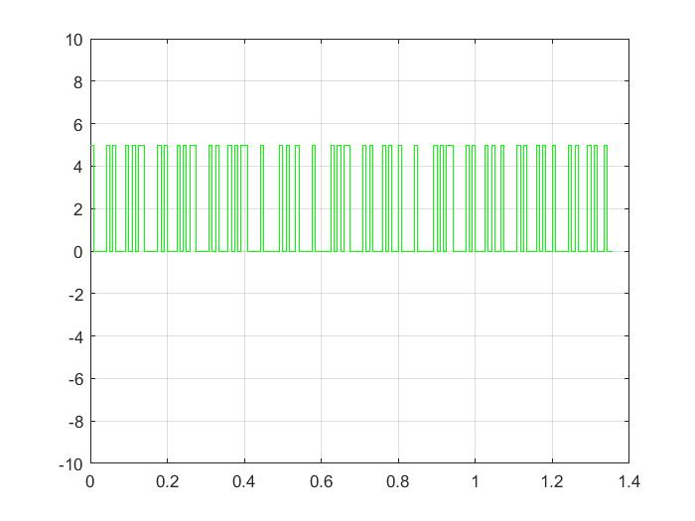

Figure 3_Test_Case_1_Encoder_UniPolar

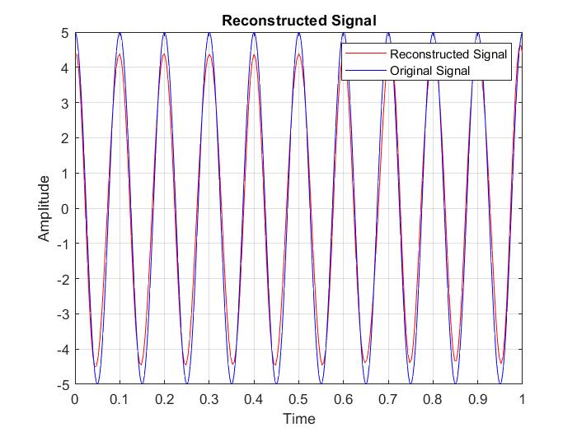

Figure 4_Test_Case_1_Resconstructed

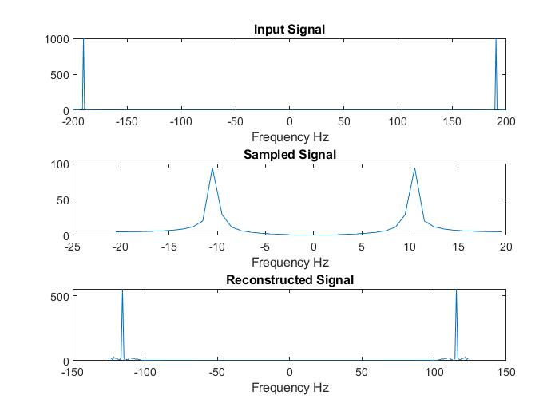

Figure 5_Test_Case_1_Combined

Comments:

* When fs=40 the signal can be reconstructed since fs 2BW.
* There is a difference between the sampled message and the quantized message due to the quantization error and can be decreased by increasing number of quantization levels.

# Test Case 2

Givens:

* m(t) = 5 cos (2πfmt)
* fm = 10
* fs = 20
* μ = 0
* L = 32
* mp = 5
* Polar NRZ

Results:

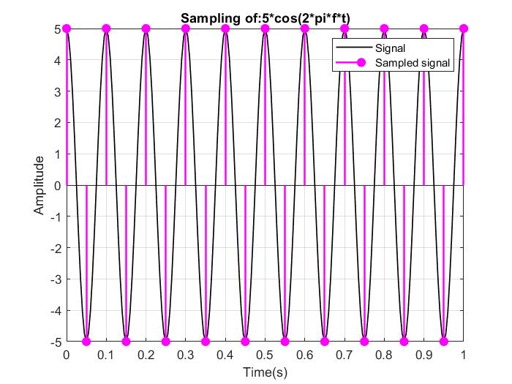

Figure 6_Test_Case_2_Sampler

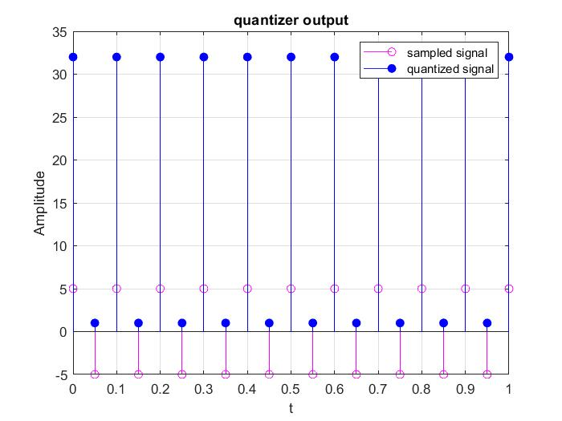

Figure 7_Test_Case_2_Quantizer

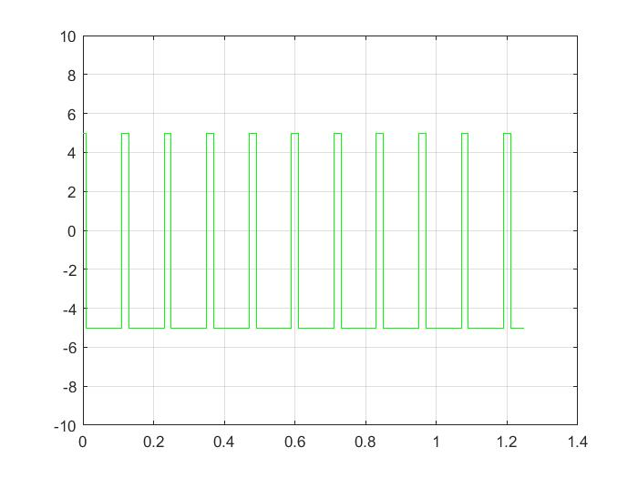

Figure 8_Test_Case_2_Encoder_Polar

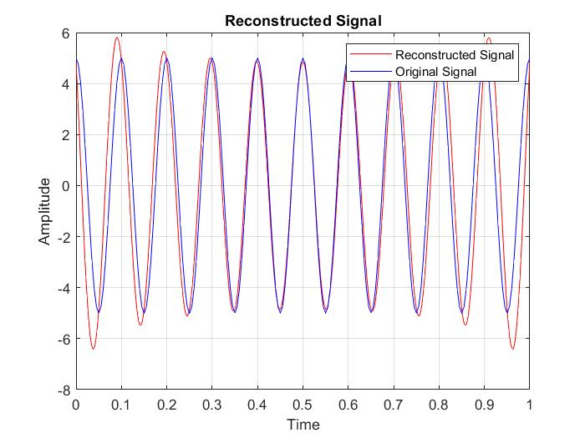

Figure 9_Test_Case_2_Resconstructed

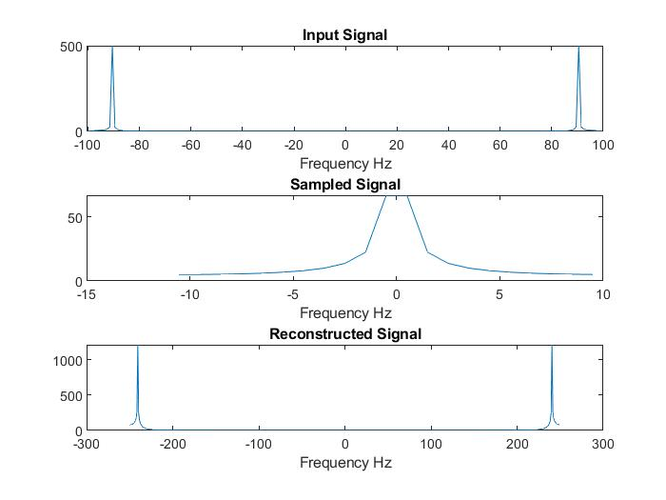

Figure 10_Test_Case_2_Combined

Comments:

* When fs = 20 the signal can be reconstructed since fs 2BW.
* The sampled message and the quantized message are almost the same as the quantization level is high as L=32.

# Test Case 3

Givens:

* m(t) = 5 cos (2πfmt)
* fm = 10
* fs = 20
* μ = 100
* L = 32
* mp = 5
* Manchester

Results:

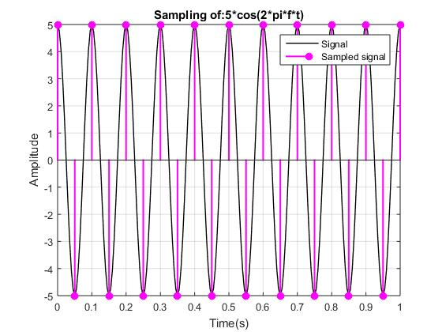

Figure 11_Test_Case_3_Sampler

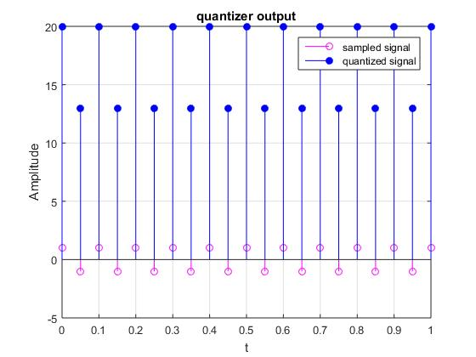

Figure 12_Test_Case_3_Quantizer

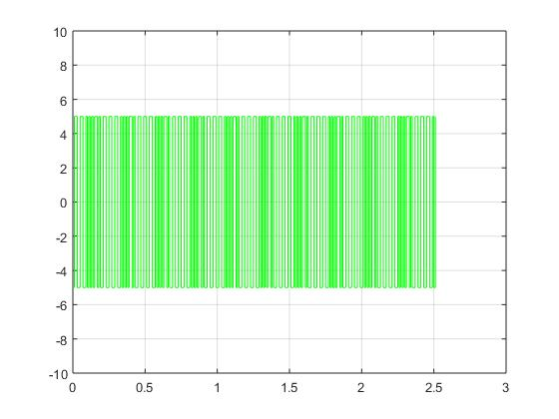

Figure 13_Test_Case_3_Encoder_Manchester

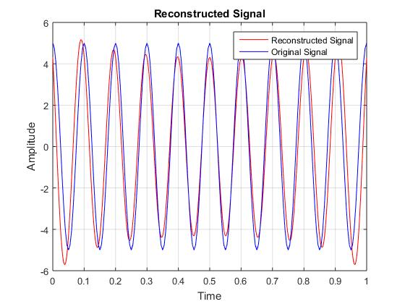

Figure 14_Test_Case_3_Resconstructed

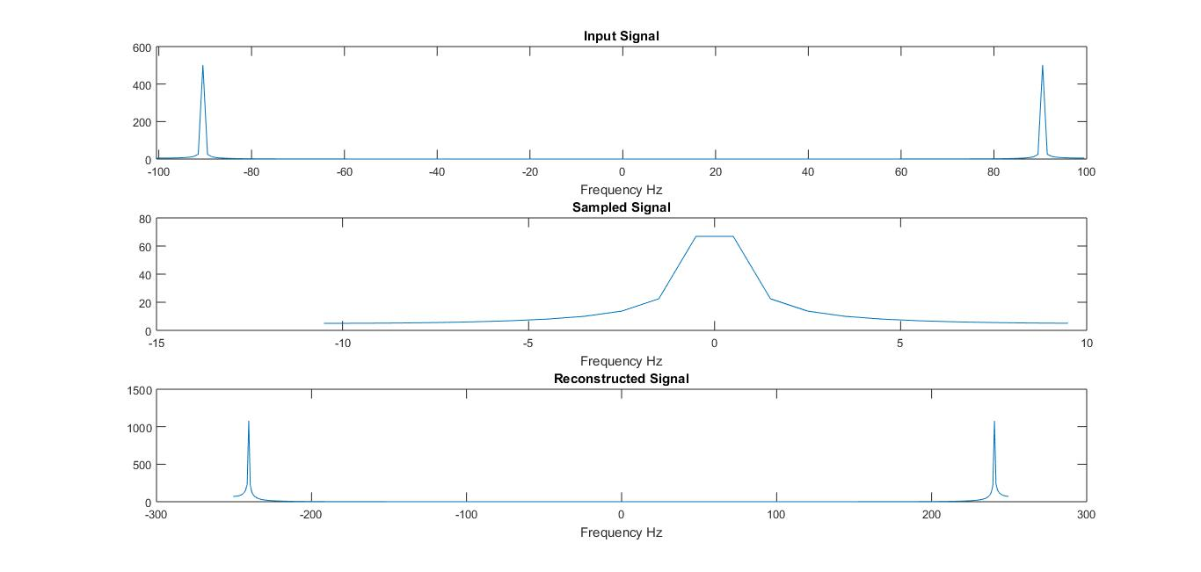

Figure 15_Test_Case_3_Combined

Comments:

* This is the only test case that employs companding rather than uniform quantization which of course will save the range that would have been wasted if we used uniform quantization.
* When a non-uniform quantization is used the signal is compressed.

# Test Case 4

Givens:

* m(t) = 5 cos (2πfmt)
* fm = 10
* fs = 15
* μ = 0
* L = 16
* mp = 5
* Unipolar NRZ

Results:

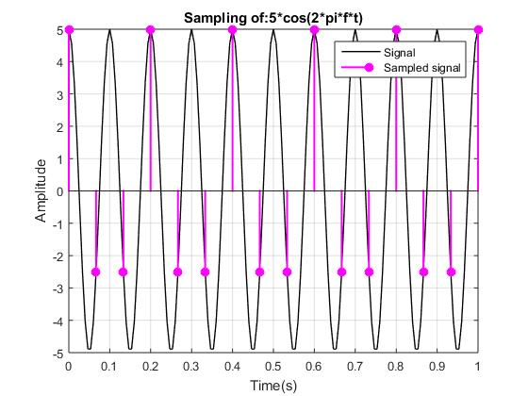

Figure 16_Test_Case_4_Sampler

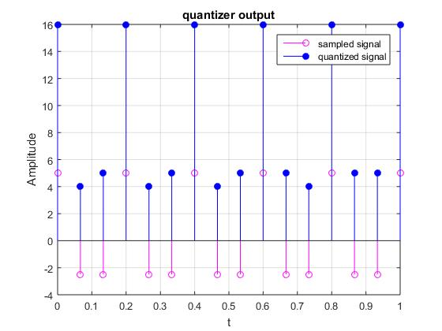

Figure 17_Test_Case_4_Quantizer

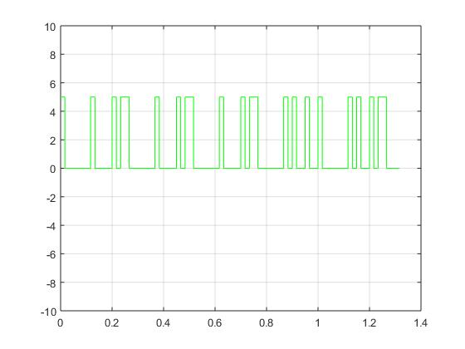

Figure 18_Test_Case_4_Encoder_Unipolar

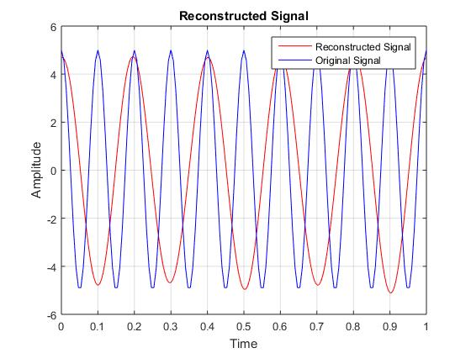

Figure 19_Test_Case_4_Resconstructed

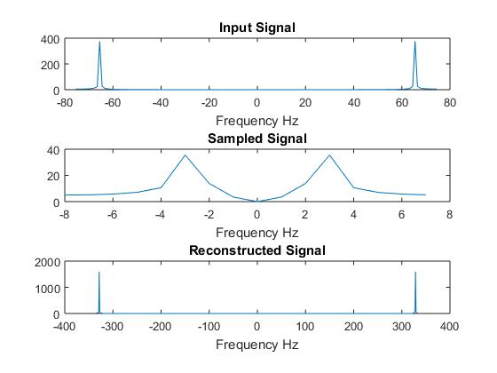

Figure 20_Test_Case_4_Combined

Comments:

* When fs=15 the signal cannot be reconstructed as fs < 2BW
* Aliasing occur.