 

|  |
| --- |
| **Credit Hours System- ELCN306** |

|  |
| --- |
| **Cairo University**  **Faculty of Engineering** |

**Communications 1**

**Final Assessment**

**Prepared by**: Kamel Mohsen Kamel Shehatah 1162325

Fatema Othman Mahmoud 1162040

Ahmed Nader Adel Assal 1162296

Rehab Ahmed

Reem Emad

***Submitted to:*** Dr. Samy Soliman

Figure 1_Test_Case_1_Sampler 3

Figure 2_Test_Case_1_Quantizer 4

Figure 3_Test_Case_1_Encoder_UniPolar 5

Figure 4_Test_Case_1_Resconstructed 5

Figure 5_Test_Case_1_Combined 6

# Test Case 1

Givens:

* m(t) = 5 cos (2πfmt)
* fm = 10
* fs = 40
* μ = 0
* L = 8
* mp = 5
* Unipolar NRZ

Results:

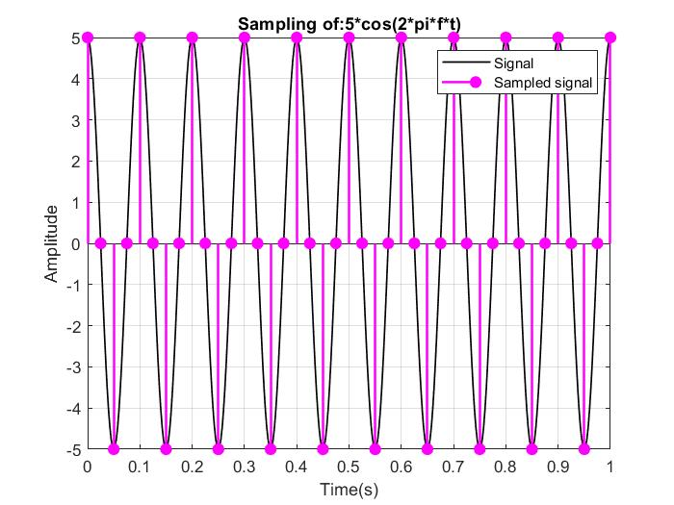

Figure _Test_Case_1_Sampler

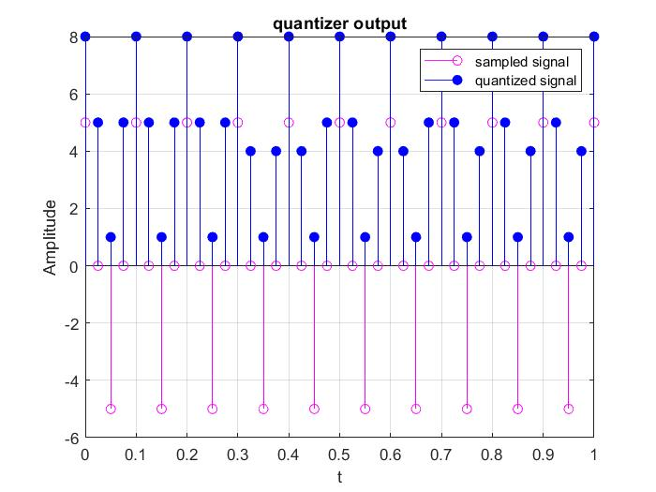

Figure _Test_Case_1_Quantizer

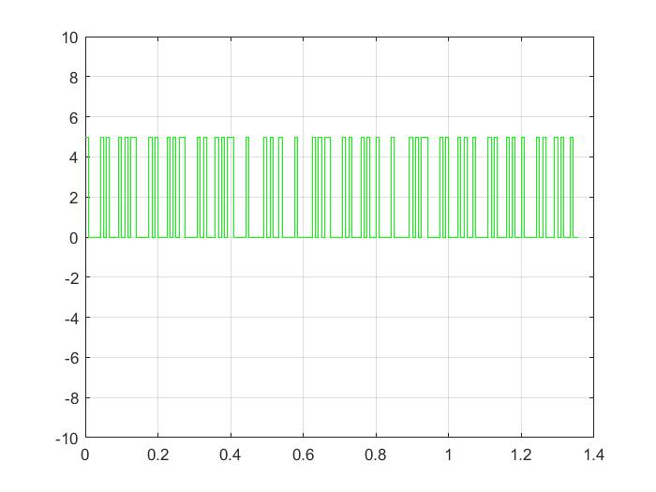

Figure _Test_Case_1_Encoder_UniPolar

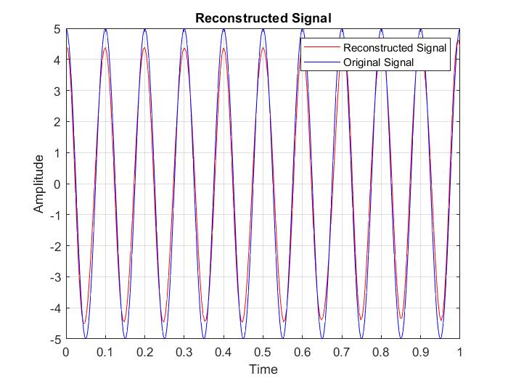

Figure _Test_Case_1_Resconstructed

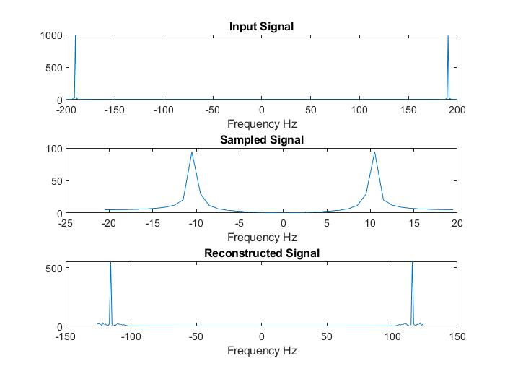

Figure _Test_Case_1_Combined

Comments:

* When fs=40 the signal can be reconstructed since fs 2BW.
* There is a difference between the sampled message and the quantized message due to the quantization error and can be decreased by increasing number of quantization levels.

# Test Case 2

Givens:

* m(t) = 5 cos (2πfmt)
* fm = 10
* fs = 20
* μ = 0
* L = 32
* mp = 5
* Polar NRZ

Results:

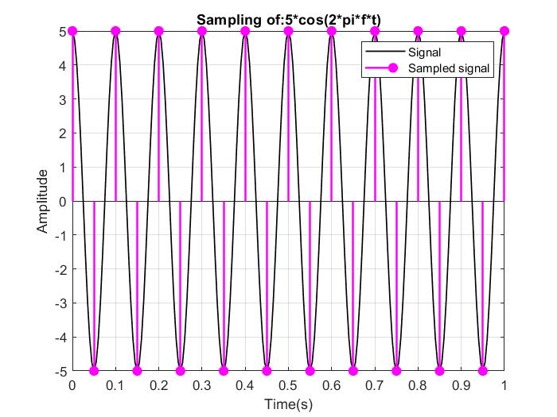

Figure _Test_Case_2_Sampler

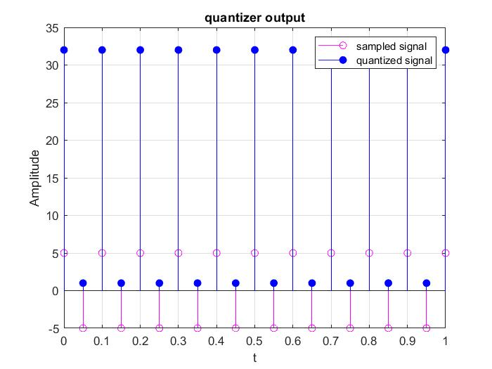

Figure _Test_Case_2_Quantizer

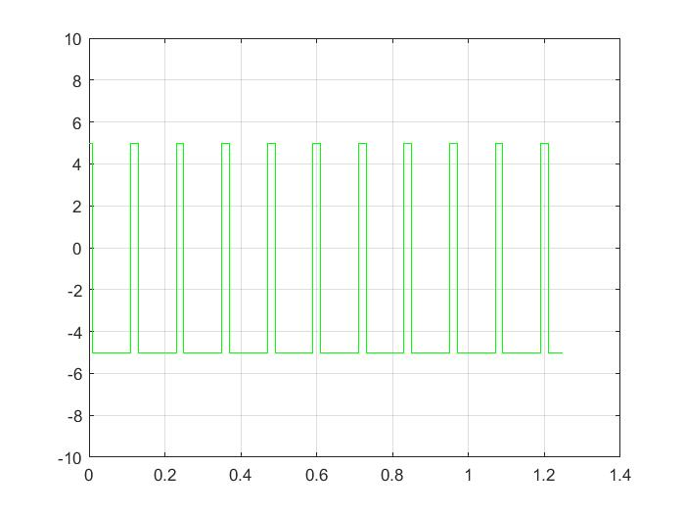

Figure _Test_Case_2_Encoder_Polar

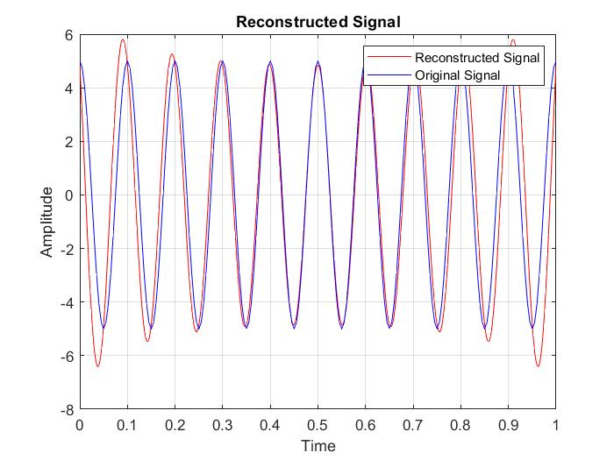

Figure _Test_Case_2_Resconstructed

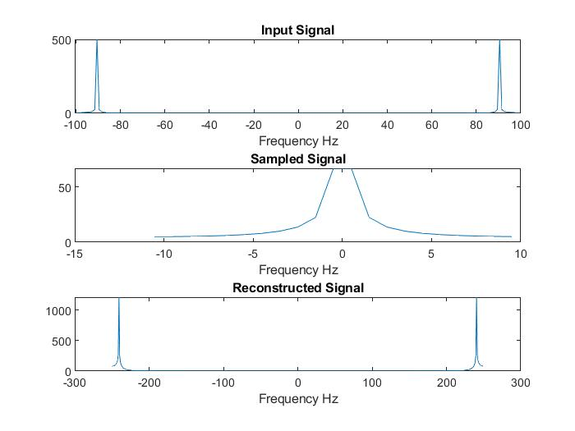

Figure _Test_Case_2_Combined

Comments:

* When fs = 20 the signal can be reconstructed since fs 2BW.
* The sampled message and the quantized message are almost the same as the quantization level is high as L=32.

# Test Case 2

Givens:

* m(t) = 5 cos (2πfmt)
* fm = 10
* fs = 20
* μ = 0
* L = 32
* mp = 5
* Polar NRZ

Results:



Figure 6_Test_Case_2_Sampler



Figure 7_Test_Case_2_Quantizer



Figure 8_Test_Case_2_Encoder_Polar



Figure 9_Test_Case_2_Resconstructed



Figure 10_Test_Case_2_Combined

Comments:

* When fs = 20 the signal can be reconstructed since fs 2BW.
* The sampled message and the quantized message are almost the same as the quantization level is high as L=32.