KABARAK UNIVERSITY

SCHOOL OF SCIENCE, ENGINEERING AND TECHNOLOGY

RESEARCH PROJECT

TOPIC: EMERGECNY ALERT SYSTEM

NAME: VINCENT KAMEMIA REG NO: CS/MG/2774/09/19

This research proposal is submitted to Kabarak University School of Science, Engineering and Technology in partial fulfillment of Degree in Computer Science.

DATE: AUGUST 2023

# DECLARATION

This is to certify that the following proposal submitted for partial fulfillment of degree in Computer Science is my original work and has not been submitted elsewhere before for the same degree or any other examination of the same.

Name: Vincent Kamemia

Reg no: CS/MG/2774/09/19

Signature: …………………. Date: ……………………….

# RECOMMENDATION

This project proposal has been submitted for examination to department of Computer Science and IT under School of Science, Engineering and Technology with approval of the supervisor.

Name: Simon Ruoro

Department: Computer Science and IT

Signature: …………………… Date: …………………

# DEDICATION

I dedicate this project to my parent Mrs. Kimani who has encouraged and supported me throughout this journey of working hard to achieving my goals. They have been a blessing unto my life, and I thank them so much for this far.

# ACKNOWLEDGEMENT

I’d like to acknowledge the goodness of God for the gift of life and that He has enabled me to reach this far. I also thank my parents for the love and support they have showed me throughout the process. I won’t forget my supervisor Mr. Simon Ruoro who has helped a lot in making sure this project becomes a success.

# ABSTRACT

An efficient emergency management system is essential for minimizing the impact of disasters and crises. This study examines the critical components of an effective emergency management system, including preparedness, response, recovery, and communication. By analyzing various emergencies, such as natural disasters, pandemics, and terrorist threats, we identify the significance of a coordinated and integrated approach in handling diverse crisis situations. Our recommendations include conducting comprehensive risk assessments, fostering multi-agency collaboration, integrating advanced technologies, engaging communities through education, establishing robust communication systems, pre-positioning essential resources, and continuous evaluation for improvement. By implementing these measures, the emergency management system can enhance its preparedness and response capabilities, ensuring a resilient and coordinated approach to future emergencies. Investing in disaster preparedness is a cost-effective strategy for reducing the overall impact of crises and safeguarding communities.

Table of Contents

DECLARATION 1

RECOMMENDATION 1

DEDICATION 2

ACKNOWLEDGEMENT 3

ABSTRACT 4

CHAPTER ONE: INTRODUCTION 8

1.1 Introduction 8

1.2 Background of the study 8

1.3 Statement of the problem 8

1.4 General Objectives 8

1.4.1 Specific Objectives 8

1.5 Research Questions 9

5.2 JUSTIFICATION FOR THE STUDY 9

1.7 SCOPE AND LIMITATION OF THE STUDY 9

CHAPTER TWO: LITERATURE REVIEW 10

2.1 Introduction 10

2.2 Conceptual Framework 10

2.3 Theoretical Framework 11

2.4 Empirical Review 12

2.5 Summary of Literature 13

CHAPTER THREE: METHODOLOGY 14

3.1 Introduction 14

3.2 Research Design 14

3.3 Location of the study 16

3.4 Population of the study 16

3.5 Sampling procedure and sample size 16

3.5.1 Stratified Sampling Procedure 16

3.5.2 Sample size 16

3.6 Data collection procedure 17

3.7 System analysis and design 17

3.8 Research Ethics 18

CHAPTER FOUR 20

SYSTEM IMPLEMENTATION AND DEPLOYMENT 20

4.0 SYSTEM IMPLEMENTATION AND DEPLOYMENT 20

4.1 Introduction 20

**4.2 System Description** 20

4.3 Front-end 20

**4.4 User Interface Design** 23

**4.5 Back-end Development** 23

**4.5.1 Code Testing** 24

**4.6 Deployment Method** 25

CHAPTER FIVE 27

CONCLUSION AND RECOMMENDATIONS 27

5.0 Introduction 27

**Recommendations:** 27

Based on the findings, I recommend the following steps to enhance the emergency management system: 27

REFERENCES 28

Appendix A: Interview Guide 29

# CHAPTER ONE: INTRODUCTION

# Introduction

This chapter deals with the background of the study, statement of the problem, purpose of the study, objectives of the study, research questions and significance of the study. It also highlights the scope and limitations and of the study and some of the basic assumptions of the study.

# Background of the study

Disasters and emergencies, both natural and human-made, have become increasingly frequent and devastating in recent times. From earthquakes and hurricanes to pandemics and terrorist attacks, these events have significant social, economic, and environmental consequences. As a result, the need for a robust emergency management system has become paramount to effectively respond to and mitigate the impact of such crises.

The primary goal of emergency management is to reduce the loss of life, minimize property damage, and facilitate a swift recovery process. Historically, emergency management focused mainly on reactive measures, emphasizing response efforts once disasters occurred. However, this approach proved inadequate in dealing with the complexity and severity of modern crises.

In the wake of several high-profile disasters, there has been a paradigm shift towards a more proactive and comprehensive emergency management approach. This new approach encompasses four phases: preparedness, response, recovery, and mitigation. Preparedness involves planning, training, and resource allocation before a disaster occurs. Response encompasses actions taken during the disaster to address immediate needs and save lives. Recovery refers to the post-disaster phase focused on rebuilding and restoring communities, while mitigation involves efforts to prevent or reduce the impact of future disasters.

The success of an emergency management system relies heavily on various factors, such as effective communication, collaboration between agencies, community engagement, and the integration of advanced technologies. Communication plays a crucial role in disseminating timely and accurate information to the public, enabling them to make informed decisions during crises. Collaboration among different stakeholders, including government entities, emergency services, healthcare providers, and non-governmental organizations, ensures a more coordinated and efficient response.

The advent of modern technologies, such as artificial intelligence, data analytics, and geographic information systems, has revolutionized emergency management. These technologies offer real-time data analysis, predictive modeling, and visualization tools that aid decision-making and resource allocation during emergencies.

Community engagement and education play a vital role in fostering resilience. By raising awareness about potential risks and encouraging preparedness measures, communities can become more self-sufficient in managing crises until professional assistance arrives.

In this context, this study aims to analyze the key components of an effective emergency management system and identify best practices for enhancing preparedness and response capabilities. By examining different types of emergencies and studying successful emergency management strategies from various regions, we seek to provide valuable insights and practical recommendations to strengthen emergency management systems. Ultimately, the research endeavors to contribute to more resilient and adaptive communities better equipped to face the challenges posed by emergencies and disasters in an increasingly uncertain world.

# Statement of the problem

The functionality of the existing applications is quite difficult to use and are less effective during cases of emergency, for instance the user needs to unlock the phone and click on the widget or icon of the app and only then will the system be activated. People might be facing this problem when they want to active the application. This problem is crucial, as it hinders one during an emergency, as one may find it difficult to unlock the phone.

# General Objectives

In this project, the emergency based mobile application is to develop to help people to act quickly when they are in emergency situation. The system will help to send all the personal information including the location, sound recorder or picture of the user to the emergency contact that the user set in the system. The information will send when the user triggers the system.

# 1.4.1 Specific Objectives

The specific objectives of this project are:

1. To design an app that shall assist in alerting the emergency agency in case of an emergency.
2. To design a system for easier accident response
3. To develop a simple, effective and user-friendly emergency web application.
4. To apply the time interval function that allows user to select the duration to re-launch the emergency function.

# Research Questions

1. What are the requirements needed in implementing an emergency response system?

1. What are the key components and features of an effective emergency system?
2. What are the best practices in emergency management systems for specific types of disasters?
3. How does technology, such as artificial intelligence, big data, and IoT, enhance emergency management systems' efficiency and effectiveness?

# JUSTIFICATION FOR THE STUDY

This emergency mobile application will provide user a fast way to look for help. Besides, because of the complete information that set in the apps by the user, the emergency contact or police official will be easy to know who and what exactly is happening in that emergency situation. The rescue process will be performed quickly and accurately according to the user complete information. By using this emergency mobile application people can be react fast or look for help in a short period of time when they are in trouble. The emergency mobile application could be reducing the possibility of people kidnapped by someone or increase the chance of people get rescue. Other than the emergency mobile application will improve the efficiency of police or the friend and family to look for the user that are in trouble. For example, when the people who installed this apps, suddenly some emergency situation is happen, the user will trigger the apps in order to look for help in quickly without suffering.

# 1.7 SCOPE AND LIMITATION OF THE STUDY

This mobile app is targeted for all smartphone users, whoever has a smartphone will be able to use this mobile application. The app requires the user to use mobile data in order to detect their location. Their GPS location is that of the application user which will be relayed to their emergency contact when the app is triggered. This mobile app will send SMS to the emergency contact that set by user. The SMS will include all the personal information of the user. The mobile app requires all the personal information from the user, some emergency contact and personal message to create an account in the app.

# CHAPTER TWO: LITERATURE REVIEW

# 2.1 Introduction

This chapter is concerned about the literature review which consists of three sections which are the conceptual framework, theoretical framework, and the empirical review. The main topic that uses to review the literature is emergency based mobile application. There are many literatures and theories that are related to this kind of topic, but in this review, we will only focus on three groups. Which is the emergency-based handling system, the mobile emergency response technology by using geolocation and safety triggering system. These three groups will be mainly focus and review, in order to improve the understanding of emergency based mobile application.

# 2.2 Conceptual Framework

The application will be using the Model-View-Controller (MVC) architecture, shown in Figure 1. The MVC paradigm is an approach used to develop software programs in a maintainable and clear way. This architecture has many advantages as it separates concerns by programming independent elements that are interchangeable and reusable, and results in a clear well-structured program.

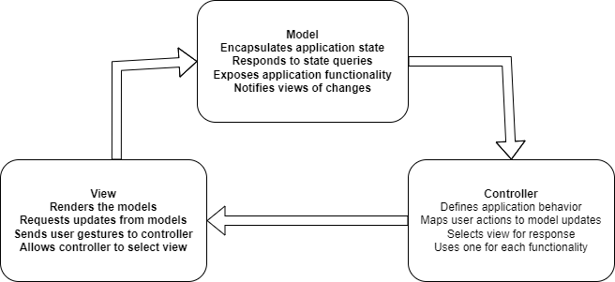

Figure 1

The interaction between the components of the MVC design pattern goes as follows: The Model is the central element of the pattern because it represents the domain logic of the application, which gives meanings to the data and information on which it operates. The view is the representation of the output as it renders the model to provide a better form of interaction with the user. We can have multiple views of an application as the output can represented using more than one form. The last element of this architectural pattern is the Controller. It gets the input from the user and transforms it into a set of commands for the model to manipulate it and make changes in it. It also makes changes on the views of the model content because the views are a representation of the model.

# 2.3 Theoretical Framework

The main topic that uses to review the literature is emergency based application. There are many literatures and theories that are related to this kind of topic, but in this review, we will only focus on three group. Which is the emergency-based handling system, the web emergency response technology by using geolocation and safety triggering system. These three groups will be mainly focus and review, in order to improve the understanding of emergency based web application.

1. **Emergency based handling system**

Firstly, the meaning of emergency-based handling system group is when people have any incident or emergency, people will use the system to get help and the system will handle this every critical situation to provide help and response to the people. Maznah Kamat, conducted a research and development regarding the emergency handling system. They developed the system call emergency handling system (EHS), they applied location-based technologies to this system, in order to detect the caller or the user location and connect to a database server. This kind of system they enable user to send an emergency message to a police station, rescue team, hospital etc. The receiver will check and ensure the location when they login in to the system portal and check the message of the sender to estimate the location.

1. **Emergency response technology by using geolocation**

Following the first group, the second group is the mobile emergency response technology by using geolocation. The meaning of this group is using the location service in smart phone such as GPS and A-GPS to keep track user location when the user is in urgent. Jethro, Ritz and Engr conducted research or a development regarding the mobile emergency response technology by using geolocation. They develop a mobile application can Rescue Me, which using this technologic and the mobile application will work together with the web application command center. The command center will read the user information when the user request certain emergency unit. The application will have three type of emergency unit, for example ambulance, police and fire truck. After the command center get the user information from the mobile application, the command center will immediately plot the information on google map (Jethro, Ritz & Engr 2014).

1. **Safety triggering system**

The last group is safety triggering system. Safety triggering system is when a person who fall in to a stressful situation, in that situation they feel trouble to doing anything, the safety triggering system will help the user handle everything when the user triggers the system. Kalyanchakravarthy, conducted a research and development about safety triggering system. They develop an android based safety triggering mobile application, the main purpose of them to create this apps are woman’s safety, to provide a quick react when the user is in emergency situation. This application will operate when the user presses the power button of the phone, after pressed the power button, the phone will pop up an alert screen and the screen will show user a button, when the pressed the triggering button to active the apps and the apps will starting perform the emergency function at the background. The application will detect the current location of the user and append with the message together and send it to the user family and friend, the user can stop application continue sending message by using the personal password

# 2.4 Empirical Review

The best approach was to first determine the different features that are offered as services by already implemented solutions that help people in difficult situations. As previously discussed, the existing solutions offer first aid help to users as form of steps to follow in each specific situation. In our solution, we offer another kind of service which is different from the already existing ones, as the users of the application will seek help from other people or organizations. Therefore, we need to conduct requirements analysis in order to include these new features that are mandatory to implement. The next step is to get the non-functional requirements that we would like to provide along with the functional requirements, which include the design of the user interface and the additional features that would offer better services to the client. The design phase would be the next step. This step would be delicate as the application will be used in different platforms including Android, iOS, and Windows Phone 8. To realize this, we will use a cross-platform development tool that is a native container that wraps the code of a web application written in JavaScript, HTML, and CSS. This hybrid model to implement mobile applications has many advantages. They include the ability to have access to native APIs of the different platforms, which is not usually possible through browsers. Another advantage is that a developer does not need to learn about the different programming languages and tools to develop a single application for each platform.

# 2.5 Summary of Literature

In conclusion, by going through all the three group which is emergency-based handling system, the web emergency response technology by using geolocation and safety triggering system in this literature review. The group of safety triggering system will be more suitable for the world today and it is more related to my project, this is because my project will be more on safety triggering emergency call web application such as pressed a physical button to send all information of the user in order to get help. In this whole process of literature review, I learned the different function and purpose of different group and my understanding regarding the emergency-based system become stronger. In order for me to create a useful emergency system, the review and also comparison that I make in this review will help me a lot and give me an idea how to make my system become more useful.

# CHAPTER THREE: METHODOLOGY

# Introduction

This chapter will cover the details and explanations of the methodology that is being used to make the project complete. Methodology involves the specific procedures or techniques used to identify, select, process, and analyze information about a topic. As such, it will enumerate the research design to be employed in the study and the data collection methods method that will be used to achieve the objective of the project and ensure a perfect result.

# Research Design

The software methodology that are used for this project is Iterative and incremental development. Iterative and incremental development is the method that use to produce a good quality and reliable system. This model allows the developer to increase the functionality of the system in the increment way. Basically, this method has divided into two approach which is iterative and incremental approach. In iterative approach the author can choose to review or redesign part of the system and improve some of the feature in order to make the system become better. For instance, every time the developer review or revisit the system, some modification or improvement will be made in that iteration. By the way, the developer can get user feedback in order to make quality improvement for the system. In incremental approach the developer is develop and analyse the system many times at different portion, each times the new feature of the system will be add incrementally until the whole system is finish developed. Besides, the system design, testing and implement also will perform incrementally until the system is done. In the end of the development the author will check the system completion and make sure it is fulfilling the user requirement. The reason that choosing this methodology is because the method allows the emergency web apps add new feature in anytime. For example, when the developer is working on the photo auto capture module in the process and they figure out that video recorder function can be improve the functionality of the system, the developer can just redesign and make modification of the system. Besides, the method allows the developer to design and testing the emergency call web application in an incrementally way. For example, during each iterative process some of the feature and the function of the system will be added or modify. The function such as the social emergency post function, sound recorder function etc. More over the method allow the developer to get user feedback in order to make a good improvement for the system. The stage of iterative and incremental development is divided into six stages, which is initial planning, planning and requirement, analyse and design, test, evaluation and deployment. **Stages 1. Initial Planning**

* Rough work plan for this project had been carry out, for instance decide the function and the feature that should have in the apps.

**2. Planning and requirement**

* Carry feasibility analysis to analyse user requirement, the method have been chosen to collect data for the analysis is questionnaire.
* The project work plan will be made during this stage, Gantt Chart will be used to support the project work plan.

**3. Analysis and design**

* The data have been collected will analyse in this stage.
* The standard of the system or apps will be based on the analysis result.
* System design will carry out in these stages, the system design will be use case diagram, activity diagram, sequence diagram, entity relationship diagram and class diagram.
* Simple layout of the system will be construct in this stage.

**4. Testing**

* In this phase system testing and acceptance testing will be carry out.
* The system will test with test plan in order check each functionality in the web application and check the bugs contain inside the app.

**5. Implementation**

* Test the bug in the system.
* The system will be fully integrated and construct.

**6. Evaluation**

* Benchmarking the system to know standard of the system.
* To check whether the system match the user requirement.

**7. Deployment**

* Transform the system to fully working system.
* Deploying the complete function system to the user.

# 3.3 Location of the study

The study will be conducted in Nakuru county. This is due to easy access from the town which is only some few kilometers away from the university. The site is also a favorable learning environment for adults which can accommodate a large number from various backgrounds.

# 3.4 Population of the study

Population is a total collection of elements with apparent characteristics which can be used to make references. This study intends to target adult population in the county who have access to a smartphone.

# 3.5 Sampling procedure and sample size

Sampling is a method or technique for selecting a subset of a population to take part in a study; it is the process of choosing a number of people so that they accurately reflect the larger group from which they were chosen. This study will employ stratified sampling procedure which is a probability type of sampling because it will be used to get the representative sample of the population.

# 3.5.1 Stratified Sampling Procedure

Stratified sampling procedure is the most effective method of sampling in this case because it will be used to get a representative sample of a population. It involves categorizing the members of the population into mutually exclusive and collectively exhaustive groups. Then, a sample is chosen at random and independently from each group. This technique can enable the researcher to determine desired levels of sampling precision for each group and can provide administrative efficiency.

# 3.5.2 Sample size

The sample size computes the average number of measurements or observations made during an experiment or survey. For example, the sample size in this study will be 60 residents from the Nakuru Township.

# 3.6 Data collection procedure

This study used unstructured interviews so that participants could elaborate on the questions as much as they wanted. Furthermore, it ensured that precise information was acquired regarding the attitudes, values, and opinions of the respondents. The informal setting encouraged the respondents to be honest and open-minded. Additionally, flexibility was offered by unstructured interviewing because it was simple for the researcher to alter the interview questions as they were being answered. For the reasons indicated below, a researcher might opt to use unstructured interviews:

1. Since questions in unstructured interviews can be changed in response to respondents' comments, they are flexible. The interview may last longer than the allotted time.
2. Unstructured interviews allow for the use of open-ended queries. The interviewee is free to talk in-depth and in their own terms.
3. Because they give the interviewer the ability to elicit more information and ask questions that will increase their understanding of the subject, unstructured interviews have higher validity.

# 3.7 System analysis and design

The design document's goal is to describe how the code is organized. A well written design document will reduce the amount of time it takes programmers new to a project to read and understand the code at the level needed to make modifications and enhancements.

Software architecture and designs are typically expressed with a mix of UML models for example the use case diagram and class diagram. Dataflow diagrams are also helpful for understanding the interaction between components and overall flow of data through the system request.

# 3.7.1 Use case diagram

The use case diagram is use to describe how the system work and interact. The reason to use a Use Case Diagram, this is because Use Case Diagram can be clearly showing the overall system in the perfect view including every function and method in the system.

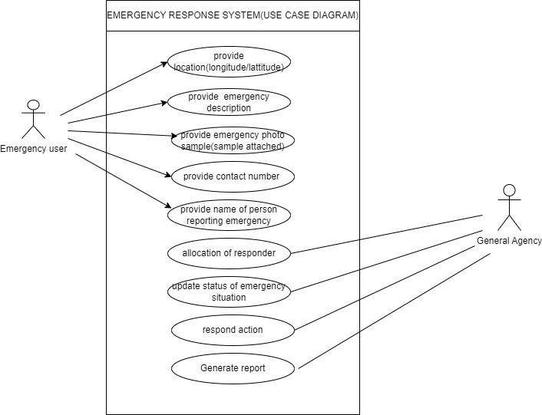

Figure 2Use case diagram

# 3.7.2 Data Flow Diagram

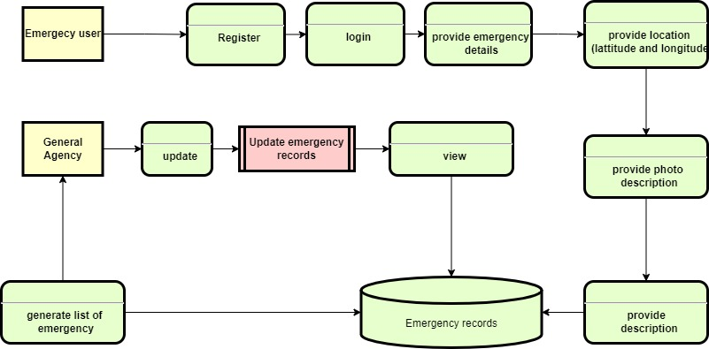

# 3.7.3 Context Diagram

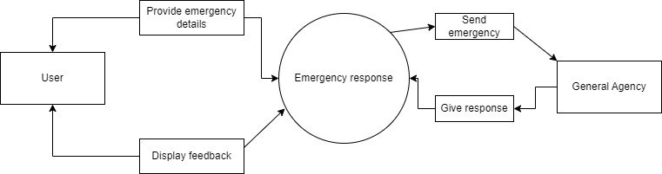

# 3.8 Research Ethics

Guidelines for conducting research responsibly are provided by research ethics. The subsequent ethical guidelines were followed throughout the research process. These are;

1. Honesty -The information gathered for this study was not created or falsified in any way. The information was given truthfully.
2. Carefulness - Excellent care was taken to collect the data during the entire process. The conduct of the research was well documented.
3. Confidentiality – User records, including confidential communications, were safeguarded.
4. Competence - I promoted scientific competency as a whole and took steps to preserve and develop my own professional competence and expertise through lifelong learning.

# CHAPTER FOUR

# SYSTEM IMPLEMENTATION AND DEPLOYMENT

# 4.1 Introduction

This system is aimed to assist in quick emergency response at any location using their geo-tag and also IP address. The web browser gets the users location and saves it on the mysql database. The chapter will discuss the various components of the system, including the front-end, back-end, user interface design, and deployment method. Additionally, the chapter will cover the testing process and the results obtained.

## **4.2 System Description**

The emergency response system is designed to capture the user’s location, date of the incident and pick the exact responder will locate the user. The system itself compromises of two primary components, the front-end, database and the back-end. The front-end is responsible for capturing name, location, date, a photo of the incident. The data collected in the database includes, users table, admin table, emergency types table, emergency table and agency table. The front-end code is connected to the back end. The system is designed to be efficient, reliable, and accurate, and the two main components work seamlessly to provide an easy emergency response.

# 4.3 Front-end

The front-end of the system is built with HTML, CSS and JavaScript. The front-end mostly involves a user friendly design to enable its users to be quite able to use the system quite easily. The user of the system include a super admin, the emergency agency and the normal user. The main objective of the code is to be able to send the response signal of their exact location and to the right agency for a quick response.

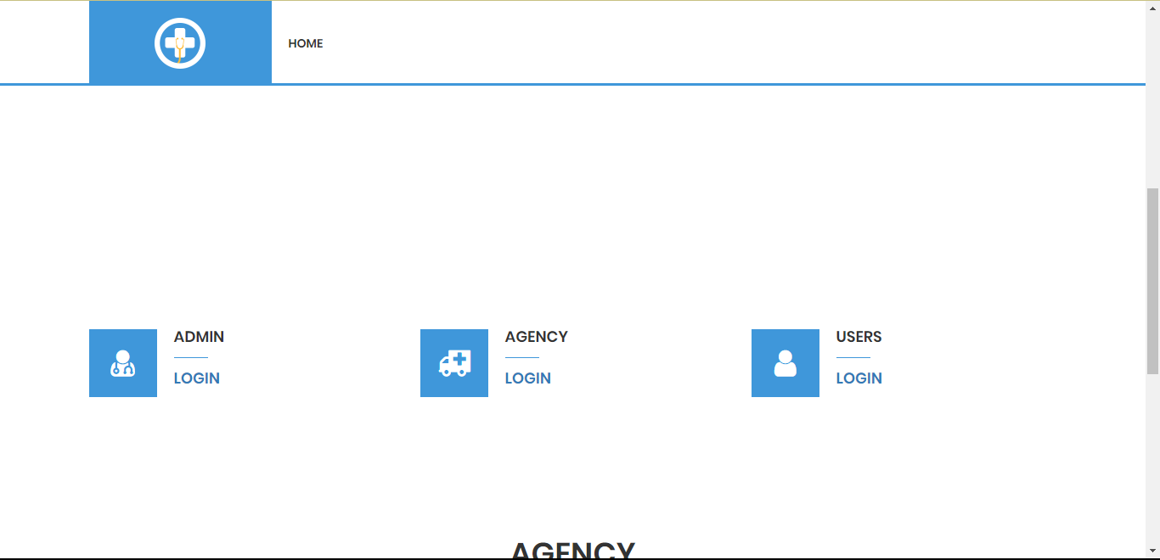

Figure 3Homepage

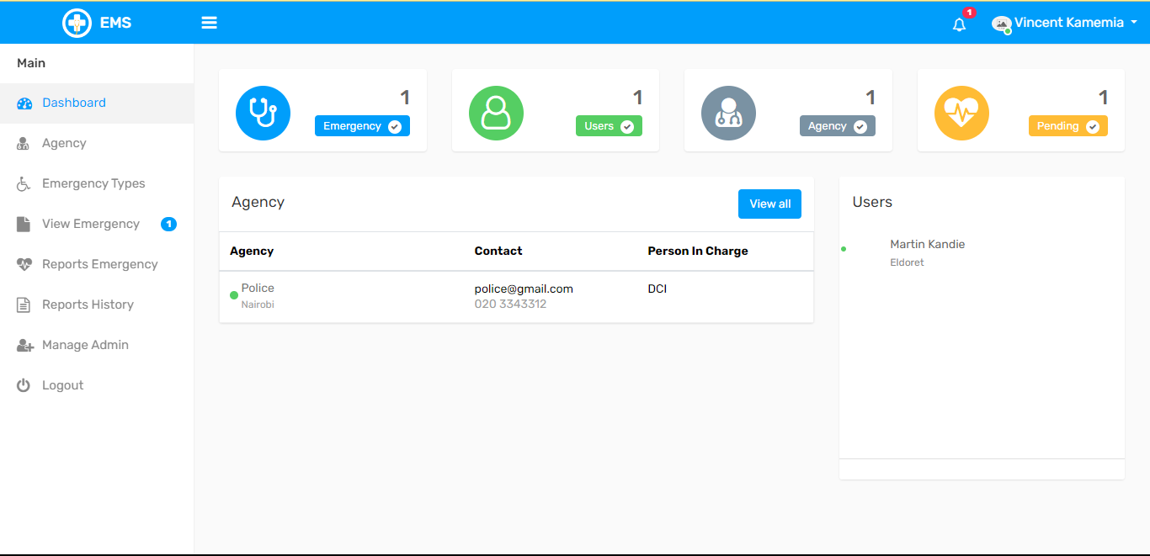

Figure 4Admin

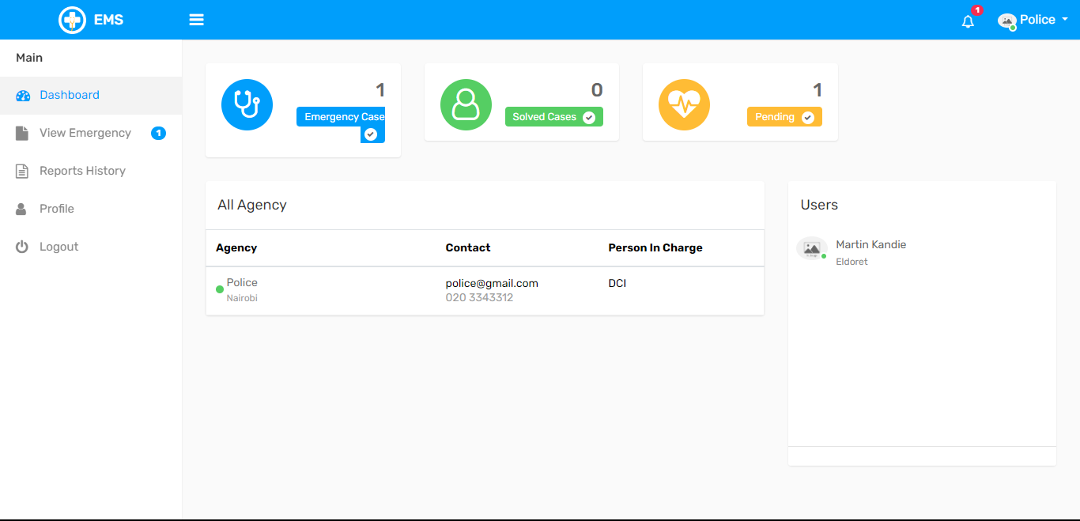

Figure 5Agency

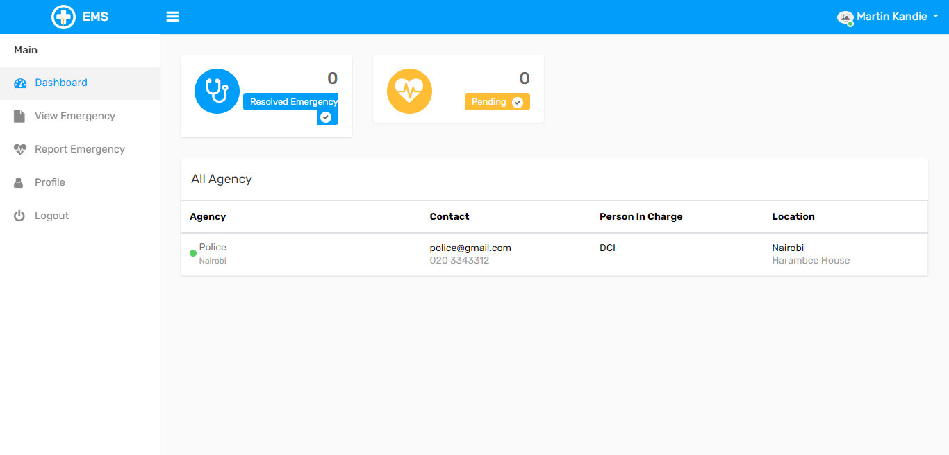

Figure 6User

## **4.4 User Interface Design**

The user interface of the system is simple and easy to use. It consists of a dashboard that can easily tell which user you currently are and their exact geo-location.

## **4.5 Back-end Development**

The back-end development is the one responsible for processing all the information and sending them to the database. Once any button with a field area the data is required to be filled, the data is immediately processed and pushed to the mysql database currently being run on xampp.

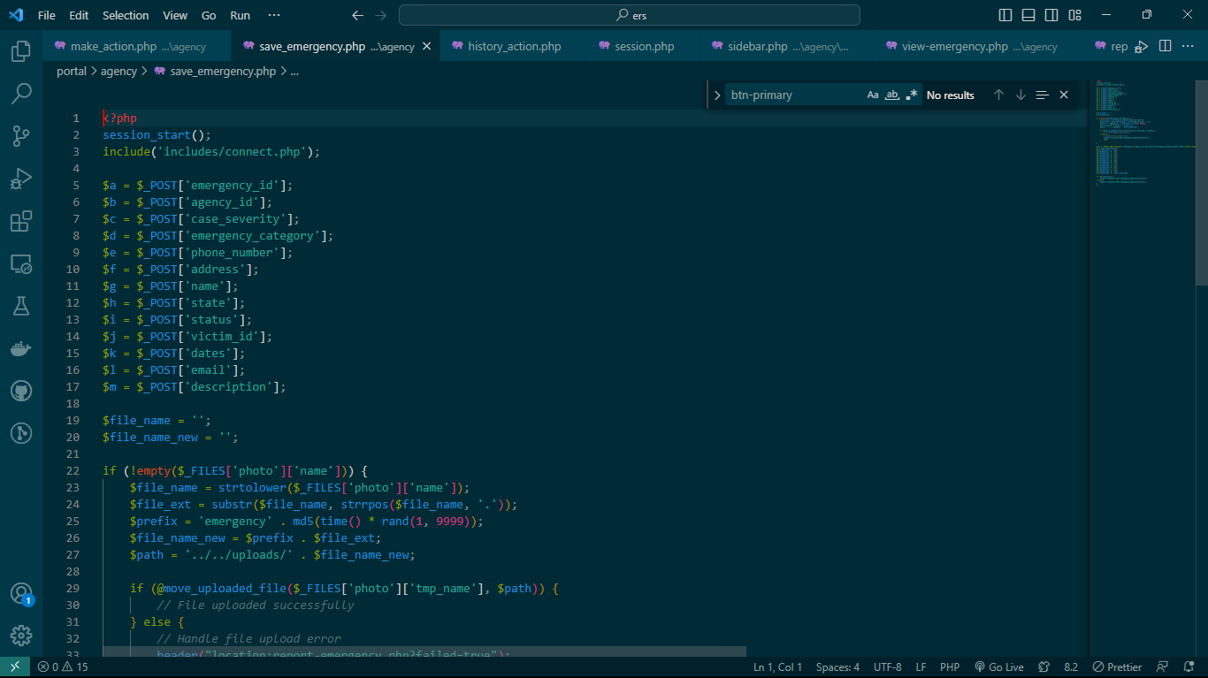

Figure 7Backend

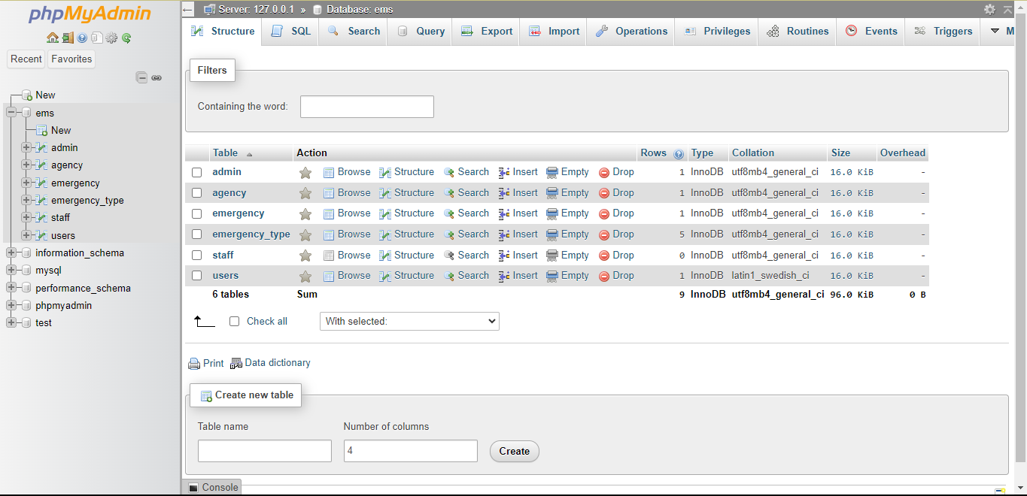

Figure 8MySQl

## **4.5.1 Code Testing**

Before deploying the system, extensive testing was done to ensure that the system was working as expected. The system was tested using various scenarios, including different lighting conditions, different locations, and different users. The testing was successful, and the system was ready for deployment.

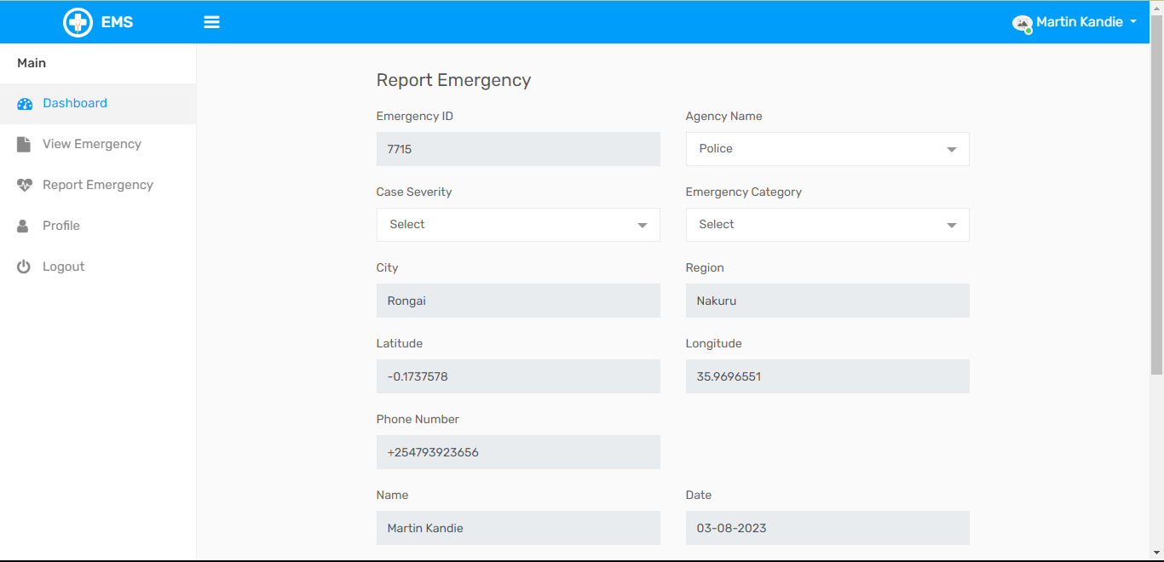

Figure 9Sample Report Emergency

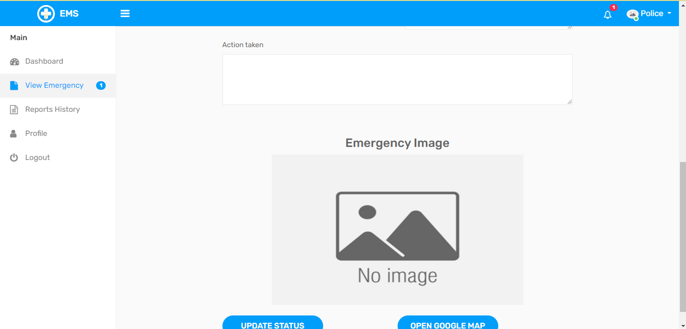

Figure 10Sample response from agency

## **4.6 Deployment Method**

This is the part that we launch our product in the market. I decided to use Phased deployment, Phased deployment can be an effective deployment method to consider for software systems with a high degree of customization or those that require significant training to use effectively. With this approach, the new system is released gradually, starting with a small group of users or a specific region before rolling out to the entire organization or market. This allows for feedback and usage data to be collected, which can help identify and address any issues that arise before the system is released to a wider audience. Additionally, phased deployment can help build excitement and anticipation for the new system, and users can gradually become accustomed to its features and functionality, reducing the risk of confusion or frustration during the transition. Overall, phased deployment can be an effective way to minimize the risk of disruption during the deployment process and ensure a smooth transition to the new system.

# CHAPTER FIVE

# CONCLUSION AND RECOMMENDATIONS

# 5.0 Conclusion

The development and implementation of an effective emergency management system are crucial to mitigating the impact of disasters and emergencies. Throughout this analysis, we have explored the key components that contribute to an efficient emergency management system, including preparedness, response, recovery, and communication. It is evident that an integrated and well-coordinated approach is essential for handling various emergencies, whether they be natural disasters, pandemics, terrorist attacks, or any other crisis situation.

## **5.1 Recommendations:**

Based on the findings, I recommend the following steps to enhance the emergency management system:

**Comprehensive Risk Assessment:** Conduct a detailed risk assessment to identify potential hazards and vulnerabilities specific to the region. This will enable better planning and resource allocation.

**Multi-Agency Collaboration**: Foster collaboration and communication between different agencies, including government bodies, emergency services, healthcare providers, and NGOs. Establishing a unified command structure will help streamline decision-making during crises.

**Advanced Technology Integration**: Embrace modern technologies, such as artificial intelligence, data analytics, and geographic information systems, to improve real-time data collection, analysis, and visualization. This will aid in making informed decisions and resource allocation during emergencies.

# REFERENCES

1]. Trukky: Online Load, Truck Booking [2]. JMIR Publication : https://www.jmir.org/2020/12/e23170/ [6].:https://link.springer.com/article/10.1007/s13755- 021-00147-7/ [7].G. Jayasinghe, F. Fahmy, N. Gajaweera, D. Dias, A GSM Alarm Device for Disaster Early Warning, First International Conference on Industrial and Information Systems. IEEE, 2006. [online] https://doi.org/10.1109/ICIIS.2006.365757 [8].ussam Elbehiery, Developed Intelligent Fire alarm system, 8(8), 2012 https://www.researchgate.net/publication/30888068 4_Design_and_Deployment_of_Mobile Based_Medical_Alert_System Professional Android 2 Application Development, R. Meier, Wiley (2010). Beginning Android 2, M. Murphy, Apress (2010). Android Developer Guide:

Agrawal, P., Rauschert, I., Inochanon, K., Bolelli, L., Fuhrmann, S., Brewer, I., Cai, G., MacEachren, A., & Sharma, R. (2004). Multimodal interface platform for geographical information systems (GeoMIP) in crisis management. In, Proceedings of the 6th international conference on Multimodal interfaces (pp. 339-340): ACM Amit Kushwaha, V.K. (2011). Location Based Services using Android Mobile Operating System. International Journal of Advances in Engineering & Technology Appelt, D.E., Hobbs, J.R., Bear, J., Israel, D., & Tyson, M. (1993). FASTUS: A finite-state processor for information extraction from real-world text. In, IJCAI (pp. 1172-1178) Arnold, S., Arnold, W.D., & Langsenkamp, A. (1996). Automated calling system with database updating. In: Google Patents Bhanumurthy, V., Rao, G.S., Karnatak, H.C., Mamatha, S., Roy, P., & Radhakrishnan, K. (2008). EMERGENCY MANAGEMENT–A GEOSPATIAL APPROACH. the International Archives of the Photogrammetry, Remote Sensing and Spatial Information Sciences, Beijing, 3

# Appendix A: Interview Guide

1. Build Rapport:

Provide introductions and ask rapport-building questions to put the candidate at ease.

2. Establish motive:

Explain to the candidate the reasons for wanting to conduct the interview.

3. Begin interview:

**General Background**

1. Name.

2. Number of years working as a Security Personnel.

3. Other work stations they have been posted in.

4. How often do they rotate in their work stations?

**Specific Information.**

1. How do you decide which vehicle should enter and which one should not?

2. How do register vehicles when they enter?

3. What details do you capture while registering the vehicle?

4. How and where do you record the vehicle details?

5. What are some of the difficulties you experience in registering vehicles?

6. What are the recorded details used for?

**Interview conclusion**

1. Is there any significant information that we may not have discussed that you would like to

include?

2. Thank the Interviewee for his/her time.